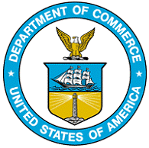

Generated

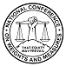

barriers to permissible metric-only labeling in federal and state packaging and labeling laws and regulations.

**Forum Participation**

More than 60 people, including representatives of state and federal agencies, foreign governments, trade associations, manufacturers, retailers, and other interested parties, attended the forum held at the United States Department of Commerce in Washington, D.C. A list of registrants and attendees and copies of several presentations are available at http://www.nist.gov/metric on the Internet. The participants included:

**International:** Representatives from Measurement Canada and the European Union/Delegation of the European Commission.

**Federal Agencies:**

