# Milwaukee Road Redevelopment

Developer/Sponsor:

Menomonee Valley Partnership, Inc., City of Milwaukee, Went Associates, Solomon/WRT, HNTB

Other Contributors:

Menomonee Valley Business Improvement District, Menomonee Valley Business Association, City of Milwaukee Department of City Development, Milwaukee County Economic and Community Development Division, Milwaukee Economic Development Corporation, Sixteenth Street Community Health Clinic, Forest County Potawatomi Community, WE Energies, Friends of the Hank Aaron State Trail

Status: Under Construction 1996-2010

Aim:

Developers aim to restore 200 acres of Milwaukee Road to its former glory as one of the main industrial centers—with a few alterations. Each building will comply with the Sustainable Design Guidelines set forth by the City of Milwaukee and Menomonee Valley Partnership (MVP), to promote energy efficient “green” facilities. Included in the redevelopment will be 70 acres of green space that re-establish Milwaukee Road’s previous ecosystems and protect them from further damage. In addition to considering environmental aspects developers will contribute to the community and economy by selling parcels to companies offering the most family-supportive jobs. Family supportive jobs entail high wages and health benefits. Upon completion, city officials estimate 1,830 new jobs will be created.

*“A revitalized Valley at the Center of Milwaukee; economically with strong companies and jobs near workers’ homes, geographically with renewed ties to the surrounding city, ecologically with healthy waterways and greenspace, and culturally with firm roots in its past and a role in histories to come.”—Aim of Milwaukee Road Redevelopment*

Project Description:

The Milwaukee Road is an extensive brownfield redevelopment project incorporating green technology and economic stimulation through job creation. The Menomonee River Valley consists of 1,500 acres and drains into a watershed, ultimately ending up in Lake Michigan. Previously the site was home to the first railroad between Wisconsin and Minnesota, known as the Milwaukee Road

Generated



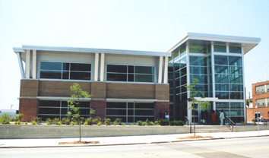



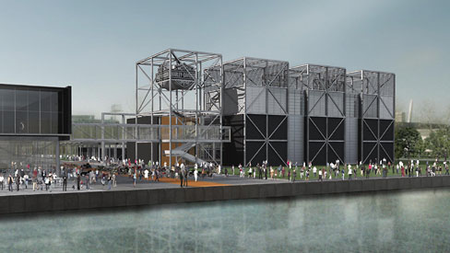

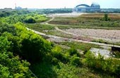

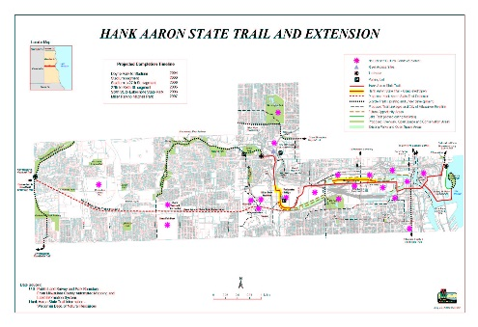

Generated

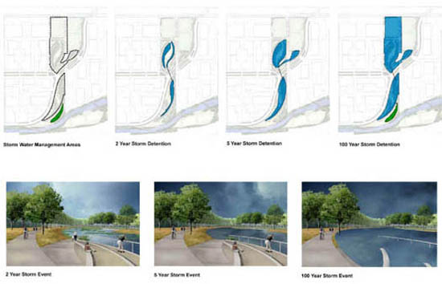













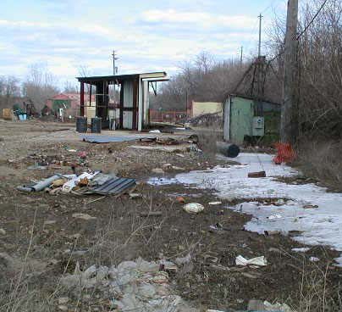

l as its location near downtown Milwaukee. The MVBI is monitoring both mobile and non-mobile emissions to determine the severity of impact on the air quality at the site of the redevelopment project. In addition to monitoring the Fine Particulate Matter (PM2.5), MVBI is monitoring five prevalent air toxins; Formaldehyde, Acetaldehyde, Benzene, 1,3-Butadiene, and PCBs, and both one hour and eight hour ozone concentrations.

Generated

The PM2.5 are being recorded every third calendar day by the Wisconsin Department of Natural Resources in various locations across the valley. These PM2.5 pose a significant threat to humans, once they are inhaled they are imbedded into the deep lunge tissue causing respiratory problems and a variety of health issues. The National Ambient Air Quality Standards set the average annual concentrations below 15ug/m3, and average 24-hour concentrations no greater than 65ug/m3. Over the past six years the amount of PM2.5s is declining rapidly and falls within the federal standards.

|  |  |  |
| --- | --- | --- |
| Toxic Compounds | (cancer risk)  1 in 100,000 | 1 in 1,000,000 |
| Acetaldehyde | .45ug/m3 | 4.5ug/m3 |
| Formaldehyde | .077ug/m3 | .77ug/m3 |
| 1,3-Butadiene | .3ug/m3 | .033ug/m3 |
| Benzene | 1.3ug/m3 | .13ug/m3 |

Fifty-six toxic compounds are presently being monitored at Menomonee Valley. Of the fifty-six, Formaldehyde, Acetaldehyde, Benzene, 1,3-Butadiene, and PCBs have been assessed as the highest health risk. These compounds are known to be possible carcinogens, causing various other health conditions, and have a negative effect on the environment. These toxins

were observed from 2000-2004 at Valley 1, located at 1337 S. Cesar Chavez Drive. As no National Ambient Air Quality Standards address toxic compounds the Environmental Protection Agency standards were applied (see table). Of the five compounds only 1,3-Butadiene is below the standard. PCBs in 2004 finally declined, falling below the Environmental Protection Agency’s annual average of 0.45ng/m3. In all prior years (2000-2003), the average of PCBs at Valley 1 exceeded the Environmental Protection Agency’s recommended maximum average.

The final component that the MVBI recorded was the one hour and eight hour ozone concentrations. The National Ambient Air Quality Standards establish that the average one-hour ozone concentration cannot exceed 124 ppb (parts per billion) and the average eight-hour ozone concentration cannot exceed 84 ppb. Observations took place at Valley 1 and hourly readings were recorded; the greatest reading of the day is termed the daily peak 1-hour ozone concentration. The average daily peak 1-hour ozone concentrations were well below the standards and were considerably lower in 2004 than in 2003. The eight-hour ozone standard is the federal government standard that replaced the 1-hour ozone standard. Likewise, the average daily peak 8-hour ozone concentration was significantly lower than the 84ppb standard. The highest readings in close proximity to the valley were 74ppb and 82ppb, still below the federal standard.

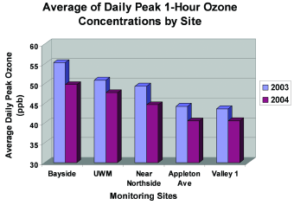

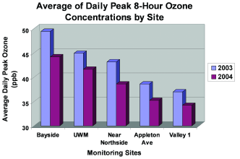

Groundwater:

The groundwater within the Menomonee Valley was examined meticulously by the City of Milwaukee and USGS from 1999-2001. The study was divided into separate parts, the first studying the location and flow of the groundwater through the valley, and the second determined the extent of contamination through chemical sampling (It is important to note that the final location of all surface water was impossible to determine conclusively because of the history of the site and the various waterways). Studies determined that there were two main receptors for shallow groundwater; the Deep Tunnel System and the Menomonee River, flowing into Lake Michigan. For surface water within 100 feet of river or canals, the final destination was not conclusive. Nevertheless, the approximate time for groundwater to travel from the valley to the Deep Tunnel System is 250 years, which is a substantial amount of time allowing for elimination of contaminants through natural mechanisms. In the event that contaminates are not completely dissolved, all water from the Deep Tunnel System is directed to the Jones Island Treatment Plant. The USGS confirmed that there was little cross flow between properties, negating the potential for widespread groundwater contamination. However, some site-specific contamination was present and can be handled on a case-by-case basis with the assistance of the Wisconsin Department of Natural Resources (WDNR). Typically mitigation measures such as removing the effected soil and monitoring for 1-2 years should rectify the situation.

(For more information regarding the groundwater study click here [http://www.renewthevalley.org/files/pdf/epareport.pdf])

Stormwater Management:

The Menomonee Valley stormwater management stratagem is founded on natural means. Developers are restoring wetlands and green space once prevalent in the valley and incorporating stormwater management into parks. There will be two main stormwater management areas and a Swamp Forest to accommodate stormwater from the surrounding developments. These three areas will treat stormwater in three steps. First, all water will be collected and transferred through a system of pipes where it will accumulate in small pools of water. Second, stormwater will

disperse across the shallow wetland meadows and will infiltrate through crushed pieces of concrete (this layer is known as an ‘infiltration gallery’). The stormwater will then be distributed to the Swamp Forest where the natural vegetation will remove contaminants. In order to decrease the actual amount of stormwater, builders must limit the number of impervious surfaces. By promoting permeable surfaces infiltration of stormwater will be amplified. Builders are also being urged to increase canopy coverage on their property, which will in turn contribute to the reduction of stormwater.

(For more information on MVBI Click Here [http://epic.cuir.uwm.edu/mvbi/other_docs.htm])

(For more information on the Master Land Use Plan Click Here [http://www.renewthevalley.org/files/pdf/MVIC%20-%20Master%20Use%20Plan%20-%20RACM%20Adopted.pdf])

Financial Structure

Section 108$10,000,000

BEDI $2,000,000

EPA Clean Up Grant $200,000

EDA BCR Loan Fund $1,125,000

HUD Neighborhood Grant $1,950,000

DNR SUDA Grant $837,000

WI Commerce Grant $1,250,000

Redevelopment Authority Loan $6,475,000

Total:$23,837,000