mostly minor contamination from in-depth investigations, redevelopment commenced. The project itself is divided into three sections beginning with the West End, which extends from the Menomonee River to 27th Street, Central Valley beginning at 27th Street and ending at the I-94/I-43, and finally the East End starting at the I-94/I-43 and ending near Downtown Milwaukee.

Generated

West End:

Consisting of 70-acres designated for light industry and 70-arces for a community park the West End is a premier location for development. The 70-acres reserved for a community park will be sectioned into three separate parks, namely, Chimney Park, River Lawn, and Airline Yards. The 70 acres allotted for light industry have yet to be sold completely, however Palermo has committed to constructing their manufacturing plant in the West End of the Menomonee River Valley.

Chimney Park pays homage to the history of Milwaukee Road with the placement of two Chimney Stacks as the focal points of the park. The park provides visitors with three soccer fields, two basketball courts, four handball courts, picnic areas, a playground, a skate park, and a sand volleyball court. A community gathering space consisting of a multipurpose indoors meeting space and basic facilities will also be built. To facilitate surrounding industrial buildings there will be naturalized stormwater management in the form of wetlands, ponds and meadows. There will also be a swamp forest reconstructed to restore the habitat and assist in additional stormwater management needs. In total there will be nine acres of stormwater management within Chimney Park.

River Lawn gives visitors access to the Menomonee River for kayaking and canoeing. These access points were constructed to provide flood control and improve habitats along the banks. Builders integrated limestone walls into the landscape along the rivers to both protect and provide seating for visitors. A network of trails both for walking and bicycling are found at River Lawn as well.

Airline Yards is 23 acres and possesses 2,600 feet of riverbank. This park represents the definitive attempt to restore the natural habitats and environment found in the Menomonee Valley prior to human contact. As a result three large mounds, reminiscent of the glacial drumlins once populating this area, are located within Airline Yards. These mounds were constructed using debris collected from the Milwaukee Shops site, filled in, and then covered with native foliage. The landscaping of the park includes a variety of environments including savannah, upland prairies, riparian forest, wetlands, bluffs, and meadows. Easy access points to the river are also provided for visitors as well as a network of trails, and athletic fields.

Palermo Villa Inc., the nations second fastest frozen pizza manufacturer, is the first business to purchase land at the Milwaukee Shops site. They will construct a manufacturing plant on 14 acres to consolidate their facilities in both Milwaukee and Illinois. Palermo will bring approximately 190 new jobs with substantial wages to the Menomonee Valley. As per agreement Palermo will construct its new plant in accordance with the Sustainable Design Guidelines.

Central Valley:

The Central Valley is composed of the Stockyards parcels. These sections of land will be sold to “high-quality, high-yield” industries.

In 2003 The Sigma Group relocated their 28,600 square foot headquarters to demonstrate that safe relocation on a brownfield is possible. The Sigma Group Environmental Headquarters adheres to the Sustainable Design Guidelines making it energy efficient and environmentally friendly. They are currently studying the environmental effects of their headquarters in order to quantify the impact. (For Information on Sigma Impact Study Click Here [http://epic.cuir.uwm.edu/mvbi/pdfs/sigma_impact_report.pd])



The 40,000 square foot Potawatomi Administration Building is also reconstructed within Central Valley. This building houses the Potawatomi Casino’s human resource department, the marketing department and the tribe’s legal department, as well as The Forest County Potawatomi Community Foundation. This exemplary building incorporates many green components compliant with the Sustainable Design Guidelines. In addition to being environmentally cognoscente, developers of the Potawatomi Administration Building purchased locally made products in order to contribute to the economy while saving money on shipping expenditures.

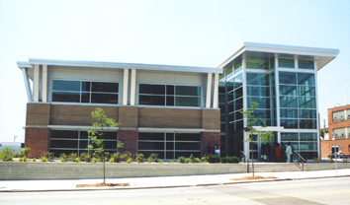

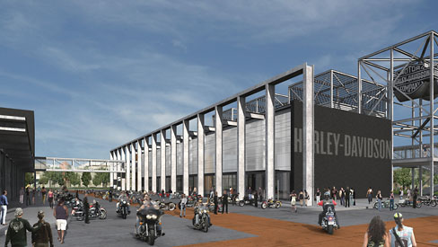

East End:

The highlight of the East End is the Harley-Davidson Museum. The project will consist of three separate buildings totaling 130,000 square feet. The first will house the museum, the second annex and archives, and the third will contain a restaurant, café, retail shops, and a special events facility. Another phase will be constructed at a later date to provide offices for Harley-Davidson employees. The $95 million dollar development will offer 70 permanent full-time jobs to residents and approximately 350 temporary construction jobs. In addition to contributing to the economy, the developers will also improve the environment. Harley-Davidson has committed to abide by the Sustainable Design Guidelines. (For more information on the Harley-Davidson Museum Click Here [www.h-dmuseum.com])

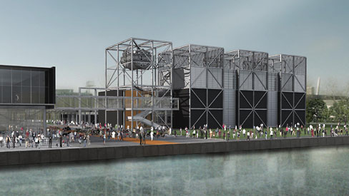

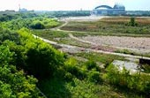

The Hank Aaron Trail, once extensions are finished, will be seven miles in length. It will connect with the Oak Leaf Trail, and will traverse the entire county of Milwaukee. The trail will take bicyclists and hikers through the Menomonee Valley as well as the historic districts surrounding the valley and other notable attractions. The Friends of the Hank Aaron Trail are committed to restoring the natural environment that was once present in the Valley along the trail. In order to re-establish the prairie environment The Friends of the Hank Aaron Trail are using controlled fires, mowing, seeding native plants, and removing aggressive non-native plant species. (For more information on the Hank Aaron Trail Click Here [http://www.hankaaronstatetrail.org/])

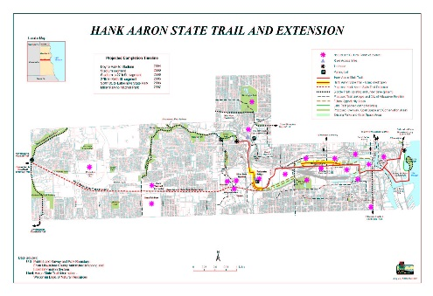

Green Components:

The Sigma Group Headquarters:

Extensive Natural Day Lighting—12% decrease in lighting expenditures compared to previous location, 85% Increase in Natural Day Lighting

Creation of 59,240 feet of Tree Canopy

14% Reduction in storm Water Run-off

36% Increase in Green Space

Low Flow Drainage Fixtures

100% Reduction in Salt, Fertilizer, and Pesticides

Capped/Removed Polynuclear Aromatic Hydrocarbon (PAH) contaminated soil

High Efficiency HVAC roof Top Unit

Baseboard Electrical Units

High Efficiency Gas-filled Rotary Unit (Heating)

Native Planting, Eradicating Non-native Plants

Passive Methane Venting System

The Potawatomi Administration Building:

Recycled Brick and Carpeting

Recycled Materials from casino construction

Exterior Sunshade

Grass Roof

High Efficiency Lighting Fixtures

Optimal use of Natural Lighting

3 40-ton HVAC units

Harley Davidson Museum:

Reflective Roof (Heat Absorption)

Permeable Pavement

Lawns, Terraces, Native Plantings, Native Trees

Creation of Green Space

For other green components that will be found in future buildings constructed in Menomonee Valley click here (Sustainable Guidelines Website http://design.renewthevalley.org/images/pdf/GuidelinesPrintable.pdf)

Environmental Complications and Solutions:

Generated

The Menomonee Valley is a brownfield and required intensive environmental investigations in order to ascertain the state of the valley and the safety of redevelopment on the site. Studies were conducted on Flood Plain, Soil Contamination, Air Quality, Groundwater, and Stormwater Management, each one of these required mitigation efforts to bring the redevelopment into compliance with both State and Federal standards. The majority of

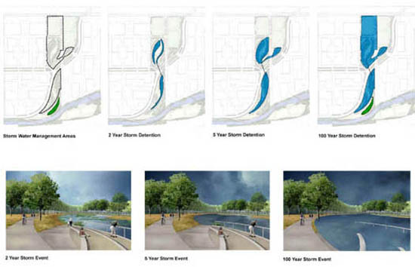













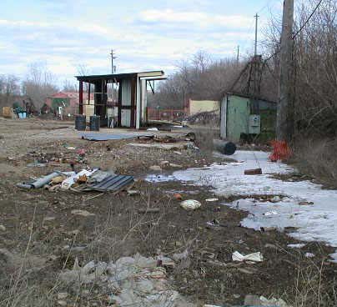

Generated

|  |  |  |
| --- | --- | --- |
| Toxic Compounds | (cancer risk)  1 in 100,000 | 1 in 1,000,000 |
| Acetaldehyde | .45ug/m3 | 4.5ug/m3 |
| Formaldehyde | .077ug/m3 | .77ug/m3 |
| 1,3-Butadiene | .3ug/m3 | .033ug/m3 |
| Benzene | 1.3ug/m3 | .13ug/m3 |

