hop Site. In 1985, after 106 years of service, the railroad declared bankruptcy; the surrounding industries declined and the land became vacant. Rebuilding on the site was postponed because the land was considered a brownfield. Stigmas associated with brownfields delay redevelopment because of the fear of contamination and safety of rebuilding, as well as the costs of clean up. However, in 2002, after conclusive findings of mostly minor contamination from in-depth investigations, redevelopment commenced. The project itself is divided into three sections beginning with the West End, which extends from the Menomonee River to 27th Street, Central Valley beginning at 27th Street and ending at the I-94/I-43, and finally the East End starting at the I-94/I-43 and ending near Downtown Milwaukee.

Generated

West End:

Consisting of 70-acres designated for light industry and 70-arces for a community park the West End is a premier location for development. The 70-acres reserved for a community park will be sectioned into three separate parks, namely, Chimney Park, River Lawn, and Airline Yards. The 70 acres allotted for light industry have yet to be sold completely, however Palermo has committed to constructing their manufacturing plant in the West End of the Menomonee River Valley.

Chimney Park pays homage to the history of Milwaukee Road with the placement of two Chimney Stacks as the focal points of the park. The park provides visitors with three soccer fields, two basketball courts, four handball courts, picnic areas, a playground, a skate park, and a sand volleyball court. A community gathering space consisting of a multipurpose indoors meeting space and basic facilities will also be built. To facilitate surrounding industrial buildings there will be naturalized stormwater management in the form of wetlands, ponds and meadows. There will also be a swamp forest reconstructed to restore the habitat and assist in additional stormwater management needs. In total there will be nine acres of stormwater management within Chimney Park.

River Lawn gives visitors access to the Menomonee River for kayaking and canoeing. These access points were constructed to provide flood control and improve habitats along the banks. Builders integrated limestone walls into the landscape along the rivers to both protect and provide seating for visitors. A network of trails both for walking and bicycling are found at River Lawn as well.

Airline Yards is 23 acres and possesses 2,600 feet of riverbank. This park represents the definitive attempt to restore the natural habitats and environment found in the Menomonee Valley prior to human contact. As a result

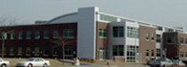

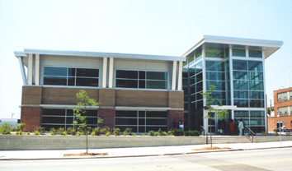

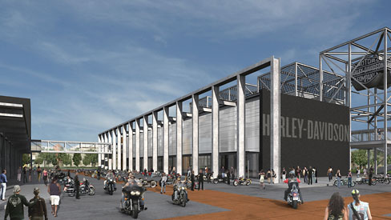

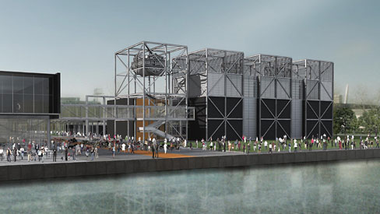

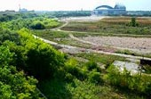

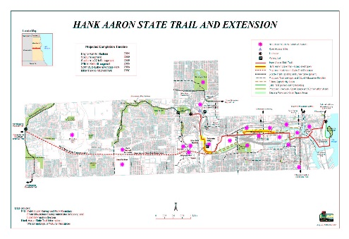

Generated

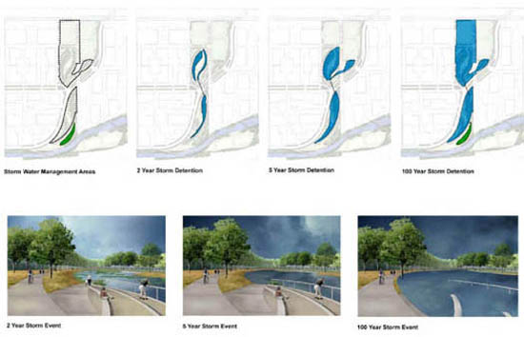













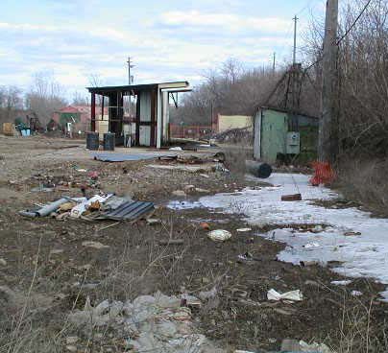

Generated

|  |  |  |
| --- | --- | --- |
| Toxic Compounds | (cancer risk)  1 in 100,000 | 1 in 1,000,000 |
| Acetaldehyde | .45ug/m3 | 4.5ug/m3 |
| Formaldehyde | .077ug/m3 | .77ug/m3 |
| 1,3-Butadiene | .3ug/m3 | .033ug/m3 |
| Benzene | 1.3ug/m3 | .13ug/m3 |

