Generated



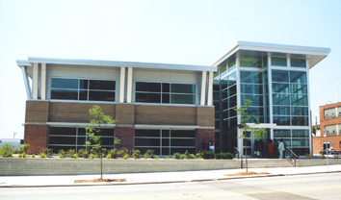



ick Here [www.h-dmuseum.com])



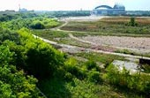

The Hank Aaron Trail, once extensions are finished, will be seven miles in length. It will connect with the Oak Leaf Trail, and will traverse the entire county of Milwaukee. The trail will take bicyclists and hikers through the Menomonee Valley as well as the historic districts surrounding the valley and other notable attractions. The Friends of the Hank Aaron Trail are committed to restoring the natural environment that was once present in the Valley along the trail. In order to re-establish the prairie environment The Friends of the Hank Aaron Trail are using controlled fires, mowing, seeding native plants, and removing aggressive non-native plant species. (For more information on the Hank Aaron Trail Click Here [http://www.hankaaronstatetrail.org/])

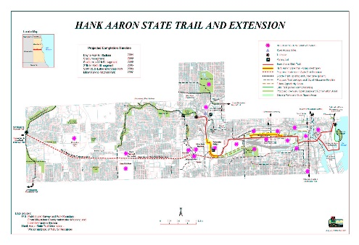

Green Components:

The Sigma Group Headquarters:

Extensive Natural Day Lighting—12% decrease in lighting expenditures compared to previous location, 85% Increase in Natural Day Lighting

Creation of 59,240 feet of Tree Canopy

14% Reduction in storm Water Run-off

36% Increase in Green Space

Low Flow Drainage Fixtures

100% Reduction in Salt, Fertilizer, and Pesticides

Capped/Removed Polynuclear Aromatic Hydrocarbon (PAH) contaminated soil

High Efficiency HVAC roof Top Unit

Baseboard Electrical Units

High Efficiency Gas-filled Rotary Unit (Heating)

Native Planting, Eradicating Non-native Plants

Passive Methane Venting System

The Potawatomi Administration Building:

Recycled Brick and Carpeting

Recycled Materials from casino construction

Exterior Sunshade

Grass Roof

High Efficiency Lighting Fixtures

Optimal use of Natural Lighting

3 40-ton HVAC units

Harley Davidson Museum:

Reflective Roof (Heat Absorption)

Permeable Pavement

Lawns, Terraces, Native Plantings, Native Trees

Creation of Green Space

For other green components that will be found in future buildings constructed in Menomonee Valley

Generated















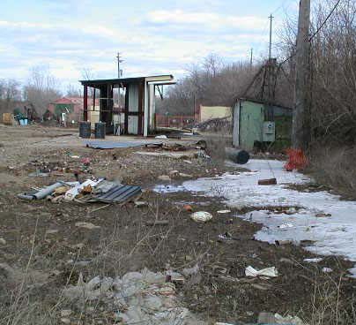

Generated

|  |  |  |
| --- | --- | --- |
| Toxic Compounds | (cancer risk)  1 in 100,000 | 1 in 1,000,000 |
| Acetaldehyde | .45ug/m3 | 4.5ug/m3 |
| Formaldehyde | .077ug/m3 | .77ug/m3 |
| 1,3-Butadiene | .3ug/m3 | .033ug/m3 |
| Benzene | 1.3ug/m3 | .13ug/m3 |

