Generated

Palermo will construct its new plant in accordance with the Sustainable Design Guidelines.

Central Valley:

The Central Valley is composed of the Stockyards parcels. These sections of land will be sold to “high-quality, high-yield” industries.

In 2003 The Sigma Group relocated their 28,600 square foot headquarters to demonstrate that safe relocation on a brownfield is possible. The Sigma Group Environmental Headquarters adheres to the Sustainable Design Guidelines making it energy efficient and environmentally friendly. They are currently studying the environmental effects of their headquarters in order to quantify the impact. (For Information on Sigma Impact Study Click Here [http://epic.cuir.uwm.edu/mvbi/pdfs/sigma_impact_report.pd])



The 40,000 square foot Potawatomi Administration Building is also reconstructed within Central Valley

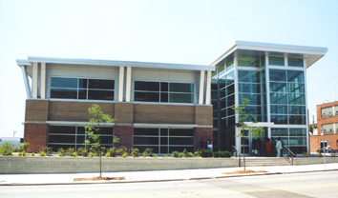

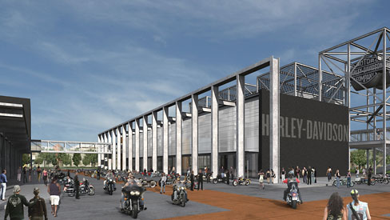

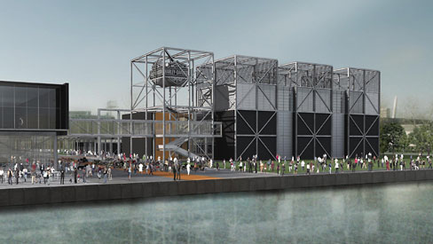



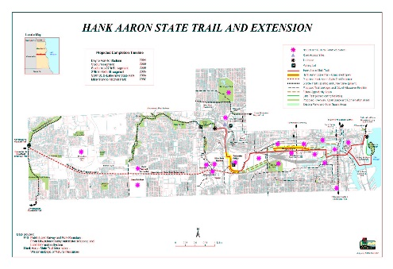

Generated

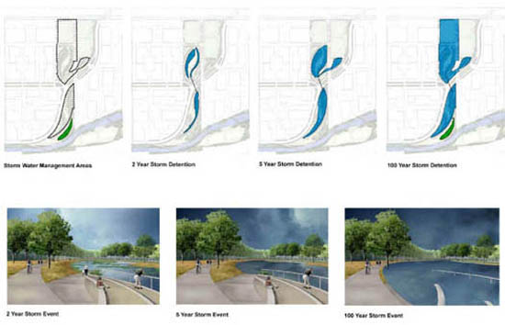













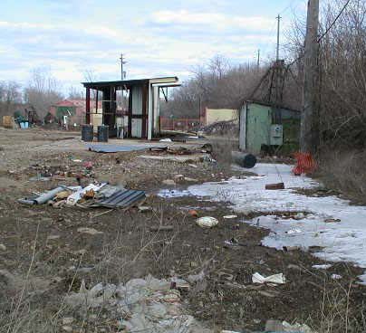

Generated

|  |  |  |
| --- | --- | --- |
| Toxic Compounds | (cancer risk)  1 in 100,000 | 1 in 1,000,000 |
| Acetaldehyde | .45ug/m3 | 4.5ug/m3 |
| Formaldehyde | .077ug/m3 | .77ug/m3 |
| 1,3-Butadiene | .3ug/m3 | .033ug/m3 |
| Benzene | 1.3ug/m3 | .13ug/m3 |

