Generated











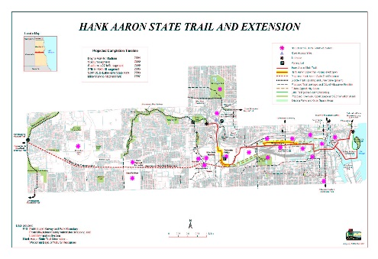

Generated

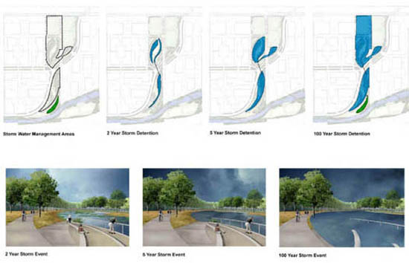













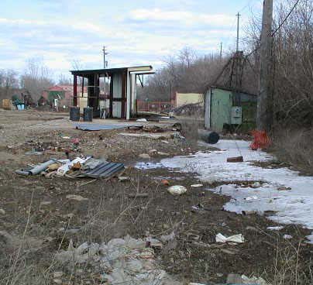

Generated

|  |  |  |
| --- | --- | --- |
| Toxic Compounds | (cancer risk)  1 in 100,000 | 1 in 1,000,000 |
| Acetaldehyde | .45ug/m3 | 4.5ug/m3 |
| Formaldehyde | .077ug/m3 | .77ug/m3 |
| 1,3-Butadiene | .3ug/m3 | .033ug/m3 |
| Benzene | 1.3ug/m3 | .13ug/m3 |

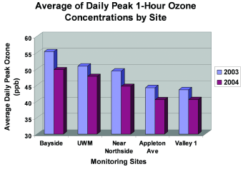

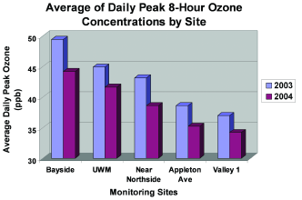

he Wisconsin Department of Natural Resources (WDNR). Typically mitigation measures such as removing the effected soil and monitoring for 1-2 years should rectify the situation.

(For more information regarding the groundwater study click here [http://www.renewthevalley.org/files/pdf/epareport.pdf])

Stormwater Management:

The Menomonee Valley stormwater management stratagem is founded on natural means. Developers are restoring wetlands and green space once prevalent in the valley and incorporating stormwater management into parks. There will be two main stormwater management areas and a Swamp Forest to accommodate stormwater from the surrounding developments. These three areas will treat stormwater