Generated

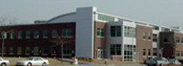

on shipping expenditures.

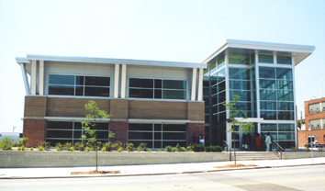

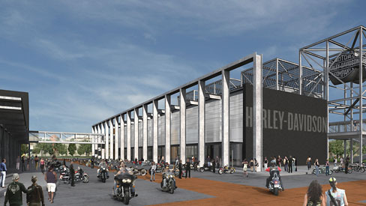

East End:

The highlight of the East End is the Harley-Davidson Museum. The project will consist of three separate buildings totaling 130,000 square feet. The first will house the museum, the second annex and archives, and the third will contain a restaurant, café, retail shops, and a special events facility. Another phase will be constructed at a later date to provide offices for Harley-Davidson employees. The $95 million dollar

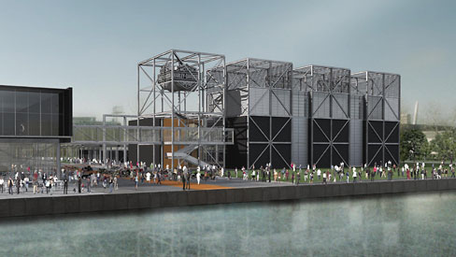

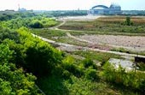

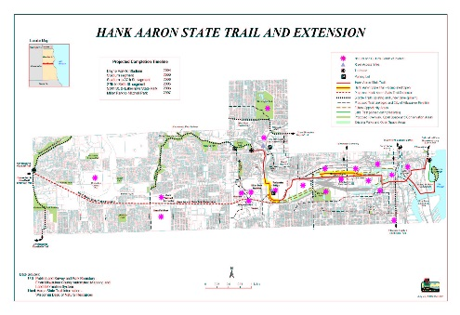

Generated

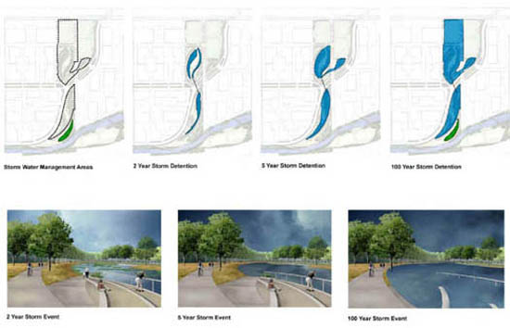













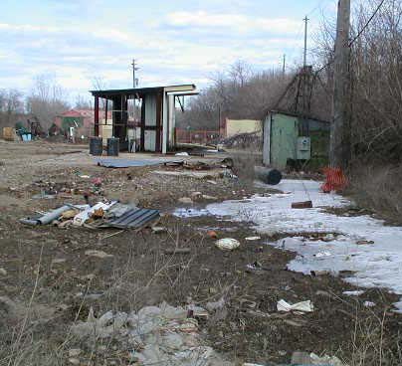

Generated

|  |  |  |
| --- | --- | --- |
| Toxic Compounds | (cancer risk)  1 in 100,000 | 1 in 1,000,000 |
| Acetaldehyde | .45ug/m3 | 4.5ug/m3 |
| Formaldehyde | .077ug/m3 | .77ug/m3 |
| 1,3-Butadiene | .3ug/m3 | .033ug/m3 |
| Benzene | 1.3ug/m3 | .13ug/m3 |

