Generated



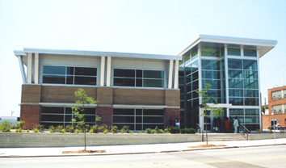

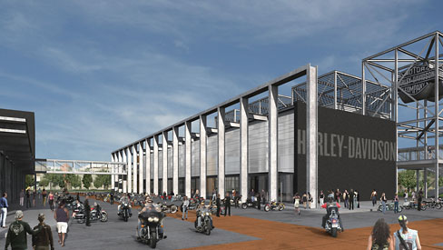

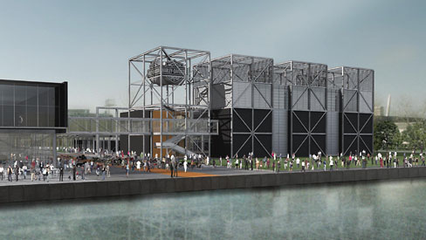

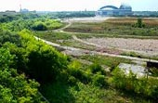

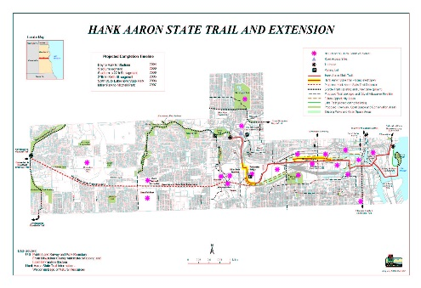

Generated

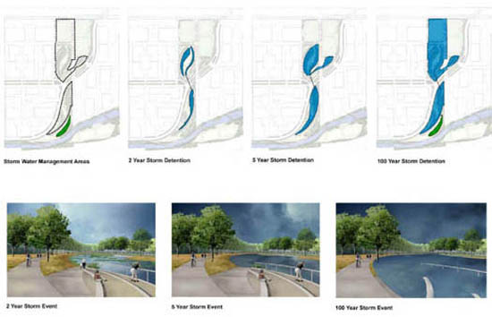



tion efforts began as eight feet of fill, transferred from the Marquette Interchange, were added to the Shop site. Restoring the natural environment is also an important measure that will contribute to the decrease in flooding. Another core component is the Hydraulic Modeling system. The USGS conducted a study of the flow systems present in the Menomonee Valley in order to











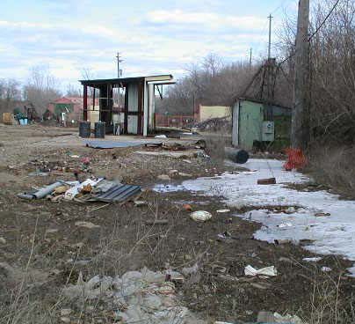

Generated

|  |  |  |
| --- | --- | --- |
| Toxic Compounds | (cancer risk)  1 in 100,000 | 1 in 1,000,000 |
| Acetaldehyde | .45ug/m3 | 4.5ug/m3 |
| Formaldehyde | .077ug/m3 | .77ug/m3 |
| 1,3-Butadiene | .3ug/m3 | .033ug/m3 |
| Benzene | 1.3ug/m3 | .13ug/m3 |

