# Milwaukee Road Redevelopment

Developer/Sponsor:

Menomonee Valley Partnership, Inc., City of Milwaukee, Went Associates, Solomon/WRT, HNTB

Other Contributors:

Menomonee Valley Business Improvement District, Menomonee Valley Business Association, City of Milwaukee Department of City Development, Milwaukee County Economic and Community Development Division, Milwaukee Economic Development Corporation, Sixteenth Street Community Health Clinic, Forest County Potawatomi Community, WE Energies, Friends of the Hank Aaron State Trail

Status: Under Construction 1996-2010

Aim:

Developers aim to restore 200 acres of Milwaukee Road to its former glory as one of the main industrial centers—with a few alterations. Each building will comply with the Sustainable Design Guidelines set forth by the City of Milwaukee and Menomonee Valley Partnership (MVP), to promote energy efficient “green” facilities. Included in the redevelopment will be 70 acres of green space that re-establish Milwaukee Road’s previous ecosystems and protect them from further damage. In addition to considering environmental aspects developers will contribute to the community and economy by selling parcels to companies offering the most family-supportive jobs. Family supportive jobs entail high wages and health benefits. Upon completion, city officials estimate 1,830 new jobs will be created.

*“A revitalized Valley at the Center of Milwaukee; economically with strong companies and jobs near workers’ homes, geographically with renewed ties to the surrounding city, ecologically with healthy waterways and greenspace, and culturally with firm roots in its past and a role in histories to come.”—Aim of Milwaukee Road Redevelopment*

Project Description:

The Milwaukee Road is an extensive brownfield redevelopment project incorporating green technology and economic stimulation through job creation. The Menomonee River Valley consists of 1,500 acres and drains into a watershed, ultimately ending up in Lake Michigan. Previously the site was home to the first railroad between Wisconsin and Minnesota, known as the Milwaukee Road, and the subsequent locomotive and rail car repair shops inhabiting what is currently the Milwaukee Road Shop Site. In 1985, after 106 years of service, the railroad declared bankruptcy; the surrounding industries declined and the land became vacant. Rebuilding on the site was postponed because the land was considered a brownfield. Stigmas associated with brownfields delay redevelopment because of the fear of contamination and safety of rebuilding, as well as the costs of clean up. However, in 2002, after conclusive findings of mostly minor contamination from in-depth investigations, redevelopment commenced. The project itself is divided into three sections beginning with the West End, which extends from the Menomonee River to 27th Street, Central Valley beginning at 27th Street and ending at the I-94/I-43, and finally the East End starting at the I-94/I-43 and ending near Downtown Milwaukee.

Generated

West End:

Consisting of 70-acres designated for light industry and 70-arces for a community park the West End is a premier location for development. The 70-acres reserved for a community park will be sectioned into three separate parks, namely, Chimney Park, River Lawn, and Airline Yards. The 70 acres allotted for light industry have yet to be sold completely, however Palermo has committed to constructing their manufacturing plant in the West End of the Menomonee River Valley.

Chimney Park pays homage to the history of Milwaukee Road with the placement of two Chimney Stacks as the focal points of the park. The park provides visitors with three soccer fields, two basketball courts, four handball courts, picnic areas, a playground, a skate park, and a sand volleyball court. A community gathering space consisting of a multipurpose indoors meeting space and basic facilities will also be built. To facilitate surrounding industrial buildings there will be naturalized stormwater management in the form of wetlands, ponds and meadows. There will also be a swamp forest reconstructed to restore the habitat and assist in additional stormwater management needs. In total there will be nine acres of stormwater management within Chimney Park.

River Lawn gives visitors access to the Menomonee River for kayaking and canoeing. These access points were constructed to provide flood control and improve habitats along the banks. Builders integrated limestone walls into the landscape along the rivers to both protect and provide seating for visitors. A network of trails both for walking and bicycling are found at River Lawn as well.

Airline Yards is 23 acres and possesses 2,600 feet of riverbank. This park represents the definitive attempt to restore the natural habitats and environment found in the Menomonee Valley prior to human contact. As a result three large mounds, reminiscent of the glacial drumlins once populating this area, are located within Airline Yards. These mounds were constructed using debris collected from the Milwaukee Shops site, filled in, and then covered with native foliage. The landscaping of the park includes a variety of environments including savannah, upland prairies, riparian forest, wetlands, bluffs, and meadows. Easy access points to the river are also provided for visitors as well as a network of trails, and athletic fields.

Palermo Villa Inc., the nations second fastest frozen pizza manufacturer, is the first business to purchase land at the Milwaukee Shops site. They will construct a manufacturing plant on 14 acres to consolidate their facilities in both Milwaukee and Illinois. Palermo will bring approximately 190 new jobs with substantial wages to the Menomonee Valley. As per agreement Palermo will construct its new plant in accordance with the Sustainable Design Guidelines.

Central Valley:

The Central Valley is composed of the Stockyards parcels. These sections of land will be sold to “high-quality, high-yield” industries.

In 2003 The Sigma Group relocated their 28,600 square foot headquarters to demonstrate that safe relocation on a brownfield is possible. The Sigma Group Environmental Headquarters adheres to the Sustainable Design Guidelines making it energy efficient and environmentally friendly. They are currently studying the environmental effects of their headquarters in order to quantify the impact. (For Information on Sigma Impact Study Click Here [http://epic.cuir.uwm.edu/mvbi/pdfs/sigma_impact_report.pd])



The 40,000 square foot Potawatomi Administration Building is also reconstructed within Central Valley. This building houses the Potawatomi Casino’s human resource department, the marketing department and the tribe’s legal department, as well as The Forest County Potawatomi Community Foundation. This exemplary building incorporates many green components compliant with the Sustainable Design Guidelines. In addition to being environmentally cognoscente, developers of the Potawatomi Administration Building purchased locally made products in order to contribute to the economy while saving money on shipping expenditures.

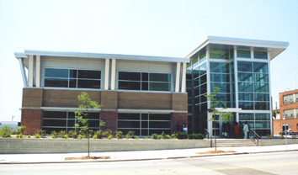

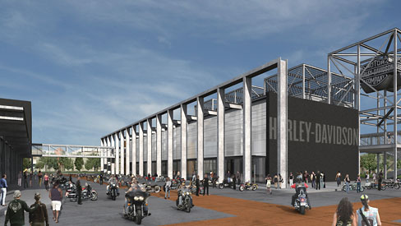

East End:

The highlight of the East End is the Harley-Davidson Museum. The project will consist of three separate buildings totaling 130,000 square feet. The first will house the museum, the second annex and archives, and the third will contain a restaurant, café, retail shops, and a special events facility. Another phase will be constructed at a later date to provide offices for Harley-Davidson employees. The $95 million dollar development will offer 70 permanent full-time jobs to residents and approximately 350 temporary construction jobs. In addition to contributing to the economy, the developers will also improve the environment. Harley-Davidson has committed to abide by the Sustainable Design Guidelines. (For more information on the Harley-Davidson Museum Click Here [www.h-dmuseum.com])

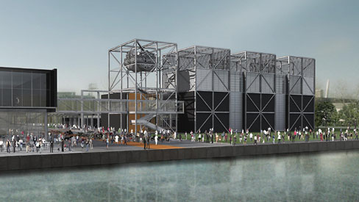

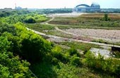

The Hank Aaron Trail, once extensions are finished, will be seven miles in length. It will connect with the Oak Leaf Trail, and will traverse the entire county of Milwaukee. The trail will take bicyclists and hikers through the Menomonee Valley as well as the historic districts surrounding the valley and other notable attractions. The Friends of the Hank Aaron Trail are committed to restoring the natural environment that was once present in the Valley along the trail. In order to re-establish the prairie environment The Friends of the Hank Aaron Trail are using controlled fires, mowing, seeding native plants, and removing aggressive non-native plant species. (For more information on the Hank Aaron Trail Click Here [http://www.hankaaronstatetrail.org/])

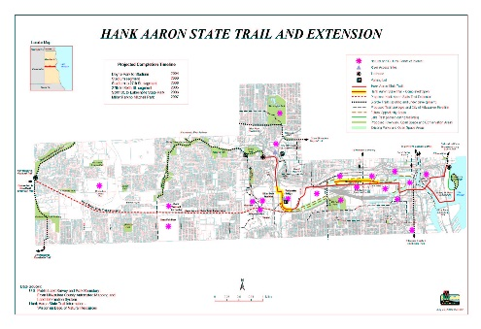

Green Components:

The Sigma Group Headquarters:

Extensive Natural Day Lighting—12% decrease in lighting expenditures compared to previous location, 85% Increase in Natural Day Lighting

Creation of 59,240 feet of Tree Canopy

14% Reduction in storm Water Run-off

36% Increase in Green Space

Low Flow Drainage Fixtures

100% Reduction in Salt, Fertilizer, and Pesticides

Capped/Removed Polynuclear Aromatic Hydrocarbon (PAH) contaminated soil

High Efficiency HVAC roof Top Unit

Baseboard Electrical Units

High Efficiency Gas-filled Rotary Unit (Heating)

Native Planting, Eradicating Non-native Plants

Passive Methane Venting System

The Potawatomi Administration Building:

Recycled Brick and Carpeting

Recycled Materials from casino construction

Exterior Sunshade

Grass Roof

High Efficiency Lighting Fixtures

Optimal use of Natural Lighting

3 40-ton HVAC units

Harley Davidson Museum:

Reflective Roof (Heat Absorption)

Permeable Pavement

Lawns, Terraces, Native Plantings, Native Trees

Creation of Green Space

For other green components that will be found in future buildings constructed in Menomonee Valley click here (Sustainable Guidelines Website http://design.renewthevalley.org/images/pdf/GuidelinesPrintable.pdf)

Environmental Complications and Solutions:

Generated

The Menomonee Valley is a brownfield and required intensive environmental investigations in order to ascertain the state of the valley and the safety of redevelopment on the site. Studies were conducted on Flood Plain, Soil Contamination, Air Quality, Groundwater, and Stormwater Management, each one of these required mitigation efforts to bring the redevelopment into compliance with both State and Federal standards. The majority of the test and evaluations done to ensure conformity to codes and regulations has been performed by the Menomonee Valley Benchmark Initiative (MVBI). MVBI has identified and grouped 50 indicators, and will observe them in five-year intervals.

Flood Plain:

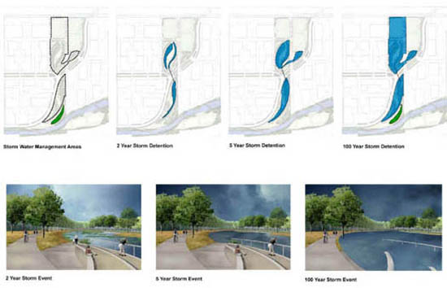



The Southeast Wisconsin Regional Planning Commission (SEWRPC) conducted a preliminary analysis of the flood plains, specifically at the Milwaukee Road Shops redevelopment site and Airline Yards site. The study found that the Shop site needed to be raised, but the Airline Yards development was for the most part excluded from the flood plain, negating the need for flood plain mitigation. SEWRPC also determined that the Shop site must withstand a 2,000 cubic feet per second flow in a 100-year old flood event. The Milwaukee Zoning Code also demands that the building floor be two feet above the regular flood elevation as well as any area within 15 feet of the building. Mitigation efforts began as eight feet of fill, transferred from the Marquette Interchange, were added to the Shop site. Restoring the natural environment is also an important measure that will contribute to the decrease in flooding. Another core component is the Hydraulic Modeling system. The USGS conducted a study of the flow systems present in the Menomonee Valley in order to determine the destination and effects of recharge in the valley. With this strategy the applicable 100 acres would have no surface water discharge. Developers maintain that the Shop site will be ready for construction in late 2006, early 2007 after the fill settles.











Soil Contamination:

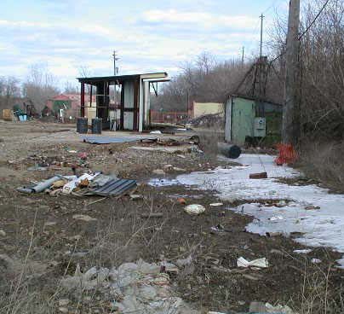

Soil Contamination poses a potentially dangerous threat throughout the valley due to the history of the site. Prior construction the site was a wetland and then a railroad and industrial center. Because of peat moss deposits and the wetlands, methane gas is a risk across the valley. The railroads and industries have left relic structures including floor slabs, sewers and foundations, causing a risk for heavy metal and Polynuclear Aromatic Hydrocarbon contamination. As a result the redevelopment site has gone through extensive testing and geotechnical evaluations. In order to impede any further damage, developers have buried contaminated soil under several feet of fill, and severely contaminated soil was extricated to another location. A designated onsite placement area for contaminated soil will be created for future projects. Engineering and institutional controls for future developments include a long-term, right-of-entry agreement giving the city access to groundwater monitoring, sampling, and NAPL collection trench sampling ports and a mandatory two foot thick clean soil cover or pavement cover. In addition, methane mitigation is mandatory and is the responsibility of the developer; recommendations for methane mitigation include passive methane/soil gas collection systems.

Air Quality:

Menomonee Valley is centrally located in a metropolitan area, and while that holds many industrial benefits the air quality can be greatly compromised because of the placement of highways through the valley as well as its location near downtown Milwaukee

Generated

|  |  |  |
| --- | --- | --- |
| Toxic Compounds | (cancer risk)  1 in 100,000 | 1 in 1,000,000 |
| Acetaldehyde | .45ug/m3 | 4.5ug/m3 |
| Formaldehyde | .077ug/m3 | .77ug/m3 |
| 1,3-Butadiene | .3ug/m3 | .033ug/m3 |
| Benzene | 1.3ug/m3 | .13ug/m3 |

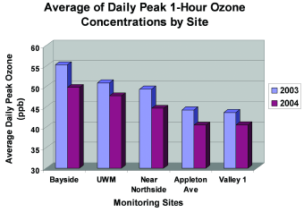

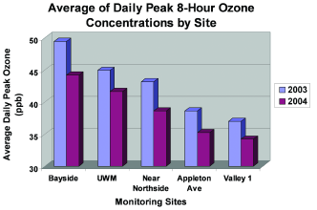

er will be collected and transferred through a system of pipes where it will accumulate in small pools of water. Second, stormwater will

disperse across the shallow wetland meadows and will infiltrate through crushed pieces of concrete (this layer is known as an ‘infiltration gallery’). The stormwater will then be distributed to the Swamp Forest where the natural vegetation will remove contaminants. In order to decrease the actual amount of stormwater, builders must limit the number of impervious surfaces. By promoting permeable surfaces infiltration of stormwater will be amplified. Builders are also being urged to increase canopy coverage on their property, which will in turn contribute to the reduction of stormwater.

(For more information on MVBI Click Here [http://epic.cuir.uwm.edu/mvbi/other_docs.htm])

(For more information on the Master Land Use Plan Click Here [http://www.renewthevalley.org/files/pdf/MVIC%20-%20Master%20Use%20Plan%20-%20RACM%20Adopted.pdf])

Financial Structure

Section 108$10,000,000

BEDI $2,000,000

EPA Clean Up Grant $200,000

EDA BCR Loan Fund $1,125,000

HUD Neighborhood Grant $1,950,000

DNR SUDA Grant $837,000

WI Commerce Grant $1,250,000

Redevelopment Authority Loan $6,475,000

Total:$23,837,000