Generated

emonstrate that safe relocation on a brownfield is possible. The Sigma Group Environmental Headquarters adheres to the Sustainable Design Guidelines making it energy efficient and environmentally friendly. They are currently studying the environmental effects of their headquarters in order to quantify the impact. (For Information on Sigma Impact Study Click Here [http://epic.cuir.uwm.edu/mvbi/pdfs/sigma_impact_report.pd])



The 40,000 square foot Potawatomi Administration Building is also reconstructed within Central Valley. This building houses the Potawatomi Casino’s human resource department, the marketing department and the tribe’s legal department, as well as The Forest County Potawatomi Community Foundation. This exemplary building incorporates many green components compliant with the Sustainable Design Guidelines. In addition to being environmentally cognoscente, developers of the Potawatomi Administration Building purchased locally made products in order to contribute to the economy while saving money on shipping expenditures.

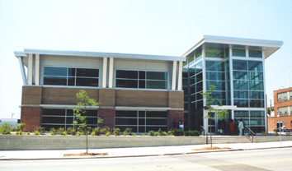



East End:

The highlight of the East End is the Harley-Davidson Museum. The project will consist of three separate buildings totaling 130,000 square feet. The first will house the museum, the second annex and archives, and the third will contain a restaurant, café, retail shops, and a special events facility. Another phase will be constructed at a later date to provide offices for Harley-Davidson employees. The $95 million dollar development will offer 70 permanent full-time jobs to residents and approximately 350 temporary construction jobs. In addition to contributing to the economy, the developers will also improve the environment. Harley-Davidson has committed to abide by the Sustainable Design Guidelines. (For more information on the Harley-Davidson Museum Click Here [www.h-dmuseum.com])

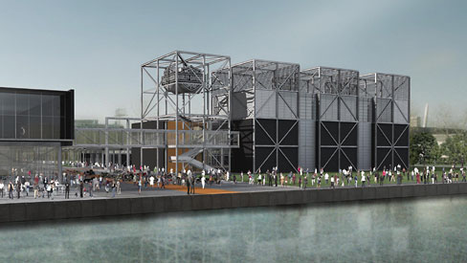



The Hank Aaron Trail, once extensions are finished, will be seven miles in length. It will connect with the Oak Leaf Trail, and will traverse the entire county of Milwaukee. The trail will take bicyclists and hikers through the Menomonee Valley as well as the historic districts surrounding the valley and other notable attractions. The Friends of the Hank Aaron Trail are committed to restoring the natural environment that was once present in the Valley along the trail. In order to re-establish the prairie environment The Friends of the Hank Aaron Trail are using controlled fires, mowing, seeding native plants, and removing aggressive non-native plant species. (For more information on the Hank Aaron Trail Click Here [http://www.hankaaronstatetrail.org/])

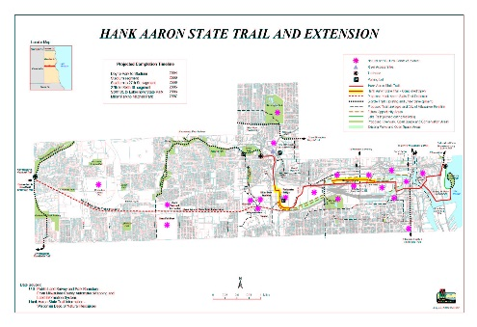

Green Components:

The Sigma Group Headquarters:

Extensive Natural Day Lighting—12% decrease in lighting expenditures compared to previous location, 85% Increase in Natural Day Lighting

Creation of 59,240 feet of Tree Canopy

14% Reduction in storm Water Run-off

36% Increase in Green Space

Low Flow Drainage Fixtures

100% Reduction in Salt, Fertilizer, and Pesticides

Capped/Removed Polynuclear Aromatic Hydrocarbon (PAH) contaminated soil

High Efficiency HVAC roof Top Unit

Baseboard Electrical Units

High Efficiency Gas-filled Rotary Unit (Heating)

Native Planting, Eradicating Non-native Plants

Passive Methane Venting System

The Potawatomi Administration Building:

Recycled Brick and Carpeting

Recycled Materials from casino construction

Exterior Sunshade

Grass Roof

High Efficiency Lighting Fixtures

Optimal use of Natural Lighting

3 40-ton HVAC units

Harley Davidson Museum:

Reflective Roof (Heat Absorption)

Permeable Pavement

Lawns, Terraces, Native Plantings, Native Trees

Creation of Green Space

For other green components that will be found in future buildings constructed in Menomonee Valley click here (Sustainable Guidelines Website http://design.renewthevalley.org/images/pdf/GuidelinesPrintable.pdf)

Environmental Complications and Solutions:

Generated

The Menomonee Valley is a brownfield and required intensive environmental investigations in order to ascertain the state of the valley and the safety of redevelopment on the site. Studies were conducted on Flood Plain, Soil Contamination, Air Quality, Groundwater, and Stormwater Management, each one of these required mitigation efforts to bring the redevelopment into compliance with both State and Federal standards. The majority of the test and evaluations done to ensure conformity to codes and regulations has been performed by the Menomonee Valley Benchmark Initiative (MVBI). MVBI has identified and grouped 50 indicators, and will observe them in five-year intervals.

Flood Plain:

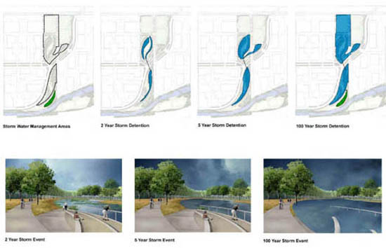



The Southeast Wisconsin Regional Planning Commission (SEWRPC) conducted a preliminary analysis of the flood plains, specifically at the Milwaukee Road Shops redevelopment site and Airline Yards site. The study found that the Shop site needed to be raised, but the Airline Yards development was for the most part excluded from the flood plain, negating the need for flood plain mitigation. SEWRPC also determined that the Shop site must withstand a 2,000 cubic feet per second flow in a 100-year old flood event. The Milwaukee Zoning Code also demands that the building floor be two feet above the regular flood elevation as well as any area within 15 feet of the building. Mitigation efforts began as eight feet of fill, transferred from the Marquette Interchange, were added to the Shop site. Restoring the natural environment is also an important measure that will contribute to the decrease in flooding. Another core component is the Hydraulic Modeling system. The USGS conducted a study of the flow systems present in the Menomonee Valley in order to determine the destination and effects of recharge in the valley. With this strategy the applicable 100 acres would have no surface water discharge. Developers maintain that the Shop site will be ready for construction in late 2006, early 2007 after the fill settles.











Soil Contamination:

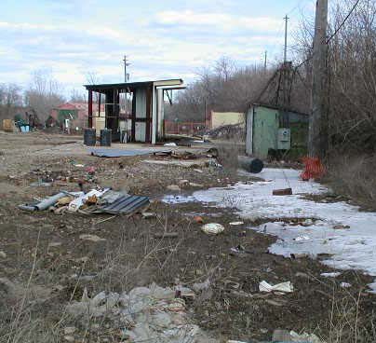

Soil Contamination poses a potentially dangerous threat throughout the valley due to the history of the site. Prior construction the site was a wetland and then a railroad and industrial center. Because of peat moss deposits and the wetlands, methane gas is a risk across the valley. The railroads and industries have left relic structures including floor slabs, sewers and foundations, causing a risk for heavy metal and Polynuclear Aromatic Hydrocarbon contamination. As a result the redevelopment site has gone through extensive testing and geotechnical evaluations. In order to impede any further damage, developers have buried contaminated soil under several feet of fill, and severely contaminated soil was extricated to another location. A designated onsite placement area for contaminated soil will be created for future projects. Engineering and institutional controls for future developments include a long-term, right-of-entry agreement giving the city access to groundwater monitoring, sampling, and NAPL collection trench sampling ports and a mandatory two foot thick clean soil cover or pavement cover. In addition, methane mitigation is mandatory and is the responsibility of the developer; recommendations for methane mitigation include passive methane/soil gas collection systems.

Air Quality:

Menomonee Valley is centrally located in a metropolitan area, and while that holds many industrial benefits the air quality can be greatly compromised because of the placement of highways through the valley as well as its location near downtown Milwaukee. The MVBI is monitoring both mobile and non-mobile emissions to determine the severity of impact on the air quality at the site of the redevelopment project. In addition to monitoring the Fine Particulate Matter (PM2.5), MVBI is monitoring five prevalent air toxins; Formaldehyde, Acetaldehyde, Benzene, 1,3-Butadiene, and PCBs, and both one hour and eight hour ozone concentrations.

Generated

The PM2.5 are being recorded every third calendar day by the Wisconsin Department of Natural Resources in various locations across the valley. These PM2.5 pose a significant threat to humans, once they are inhaled they are imbedded into the deep lunge tissue causing respiratory problems and a variety of health issues. The National Ambient Air Quality Standards set the average annual concentrations below 15ug/m3, and average 24-hour concentrations no greater than 65ug/m3. Over the past six years the amount of PM2.5s is declining rapidly and falls within the federal standards.

|  |  |  |
| --- | --- | --- |
| Toxic Compounds | (cancer risk)  1 in 100,000 | 1 in 1,000,000 |
| Acetaldehyde | .45ug/m3 | 4.5ug/m3 |
| Formaldehyde | .077ug/m3 | .77ug/m3 |
| 1,3-Butadiene | .3ug/m3 | .033ug/m3 |
| Benzene | 1.3ug/m3 | .13ug/m3 |

Fifty-six toxic compounds are presently being monitored at Menomonee Valley. Of the fifty-six, Formaldehyde, Acetaldehyde, Benzene, 1,3-Butadiene, and PCBs have been assessed as the highest health risk. These compounds are known to be possible carcinogens, causing various other health conditions, and have a negative effect on the environment. These toxins

were observed from 2000-2004 at Valley 1, located at 1337 S. Cesar Chavez Drive. As no National Ambient Air Quality Standards address toxic compounds the Environmental Protection Agency standards were applied (see table). Of the five compounds only 1,3-Butadiene is below the standard. PCBs in 2004 finally declined, falling below the Environmental Protection Agency’s annual average of 0.45ng/m3. In all prior years (2000-2003), the average of PCBs at Valley 1 exceeded the Environmental Protection Agency’s recommended maximum average.

The final component that the MVBI recorded was the one hour and eight hour

