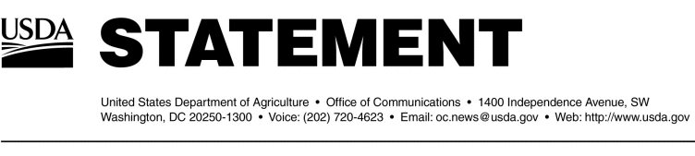

.

Other Issues

Additional information on BSE can be obtained by visiting the USDA website at http://www.usda.gov. Past BSE updates can also be found at http://www.aphis.usda.gov.

#