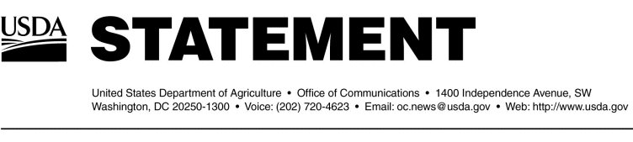

. Past BSE updates can also be found at http://www.aphis.usda.gov.

#