Generated

Generated

|  |  |
| --- | --- |
| Concentrations of CCA Wood TreatmentsRecommended for Various Uses | |
| Retentions *(lbs./cu.ft.)* | Uses/Exposures |
| 0.10 – 0.25  0.21 – 0.41  0.31– 0.61  2.50 | Above ground  Soil & Freshwater use  Permanent Wood Foundation  Saltwater use |

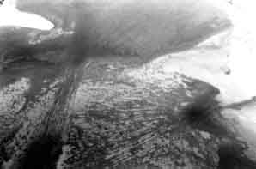

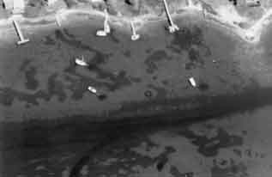

Weigert, R.G., L.R. Pomeroy, and W.J. Wiebe. 1981. Ecology of Salt Marshes: An Introduction. In *The Ecology of a Saltmarsh.* Eds. L.R. Pomeroy and R.G. Wiegert. Springer-Verlag.

Weinstein, J.E. 1996. Anthropogenic Impacts on Salt Marshes—A Review. In *Sustainable Development in the Southeastern Coastal Zone.* Eds. Vernberg, F.J., W.B. Venberg and T. Siewicki. University of South Carolina Press.

Weis, P., J.S. Weis, and L.M. Coohill. 1991. Toxicity to Estuarine Organisms of Leachates from Chromated Copper Arsenate Treated Wood. *Archives of. Environmental Contamination and Toxicology*. 20: 118–124.

Weis, P., J.S. Weis, A. Greenberg, and T.J. Nosker. 1992 Toxicity of Construction Materials in the Marine Environment: A Comparison of Chromated-Copper-arsenate-Treated Wood and Recycled Plastic. *Archives of Environmental Contamination and Toxicology*. 22: 99–106.

Weis, P. J.S. Weis and J. Couch 1993. Histopathology and bioaccumulation in oysters (*Crassostrea virginica*) living on wood preserved with chromated copper arsenate. *Diseases of Aquatic Organisms.* 17: 41-46.

Weis, J.S., P. Weis, and T. Proctor. 1998. The extent of benthic impacts of CCA-treated wood structures in Atlantic Coast Estuaries. *Archives of Environmental Contamination and Toxicology*. 34: 313–322.

Weis, J.S. and P. Weis. 1996. The effects of using wood treated with chromated copper arsenate in shallow water environments: a review. *Estuaries* 19:306–310.

Weis, J.S. and P. Weis. 1998. *Effects of CCA Wood Docks and Resulting Boats on Bioaccumulation of Contaminants in Shellfish Resources: Final Report to DEP*. A report to the NJ DEP.

Wendt, P.H., R.F. Van Dolah, M.Y. Bobo, T.D. Mathews, and M.V. Levisen. 1996. Wood Preservative Leachates from Docks in an Estuarine Environment. *Archives of Environmental Contamination and Toxicology*, 31:71–79.

Wilson, Joshua. 2002. *The Effects of Docks and Mechanical Disturbance on Submerged Aquatic Vegetation in Tidal-Fresh Hamburg Cove (Lyme, CT)*. Yale School of Forestry and Environmental Studies.

Zabawa, C., C. Ostrom, R. J. Byrne, J. D. Boon III, R. Waller, and D. Blades. 1980. *Final report on the role of boat wakes in shore erosion in Anne Arundel County, Maryland*. Tidewater Administration, Maryland Dept. of Natural Resources. 12/1/80. 238 pp

Zieman, J.C. 1976. The ecological effects of physical damage from motorboats on turtle grass beds in southern Florida. *Aquatic Botany* 2:127–139

Ziencina, Mitchell. 2002. Massachusetts Department of Environmental Protection, Lakeville, MA.