Generated

Generated

|  |  |
| --- | --- |
| Concentrations of CCA Wood TreatmentsRecommended for Various Uses | |
| Retentions *(lbs./cu.ft.)* | Uses/Exposures |
| 0.10 – 0.25  0.21 – 0.41  0.31– 0.61  2.50 | Above ground  Soil & Freshwater use  Permanent Wood Foundation  Saltwater use |

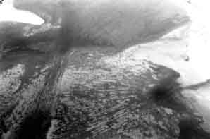

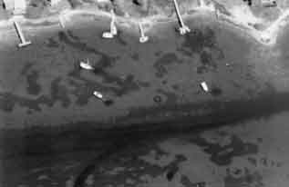

. A report to the NJ DEP.

Wendt, P.H., R.F. Van Dolah, M.Y. Bobo, T.D. Mathews, and M.V. Levisen. 1996. Wood Preservative Leachates from Docks in an Estuarine Environment. *Archives of Environmental Contamination and Toxicology*, 31:71–79.

Wilson, Joshua. 2002. *The Effects of Docks and Mechanical Disturbance on Submerged Aquatic Vegetation in Tidal-Fresh Hamburg Cove (Lyme, CT)*. Yale School of Forestry and Environmental Studies.

Zabawa, C., C. Ostrom, R. J. Byrne, J. D. Boon III, R. Waller, and D. Blades. 1980. *Final report on the role of boat wakes in shore erosion in Anne Arundel County, Maryland*. Tidewater Administration, Maryland Dept. of Natural Resources. 12/1/80. 238 pp

Zieman, J.C. 1976. The ecological effects of physical damage from motorboats on turtle grass beds in southern Florida. *Aquatic Botany* 2:127–139

Ziencina, Mitchell. 2002. Massachusetts Department of Environmental Protection, Lakeville, MA.