Generated

Generated

|  |  |
| --- | --- |
| Concentrations of CCA Wood TreatmentsRecommended for Various Uses | |
| Retentions *(lbs./cu.ft.)* | Uses/Exposures |
| 0.10 – 0.25  0.21 – 0.41  0.31– 0.61  2.50 | Above ground  Soil & Freshwater use  Permanent Wood Foundation  Saltwater use |

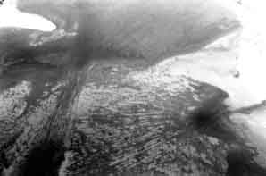

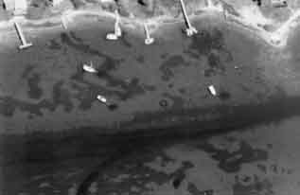

Zabawa, C., C. Ostrom, R. J. Byrne, J. D. Boon III, R. Waller, and D. Blades. 1980. *Final report on the role of boat wakes in shore erosion in Anne Arundel County, Maryland*. Tidewater Administration, Maryland Dept. of Natural Resources. 12/1/80. 238 pp

Zieman, J.C. 1976. The ecological effects of physical damage from motorboats on turtle grass beds in southern Florida. *Aquatic Botany* 2:127–139

Ziencina, Mitchell. 2002. Massachusetts Department of Environmental Protection, Lakeville, MA.