|  |  |
| --- | --- |
| ***Science Members*** |  |
| Andrew Steele | Carnegie Institution of Washington |
| Bob Anderson | University of Colorado |
| David Blake | Ames Research Center |
| Hunter Waite | University of Michigan |
| Jack Mustard | Brown University |
| Jan Amend | Washington University |
| Jan Toporski | Carnegie Institution of Washington |
| Janok Bhattacharya | Univ. of Texas, Dallas |
| Jennifer Biddle | Penn State |
| John Lindsay | JSC/LPI |
| Liane Benning | Leeds University |
| Luther Beegle | JPL |
| Pan Conrad | JPL |
| Rocco Mancinelli | SETI/ARC |
| Sherry Cady | Portland State |
| Will Brinckerhoff | APL |
| ***Engineering Members*** | |
| Greg Mungas | JPL |
| Knut Oxnevad | JPL |
| Roger Diehl | JPL |
| ***Program*** |  |
| David Beaty | Program Office--JPL |
| Jim Garvin | Program Office--HQ |
| Marguerite Syvertson | Program Office--JPL |

Generated

|  |  |
| --- | --- |
| **Source of Carbon** | **Carbon compounds. examples/comments** |
| Abiotic molecules from meteoritic / cometary influx | Amino acids, purines and pyrimidines, polycyclic aromatic hydrocarbons, chain hydrocarbons, fatty acids, sugars and sugar derivatives. |
| Prebiotic/abiotic molecules from synthesis reaction process on Mars | Amino acids, purines and pyrimidines, polycyclic aromatic hydrocarbons, chain hydrocarbons, fatty acids, sugars and sugar derivatives. |
| Terrestrial contaminating organics | Condensation products derived from rocket exhaust, lubricants, plasticizers, atmospheric contaminants |
| Terrestrial contaminating organisms | Whole cells, cell components (LPS, DNA, proteins, cytochromes) found on AFL itself. |
| Terrestrial like organisms – from Earth | Organisms not present on the craft measuring them, but had been previously transferred from Earth by either meteorite impact or contamination of previous spacecraft. Target molecules could include individual genes, membrane constituents, specific enzymes, and co-enzymes that would be expected to be over expressed or adapted in Martian conditions |
| Terrestrial-like organisms – evolved on Mars | Organisms that utilize terrestrial like biochemistries and have evolved on Mars Target molecules could include individual genes, membrane constituents, specific enzymes, and co-enzymes that would be expected to be over expressed or adapted in Martian conditions or organisms using metabolisms that would not be present on a space craft contaminant such as methanogens, psychrophiles endolithic survival mechanisms. |
| Non-terrestrial-like organisms | Utilizes an array of molecules for information storage, information transfer, compartmentalization and enzymatic activity that differ from those used by extant terrestrial life. Examples would be the use of novel amino acids and nucleotides or the use of novel nitrogen utilization strategies. |
| Fossil biomarkers | Detection of established terrestrial fossil biomarkers such as hopanes, archaeal lipids and steranes, for the detection of the diagenetic remains of terrestrial based life. Characterization of potential breakdown products that can be reasonably extrapolated from the detection of molecules comprising an extant Martian life form. Detection of the diagenesis products of extinct Martian organism based on carbon compositions consistent with biological fractionation of a narrow range of abiotic precursors. |

|  |  |  |  |
| --- | --- | --- | --- |
| **Component** | **% Total Weight (or mass C x10-13 g)** | **Number of Types** | **Preservation** |
| **Water** | 70 (NA) | 1 | Unknown in Organic and mineral phases |
| **Proteins** | 15 | ~2000 | 1000’s without protection by a mineral matrix. ~45Ma with protection?. |
| **Nucleic Acids** |  |  |  |
| DNA | 1 | 2+ | Oldest ? ~350,000 |
| RNA | 6 | (see below) | Days – Months (studies on longevity of RNA other than in clinical settings have not been performed. |
| *rRNA* | 5.5 | 3 | Days – Months |
| *tRNA* | 0.1 | ~32 | Days – Months |
| *mRNA* | 0.3 | 1000’s | Days – Months |
| *Non coding RNA* | 0.1 | 1000’s | Days – Months |
| **Polysaccharides** | ~1 | Uncounted | Chitin - 25Ma. Exopolymer sheaths ~2Ga |
| **Lipids** | 2 | ~50 | Cell wall components - Hopanes 2.7Ga |
| **Amino acids** | 0.4 | ~100 (20 main ones) | As protein diagenesis – Ma.  Chiral signal in fossils lost after ~ 1 Ma. |
| **Sugars** | ~3 | ~200 | Days to weeks (see polysaccharides) |
| **Other small organics** | 0.2 | ~200 | Porphyrins ~ 2 Ga |
| **Inorganic species (C, H, N, O, Fe, P, S etc).** | 1 (~100% dry weight) | ~20 – 30 (including inorganic complexes) | Isotopes may preserved for ? 3.5 Ga for C.  Research is continuing to define other isotope systematics for preservation of a biogenic signature. |
| **Diagenetic Macromolecular material** | Total cell breakdown products (100% dry weight of cells) | Kerrogens (4 types)  Melanoidins (100’s) | Kerrogens – ? 3.5Ga for biogenic (Type 1-3). Type 4 indicative of meteoritic input.  Melanoidins conbination of sugar and proteins, ~50 Ma. |

Generated

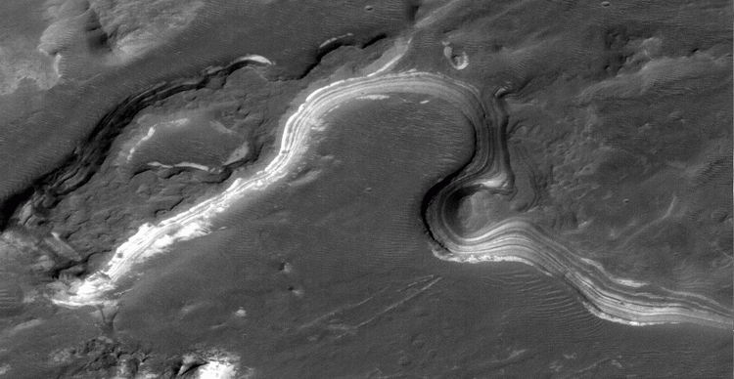

Generated

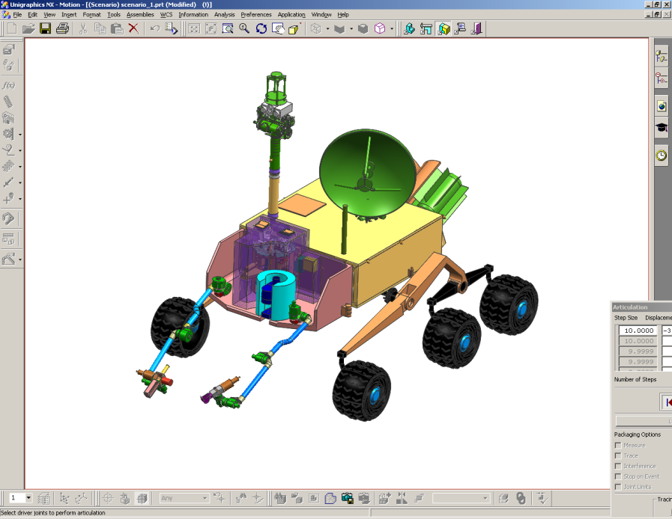

Generated

Mass Range column gives the typical range of molecular weights that are accessible with a given mass spectrometric method.

Finally, the remaining columns provide a correlation of where a technique would be applied in support of various *discovery-responsive measurements* by AFL that would be called for following the discoveries listed in Appendix 2. This separate correlation, beyond the technique-to-measurement requirement-to-mission objective logical chain, permits a greater flexibility and responsiveness of the AFL concept to specific scenarios that may develop from current Mars missions and over the next several years.

|  |  |  |  |  |  |  |  |  |  |  |  |  |  |  |  |  |  |  |  |  |  |  |  |  |  |
| --- | --- | --- | --- | --- | --- | --- | --- | --- | --- | --- | --- | --- | --- | --- | --- | --- | --- | --- | --- | --- | --- | --- | --- | --- | --- |
| **Table 8- Techniques Suggested for AFL by SSG Members** | | | | | | | | | | | |  |  |  |  |  |  |  |  |  |  |  |  |  |  |
|  |  |  | Measurement Tier | | | Example Target/Sample Information | | |  | Example Technique Characteristics (instrument implementation) where appropriate | | | | | | | |  | Discovery/Follow-up per Table 7 | | | |  |  |  |
| Technique | Data/ Signatures Sought | Mmnt Reqts Addessed (Section 7) | Remote Sensing/Standoff | Contact or Close Range | Analytical Lab | Physical Form (Solid, Gas, Liquid) | Example Origin/Host Material | Processing Required/ (Desired) | Sample Mass/ Volume | Distance to Target | Size of Area Probed/ FOV | Target Feature Scale | Selectivity | Detection Limits | Resolution | Precision | Mass Range | Other | Recent Surface Water | Hydrous Mineral Phases | Organic Molecules | Sedimen. Structures | Sedimen. Rocks | Evidence for Fossil Life | Microbes |
|  |  |  |  |  |  |  |  |  |  |  |  |  |  |  |  |  |  |  |  |  |  |  |  |  |  |
| stereo optical imaging | identify targets, evidence of weathering, sedimentation, alteration, etc. | A | x |  |  |  | sedimentary rocks/ structures | n |  | 1m - 10+km | 10cm - 1+km |  |  |  |  |  |  |  | 1 | 6 |  | 1,2,3,4 | 4 | 1,2,3,6,8 | 3 |
|  | identify surface samples | A |  |  |  |  |  |  |  | 10-100 m | 1-10 m | 10cm-1m |  |  |  |  |  |  |  |  |  |  |  |  |  |
|  | identify distant sedimentary outcrops | A |  |  |  |  |  |  |  | 1 km | 10-100 m | 1-10 cm |  |  | 10 cm @ 1 km | |  |  |  |  |  |  |  |  |  |
| VIS/NIR Spectroscopy | surface mineralogy, texture | B | x | x |  | s | rocks, fines | n (abr) |  | cm - m |  |  |  |  |  |  |  |  |  |  |  |  |  |  |  |
| mini TES | mineralogy | B | x |  |  | s |  | n (abr) |  | m - km |  |  |  |  |  |  |  |  |  |  |  |  | 1 |  |  |
| long focal length imaging | identify distant sedimentary outcrops | A | x |  |  |  |  | n |  | 10m - km | cm-10m | cm |  |  |  |  |  |  |  |  |  |  |  |  |  |
| laser ranging | distance to target | A | x |  |  |  | boulders, vertical faces | n |  | 100m - km | cm spot |  |  |  | cm @ 100 m | |  |  |  |  |  |  |  |  |  |
| LIBS | elemental composition | B | x |  |  | s | boulders, slopes | n |  | 1 - 25m | mm - cm spot |  | low (l absorb.) | ppmw |  | ~ 10% | elements | laser ablation | | 2,4 |  |  | 2,5 | 3 |  |
| ground penetrating radar | ice, H2O, other | B, C | x |  |  | s | subsurface | n |  | m - 10s m |  |  |  |  |  |  |  |  | 3 |  |  |  |  |  |  |
| seismic sounding | ice, H2O, other | B, C | x | x |  | s | subsurface | n |  | 100's m - km |  |  |  |  |  |  |  |  | 3 |  |  |  |  |  |  |
| neutron spectroscopy | ice, hydrated minerals | B | x | x |  |  | drill cores, fines | n (acq) |  | 10's cm - m's |  |  | high | variable <%-% | |  |  |  |  |  |  |  |  |  |  |
| gamma ray spectroscopy | elemental composition | B | x | x |  |  | any | n |  | 10's cm - m's |  |  | med | variable <%-% | |  |  |  | 5 |  |  |  |  |  |  |
| x-ray spectroscopy | elemental composition | B, E2 |  | x |  |  | any | n (acq) |  | cm | cm+ |  | med | variable <%-% | |  |  |  |  |  |  |  |  |  |  |
| Raman spectroscopy | mineralogy, some geochemical/organic | B, E | x | x |  |  | rocks | n (abr) |  | cm - m | cm+ |  | med |  |  |  |  |  |  | 1,5 | 1,4 |  | 2 | 1 |  |
| micro-Raman spectroscopy | mineralogy, some geochemical/organic | B,D,E |  | x | x |  | rock chips | n (acq, abr) | | mm - cm | < mm |  | med |  |  |  |  |  |  | 1,5 | 1,4 |  | 2 | 1 |  |
| micro-LIBS | elemental composition | B,D |  | x | x | s | rocks, chips | acq,pos |  | mm - cm | < mm |  | low (l absorb.) | |  |  |  |  |  | 2,4 |  |  | 2,5 | 3 |  |
| hand-lens-scale imaging | phase texture/identity | D |  | x |  | s |  | n (abr) |  | cm - m's | 0.1-10 mm | grains |  |  |  |  |  |  |  |  |  |  |  |  |  |
| optical microscopy | fine morphology | D,E |  | x | x | s |  | n (abr) |  | mm - cm | 0.001-1 mm | subgrain |  |  |  |  |  |  |  |  | 2 |  |  | 1,2,3,6,8 |  |
| confocal microscopy |  | D,E |  |  | x | s |  |  |  | mm | 0.001-1 mm | subgrain |  |  |  |  |  |  |  |  | 2 |  |  | 1,2,3,6,8 |  |
| near-field microscopy | very high res imaging | D,E |  |  | x | s | flat chip | acq, pos |  |  |  | subgrain |  |  |  |  |  |  |  |  |  |  |  |  |  |
| Mossbauer | Fe-bearing mineralogy | B |  | x | x | s |  |  |  | mm - cm |  | avg |  |  |  |  |  |  |  |  |  |  |  |  |  |
| Fe-NMR |  | B |  | x |  | s |  |  |  | mm - cm |  |  | high |  |  |  |  |  |  |  |  |  |  |  |  |
| XRD/XRF | mineralogy | B,D |  |  | x | s | drill cores, fines | acq, pow | mg's | 0 | whole sample | avg or grains | |  |  |  |  |  |  | 1 |  |  | 1,5 |  |  |
| FTIR | mineralogy, some geochemical/organic | B |  |  | x | s |  |  |  |  |  |  |  |  |  |  |  |  |  | 1,5 | 1,4,6 |  | 2,5 | 3 | 4 |
| VCD |  |  |  |  | x | s |  |  |  |  |  |  |  |  |  |  |  |  |  |  |  |  |  |  |  |
| deep UV fluorescence | organics: identity, oxidation state, … | B,D,E |  | x | x | s |  | n (abr) | surface? | mm - m |  | grain scale+ | |  |  |  |  |  |  |  | 1 |  |  | 3 |  |
| pyrolysis/GCMS | organic and some mineralogical/inorganic composition; isotopes | B,E |  |  | x | s,g,l |  | acq, pos, vac | mg-10's mg | 0 | whole sample | avg | low |  |  |  |  |  | 4 |  | 1,5 |  | 5 |  |  |
| chemical derivatization | less-tractable organics | E |  |  | x | s,l |  | liq |  | 0 | whole sample | avg |  |  |  |  |  |  | 4 |  | 1,4,7 |  | 5 |  |  |
| isotope ratio MS (IRMS) | C and other isotopes for bio-fractionation, age dating | E2 |  |  | x | s,l |  | acq, pos, vac | | 0 | whole sample | avg |  |  |  |  |  |  | 2 |  |  |  |  |  |  |
|  | compound-specific IRMS using sampling selectivity | E2 |  |  |  |  |  |  |  |  | whole sample | avg | cmpd isolated w/pyr, GC,or other proc. | | | |  |  |  |  |  |  |  |  |  |
| chiral GC | enantiomeric excess (ee) | E3 |  |  | x | s,g,l |  | acq, pos, gas | | 0 | whole sample | avg |  |  |  |  |  |  |  |  | 3 |  |  |  |  |
| circular dichroism | enantiomeric excess (ee) | E3 |  |  | x |  |  |  |  | 0 |  | avg |  |  |  |  |  |  |  |  | 3 |  |  |  |  |
| liquid chromatography (LC) | organics, ee | E |  |  | x | s,l |  | liq |  | 0 | whole sample | avg |  |  |  |  |  |  | 4 |  | 1,3,5 |  | 5 |  |  |
| 2D GCMS/TOF-MS | organic and some mineralogical/inorganic composition; isotopes | B,E |  |  | x | s,g,l | rocks/cores, fines | acq, pos, vac | 10's mg | 0 | whole sample | avg | low |  |  |  | ~1E3-1E5+ | | 4 |  | 1,5 |  | 5 |  |  |
| electrospray ionization MS (ESI/IMS/CIT-MS) | | E |  |  | x | s,g,l |  | acq, pos, vac | g's | 0 | whole sample | avg | low |  | Dm/m 1E2-1E3+ | |  | contact w/ fluidized sample | | |  |  |  |  |  |
| laser ablation TOF-MS | local elemental/isotopic composition | B,D |  |  | x | s | rock chips, fines | acq, pos, vac | surface | 0 | 10mm - 1 mm | grain scale+ | low (l absorb.) | ppbw-ppmw | Dm/m 1E2-1E3 | 5-25% | ~ 300 |  | 4 | 2,4 |  |  | 2,5 | 1,3 |  |
| LD/MALDI-TOF MS | high-MW organics; some inorganic molecules | D,E |  |  | x | s | rock chips, fines | acq, pos, vac (pow, liq) | surface/prep film | 0 | 100mm - 1 mm | grain scale+ | med (l absorb.) | fmol-pmol | Dm/m 1E3-1E4 | | ~1E3-1E5+ | |  |  | 1,2,4,7 |  |  | 3 | 4 |
| REMPI-MS/RIMS | organics, elements (trace) | E |  |  | x | s |  | acq, pos, vac | | 0 | 10mm - 1 mm |  | very high (l absorb.) | s. atom - pmol | Dm/m 1E2-1E4 | | ~ 1E3 |  |  |  |  |  |  |  |  |
| AP-MALDI-MS (TOFMS or ITMS) | organic, inorganic molec. | D,E |  | x | x | s | rocks, ices | vac | surface | mm | 10mm - 1 mm | grain scale+ | med (l absorb.) | fmol-nmol | Dm/m 1E3-1E4+ | | ~ 1E3-1E5 |  |  |  |  |  |  |  |  |
| electrospray TOF-MS | high-MW organics | E |  |  | x | s,l | rocks/cores, fines | acq, liq, pos, vac | | 0 | whole sample | avg | med |  | Dm/m 1E2-1E4 | | ~1E4-1E5+ | |  |  | 1,2,7 |  |  | 3 | 4 |
| TOF-SIMS | chemical imaging | B,E |  |  | x | s | rock chips | acq, pos, vac | surface | 0 | 50nm-50mm | sub-grain+ | low |  | Dm/m 1E3-1E4 | | ~1E3-1E4 |  |  |  |  |  |  |  |  |
| ICP-MS | trace elements | B |  |  | x | s,g,l | rock chips, fines | acq, pos, vac, gas | | 0 | whole sample | avg or grains | low | pptw-ppbw | Dm/m 1E3+ | 0.1-10% | ~ 300 |  | 2,4 |  | 1,3,5 |  | 5 |  |  |
| TIMS | isotope ratios (~IRMS) | B,E2 |  |  | x | s |  | acq, pos, vac | | 0 | whole sample | avg | low | pptw-ppbw | Dm/m 1E3+ | 0.1-1% | ~ 300 |  | 2 |  | 5 |  |  |  |  |
| AFM | nanoscale imaging | D, E3 |  |  | x | s | flat chip | acq, pos | chips |  | 1nm-1mm | sub-micron | |  |  |  |  |  |  |  |  |  |  |  |  |
| TEM/SEM | nanoscale imaging | D |  |  | x | s | flat chip | acq, pos, vac | chips |  | 1nm-1mm | sub-micron | |  |  |  |  |  |  |  |  |  |  |  |  |
|  | image microbes in ice cores | D,E3 |  |  |  |  |  |  |  |  |  |  |  |  |  |  |  |  |  |  |  |  |  |  |  |
| XPS | chemical comp. and bond state | B,C |  |  | x | s,l |  | vac | 100's mg |  |  |  |  |  |  |  |  |  |  |  |  |  |  |  |  |
| Auger spectroscopy | bond state of elements | B,C |  |  |  | s,l |  | vac | 100's mg |  |  |  |  |  |  |  |  |  |  |  |  |  |  |  |  |
| amino-acid sensors (eg MOD) | detection of amino acids | E |  |  | x | s,l |  | acq | 100's mg |  | whole sample |  | high |  |  |  |  |  |  |  | 1,3 |  |  |  |  |
| oxidant sensors | detection of oxidants | C |  |  | x | s,l |  | Acq, dry | 100's mg |  | whole sample |  | high |  | per sample weight | |  |  |  |  | 6 |  |  |  |  |
| bio-assay chip lab |  | E |  |  | x | s,l |  | liq | 100's mg | 0 | whole sample |  | high | pptw | per sample weight | | Kda |  |  |  | 7 |  |  | 1,5,6 | 1,5,6 |
| micro-array sensors |  | E |  |  | x | s,l |  | Liq | 100's mg |  | whole sample |  | high | pptw | per sample weight | | Kda |  |  |  | 7 |  |  | 1,5,6 | 1,5,6 |
| MORD |  |  |  |  | x | s |  |  | 100's mg | 0 | whole sample |  | high |  | per sample weight | |  |  |  |  |  |  |  |  |  |
| fluorescence staining | organics | E |  | x | x | s,l |  | Liq | 100's mg |  | whole sample | avg | high | single cell | per sample weight | |  |  |  |  | 7 |  |  |  |  |
|  | SYBR gold, SYTO, DAPI nucleic acid stains for counting microbes | E |  |  | x | s,l |  | Liq | 100's mg |  | whole sample |  | Medium | single cell | per sample weight | |  |  |  |  |  |  |  |  | 1.5.6 |
|  | CTC, tetrazolium salt redox stains for individual cells | E |  |  | x | s,l |  | Liq | 100's mg |  | whole sample |  | Medium | Single cell | per sample weight | |  |  |  |  |  |  |  |  | 1,5,6 |
| isotopic labelling | 14CO2 or 3H for total population activity | E |  |  | x | s,g,l |  | Lig | 100's mg |  | whole sample | avg | medium | single cell | per sample weight | |  |  |  |  |  |  |  |  | 1,5,6 |
| flow-cytometry |  | E |  |  | x | s,l |  | liq | 100's mg |  | whole sample | avg | medium | single cell | per sample weight | |  | If have required media | | |  |  |  |  | 1,5,6 |
| culturing/cell-growth assays |  | E |  |  | x | s,l |  | liq | 100's mg |  | whole sample | avg | high | single cell | per sample weight | |  | If have required media | | |  |  |  |  | 1,5,6 |
| ATP and LAL enzyme assays |  | E |  |  | x | s,l |  | liq | 100's mg |  | whole sample | avg | high | pptw | per sample weight | |  |  |  |  |  |  |  |  | 1,5,6 |
| DNA extraction/PCR |  | E |  |  | x | s,l |  | liq | 100's mg |  | whole sample | avg | high | 100 cells | per sample weight | |  | with correct primers | | |  |  |  |  | 5,6 |
| capillary electrophoresis (CE) |  | E |  |  | x | s,l |  |  | 100's mg |  | whole sample | avg | high | pptw | per sample weight | |  |  |  |  | 7 |  |  |  | 1,5,6 |
| microcalorimetry |  |  |  |  | x |  |  |  | 100's mg |  | whole sample | avg | medium | pptw | per sample weight | |  |  |  |  | 7 |  |  |  |  |
|  |  |  |  |  |  |  |  |  |  |  |  |  |  |  |  |  |  |  |  |  |  |  |  |  |  |
| **KEY:** |  |  |  |  |  |  |  |  |  |  |  |  |  |  |  |  |  |  |  |  |  |  |  |  |  |
| n - can be operated with no sample acquisition/processing | | |  |  |  |  |  |  |  |  |  |  |  |  |  |  |  |  |  |  |  |  |  |  |  |
| abr - abrasion to remove surface layers | |  |  |  |  |  |  |  |  |  |  |  |  |  |  |  |  |  |  |  |  |  |  |  |  |
| acq - sample acquisition from host matl (via whatever means) | | |  |  |  |  |  |  |  |  |  |  |  |  |  |  |  |  |  |  |  |  |  |  |  |
| pow - powdering of solid sample | |  |  |  |  |  |  |  |  |  |  |  |  |  |  |  |  |  |  |  |  |  |  |  |  |
| pos - sample positioning (e.g., manipulation to oven, point of focus or extraction) | | | | | |  |  |  |  |  |  |  |  |  |  |  |  |  |  |  |  |  |  |  |  |
| vac - vacuum processing |  |  |  |  |  |  |  |  |  |  |  |  |  |  |  |  |  |  |  |  |  |  |  |  |  |
| liq - liquid processing |  |  |  |  |  |  |  |  |  |  |  |  |  |  |  |  |  |  |  |  |  |  |  |  |  |
| gas - gas processing |  |  |  |  |  |  |  |  |  |  |  |  |  |  |  |  |  |  |  |  |  |  |  |  |  |