

Generated



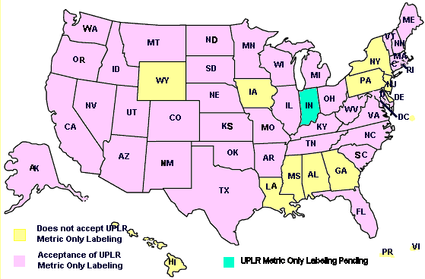

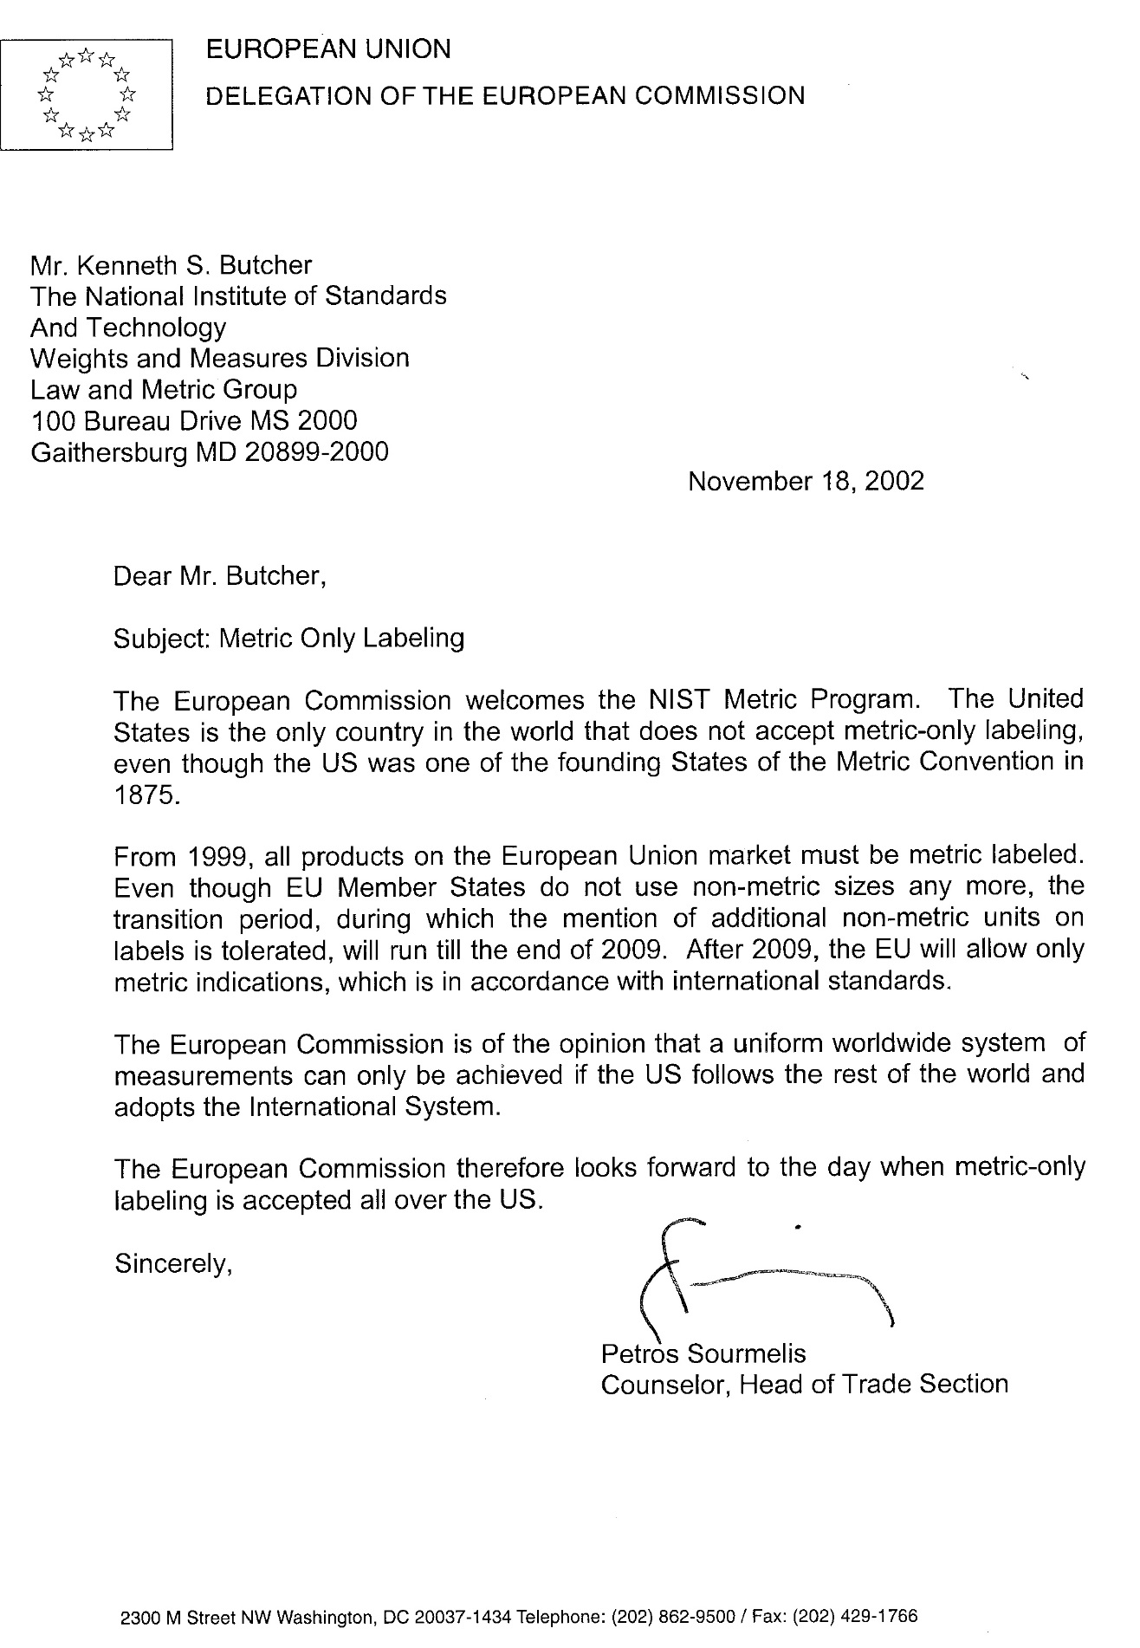

(4) prevent the nonfunctional-slack-fill of packages containing consumer commodities. For purposes of paragraph (4) of this subsection, a package shall be deemed to be nonfunctionally slack-filled if it is filled to substantially less than its capacity for reasons other than (A) protection of the contents of such package or (B) the requirements of machines used for enclosing the contents in such package.

(d) Development by manufacturers, packers, and distributors of voluntary product standards - Whenever the Secretary of Commerce determines that there is undue proliferation of the weights or masses, measures, or quantities in which any consumer commodity or reasonably comparable consumer commodities are being distributed in packages for sale at retail and such undue proliferation impairs the reasonable ability of consumers to make value comparisons with respect to such consumer commodity or commodities, he shall request manufacturers, packers, and distributors of the commodity or commodities to participate in the development of a voluntary product standard for such commodity or commodities under the procedures for the development of voluntary products standards established by the Secretary pursuant to section 272 of this title. Such procedures shall provide adequate manufacturer, packer, distributor, and consumer representation.

(e) Report and recommendations to Congress upon industry failure to develop or abide by voluntary product standards - If (1) after one year after the date on which the Secretary of Commerce first makes the request of manufacturers, packers, and distributors to participate in the development of a voluntary product standard as provided in subsection (d) of this section, he determines that such a standard will not be published pursuant to the provisions of such subsection (d), or (2) if such a standard is published and the Secretary of Commerce determines that it has not been observed, he shall promptly report such determination to the Congress with a statement of the efforts that have been made under the voluntary standards program and his recommendation as to whether Congress should enact legislation providing regulatory authority to deal with the situation in question.

**§1455. Procedures for Promulgation of Regulations.**

(a) Hearings by Secretary of Health and Human Services - Regulations promulgated by the Secretary under section 1453 or 1454 of this title shall be promulgated, and shall be subject to judicial review, pursuant to the provisions of subsections (e), (f), and (g) of section 371 of title 21. Hearings authorized or required for the promulgation of any such regulations by the Secretary shall be conducted by the Secretary or by such officer or employees of the Department of Health and Human Services as he may designate for that purpose.

(b) Judicial review; hearings by Federal Trade Commission - Regulations promulgated by the Commission under section 1453 or 1454 of this title shall be promulgated, and shall be subject to judicial review, by proceedings taken in conformity with the provisions of subsections (e), (f), and (g) of section 371 of title 21 in the same manner, and with the same effect, as if such proceedings were taken by the Secretary pursuant to subsection (a) of this section. Hearings authorized or required for the promulgation of any such regulations by the Commission shall be conducted by the Commission or by such officer or employee of the Commission as the Commission may designate for that purpose.

(c) Cooperation with other departments and agencies - In carrying into effect the provisions of this chapter, the Secretary and the Commission are authorized to cooperate with any department or agency of the United States, with any State, Commonwealth, or possession of the United States, and with any department, agency, or political subdivision of any such State, Commonwealth, or possession.

(d) Returnable or reusable glass containers for beverages - No regulation adopted under this chapter shall preclude the continued use of returnable or reusable glass containers for beverages in inventory or with the trade as of the effective date of this Act, nor shall any regulation under this chapter preclude the orderly disposal of packages in inventory or with the trade as of the effective date of such regulation.

**§1456.Enforcement.**

(a) Misbranded consumer commodities - Any consumer commodity which is a food, drug, device, or cosmetic, as each such term is defined by section 201 of the Federal Food, Drug, and Cosmetic Act

(21 US C. 321), and which is introduced or delivered for introduction into commerce in violation of any of the provisions of this chapter, or the regulations issued pursuant to this chapter, shall be deemed to be misbranded within the meaning of chapter III of the Federal Food, Drug, and Cosmetic Act (21 USC 331 et seq.), but the provisions of section 303 of that Act (21 USC. 333) shall have no application to any violation of section 1452 of this title.

(b) Unfair or deceptive acts or practices in commerce - Any violation of any of the provisions of this chapter, or the regulations issued pursuant to this chapter, with respect to any consumer commodity which is not a food, drug, device, or cosmetic, shall constitute an unfair or deceptive act or practice in commerce in violation of section 45(a)of this title and shall be subject to enforcement under section 45(b) of this title.

(c) Imports - In the case of any imports into the United Statesof any consumer commodity covered by this chapter, the provisions of sections 1453 and 1454 of this title shall be enforced by the Secretary of the Treasury pursuant to section 801(a) and (b) of the Federal Food, Drug, and Cosmetic Act (21 USC. 381).

**§1457. Annual Reports to Congress: Submission Dates.**

Each officer or agency required or authorized by this chapter to promulgate regulations for the packaging or labeling of any consumer commodity, shall transmit to the Congress each year a report containing a full and complete description of the activities of that officer or agency for the administration and enforcement of this chapter during the preceding fiscal year. All agencies except the Department of Health and Human Services and the Federal Trade Commission shall submit their reports in January of each year. The Department of Health and Human Services shall include this report in its annual report to Congress on activities under the Federal Food, Drug, and Cosmetic Act (21 USC. 301 et seq.), and the Federal Trade Commission shall include this report in the Commission's annual report to Congress.

**§1458. Cooperation with State Authorities; Transmittal of Regulations to States; Noninterference with Existing Programs.**

(a) A copy of each regulation promulgated under this chapter shall be transmitted promptly to the Secretary of Commerce, who shall (1) transmit copies thereof to all appropriate State officers and agencies, and (2) furnish to such State officers and agencies information and assistance to promote to the greatest practicable extent uniformity in State and Federal regulation of the labeling of consumer commodities.

(b) Nothing contained in this section shall be construed to impair or otherwise interfere with any program carried into effect by the Secretary of Health and Human Services under other provisions of law in cooperation with State governments or agencies, instrumentalities, or political subdivisions thereof.

**§1459. Definitions.**

For the purpose of this chapter -

(a) The term ''consumer commodity'', except as otherwise specifically provided by this subsection, means any food, drug, device, or cosmetic (as those terms are defined by the Federal Food, Drug, and Cosmetic Act (21 USC. 301 et seq.)), and any other article, product, or commodity of any kind or class which is customarily produced or distributed for sale through retail sales agencies or instrumentalities for consumption by individuals, or use by individuals for purposes of personal care or in the performance of services ordinarily rendered within the household, and which usually is consumed or expended in the course of such consumption or use.

Such term does not include -

(1) any meat or meat product, poultry or poultry product, or tobacco or tobacco product;

(2) any commodity subject to packaging or labeling requirements imposed by the Secretary of Agriculture pursuant to the Federal Insecticide, Fungicide, and Rodenticide Act (7 USC. 136 et seq.), or the provisions of the eighth paragraph under the heading ''Bureau of Animal Industry'' of the Act of March 4, 1913 (21 USC. 151 et seq.), commonly known as the Virus-Serum-Toxin Act;

(3) any drug subject to the provisions of section 503(b)(1) or 506 of the Federal Food, Drug, and Cosmetic Act (21 USC. 353(b)(1) and 356);

(4) any beverage subject to or complying with packaging or labeling requirements imposed under the Federal Alcohol Administration Act (27 USC. 201 et seq.); or

(5) any commodity subject to the provisions of the Federal Seed Act (7 USC. 1551 et seq.).

(b) The term ''package'' means any container or wrapping in which any consumer commodity is enclosed for use in the delivery or display of that consumer commodity to retail purchasers, but does not include -

(1) shipping containers or wrappings used solely for the transportation of any consumer commodity in bulk or in quantity to manufacturers, packers, or processors, or to wholesale or retail distributors thereof;

(2) shipping containers or outer wrappings used by retailers to ship or deliver any commodity to retail customers if such containers and wrappings bear no printed matter pertaining to any particular commodity; or

(3) containers subject to the provisions of the Act of August 3, 1912 (37 Stat. 250, as amended; 15 USC. 231-233), or the Act of March 4, 1915 (38 Stat. 1186, as amended; 15 USC. 234-236).

(c) The term ''label'' means any written, printed, or graphic matter affixed to any consumer commodity or affixed to or appearing upon a package containing any consumer commodity.

(d) The term ''person'' includes any firm, corporation, or association.

(e) The term ''commerce'' means (1) commerce between any State, the District of Columbia, the Commonwealth of Puerto Rico, or any territory or possession of the United States, and any place outside thereof, and (2) commerce within the District of Columbia or within any territory or possession of the United States not organized with a legislative body, but shall not include exports to foreign countries.

(f) The term ''principal display panel'' means that part of a label that is most likely to be displayed, presented, shown, or examined under normal and customary conditions of display for retail sale.

**§1460. Savings Provisions.**

Nothing contained in this chapter shall be construed to repeal, invalidate, or supersede - (a) the Federal Trade Commission Act (15 USC. 41 et seq.) or any statute defined therein as an antitrust Act; (b) the Federal Food, Drug, and Cosmetic Act (21 USC. 301 et seq.); or (c) the Federal Hazardous Substances Labeling Act (15 USC. 1261 et seq.).

**§1461. Effect Upon State Law.**

It is hereby declared that it is the express intent of Congress to supersede any and all laws of the States or political subdivisions thereof insofar as they may now or hereafter provide for the labeling of the net quantity of contents of the package of any consumer commodity covered by this chapter which are less stringent than or require information different from the requirements of section 1453 of this title or regulations promulgated pursuant thereto.