

Generated



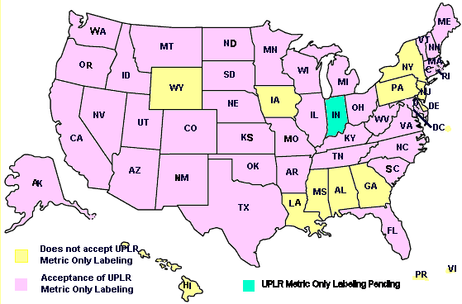

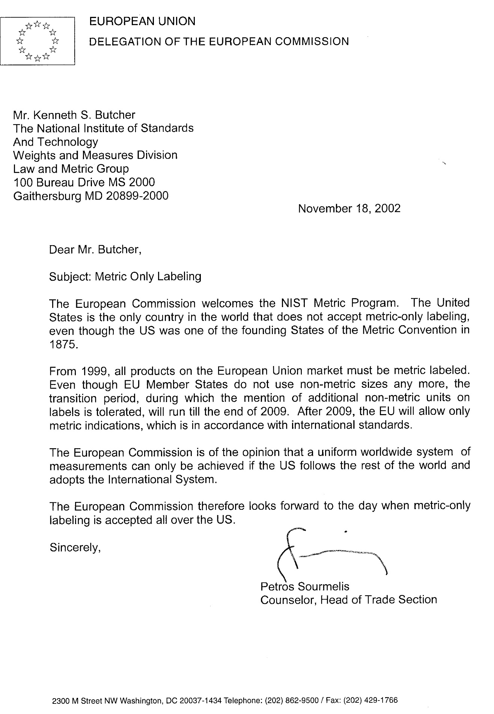

Such term does not include -

(1) any meat or meat product, poultry or poultry product, or tobacco or tobacco product;

(2) any commodity subject to packaging or labeling requirements imposed by the Secretary of Agriculture pursuant to the Federal Insecticide, Fungicide, and Rodenticide Act (7 USC. 136 et seq.), or the provisions of the eighth paragraph under the heading ''Bureau of Animal Industry'' of the Act of March 4, 1913 (21 USC. 151 et seq.), commonly known as the Virus-Serum-Toxin Act;

(3) any drug subject to the provisions of section 503(b)(1) or 506 of the Federal Food, Drug, and Cosmetic Act (21 USC. 353(b)(1) and 356);

(4) any beverage subject to or complying with packaging or labeling requirements imposed under the Federal Alcohol Administration Act (27 USC. 201 et seq.); or

(5) any commodity subject to the provisions of the Federal Seed Act (7 USC. 1551 et seq.).

(b) The term ''package'' means any container or wrapping in which any consumer commodity is enclosed for use in the delivery or display of that consumer commodity to retail purchasers, but does not include -

(1) shipping containers or wrappings used solely for the transportation of any consumer commodity in bulk or in quantity to manufacturers, packers, or processors, or to wholesale or retail distributors thereof;

(2) shipping containers or outer wrappings used by retailers to ship or deliver any commodity to retail customers if such containers and wrappings bear no printed matter pertaining to any particular commodity; or

(3) containers subject to the provisions of the Act of August 3, 1912 (37 Stat. 250, as amended; 15 USC. 231-233), or the Act of March 4, 1915 (38 Stat. 1186, as amended; 15 USC. 234-236).

(c) The term ''label'' means any written, printed, or graphic matter affixed to any consumer commodity or affixed to or appearing upon a package containing any consumer commodity.

(d) The term ''person'' includes any firm, corporation, or association.

(e) The term ''commerce'' means (1) commerce between any State, the District of Columbia, the Commonwealth of Puerto Rico, or any territory or possession of the United States, and any place outside thereof, and (2) commerce within the District of Columbia or within any territory or possession of the United States not organized with a legislative body, but shall not include exports to foreign countries.

(f) The term ''principal display panel'' means that part of a label that is most likely to be displayed, presented, shown, or examined under normal and customary conditions of display for retail sale.

**§1460. Savings Provisions.**

Nothing contained in this chapter shall be construed to repeal, invalidate, or supersede - (a) the Federal Trade Commission Act (15 USC. 41 et seq.) or any statute defined therein as an antitrust Act; (b) the Federal Food, Drug, and Cosmetic Act (21 USC. 301 et seq.); or (c) the Federal Hazardous Substances Labeling Act (15 USC. 1261 et seq.).

**§1461. Effect Upon State Law.**

It is hereby declared that it is the express intent of Congress to supersede any and all laws of the States or political subdivisions thereof insofar as they may now or hereafter provide for the labeling of the net quantity of contents of the package of any consumer commodity covered by this chapter which are less stringent than or require information different from the requirements of section 1453 of this title or regulations promulgated pursuant thereto.