Generated



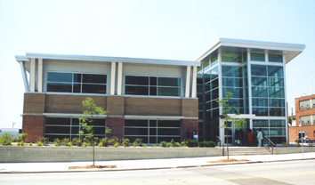

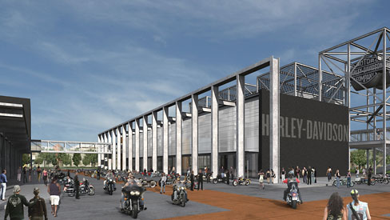

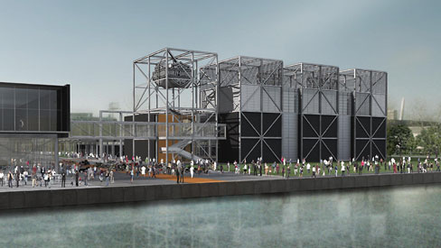

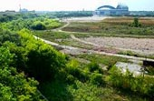

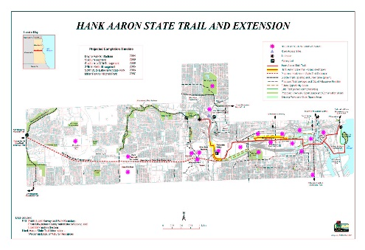

Generated

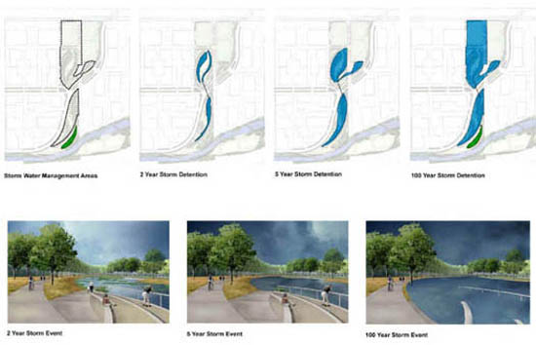













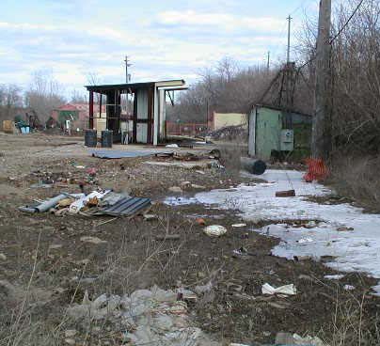

Generated

|  |  |  |
| --- | --- | --- |
| Toxic Compounds | (cancer risk)  1 in 100,000 | 1 in 1,000,000 |
| Acetaldehyde | .45ug/m3 | 4.5ug/m3 |
| Formaldehyde | .077ug/m3 | .77ug/m3 |
| 1,3-Butadiene | .3ug/m3 | .033ug/m3 |
| Benzene | 1.3ug/m3 | .13ug/m3 |

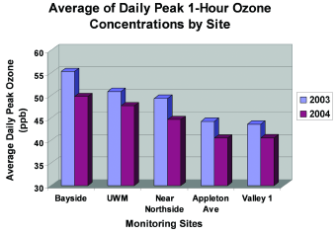

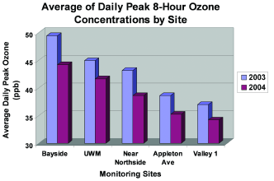

Typically mitigation measures such as removing the effected soil and monitoring for 1-2 years should rectify the situation.

(For more information regarding the groundwater study click here [http://www.renewthevalley.org/files/pdf/epareport.pdf])

Stormwater Management:

The Menomonee Valley stormwater management stratagem is founded on natural means. Developers are restoring wetlands and green space once prevalent in the valley and incorporating stormwater management into parks. There will be two main stormwater management areas and a Swamp Forest to accommodate stormwater from the surrounding developments. These three areas will treat stormwater in three steps. First, all water will be collected and transferred through a system of pipes where it will accumulate in small pools of water. Second, stormwater will

disperse across the shallow wetland meadows and will infiltrate through crushed pieces of concrete (this layer is known as an ‘infiltration gallery’). The stormwater will then be distributed to the Swamp Forest where the natural vegetation will remove contaminants. In order to decrease the actual amount of stormwater, builders must limit the number of impervious surfaces. By promoting permeable surfaces infiltration of stormwater will be amplified. Builders are also being urged to increase canopy coverage on their property, which will in turn contribute to the reduction of stormwater.

(For more information on MVBI Click Here [http://epic.cuir.uwm.edu/mvbi/other_docs.htm])

(For more information on the Master Land Use Plan Click Here [http://www.renewthevalley.org/files/pdf/MVIC%20-%20Master%20Use%20Plan%20-%20RACM%20Adopted.pdf])

Financial Structure

Section 108$10,000,000

BEDI $2,000,000

EPA Clean Up Grant $200,000

EDA BCR Loan Fund $1,125,000

HUD Neighborhood Grant $1,950,000

DNR SUDA Grant $837,000

WI Commerce Grant $1,250,000

Redevelopment Authority Loan $6,475,000

Total:$23,837,000