Generated



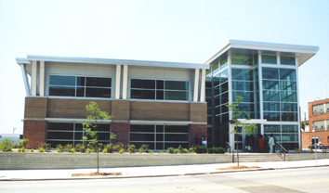



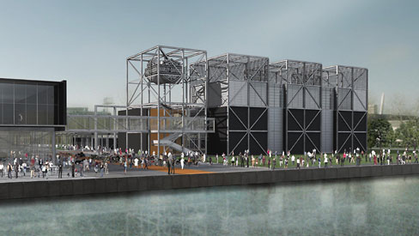

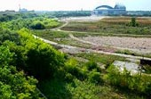

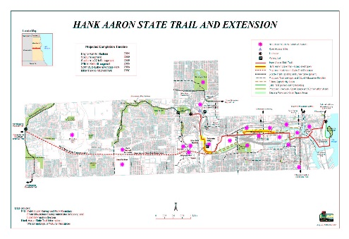

Generated

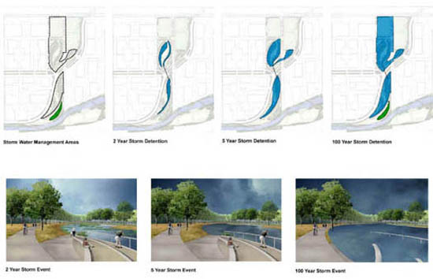













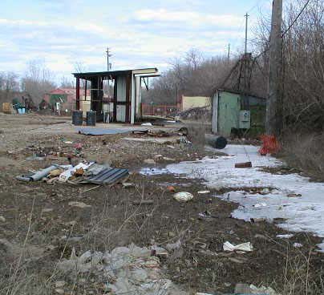

Generated

|  |  |  |
| --- | --- | --- |
| Toxic Compounds | (cancer risk)  1 in 100,000 | 1 in 1,000,000 |
| Acetaldehyde | .45ug/m3 | 4.5ug/m3 |
| Formaldehyde | .077ug/m3 | .77ug/m3 |
| 1,3-Butadiene | .3ug/m3 | .033ug/m3 |
| Benzene | 1.3ug/m3 | .13ug/m3 |

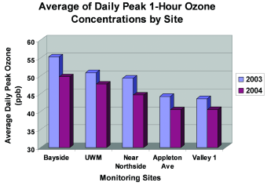

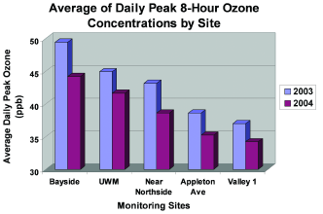

stormwater will then be distributed to the Swamp Forest where the natural vegetation will remove contaminants. In order to decrease the actual amount of stormwater, builders must limit the number of impervious surfaces. By promoting permeable surfaces infiltration of stormwater will be amplified. Builders are also being urged to increase canopy coverage on their property, which will in turn contribute to the reduction of stormwater.

(For more information on MVBI Click Here [http://epic.cuir.uwm.edu/mvbi/other_docs.htm])

(For more information on the Master Land Use Plan Click Here [http://www.renewthevalley.org/files/pdf/MVIC%20-%20Master%20Use%20Plan%20-%20RACM%20Adopted.pdf])

Financial Structure

Section 108$10,000,000

BEDI $2,000,000

EPA Clean Up Grant $200,000

EDA BCR Loan Fund $1,125,000

HUD Neighborhood Grant $1,950,000

DNR SUDA Grant $837,000

WI Commerce Grant $1,250,000

Redevelopment Authority Loan $6,475,000

Total:$23,837,000