Generated













Generated















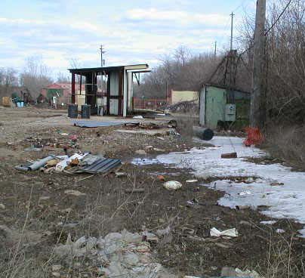

Generated

|  |  |  |
| --- | --- | --- |
| Toxic Compounds | (cancer risk)  1 in 100,000 | 1 in 1,000,000 |
| Acetaldehyde | .45ug/m3 | 4.5ug/m3 |
| Formaldehyde | .077ug/m3 | .77ug/m3 |
| 1,3-Butadiene | .3ug/m3 | .033ug/m3 |
| Benzene | 1.3ug/m3 | .13ug/m3 |

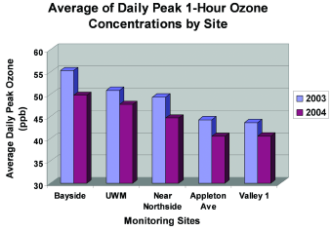

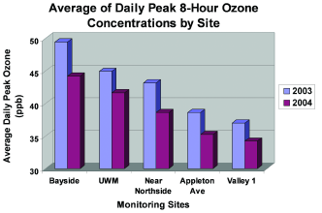

$23,837,000