**Prerequisites:**

* Install My Sql
* Create a schema called user_db and then run the below SQL command to create a table called user_info

CREATE TABLE `user_info` (

  `customer_id` int(11) NOT NULL,

  `first_name` varchar(45) DEFAULT NULL,

  `last_name` varchar(45) DEFAULT NULL,

  `age` int(11) DEFAULT NULL,

  `sex` varchar(6) DEFAULT NULL,

  `race` varchar(45) DEFAULT NULL,

  `observation` varchar(45) DEFAULT NULL,

  PRIMARY KEY (`customer_id`)

) ENGINE=InnoDB DEFAULT CHARSET=latin1;

* Kindly Note: In user_info.py file replace my Database user name and password with your Database user name and password.

**Execute: main.py:**

**(**Note that main.py will call user_info.py)

* When adding a new user

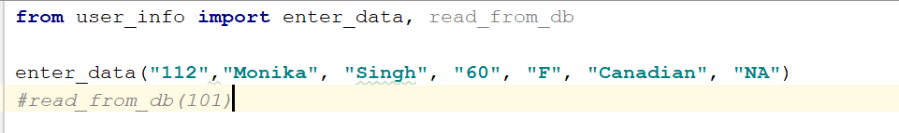

Output:

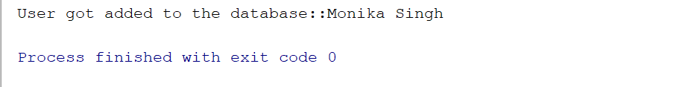

* When trying to add an existing user



Output:

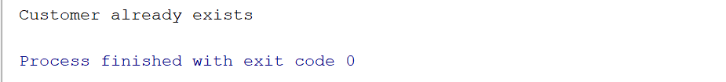

**Look for these entries i.e. the user details in the database**

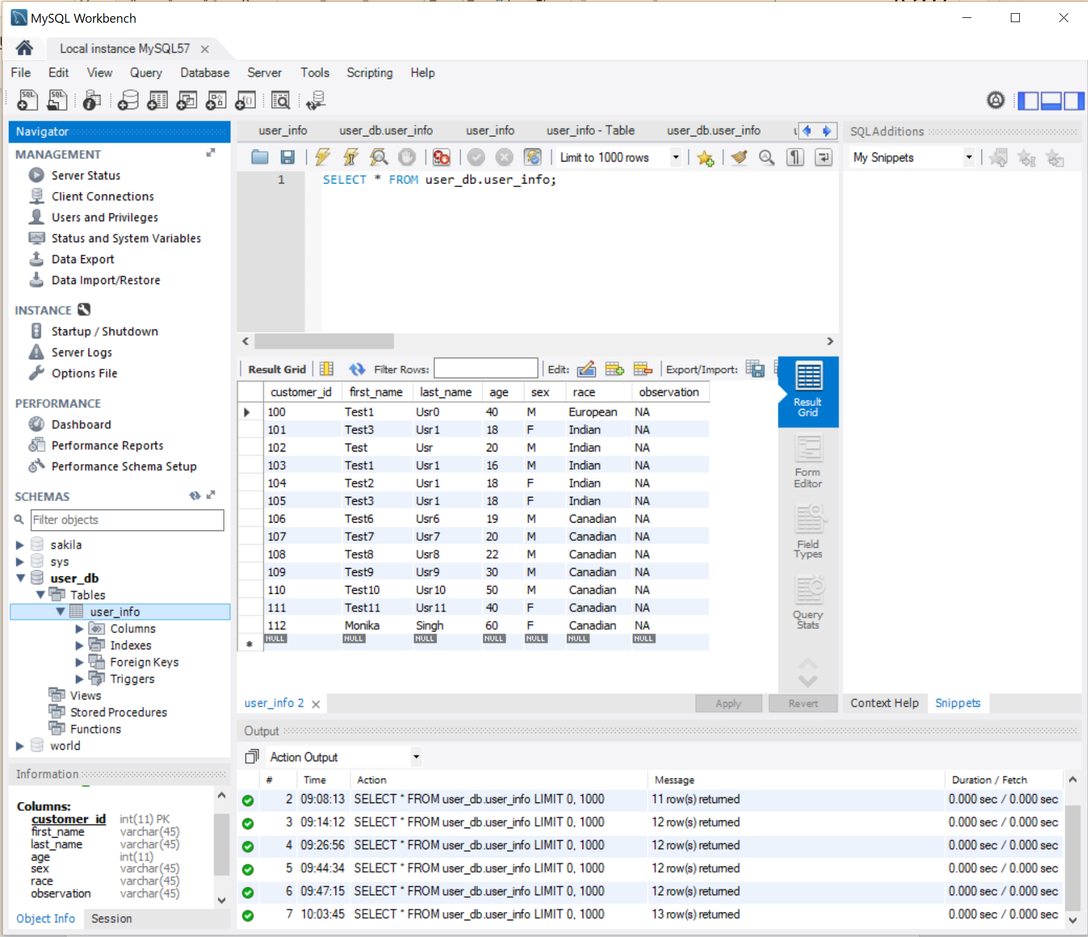

**We can see that the user details are getting stored into the database as well as getting retrieved from the database using the python files main.py and user_info.py**