Lecture 3
Homework: Pages 76-77-78: Review and summarize in your own words: Big Endian vs. Little Endian. Be ready to explain why these two systems store character data differently, but store numerical data the same way. Upload to ActivitiesAssignmentsHomework 2 before next class.
Part 1 today: Basic Error-Correcting Code Theory
Part 2 today: Actual Hamming ECC Examples
Next week’s quiz has questions from parts 1, 2, and Endian.

Basic Error-Correcting Code Theory
(Error-correcting code): use for detecting and (possibly) correcting errors in words
Sometimes we can detect and correct errors; sometimes we can detect but not correct; sometimes neither.
Example: your friend texts you the word “wouse”. There IS an error; wouse is not in the dictionary. What word was “wouse” supposed to me: souse, mouse, house, worse… we can’t necessarily correct all errors that we can detect. Error detection is often quite easy. Error correction is harder. Some spelling errors cannot be detected: your friend texts you that they want to go to the club (they intended to say “pub”). Since club also makes sense, this error could be undetectable. Even worse case: some spelling errors are worse than others. You text your girlfriend “will you marry me?” and she means to type “yes” but instead typed “no” by mistake.
Definition: Data word (aka memory word): the raw data word we want to protect and store without errors
Codeword: the dataword, with extra bits added into it. The extra bits are called parity bits or check bits or redundant bits, and these extra bits are what allow us to detect/correct errors.
Hamming code is an official protocol for error detection and correction.
First, though, let’s create our own example codes.

Code A: A code is a set of words that we agree are valid (like a dictionary). Example: if you and I wanted to create a code with just two words, we could pick the words 0 and 1. This is very efficient code but it’s actually an awful code: if some error happens and a word of 0 gets corrupted and changed to 1, we cannot detect it because 1 is also a valid word. One way to solve this problem is to create LONGER words. I’ll use code A, with a new vocabulary of two words that we both agree are valid:
00000000
11111111
These are the ONLY two valid words in code A.
The other 254 combinations of bits in these 8-bit words are INVALID.
Assume you retrieve the word 00000001 from RAM.
This word is clearly wrong. Error detection is quite easy: this is not 00000000 and it’s not 11111111.
Error correction is more difficult: what word was 00000001 supposed to be?
Probably 00000000 It’s a guess, it’s a great guess, it will usually be correct to assume 00000001 was supposed to be 00000000
00000000 and 11111111 is a better code than 0 and 1, for error detection and correction. Because the latter code is impossible to detect errors (and therefore uncorrectable).
** We see the tradeoff already: clarity versus efficiency. To get clearer words, we need longer words with lots of differences between them.
Assume you retrieve the word 00001111 from RAM. This is trouble.
Fix the spelling errors:
hib ?????????????
hospitalizatiom hospitalization

Code B: Here is our code B, with 8-bit words, and a 254-word vocabulary:
00000000 and 11111111 are the only two INVALID words. The other 254 eight-bit words are all valid.
Assume you retrieved the word 01110100 from RAM. It IS a valid word. Is there an error though? This word is valid but possibly not correct (i.e. it may not be the actual word that was stored/intended).

Summary of codes A and B: Code A is easy to detect errors, and possible to correct many errors, but it is inefficient in space (one-bit words would also have sufficed for a two-word code). Code B is impossible to detect most errors (therefore they would be uncorrectable). It is very space efficient (254 of 256 possible 8-bit words are usable). Code B does not offer clarity. Code B sucks.

QUESTION: Which code (A or B) is better for detecting and correcting errors? Why?
ANSWER: A because: it can correct lots of errors: cannot correct 00001111; cannot correct big huge errors such as storing 00000000 and then it’s corrupted to 11111110. It can correct all small errors such as storing 00000000 and then it’s corrupted to 00100000 or corrupted to 01001000

QUESTION:
00000000
11111111
These are the ONLY two valid words in code A.
What is an even BETTER code than A for detecting and correcting errors? Give an example. Explain.
0000000000000000 (16-bit words)
1111111111111111
We do NOT want these words to be confused with each other, therefore we make the code longer and the words are more different from each other.
Why is this better than A? 0000000000001111 is now (probably) correctable; but code A could NOT fix 4-bit errors

9-bit words are better than 8-bit words; odd numbers of bits makes a 50/50 word impossible to exist e.g. 00001111 is impossible with an odd number of bits
The higher number of bit differences (9 instead of 8) lets us detect and correct MORE. So a code with 9-bit words of 000000000 and 111111111 would be better than code A.
e.g. consider code A: retrieve 00000111
This is either 3 bits wrong (supposed to have been 00000000) or 5 bits wrong (11111111)
But WE will assume it was supposed to be 00000000. We cannot correct 4-bit errors with A. We CAN correct 4-bit errors with a 9-bit code: 000001111

Question: can code A correct 1-bit errors? Why/why not? Explain. Yes. With a 1-bit error, the word looks 7/8ths like one word and only 1/8th like the other word. We would therefore assume it was supposed to be the 7/8ths word: e.g. store 00000000 and retrieve 00000001: we could easily fix this to 00000000 and we would be right.
Question: can code A correct 2-bit errors? Why/why not? Explain. Yes. Similar reasoning.
Question: can code A correct 3-bit errors? Why/why not? Explain. Yes. Similar reasoning.
Question: can code A correct 4-bit errors? Why/why not? Explain. No. This word looks exactly half like one word and half like the other word. There is no way to correct this. 00001111
Question: can code A correct 5-bit errors? Why/why not? Explain. NO! This word with 5 errors looks MORE LIKE THE WRONG WORD than it looks like the right word. We will assume it was supposed to be that wrong word, make our wrong assumption, and have NOT corrected it. We have made things worse. if the word was supposed to be 00000000 and you got 00011111 you would think its supposed to be 11111111 (but we would be wrong if 5 errors had actually occurred).
Question: can code A correct 6-bit errors? Why/why not? Explain. No similar reasoning as 5-bit errors but now we are even MORE confident (but we are wrong). 00000000 -> 00111111
Question: can code A correct 7-bit errors? Why/why not? Explain. No. Example: Store 11111111; retrieve after error 00000001. We would confidently but incorrectly change this to 00000000.
Question: can code A correct 8-bit errors? Why/why not? Explain. NO. This word is now valid (but the wrong, unintended word): e.g. store 11111111 but retrieve after error: 00000000. Not only is this uncorrectable, but we would not even TRY to correct it…this is UNDETECTABLE. Valid but incorrect/unintended word.
The worst cases for code A:
- 4-bit errors
- 8-bit errors
- 5/6/7-bit errors

00000000
11111111
These are the ONLY two valid words in code A.

Code A has 8-bit differences between its closest words. That’s called the Hamming Distance (HD). A code with HD of 8 bits can correct up to three-bit errors. Why not 4? It’s stuck right in the middle looking halfway like each of two different words: e.g. 00001111. Why can’t a code with a Hamming Distance of 8 bits correct a word with a 5-bit error: 00000000 00011111? Because the erroneous word looks closer to a wrong word and would be corrected to that wrong word instead. Why can’t a code with a Hamming Distance of 8 bits correct a word with a 6-bit error? Now it looks even MORE like that wrong word. Why can’t a code with a Hamming Distance of 8 bits correct a word with a 7-bit error? Now it looks even MORE like that wrong word. Why can’t a code with a Hamming Distance of 8 bits correct a word with an 8-bit error? It IS the wrong word (valid, but not the intended word) so it is not even DETECTED as an error: 00000000 11111111.
DEFINITION: Hamming Distance: the minimum number of bits different between any 2 valid words in a code.
A code with Hamming Distance of h bits can detect up to less than h bit errors (anything but h amount of errors).
A code with Hamming Distance of h bits can correct up to less than h/2 bit errors (not equal to h/2).
QUESTION: What is the Hamming Distance of the following (new) code: Valid words are:
000000
111111
000011
ANSWER: 2 bits 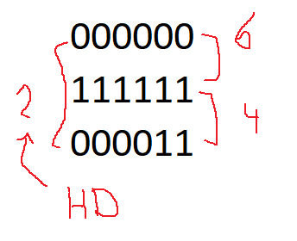
QUESTION: What would be an awful third valid word for code A?
ANSWER: 00000000
11111111
00000001 awful: HD of code A was 8 bits, now it’s 1 bit
** WE WANT LARGE GAPS BETWEEN VALID CODEWORDS
** WE WANT A LARGE HAMMING DISTANCE

QUESTION: What would be a GREAT third valid word for code A?
ANSWER: 00000000
11111111
00001111 we want words as different as possible; HD is 4 bits now
(01010101 is just as good)
The more different two words are, the less likely you are to mix them up.
e.g. BCIT YOUR // very different; good; won’t mix these up
duck **** // very often confused with another word

WE WANT LARGE GAPS BETWEEN VALID WORDS
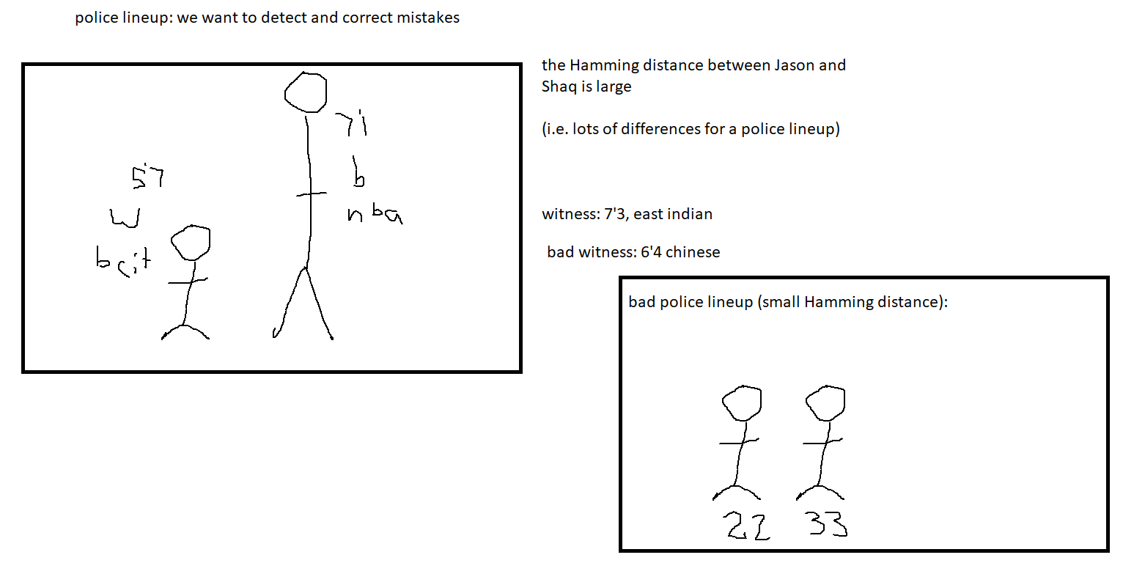
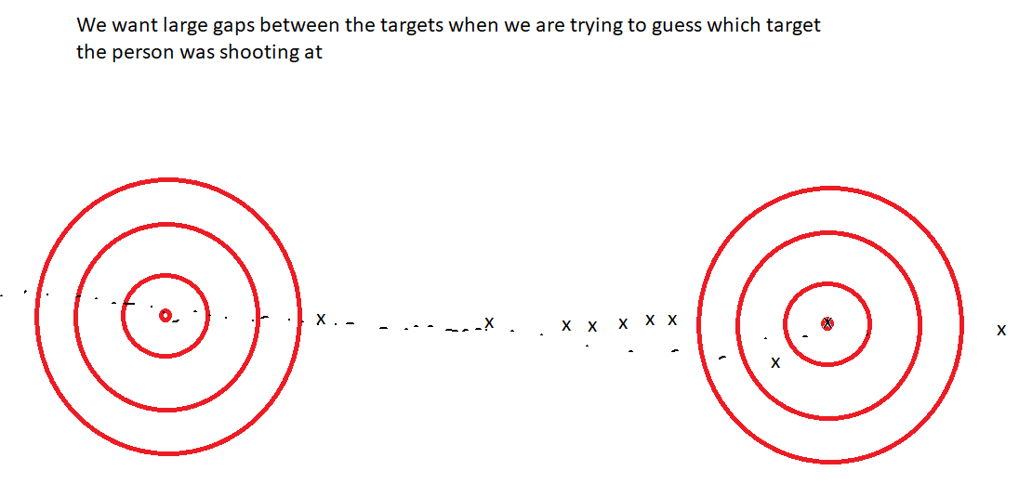
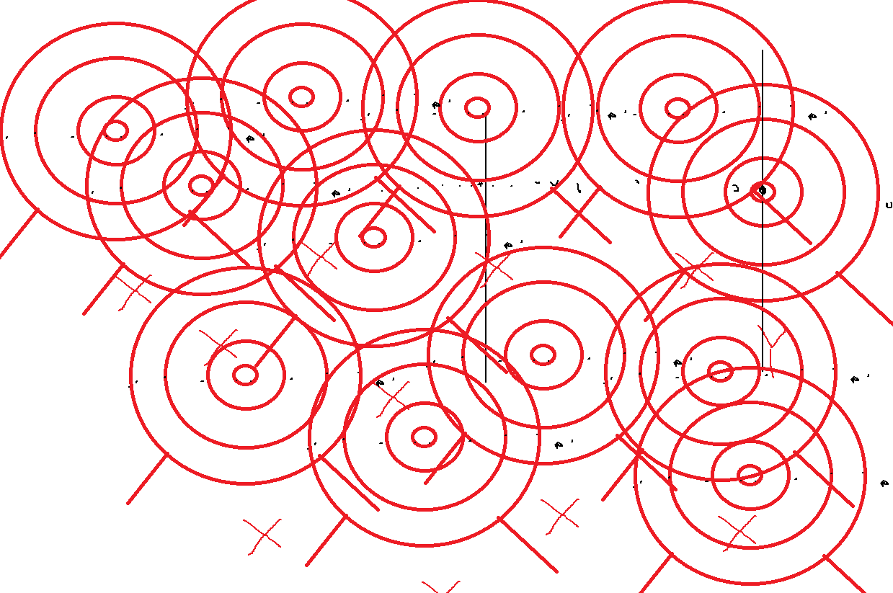

HD | ED (# bit errors detectable) | EC (# bit errors correctable)
8 | Up to 7 bits (this is code A) | Up to 3
256 | 1 to 255 | Less than 128
1 | Code B: 0 | 0
H | Less than H | Less than H/2
21 | 20 (better than code A) | Less than 10.5 (i.e. 10 or fewer)
8000 | Anything but 8000 | Less than 4000
17 | Up to 16 bits | 8 or fewer
10 | Less than 10 | Less than 5
Review:Imagine you and I are exchanging information. We agree to use certain words (e.g. English agrees on the words in the dictionary). Let’s just use two words in our CODE:
000000
111111
You can send only six zeroes or six ones.
If I send you 000000 and there is an error, and you receive 100000, what would you do? It’s definitely NOT a correct word because it’s not 000000 and it’s not 111111. It was probably supposed to 000000. This lesson is about ERROR DETECTION and ERROR CORRECTION. Your computer guesses (i.e. uses probability) that it was not 111111.
# of errors | The word I sent | What you received | Detect error(s)? | Correct error(s)?
6 | 000000 | 111111 | No, a wrong (but valid!) word was received | No, wouldn’t even try to correct since it looks good
5 | 000000 | 111110 | Yes: it’s not 000000 and not 111111 | NO. You think you could, but you’d be wrong; it looks like 111111 but in this case, with 5 errors, we would be wrong
4 | 000000 | 111100 | Yes | No, same as above
3 | 000000 | 111000 | Yes | No, it looks half like each of two words. We have no clue what to do
2 | 000000 | 110000 | Yes | Yes, it looks more like 000000 and in this case we would be right
1 | 000000 | 100000 | Yes | Yes, see the paragraph above

The distance between 000000 and 111111 is 6 bits. The Hamming Distance of a code is the minimum number of bit differences between any two words.
The bigger the Hamming Distance, the more errors we can detect and correct.
Imagine if we had THESE two words instead:
00000000000000000000000000000000
11111111111111111111111111111111
32 zeroes is one word; 32 ones is the other word
Hamming Distance is 32 bits! We can detect up to 31 errors. We can correct up to 15-bit errors. Cannot fix 16 errors: 00000000000000001111111111111111 is not fixable. Cannot fix 17 to 31 errors: because we would be “correcting” to the wrong word (which it more closely resembles). Cannot fix 32 errors: it now looks like the wrong word exactly (which is another valid word but not the one we intended).
If we had this code:
00000000000000000000000000000000
11111111111111111111111111111111
And then had to pick a third word to agree to use, a GOOD word would be:
00000000000000001111111111111111
…because it is as different as possible from the other words, giving a new Hamming Distance of 16 bits.
Just as good would have been: 01010101010101010101010101010101 etc…
A terrible third word to add to our code would have been:
00000000000000000000000000000001
…or anything else that’s too close to the first two words. That ruins the whole code. The HD is now 1 bit.

Hamming Distance (bits) | # of errors detectable | # of errors correctable
6 | 5 or fewer | 2 or fewer
32 | Up to 31 | Up to 15
1 | 0 | 0
H | Less than H | Less than H/2
43 | Less than 43 | Up to 21

Actual Hamming Code: Error Detection, Correction, and Measurement
Dataword: The raw data we want to store or send
Codeword: The dataword plus extra bits. The extra bits are called parity bits and they are what allow us to detect / correct errors
Data word: 10011
Let’s create the Hamming codeword for this dataword. We can use even or odd parity. Let’s choose even parity.
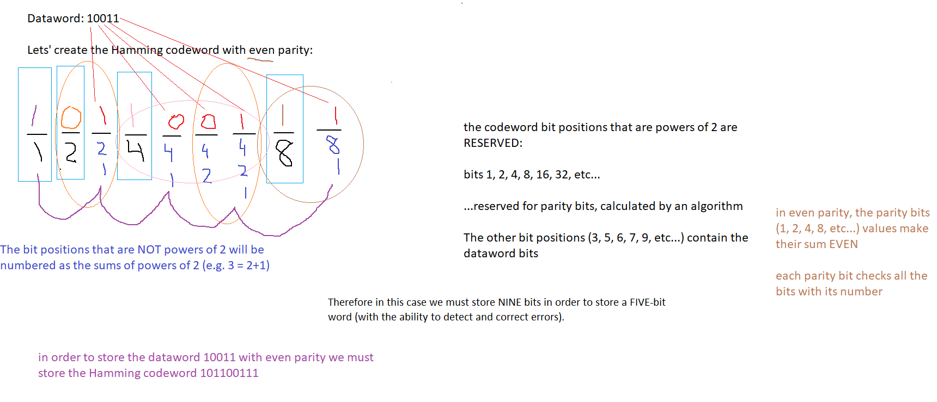
QUESTION: Create the Hamming codeword with even parity for the dataword 010000001
ANSWER:
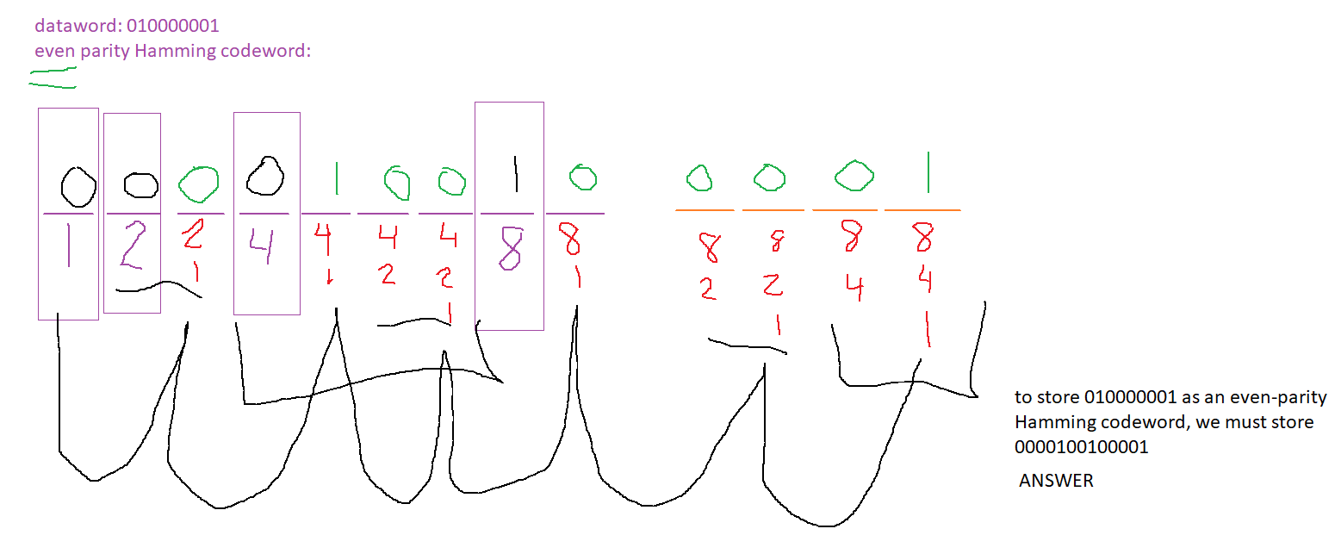
SAME QUESTION, but now we want an odd-parity codeword. ANSWER: flip bits 1-2-4-8: 1101100000001

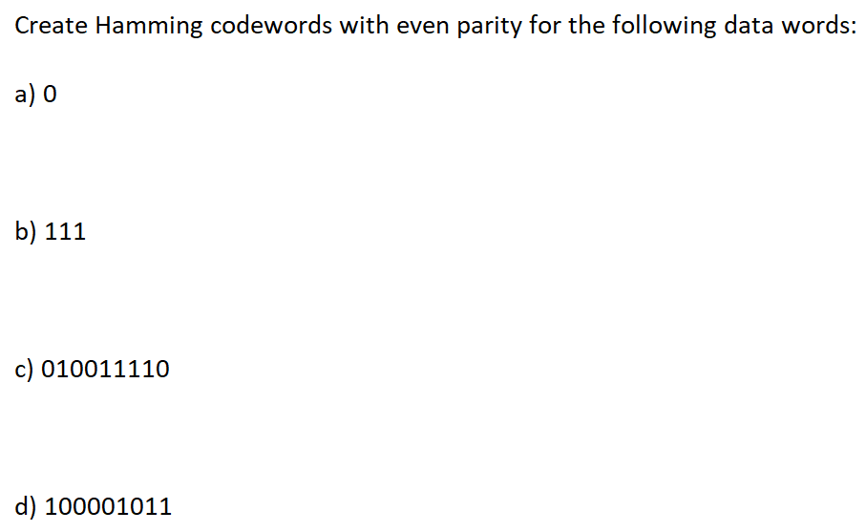

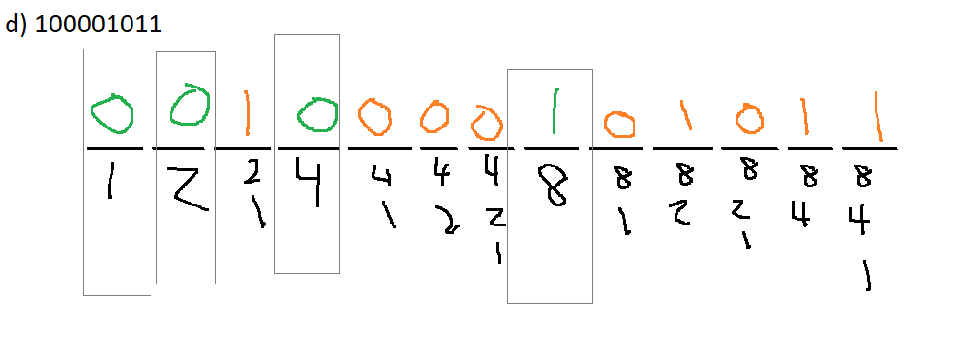
For the last question, for ODD parity instead, just flip the parity bits: 1111000001011

The following Hamming codeword was created with EVEN parity. Does it contain errors? Where? What was the original data word supposed to be?
111100001011

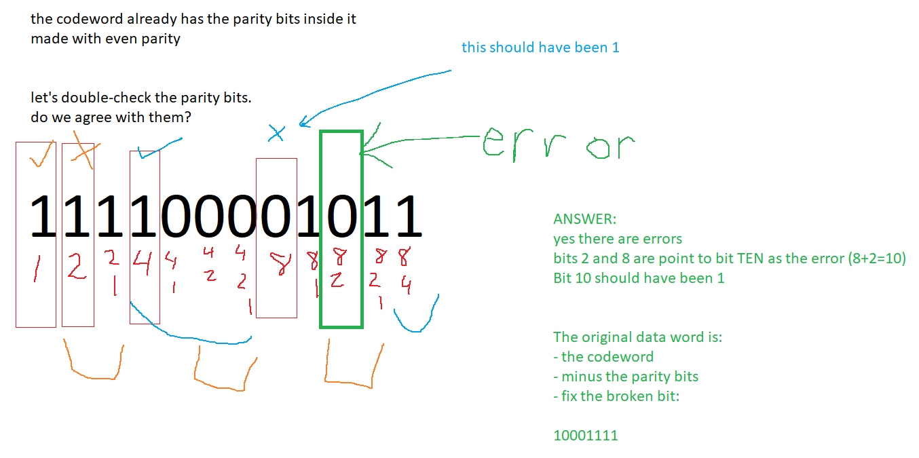
The following Hamming codeword was created with ODD parity. Does it contain errors? Where? What was the original data word supposed to be?
1000001001
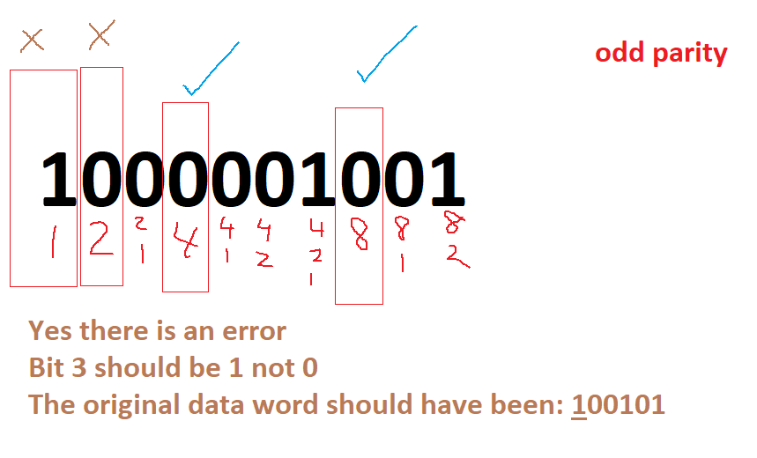
QUESTION: What if only bit 2 had been wrong?
ANSWER: Then bit 2 was wrong. That’s it.
May 12:
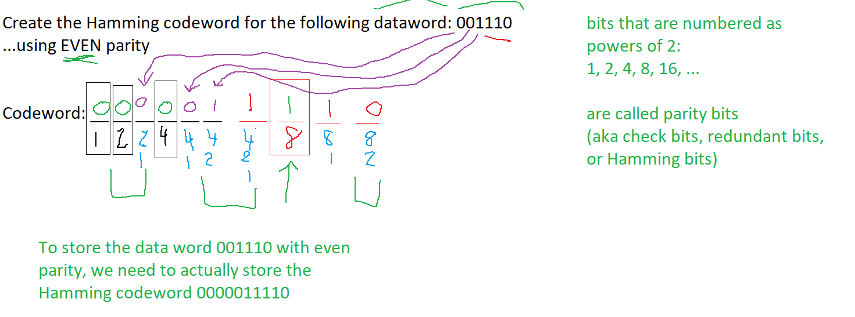

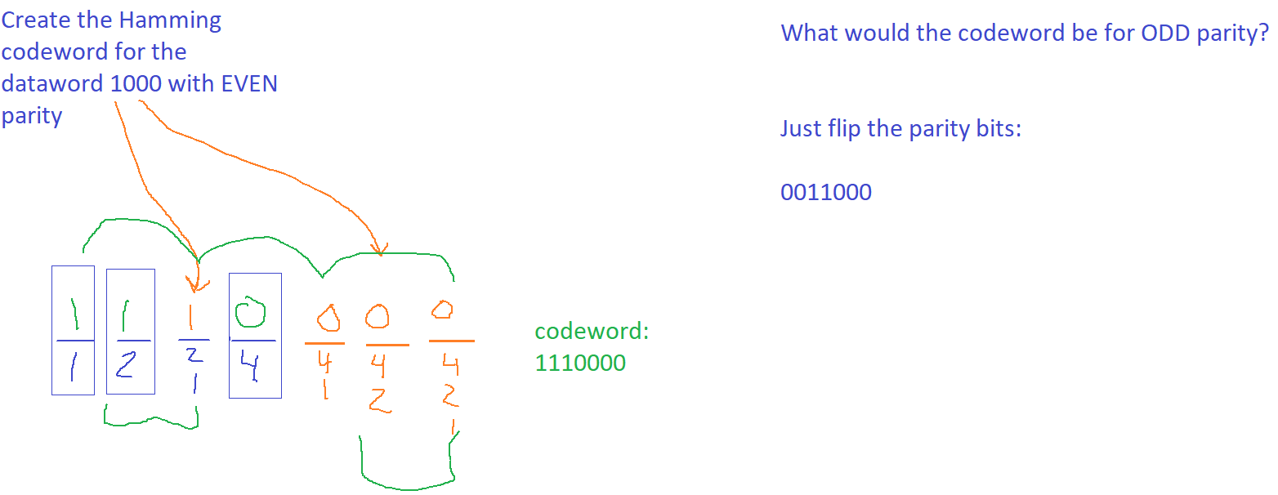
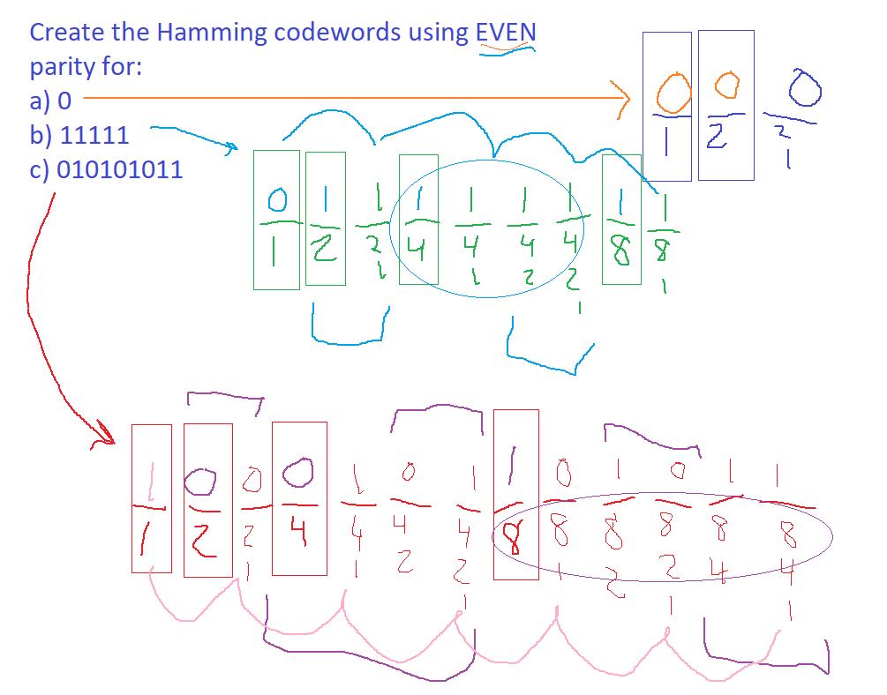
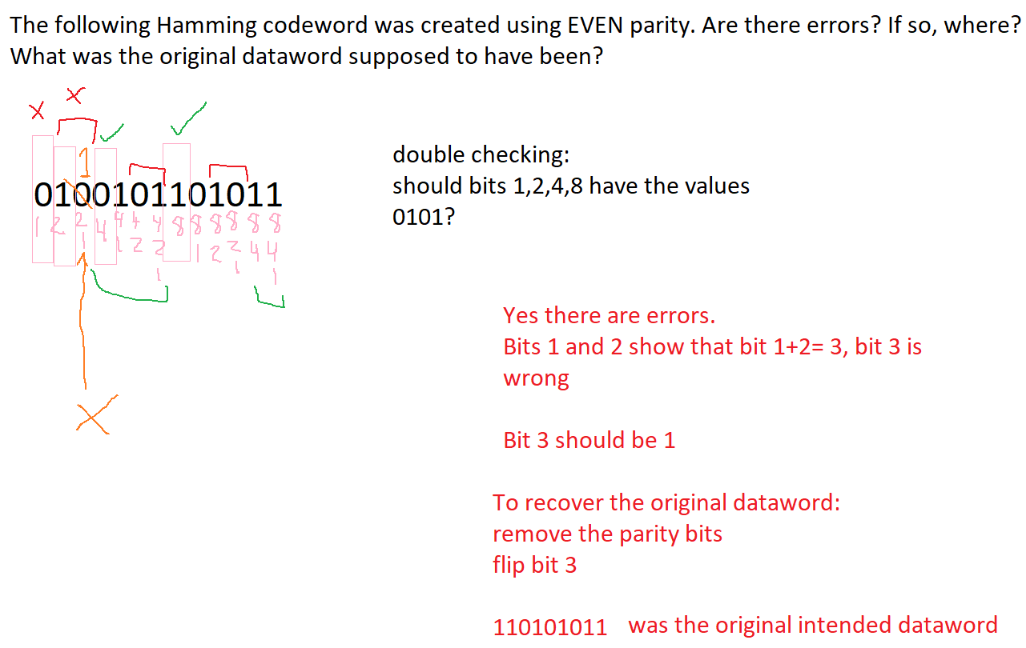
New question: The following Hamming codeword was made using even parity. Are there errors? Where? What was the original dataword supposed to have been? Show your work. Clearly identify parity bits:
111111101
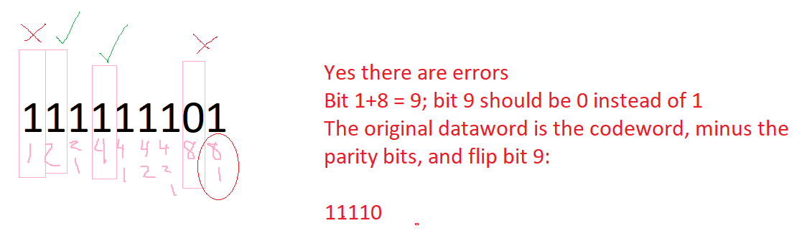
Follow-up question: what if the previous question used ODD parity instead?
Answer: Yes. Bit 2+4 = 6; bit six is the error. Bit 6 should be 0 instead of 1. Flip bit 6, remove bits 1,2,4,8, and get the original intended dataword: 11011
QUESTION: what if the only bit that “looked wrong” was bit 2?
ANSWER: then only bit 2 was wrong!

