**ABSTRACT**

The Financial Forecasting Dashboard using Power BI project focuses on leveraging Power BI's advanced analytics and visualization capabilities to predict financial trends and support data-driven decision-making. The dashboard provides an intuitive and interactive platform for analyzing historical financial data and forecasting future performance with a high level of precision.

The process begins with importing a dataset containing historical financial metrics such as revenue, expenses, or cash flow. Using Power BI’s temporal analysis capabilities, the data is visualized on a line chart, where the x-axis represents a continuous time-based reference and the y-axis displays the aggregated financial measure. The granularity of the data points is maintained to ensure accurate forecasting. Power BI’s built-in forecasting feature is then applied to project future financial outcomes, with adjustable parameters like confidence intervals and seasonality to suit specific needs.

The dashboard is designed to be user-friendly, enabling real-time updates as new data becomes available, ensuring decisions are always based on the latest insights. It equips businesses with tools to identify trends, anticipate financial risks, and make informed strategic plans. This project is a valuable solution for organizations aiming to optimize their financial planning and gain a competitive edge through actionable insights.

**CHAPTER 1**

**INTRODUCTION**

* 1. **OVERVIEW**

The Financial Forecasting Dashboard project aims to leverage Power BI's robust capabilities to create a dynamic and interactive tool for predicting financial trends. Forecasting is conducted at the same granularity level as the data points, ensuring precise and actionable insights. The project begins with importing a dataset containing historical financial data, such as sales, revenue, or expenses, which serves as the foundation for analysis.

A core feature of this project is temporal analysis, achieved by visualizing data on a line chart. This visualization ensures a clear, continuous time-based reference on the x-axis, while the y-axis represents the aggregated financial measure (e.g., monthly revenue or quarterly expenses) aligned with the data granularity. Power BI's built-in forecasting functionality is then employed to project future trends based on historical patterns. Users can adjust forecasting parameters, such as confidence intervals and seasonality, for customized insights.

The dashboard provides users with an intuitive platform to monitor financial performance, identify trends, and anticipate future outcomes. With its real-time data update capabilities, decision-makers can make proactive and informed financial decisions. This project is a practical solution for businesses looking to enhance their financial planning and risk management strategies through data-driven predictions.

* 1. **Problem Statement**

Forecasting is a prediction with the same level of granularity as the data point used. After importing the dataset, temporal analysis via the built-in option involves using a line chart because it is essential to have a continuous temporal reference on the x-axis. On the y-axis, you will insert the aggregated measure, relative to the data point’s granularity level, for which we want to calculate the forecast.

**CHAPTER 2**

**MODULES TO BE IMPLEMENTED**

### Data Preparation

### Creating Time Series Visualizations

### Implementing Forecasting Models

### Finalizing the Financial Forecasting Dashboard

**MODULE 1**

**Data Preparation**

* Objective: Prepare historical financial data for forecasting.
* Tasks:
  1. Import and clean historical financial data (e.g., revenue, expenses, profit).
  2. Ensure the data is structured correctly for time series analysis, with proper date formatting.

**MODULE 2**

**Creating Time Series Visualizations**

* Objective: Visualize historical financial data over time.
* Tasks:
  1. Create line charts to show trends in revenue, expenses, and profit over time.
  2. Add a clustered bar chart to compare quarterly or yearly financial performance.
  3. Use a KPI visual to display key financial metrics like current profit margins.

**MODULE 3**

**Implementing Forecasting Models**

* Objective: Use Power BI's forecasting tools to predict future financial performance.
* Tasks:
  1. Apply built-in forecasting models to predict future revenue and expenses.
  2. Create a custom forecast using DAX and Power Query for more complex scenarios.
  3. Add visuals to compare actual versus forecasted financial performance.

**MODULE 4**

**Finalizing the Financial Forecasting Dashboard**

* Objective: Compile visualizations into a final dashboard.
* Tasks:
  1. Arrange the forecasted data and historical data in a cohesive layout.
  2. Add interactive elements like slicers to adjust forecasting periods or financial categories.
  3. Include a narrative on how forecasts can guide financial decision-making.

**Chapter 3**

**POWER BI**

**Definition:**

Power BI is a Business Intelligence tool used to clean the data, analyse the data and convert the data into visual format.

**Key Features:**

1. Data Connectivity

2. Data Transformation and Modelling

3. Real-Time Data Streaming

4. Data Analysis Expressions (DAX)

5.Interactive Visualizations

**Components:**

Power BI is a collection of Components:

1. Power Query

2. Power Pivot

3. Power View

4. Power BI Service

**1. Power Query:**

It is a ETL tool (extract, transfer (cleaning the data), Load)

=> Extracting the data, transferring the data and loading the data.

**2. Data modeling:**

when we have multiple data sources, if we want to connect them, we need to create the relationship between them by using power pivot.

**3. Power View:**

It can be help us to create 250+ visuals.

Ex: line chat, bar chart, pie chart, kpi chart ………..etc

**4. Power BI Service:**

Communicating through reports & Dashboards with clients, colleagues, end users .

**Chapter 4**

**Financial Forecasting**

Financial forecasting is the process of estimating or predicting a company's future financial outcomes based on historical data, trends, and assumptions.

Using Power BI for financial forecasting, the process includes:

* 1. **Importing Historical Data:** Bringing in data that contains past financial performance.
  2. **Temporal Analysis:** Applying a time-based analysis, often using a line chart where the time dimension (e.g., months) is displayed on the x-axis. This time series allows for continuous visualization of data trends over time.
  3. **Aggregated Measures:** Plotting measures such as revenue or profit on the y-axis, which can then be forecasted to predict future values based on historical patterns.

**Data Relationships in Power BI**

In Power BI, relationships define how tables are connected, enabling users to analyze data from multiple sources cohesively. These relationships are established using common fields (keys) and are fundamental for creating accurate and meaningful reports. The main types of relationships in Power BI include:

**1. One-to-Many (1:*):**

A common type of relationship where one record in a table is related to multiple records in another table.

Example: A Customers table with unique customer IDs (one) relates to a Sales table where each customer ID appears multiple times (many).

Usage: Ideal for master-detail scenarios (e.g., Products and Orders).

**2. Many-to-One (*:1):**

The reverse of one-to-many, where multiple records in one table relate to a single record in another table.

Power BI automatically interprets this relationship similarly to one-to-many.

**3. Many-to-Many (:):**

A more complex relationship where multiple records in one table relate to multiple records in another table.

Example: A Products table and a Stores table where a product can be sold in multiple stores and a store can sell multiple products.

Usage: Managed via intermediary tables (bridge tables) or direct many-to-many relationships introduced in Power BI.

**4. One-to-One (1:1):**

A rare relationship where one record in a table corresponds to exactly one record in another table.

Example: A table of employees and a table of employee details, both with unique employee IDs.

**DAX in Power BI**

DAX (Data Analysis Expressions) is a formula language used in Power BI, Power Pivot, and Analysis Services to create calculations and data transformations. It is essential for defining measures, calculated columns, and custom aggregations to derive insights from data models. DAX is designed to work with relational data and is optimized for fast computation.

**Key Features of DAX:**

1. Custom Calculations: Create calculated columns, measures, and tables for advanced analytics.

2. Built-in Functions: Offers over 200 functions, including mathematical, statistical, logical, and time intelligence functions.

3. Context Awareness: Leverages row context and filter context for dynamic calculations.

4. Aggregation: Enables complex summarizations like averages, sums, or counts.

**Benefits of DAX in Power BI:**

1. Enables advanced data modeling.
2. Empowers users to analyze trends, relationships, and patterns.
3. Allows for dynamic calculations based on user interactions in reports.
4. Mastering DAX is crucial for creating insightful, customized Power BI dashboards and reports.

**Chapter 4**

**Step to Demonstrate project**

**Step 1: Import Data**

1. Connect Data Sources: Open Power BI Desktop and connect to your data sources. We can import data from Excel, SQL databases, online services, or other relevant sources.

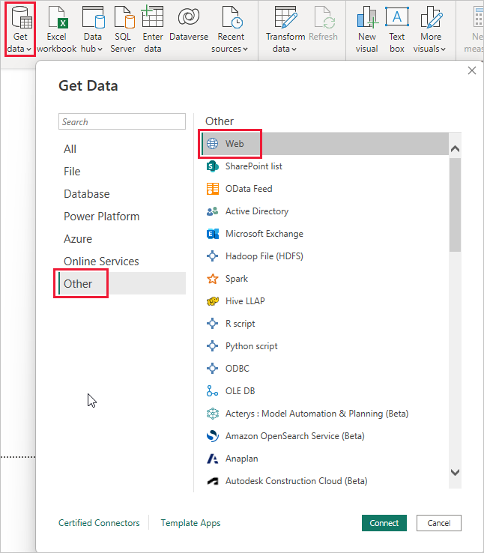

**Step 2: Transform Data (Data Cleaning and Preparation)**

* 1. Open Power Query Editor: Once data is imported, open Power Query Editor to clean and transform the data.
  2. Remove Unnecessary Columns: Delete any columns that are not relevant for your analysis to optimize data load and performance.
  3. Format Data: Ensure data types are correct (e.g., dates as Date format, currency values as Decimal, etc.).

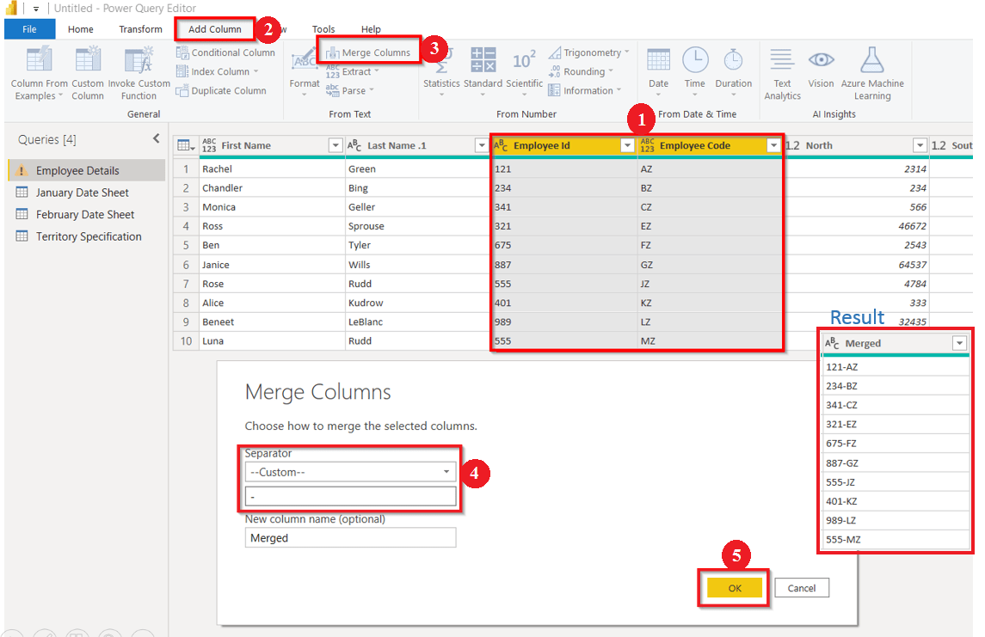

**Step 3: Define Data Model and Relationships**

* 1. Build Relationships: By using “Model” view in Power BI and establish relationships between tables (e.g., linking sales data with calendar dates).
  2. Create Measures: Use Data Analysis Expressions (DAX) to create calculated measures, such as revenue growth rate, average sales, etc., for forecasting purposes.

**Step 4: Create Visualizations for Temporal Analysis**

* 1. Add a Line Chart for Forecasting: Place the time-based field (e.g., month, quarter, year) on the x-axis. Place the measure you want to forecast (e.g., revenue, expenses) on the y-axis.

**Step 5: Add Additional Visualizations for Insight**

1. KPI Visuals: Add KPI visuals to display key metrics (e.g., revenue, profit margin, etc.).

**Step 6: Build the Dashboard**

* 1. Organize Layout: Arrange visuals in a logical and easy-to-understand layout.
  2. Use Slicers and Filters

**Step 7: Publish and Share the Dashboard**

**Step 8: Review and Refine**

* 1. Test the Dashboard: Ensure all visuals are accurate, interactive, and performing as expected.
  2. Gather Feedback: If possible, share the dashboard with stakeholders and gather feedback for any refinements.
  3. Make Adjustments: Based on feedback, make any necessary changes to improve usability and insights.

**Chapter 5:**

**Visualization**

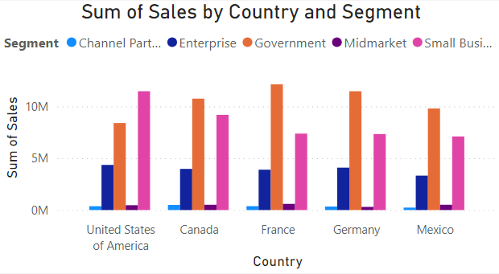

Fig 5.1: **Clustered Column Chart**

This **Clustered Column Chart** shows Sales by Country and segment where France has highest sales in government sector

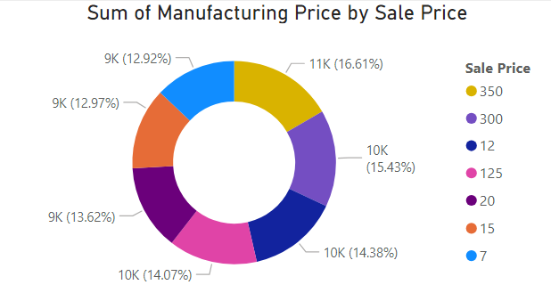

Fig 5.2**: Donut Chart**

The Donut Chart shows manufacturing price with respect to sales price where each segment represented by different colours.

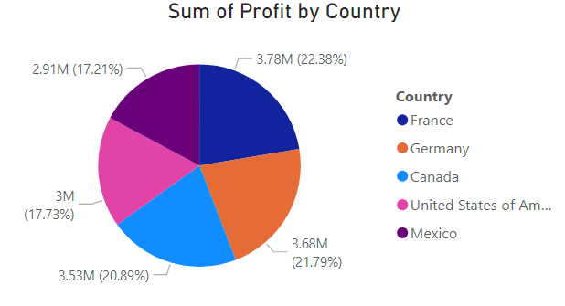

Fig 5.3**: The Pie Chart**

The Pie Chart shows profit of each country where France has more profit than other countries.

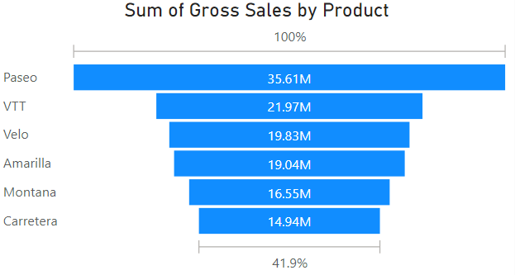

Fig 5.3**: The Funnel Chart**

The Funnel Chart shows Gross Sales of each product which concludes Paseo is more sold product.

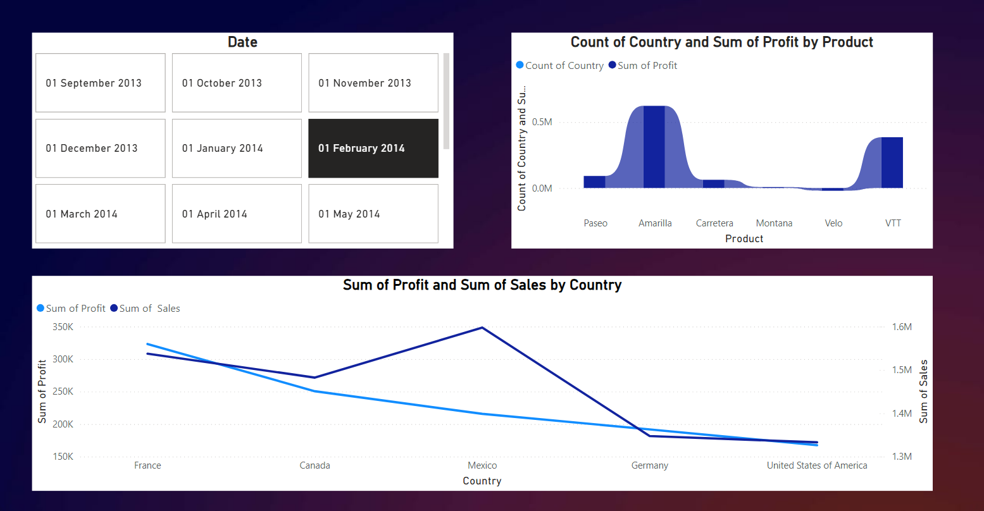

Fig 5.3**: Using Slicer to create dated visualization**

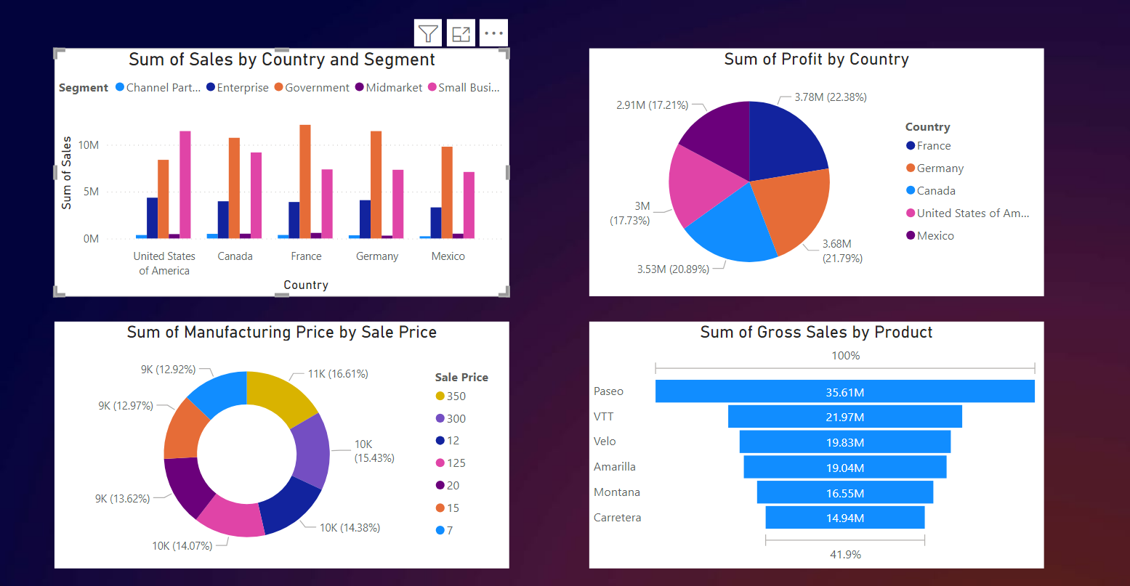

Fig 5.4**: Using Slicer to create dated visualization**

**Conclusion**

The Financial Forecasting Dashboard in Power BI offers an intuitive way to analyze and predict financial trends, helping users make more informed decisions. With its interactive visuals and forecasting features, the dashboard provides valuable insights into future financial outcomes.

Future improvements, like integrating advanced models and real-time data updates, will make the tool even more effective for financial planning and decision-making.