Introduction to AI and ML
(CSL 236)
Project Report

Air Quality Index (AQI) Prediction using Time-Series Machine Learning



Faculty name: Meghna Sharma

Nipun Juneja (23CSU215)
Nishant Rajora (23CSU220)
Monika (23CSU203)

— Semester: 5th, Group: DS-2

Department of Computer Science and Engineering
The NorthCap University, Gurugram- 122001, India
Session 2022-23

1. Abstract
Rapid industrialization and urbanization have made air pollution a critical public health challenge in India. This project aims to develop a robust machine learning pipeline to predict the daily Air Quality Index (AQI) across various Indian cities. Leveraging a dataset spanning 2015–2020, we employed a time-series approach to modeling. Key preprocessing steps included advanced imputation, log-transformations for skewed data, and the engineering of lag-based features. We trained and evaluated two ensemble learning models—Random Forest Regressor and XGBoost Regressor—using a strict time-based train-test split. Both models demonstrated high efficacy, achieving an R^2 score of approximately 0.90. The final solution was deployed as a containerized Streamlit web application, offering an interactive dashboard for real-time data visualization and prediction transparency.

2. Introduction

2.1 Background
The Air Quality Index (AQI) is a standardized number used by government agencies to communicate the level of air pollution to the public. Accurate forecasting of AQI is essential for issuing timely health advisories and enabling citizens to take preventive measures.

2.2 Problem Statement
Air quality data is often plagued by inconsistencies, including missing sensor readings, extreme outliers, and complex seasonal variations. The objective of this project was to build a predictive model that could navigate these challenges and accurately forecast daily AQI based on historical concentrations of pollutants such as PM10, NO2, CO, and SO2.

2.3 Dataset
The project utilized the "Air Quality Data in India" dataset, containing daily records from multiple cities. The data included concentrations of particulate matter (PM2.5, PM10), gases (NO2, NH3, SO2, CO, Ozone), and the target variable, AQI.
https://www.kaggle.com/datasets/rohanrao/air-quality-data-in-india/data
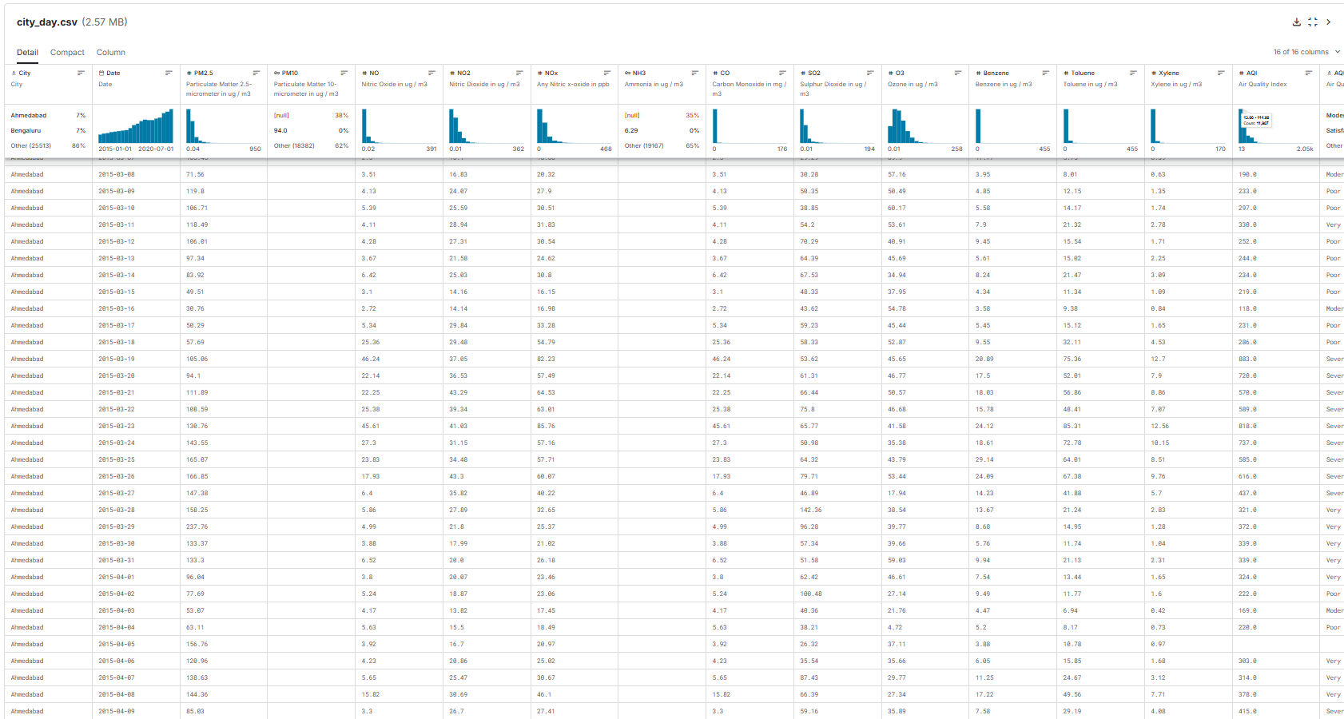

3. Methodology

3.1 Exploratory Data Analysis (EDA)
Before modeling, we conducted a comprehensive analysis using Tableau and Python to understand underlying patterns:
- Seasonality: A distinct annual cycle was observed. AQI levels consistently peak during winter months (December–January) due to temperature inversion and drop to their lowest during the monsoon season (August–September) due to washout effects.
- Skewness: Histograms revealed that pollutant distributions were heavily right-skewed. While the majority of days exhibited moderate pollution levels, "severe" pollution days created long statistical tails, posing a challenge for linear models.
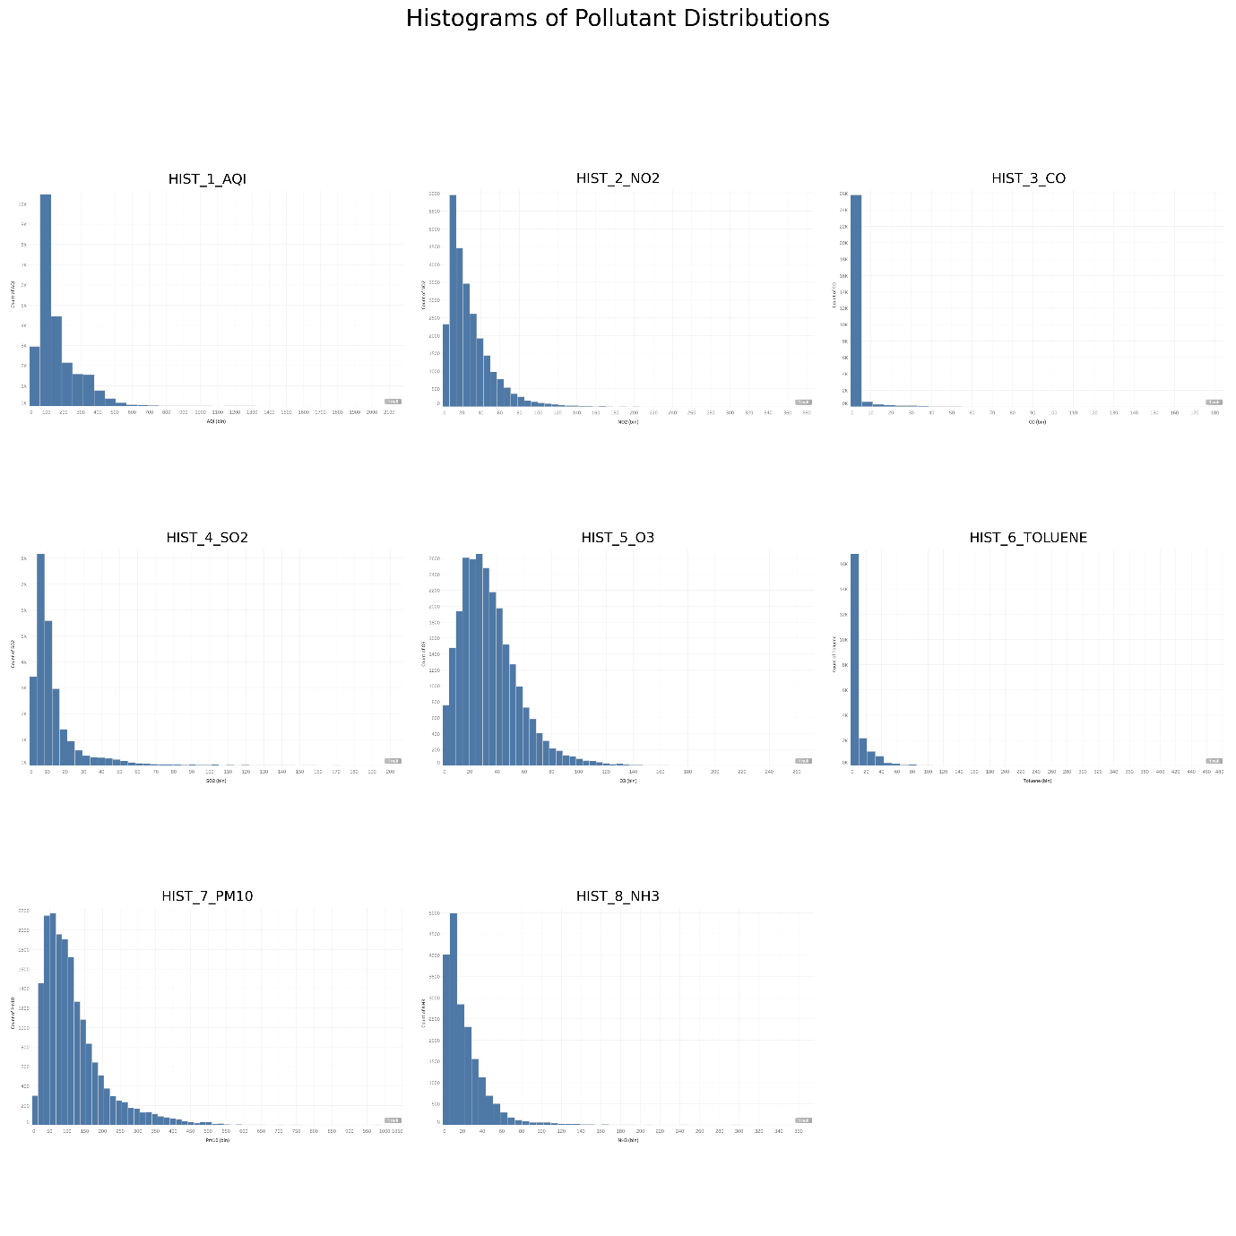

3.2 Data Preprocessing
To ensure high data quality, we implemented a rigorous cleaning pipeline:
- Feature Selection: A correlation matrix revealed high multicollinearity (e.g., PM2.5 and PM10 had a correlation > 0.85). To reduce redundancy and model complexity, highly correlated features like PM2.5, NOx, and Benzene were dropped in favor of their stronger predictors (PM10, NO2).
- Advanced Imputation: Standard mean imputation was deemed unsuitable for time-series data. Instead, we utilized a Forward-Fill (ffill) method grouped by city. This approach respects the temporal continuity of the data, assuming that air quality does not change drastically overnight.
- Log Transformation: To address the right-skewness identified during EDA, a np.log1p (Log + 1) transformation was applied to all pollutant features and the target variable. This normalized the data distribution, significantly improving model stability.
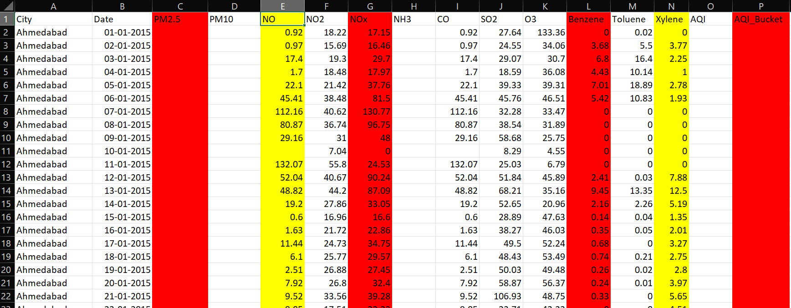

3.3 Feature Engineering
Feature engineering was the decisive factor in the model's performance. We created:
- Lag Features: We generated AQI_lag_1 and PM10_lag_1, representing the values from the previous day ($t-1$). This captured the high autocorrelation in air quality data (i.e., a polluted day is likely to be followed by another polluted day).
- Temporal Features: We extracted Month, Year, and Day_of_Week from the date column to explicitly model the seasonal trends discovered during EDA.
- Spatial Features: The City column was One-Hot Encoded, allowing the model to learn specific pollution baselines for different locations (e.g., distinguishing Delhi's pollution profile from that of Shillong).
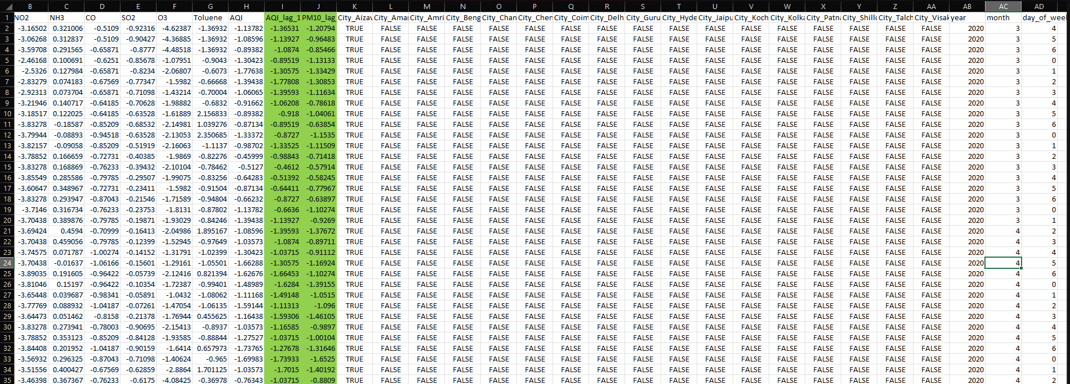

4. Model Development

4.1 Training Strategy
To simulate real-world forecasting and prevent data leakage, we avoided random splitting. Instead, we used a Time-Based Split:
- Training Set: Data from 2015 through 2018.
- Testing Set: Data from 2019 and 2020.
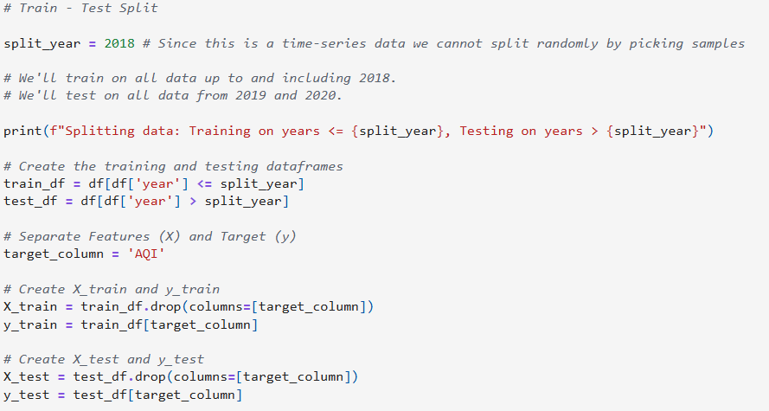
This ensured the model was evaluated strictly on its ability to predict "future" unseen data based on past patterns.

4.2 Algorithms
We trained two ensemble models known for their ability to capture non-linear relationships:
- Random Forest Regressor: A bagging technique that reduces overfitting by averaging multiple decision trees.
- XGBoost Regressor: A gradient boosting framework optimized for speed and performance, particularly effective with structured tabular data.
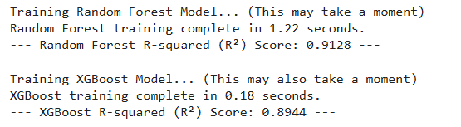

5. Results & Discussion

5.1 Model Performance
Both models delivered exceptional results on the test set, explaining over 90% of the variance in AQI levels.
- Random Forest: R^2 = 0.9021
- XGBoost: R^2 = 0.9011

5.2 Feature Importance Analysis
Post-training analysis confirmed the validity of our feature engineering strategy. Both models ranked AQI_lag_1 as the single most important predictor, contributing significantly more than any raw pollutant reading. Month was consistently ranked in the top 5 features, validating the strong influence of seasonality. Current levels of PM10 and NO2 were also identified as critical drivers.
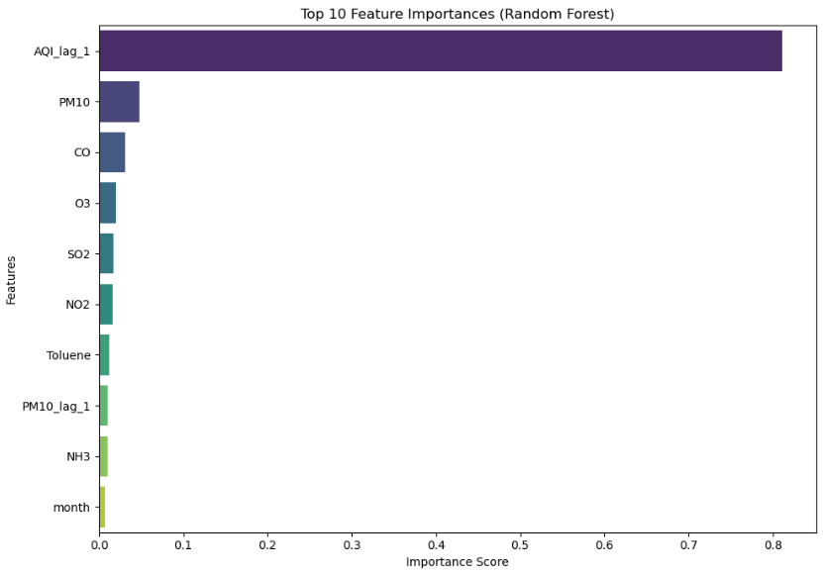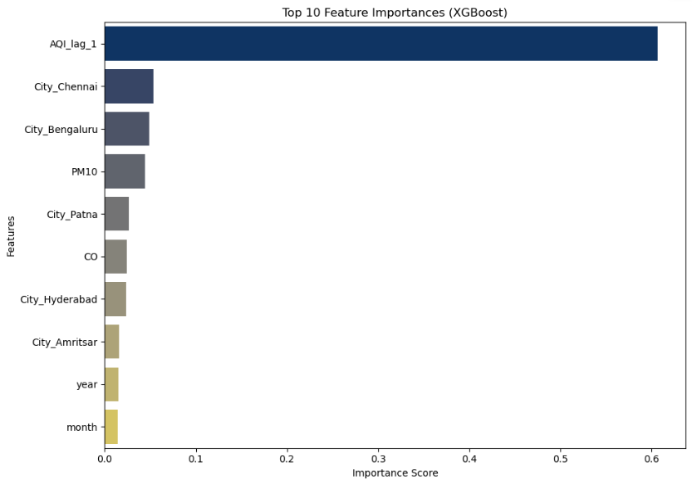

6. Deployment
To make the project accessible, we developed a web-based dashboard using Streamlit.
- Functionality: The app allows users to view project insights, explore interactive EDA plots (histograms, correlation heatmaps), and see the model's performance metrics.
- Architecture: The application was containerized using Docker to ensure consistency across environments and deployed via Streamlit Community Clou, providing a public URL for access.
https://nj-aqi-prediction.streamlit.app/
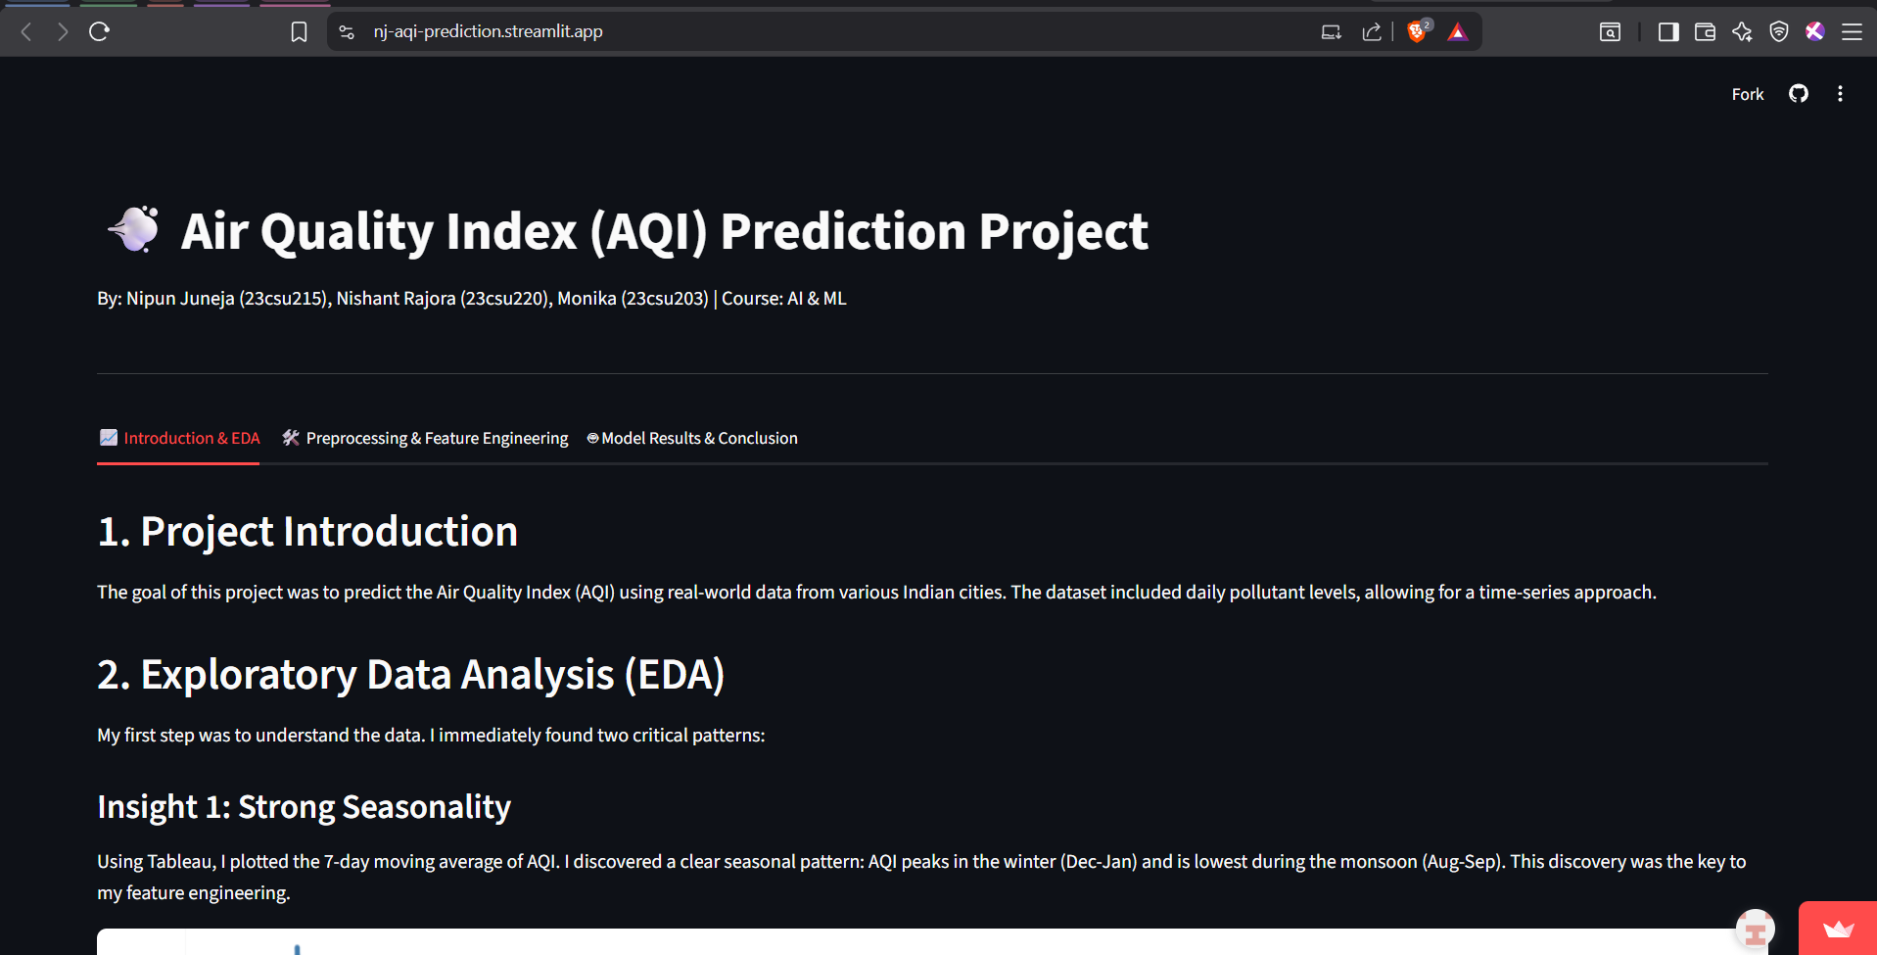

7. Conclusion
This project demonstrates that high-accuracy AQI forecasting is achievable by combining domain-specific preprocessing with powerful machine learning algorithms. The key to success was not just the choice of model, but the strategic engineering of lag and time-based features. The final solution provides a reliable tool for understanding air quality trends, potentially aiding in better public health planning.

