**Capstone-one**

Building your API Hack capstone

API Hack requirements Objective: By the end of this checkpoint, you can describe the purpose of the API hack capstone.

This module guides you through designing and implementing an API hack capstone, which will demonstrate your mastery of the HTML, CSS, and JavaScript skills you've learned so far. For this capstone, you'll build an app that integrates with a third party API. The capstone project is meant to be something you're proud to share with prospective employers, fellow hackers, friends, family, and even the general public. In short, it's your opportunity to show off what you've learned and the cool things you can build with your new skills.

In this first checkpoint, we'll go over the audience and requirements for the API hack and take a look at some example projects. See live demo below.

## **Screenshots**

Home Screen Image



Book-Title Search screen image



Author name search image

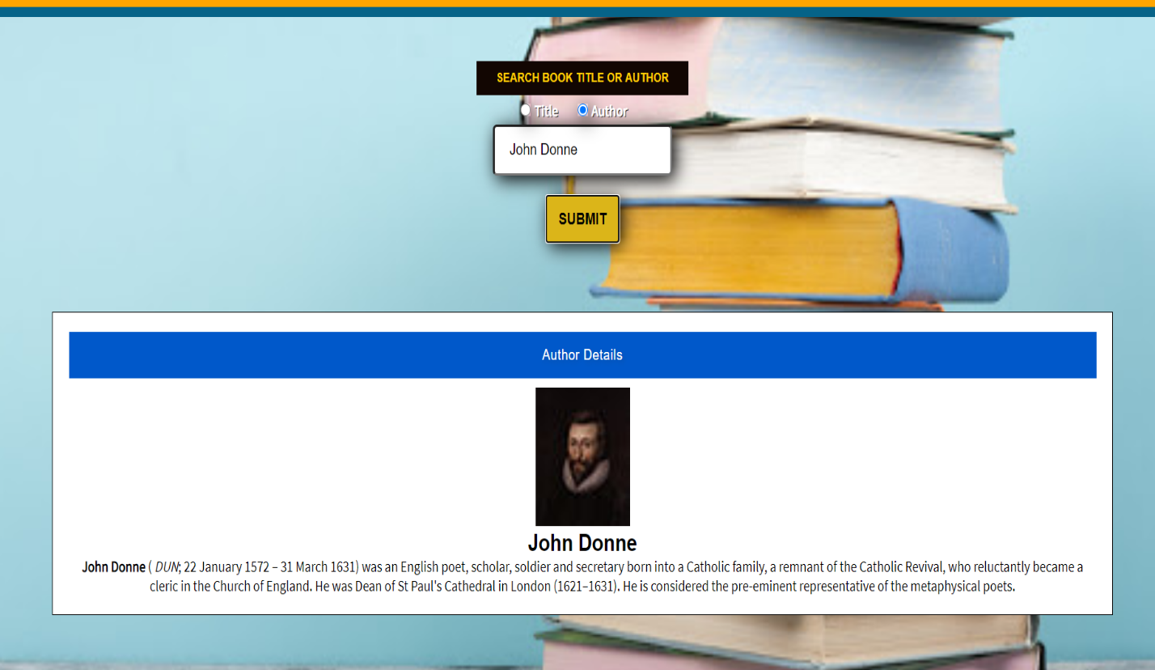

**Built With**

**Front-End Technologies**

* HTML
* CSS
* Javascript
* jQuery

**Demo**

* [Live Demo](https://monikathanki.github.io/Bookfinder/)

**Authors**

Monika Thanki - Front-End development/testing, styling