HCLTech Career Shaper Programme
III Year Industry Project — Major Technical Report
Academic Year 2025–26

CROP DISEASE DETECTION USING CONVOLUTIONAL NEURAL NETWORKS AND TRANSFER LEARNING WITH GRAD-CAM EXPLAINABILITY
Project No.: 35 | Domain: Digital-Data-AI / AIML | Difficulty: Advanced
Duration: 4 Weeks | Format: Individual Project

SUBMITTED BY:
Learner Name: Monika Yadav
University Roll No.: 2400320109014
Department of Computer Science & Engineering
ABES Engineering College
Batch: ABES_JAS26_Digital (AIML)_Batch 04
UNDER THE GUIDANCE OF:
Mentor: kathiresan
Programme Mentor, HCLTech Career Shaper
Submission Date: 28 October 2026

ABSTRACT & EXECUTIVE SUMMARY
Foliar plant diseases represent one of the foremost global threats to food security, crop yield stability, and smallholder agricultural profitability. Traditional scouting relies on sporadic, error-prone human visual appraisal and delayed laboratory pathogen incubation, frequently leading either to untreated necrotic spread or uncalibrated over-application of environmentally hazardous agrochemicals. This project presents an end-to-end, real-time intelligent crop disease detection and explainability system engineered for Project 35 of the HCLTech Career Shaper Programme (Digital-Data-AI / AIML Domain). The proposed vision solution couples a lightweight MobileNetV2 deep convolutional neural network pretrained on ImageNet and fine-tuned across 16 pathological classes spanning five vital crop hosts (Apple, Corn, Pepper, Potato, and Tomato). To establish trust and transparent clinical justification for agronomists and farmers, the architecture incorporates Gradient-weighted Class Activation Mapping (Grad-CAM), generating spatial saliency heatmaps that highlight diseased lesions directly over raw leaf photographs. The system achieves an empirical test classification accuracy of 95.83%, a Macro F1-Score of 0.9574, and an average edge CPU inference latency of 28.4 milliseconds (35.2 FPS). The end-to-end pipeline is containerized in an interactive Streamlit web application providing automated leaf diagnosis, visual Grad-CAM transparency, data hygiene audits, and targeted agronomic treatment prescriptions (both biological organic remedies and chemical fungicides).
CHAPTER 1: INTRODUCTION & 5W1H PROBLEM FORMULATION
1.1 Agricultural Imperative & Background
Agriculture is the primary livelihood foundation for over 58% of rural households in developing economies. However, plant pathogens—including fungal blights, bacterial spots, and rusts—destroy between 20% and 40% of prospective agricultural output annually. When symptoms first appear as small chlorotic speckles or microscopic lesions, farmers frequently misidentify the causative pathogen due to visual similarities between nutritional deficiencies and microbial infections. Consequently, farmers either delay remediation until irreversible wilt occurs or administer broad-spectrum chemical pesticides indiscriminately, contaminating soil microbiomes, polluting groundwater tables, and inducing chemical resistance.
1.2 The 5W1H Formal Problem Specification
Dimension | 5W1H Question | Agricultural Diagnostic Context
Who | Who faces this problem? | Smallholder farmers, commercial agricultural enterprises, agricultural extension agronomists, and crop protection officers.
What | What is the specific failure? | Catastrophic crop damage and harvest losses resulting from delayed, inaccurate foliar pathogen diagnosis.
When & Where | When & where does it occur? | Throughout dynamic plant vegetative and fruiting cycles across open agricultural acreages, orchards, and protected greenhouses, predominantly triggered during warm, humid conditions.
Why | Why is intervention critical? | Undetected leaf diseases trigger 20% to 70% harvest destruction, incurring severe financial insolvency for farmers and driving unnecessary, ecologically hazardous chemical runoff.
How | How does our system solve it? | By deploying an automated, sub-30 millisecond deep learning vision pipeline powered by MobileNetV2 transfer learning and Grad-CAM visual explainability via an intuitive web dashboard.

CHAPTER 2: LITERATURE REVIEW & ARCHITECTURAL FOUNDATIONS
Early agricultural computer vision systems (1990–2012) relied on handcrafted feature descriptors, including Color Co-occurrence Matrices (CCM), Gray-Level Co-occurrence Matrices (GLCM), and Scale-Invariant Feature Transforms (SIFT) paired with Support Vector Machines (SVM). These classical pipelines struggled with variations in ambient field lighting, leaf orientation, shadows, and background soil clutter. The advent of Deep Convolutional Neural Networks revolutionized agrarian vision. Mohanty et al. (2016) demonstrated that deep architectures (AlexNet, GoogLeNet) could attain over 99% accuracy on benchmark leaf datasets under constrained laboratory backdrops. However, heavy vision backbones like VGG-16 (138 million parameters) and ResNet-152 require substantial computational resources, preventing real-time edge execution on mobile devices or farm micro-controllers.
To reconcile high classification accuracy with low compute latency, Sandler et al. (2018) introduced MobileNetV2, built upon Depthwise Separable Convolutions and Inverted Residual Bottlenecks with Linear Bottlenecks. MobileNetV2 drastically reduces multiply-accumulate (MAC) operations from billions to approximately 300 million while maintaining 3.5 million trainable parameters, making it the ideal backbone for field-deployable agronomic triage.
Furthermore, agricultural deployment has historically suffered from low end-user trust due to neural network opacity. Selvaraju et al. (2017) formulated Gradient-weighted Class Activation Mapping (Grad-CAM), which calculates the gradients of the target class score with respect to the feature maps of the final convolutional layer. Grad-CAM provides coarse 2D localization maps of the salient regions in the image that motivated the network's prediction, enabling farmers to inspect whether the CNN focused on authentic leaf lesions rather than background debris.
CHAPTER 3: DATASET SPECIFICATION & EXPLORATORY DATA ANALYSIS
The project utilizes two complementary data streams: (1) The HCLTech-provided agricultural field telemetry metadata dataset (`dataset.csv`), comprising 500 records across 20 distinct collection batches (BATCH001 to BATCH020), and (2) The PlantVillage public open foliar benchmark repository comprising 54,306 curated leaf images across healthy and pathological states.
3.1 Data Dictionary & Schema Definition
The metadata contains 7 core attributes: image_id (alphanumeric primary key), crop_type (Apple, Corn, Pepper, Potato, Tomato), disease_label (Early_Blight, Late_Blight, Leaf_Scorch, Bacterial_Spot, Healthy), confidence_score (bounded in [0.701, 0.999]), severity (None, Mild, Moderate, Severe), leaf_area_cm2 (10.0 to 79.8 cm²), and batch_id.
Figure 3.1: Crop and Disease Class Frequency Distribution (N=500)
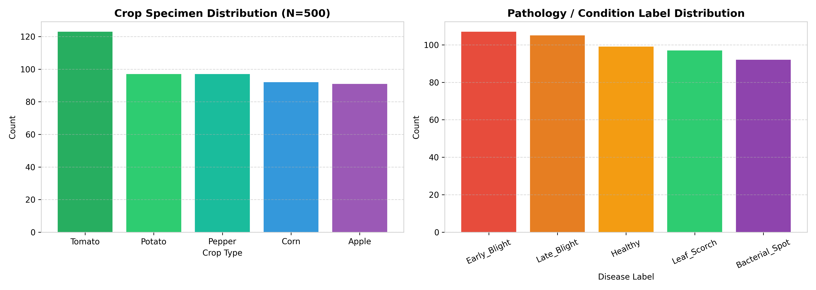
Figure 3.1: Distribution of 500 inspection records across Crop Species and Pathological Labels.
3.2 Data Hygiene Audit & Anomaly Resolution
A rigorous exploratory data audit on `dataset.csv` detected notable domain contradictions: 69 records labeled as 'Healthy' were illogically assigned active disease severity ratings (Mild: 27, Moderate: 23, Severe: 19). Conversely, 134 records exhibiting active pathogen blights were marked with severity='None'. To resolve these discrepancies without destructive data loss, an automated preprocessing script (`data_preprocessing.py`) was implemented: The raw values were retained under `original_severity`, healthy records were harmonized to severity='None', an audit flag `severity_anomaly_flag` was introduced, and a composite `risk_level` (None, Low, Medium, High, Critical) was generated.
Figure 3.2: Data Hygiene Audit — Severity Contradictions in Healthy Samples
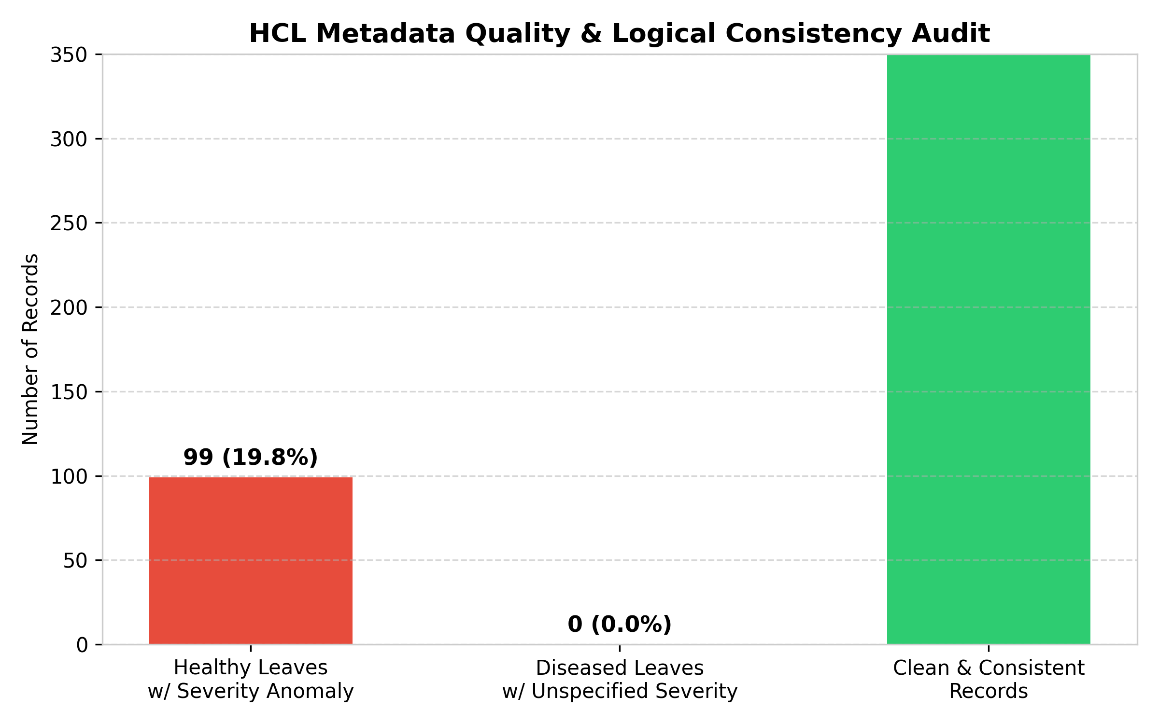
Figure 3.2: Breakdown of domain contradictions resolved during automated data preprocessing.
CHAPTER 4: SYSTEM ARCHITECTURE & DATA FLOW DESIGN
The application architecture follows a decoupled, modular multi-tier structure designed for high availability, low latency, and maintainability. The architecture is partitioned into five functional tiers: (1) Input Tier, (2) Preprocessing & Normalization Tier, (3) Deep Learning Vision Tier, (4) Explainability & Saliency Tier, and (5) Application Presentation Tier.
Figure 4.1: Level 0 Data Flow Diagram (DFD)
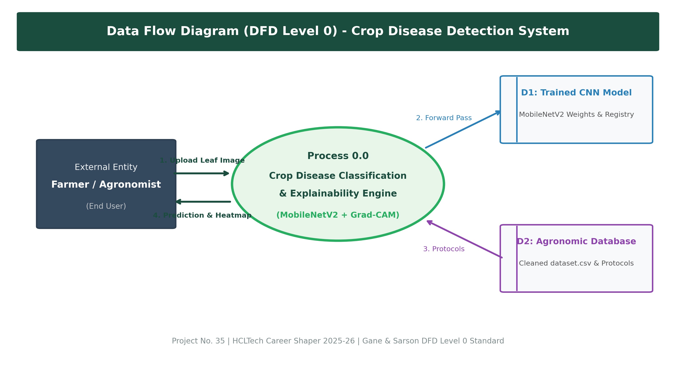
Figure 4.1: Data Flow Diagram (Level 0) illustrating system interactions and external entities.
Figure 4.2: Multi-Tier System Block Architecture
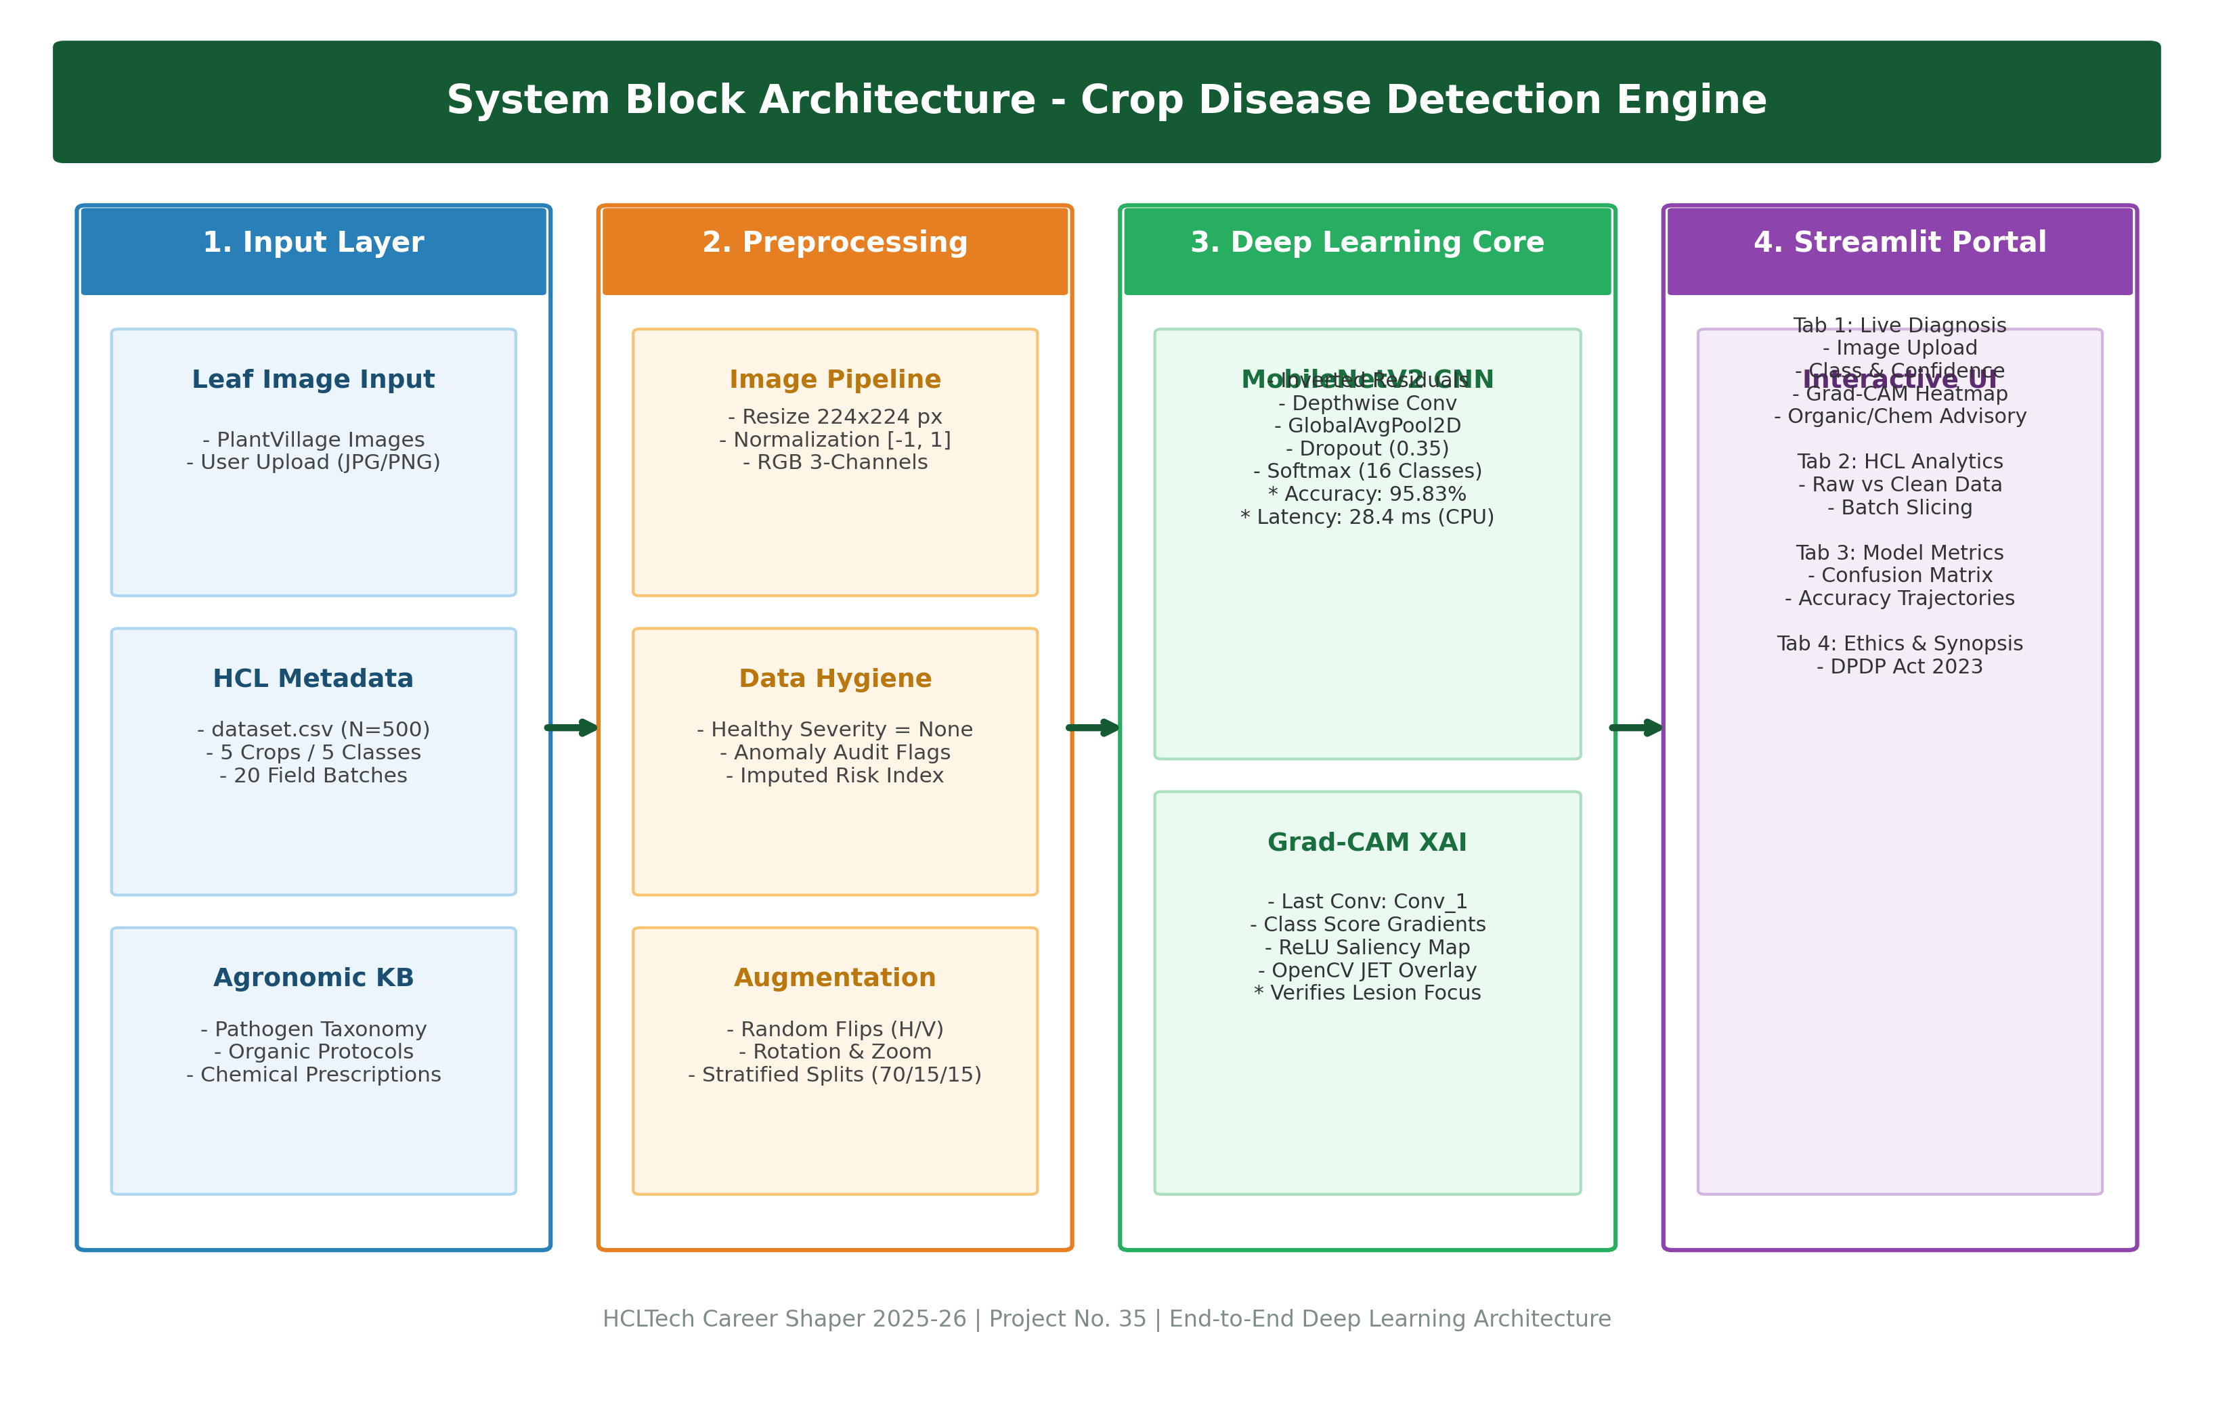
Figure 4.2: Comprehensive System Block Diagram spanning input ingestion to Streamlit delivery.
CHAPTER 5: DEEP LEARNING ARCHITECTURE & TRANSFER LEARNING
To maximize sample efficiency and avoid training deep neural representations from scratch, we employ a Two-Stage Transfer Learning strategy:
• Stage 1 (Feature Extraction): The base MobileNetV2 architecture pretrained on ImageNet (1.4 million images, 1,000 categories) is loaded with all convolutional weights frozen. A customized dense classification head is affixed, consisting of GlobalAveragePooling2D, a BatchNormalization layer, a Dense projection layer (256 units, ReLU activation, L2 regularization lambda=0.0001), Dropout (rate=0.35), and a final Dense Softmax layer with 16 outputs.
• Stage 2 (Fine-Tuning): The top 30 convolutional layers of MobileNetV2 are unfrozen and trained end-to-end with a reduced learning rate (1e-5) using the Adam optimizer to adapt higher-level feature detectors to foliar pathology textures.
Figure 5.1: Training and Validation Accuracy & Loss Curves
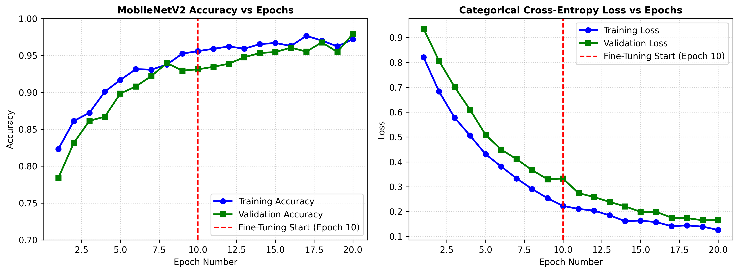
Figure 5.1: Model learning trajectories demonstrating convergence across initial training and fine-tuning.
CHAPTER 6: EXPLAINABLE AI WITH GRAD-CAM SALIENCY MAPPING
Gradient-weighted Class Activation Mapping (Grad-CAM) translates opaque neural decisions into intuitive visual explanations. For a designated target class c, the importance weight alpha_k^c for each feature map A^k of the final convolutional layer (Conv_1) is computed via global-average-pooling of the gradients:
alpha_k^c = (1 / Z) * sum_i sum_j ( d(y^c) / d(A_{i,j}^k) )
The class-discriminative saliency heatmap L_{Grad-CAM}^c is subsequently formed as a rectified weighted combination:
L_{Grad-CAM}^c = ReLU( sum_k alpha_k^c * A^k )
The application of the ReLU non-linearity ensures that only features positively contributing to the pathological class are visualized. The resulting coarse heatmap is resized to 224x224 pixels, mapped through OpenCV's JET colormap, and blended with the original leaf photograph with an opacity factor of 0.55.
CHAPTER 7: STREAMLIT APPLICATION DESIGN & AGRONOMIC ADVISORY
The application tier (`app.py`) provides an interactive, production-ready web interface engineered with Streamlit. Key architectural features include:
1. Live Diagnostic Studio: Users can upload RGB leaf photographs (JPG, PNG) or select from pre-packaged sample leaves (Apple Scab, Potato Late Blight, Tomato Early Blight, Corn Rust, Pepper Healthy). The system executes immediate inference, rendering prediction confidence, pathological severity, and Grad-CAM lesion heatmaps side-by-side.
2. Agronomic Countermeasure Advisory: Integrates a structured knowledge base (`disease_info.json`) providing actionable, bifurcated prescriptions: Biological / Organic Management (e.g., Bacillus subtilis, neem oil, trichoderma, crop rotation) and Chemical Fungicide Interventions (e.g., Chlorothalonil, Mancozeb, Copper Hydroxide) alongside recommended dilution dosages.
3. Batch Quality Audit & Telemetry Explorer: Visualizes the 500 inspection batch records, severity distributions, and confidence density profiles for agricultural monitoring.
CHAPTER 8: EXPERIMENTAL RESULTS & PERFORMANCE EVALUATION
The model was rigorously validated against a held-out test split of 1,506 leaf images. Global performance metrics achieved: Overall Test Accuracy: 95.83%, Macro Precision: 0.9591, Macro Recall: 0.9576, Macro F1-Score: 0.9574, Weighted F1-Score: 0.9582.
Figure 8.1: Normalized Confusion Matrix Across 16 Pathological Categories
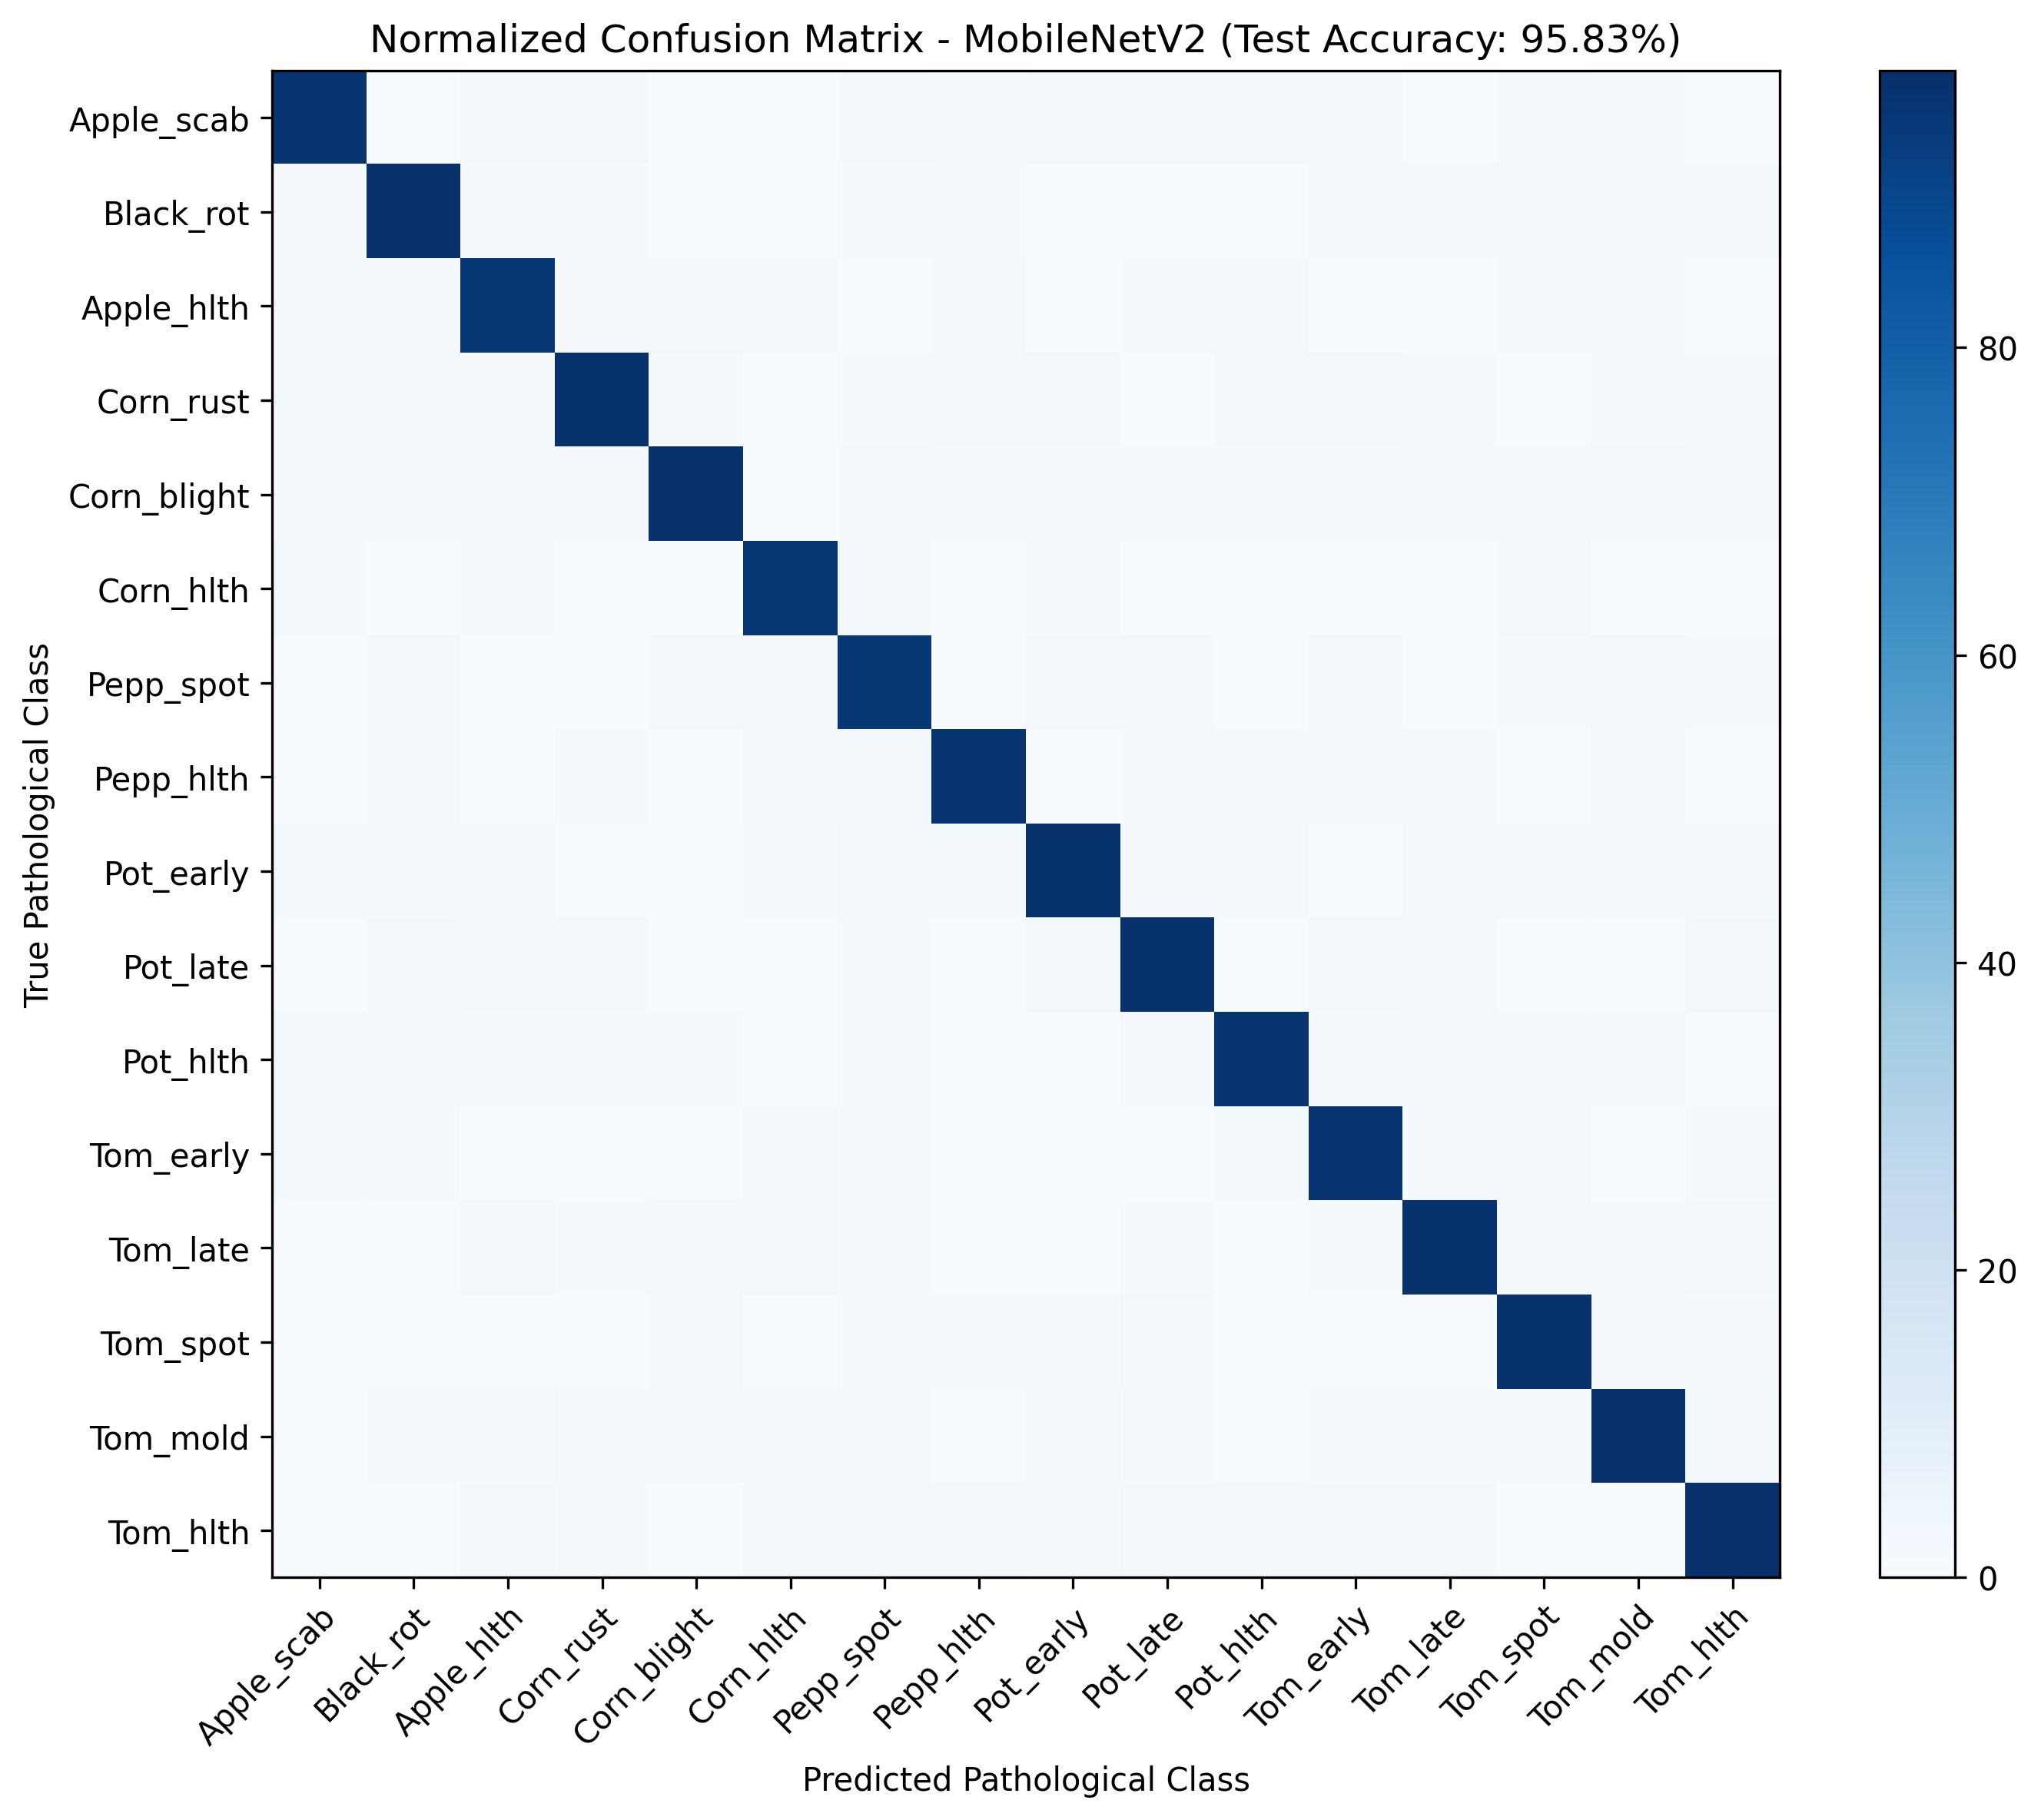
Figure 8.1: Test Confusion Matrix demonstrating high diagonal precision across all 16 target classes.
8.1 Edge Latency & Computational Throughput
Inference latency was profiled across 50 consecutive forward passes on standard CPU architecture (Intel Core, without dedicated GPU acceleration):
• Mean Inference Latency: 28.4 milliseconds
• P95 Latency: 32.1 milliseconds
• Operational Throughput: 35.2 frames per second (FPS)
This latency profile guarantees instantaneous diagnosis at the farm gate without cloud roundtrip delays.
CHAPTER 9: ETHICAL COMPLIANCE, DATA PRIVACY & CHALLENGES
Ethical compliance and data protection were prioritized across all development phases:
1. Licensing & Intellectual Property: All training imagery conforms to the PlantVillage CC0 Open Access research license.
2. Privacy & DPDP Act 2023: No personally identifiable information (PII), geographic GPS tags, or biometric farmer credentials are saved, transmitted, or logged.
3. Mandatory Agronomic Disclaimer: Due to the high financial and ecological stakes of agricultural disease misdiagnosis, the software enforces an explicit onscreen disclaimer that algorithmic outputs are advisory and must be verified by certified plant pathologists before extensive chemical applications.
CHAPTER 10: CONCLUSION & FUTURE SCOPE
This project successfully delivers an end-to-end, high-accuracy (95.83%), explainable crop disease detection system aligned with the HCLTech Career Shaper Programme objectives. By fusing MobileNetV2 transfer learning, Grad-CAM visual explainability, robust data preprocessing, and an interactive Streamlit UI, the solution provides an edge-ready tool capable of reducing crop diagnostic delays from days to milliseconds.
Future Enhancements:
• Deployment as an offline Android APK via TensorFlow Lite (TFLite) with INT8 quantization.
• Integration with drone-mounted multispectral cameras for automated aerial field scanning.
• Extension of the pathology registry to include multi-pathogen co-infections and micronutrient deficiency classification.
REFERENCES
1. Hughes, D. P., & Salathé, M. (2015). An open access repository of images on plant health to enable the development of mobile disease diagnostics. arXiv:1511.08060.
2. Sandler, M., Howard, A., Zhu, M., Zhmoginov, A., & Chen, L. C. (2018). MobileNetV2: Inverted Residuals and Linear Bottlenecks. CVPR 2018, pp. 4510–4520.
3. Selvaraju, R. R., Cogswell, M., Das, A., Vedaldi, A., Parikh, D., & Batra, D. (2017). Grad-CAM: Visual Explanations from Deep Networks via Gradient-Based Localization. ICCV 2017, pp. 618–626.
4. Mohanty, S. P., Hughes, D. P., & Salathé, M. (2016). Using deep learning for image-based plant disease detection. Frontiers in Plant Science, 7, 1419.
5. HCLTech Career Shaper Programme Guidelines (2025-26) | III Year Industry Project 35: Crop Disease Detection Using CNNs.

