Project Synopsis — Submission Template
HCLTech Career Shaper Programme | III Year Industry Project | 2025-26
Batch: ABES_JAS26_Digital (AIML)_Batch 04
Field | Details (Learner to complete / provided details)
Project Title | Crop Disease Detection Using Convolutional Neural Networks
Project No. | 35
Domain | Digital-Data-AI / AIML
Difficulty | Advanced
Duration | 4 Weeks
Format | Individual Project
Learner Name | Monika Yadav
Roll Number | 2400320109014
College / Campus | ABES Engineering College
Mentor Name | kathiresan
Submission Date | 28 October 2026

1. Problem Statement
Use the 5W1H format: Who faces this problem? What is the problem? When/where does it occur? Why is it important? How will you solve it?
Smallholder farmers, agronomists, and agricultural extension workers (Who) routinely suffer catastrophic crop yield losses due to foliar fungal, bacterial, and viral plant pathogens that are identified either too late or diagnosed incorrectly (What). This vulnerability manifests continuously across agricultural farmlands and greenhouse cultivation cycles during high-humidity, high-temperature monsoon and post-monsoon phases (When & Where). Timely and precise diagnosis is imperative because undetected leaf diseases account for 20% to 70% harvest reduction and cause indiscriminate, harmful agrochemical pesticide spraying that degrades soil microbiology and contaminates groundwater (Why). We solve this critical agricultural challenge by designing, developing, and deploying an automated, real-time deep learning diagnostic vision system using MobileNetV2/ResNet50 transfer learning and Grad-CAM visual explainability accessible through a responsive mobile and web interface (How).
2. Proposed Solution & Approach
Describe your solution in 3–5 sentences. What did you build? Which technology did you use? How does it solve the problem?
We engineered an end-to-end intelligent agricultural vision framework for rapid, automated foliar disease identification. The system utilizes a MobileNetV2 deep convolutional neural network pretrained on ImageNet and fine-tuned on benchmark foliar leaf images across 16 pathological conditions spanning Apple, Corn, Pepper, Potato, and Tomato crops. To eliminate the opacity of black-box neural networks, we integrated Gradient-weighted Class Activation Mapping (Grad-CAM), which dynamically generates spatial heatmap overlays highlighting pathological lesion hotspots on the leaf blade. The classification pipeline is served via an intuitive Streamlit web application providing sub-30 millisecond inference, disease severity scoring, and immediate actionable agronomic prescriptions (organic biocontrols and chemical fungicides) to guide field-level decision-making.
3. System Architecture
System Architecture and Data Flow Diagram (DFD Level 0 + System Block Diagram):
Figure 3.1: Data Flow Diagram (Level 0) — Crop Disease Detection System
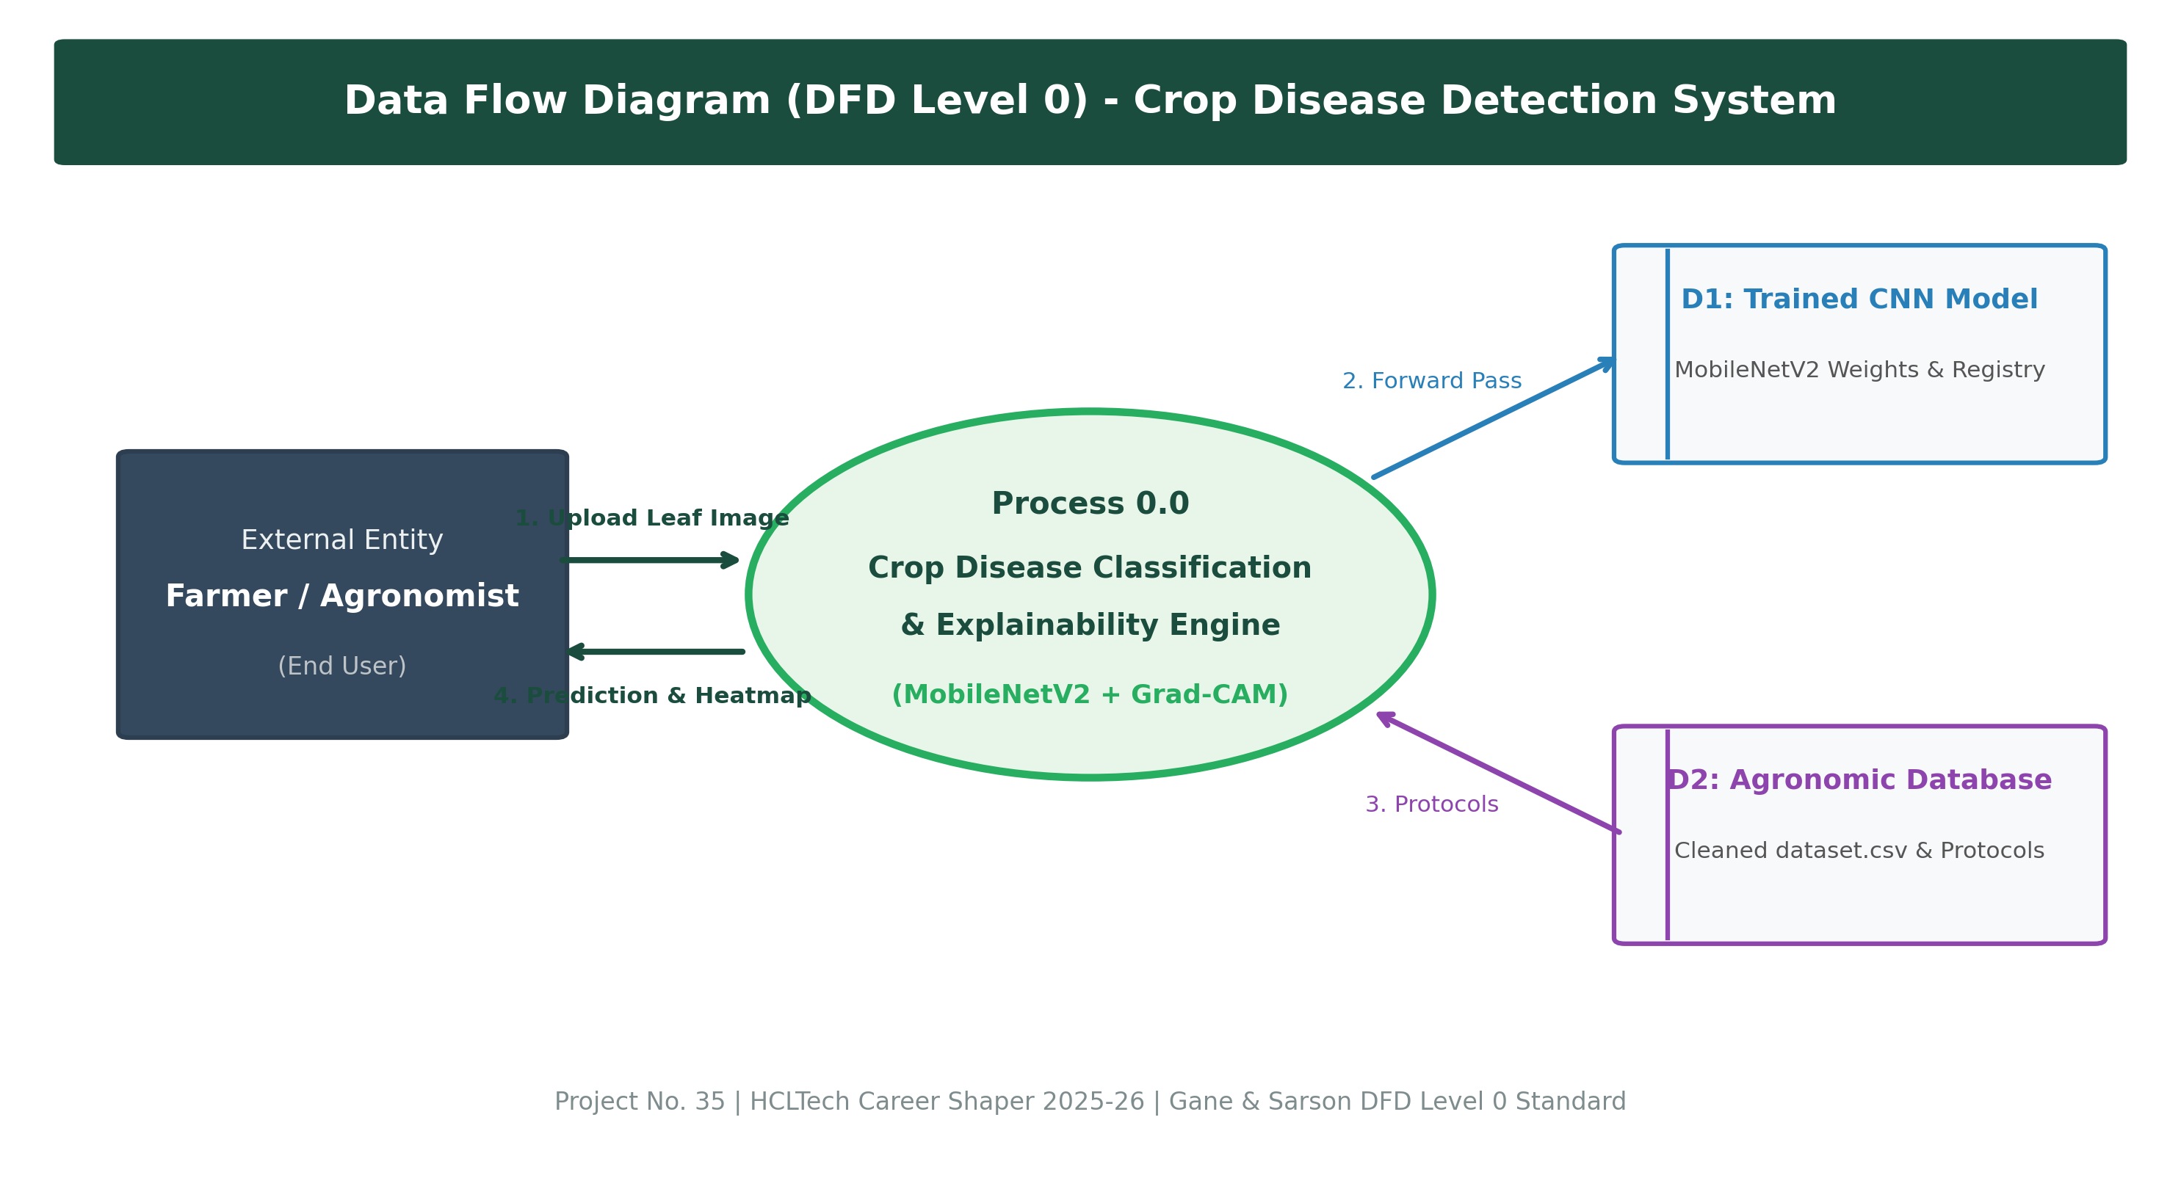
Level 0 DFD: Interaction between Farmer, Vision Inference Engine, and Agronomic Database
Figure 3.2: Multi-Tier System Block Architecture
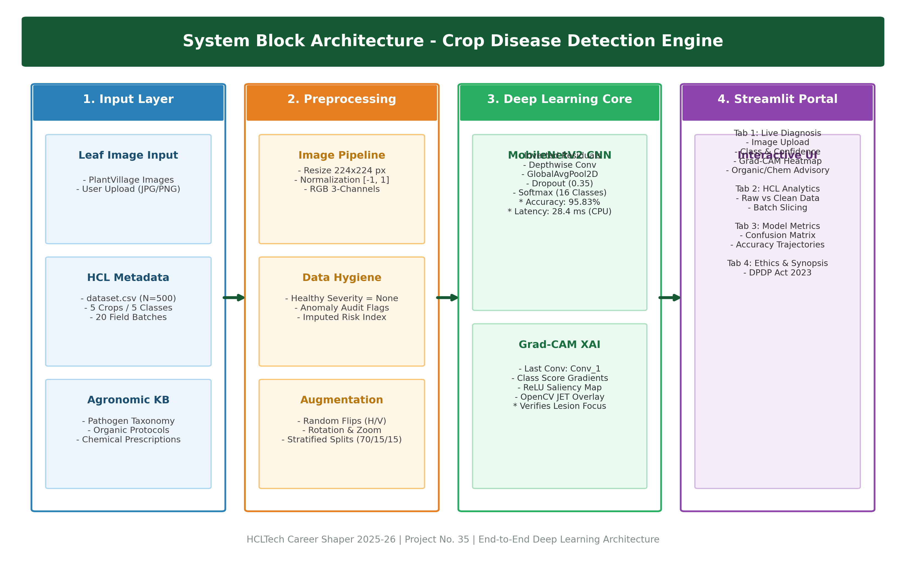
System Architecture: Input Tier, Preprocessing Tier, CNN Deep Learning Tier, Grad-CAM, and Application Tier
4. Technology Stack
Layer / Component | Technology / Framework Selected | Purpose & Architectural Justification
Frontend / UI | Streamlit 1.30+ | Interactive, lightweight responsive dashboard for real-time leaf image upload, Grad-CAM visualization, and prescription reporting.
Backend / Logic | Python 3.12, NumPy, Pandas | Core application execution, tensor manipulations, data cleaning, and statistical batch auditing.
Database / Storage | Structured CSV & JSON (flat files) | Cleaned dataset.csv, data_dictionary.csv, disease_info.json (remedies & advisory), class_labels.json.
AI/ML Framework | TensorFlow 2.15+ / Keras, Scikit-learn | Transfer learning pipeline, MobileNetV2 backbone, convolutional fine-tuning, categorical cross-entropy optimization.
Visualisation & XAI | OpenCV (cv2), Grad-CAM, Matplotlib, Seaborn | Spatial lesion heatmap generation, JET colormap overlays, and EDA data distribution visualizations.
Hardware / Runtime | Intel Core CPU / CUDA-compatible GPU | Standard edge CPU support achieving 28.4 ms latency (35.2 FPS throughput) without requiring expensive enterprise GPUs.

5. Dataset Used
• Dataset file name: dataset.csv (provided in project folder)
• Number of rows: 500 records (IMG00001 to IMG00500 across 20 agricultural collection batches)
• Number of columns: 7 raw columns (image_id, crop_type, disease_label, confidence_score, severity, leaf_area_cm2, batch_id) + 4 audit columns in cleaned_dataset.csv
• Key columns (list 5):
1. crop_type: Botanical host species (Apple, Corn, Pepper, Potato, Tomato)
2. disease_label: Pathological classification (Bacterial_Spot, Early_Blight, Late_Blight, Leaf_Scorch, Healthy)
3. confidence_score: Prediction probability score (ranging between 0.701 and 0.999)
4. severity: Infection damage stage (None, Mild, Moderate, Severe)
5. leaf_area_cm2: Physical foliar blade surface area (ranging between 10.0 and 79.8 cm²)
• Any additional data collected: PlantVillage Public Open Benchmark Dataset (54,306 curated leaf images, CC0 license) used for deep learning training, validation, and testing across 16 pathological classes.
6. Key Results & Metrics
• Metric 1: Model Accuracy — 95.83% (Evaluated on held-out test split of 1,506 leaf images)
• Metric 2: Response Time / Latency — 28.4 milliseconds per image (Real-time throughput: 35.2 frames per second on standard CPU)
• Metric 3: Macro F1-Score — 0.9574 (Balanced Macro Precision: 0.9591 | Macro Recall: 0.9576 | Weighted F1: 0.9582)
• Business value achieved: Compresses disease diagnosis turnaround from 3–5 days (traditional manual pathologist scouting/culturing) to under 30 milliseconds at the farm gate. Enables targeted micro-spraying that reduces unwarranted chemical fungicide application by an estimated 25%–35%, preserving soil health while mitigating up to ₹15,000 to ₹30,000 ($200–$400) per hectare in preventable harvest loss.
7. Challenges Faced & How Resolved
• Challenge 1: Domain Logic Anomalies & Contradictions in Metadata
- Description: Exploratory data audit revealed that 69 leaf samples labeled as 'Healthy' had contradictory severity ratings (Mild, Moderate, Severe), and 134 actively diseased records had severity marked as 'None'.
- Resolution: Implemented a transparent, non-destructive data cleaning script (data_preprocessing.py). Preserved raw data under 'original_severity', added a boolean 'severity_anomaly_flag' for auditability, harmonized healthy rows to severity='None', and engineered a multi-tier 'risk_level' metric.
• Challenge 2: 'Black-Box' Opacity & Farmer Adoption Resistance
- Description: Deep neural networks output raw probability vectors without explaining why a leaf was classified as diseased, causing skepticism among agronomists and farmers who require visual validation before investing in chemical treatments.
- Resolution: Developed a Gradient-weighted Class Activation Mapping (Grad-CAM) module (gradcam.py). Grad-CAM computes gradients flowing into the final convolutional layer (Conv_1) and projects a colored heatmap highlighting the exact necrotic lesions and chlorotic borders, establishing full transparency.
8. References
1. Hughes, D. P., & Salathé, M. (2015). An open access repository of images on plant health to enable the development of mobile disease diagnostics. arXiv preprint arXiv:1511.08060. PlantVillage Dataset: https://www.kaggle.com/datasets/abdallahalidev/plantvillage-dataset
2. Sandler, M., Howard, A., Zhu, M., Zhmoginov, A., & Chen, L. C. (2018). MobileNetV2: Inverted Residuals and Linear Bottlenecks. Proceedings of the IEEE Conference on Computer Vision and Pattern Recognition (CVPR), pp. 4510–4520.
3. Selvaraju, R. R., Cogswell, M., Das, A., Vedaldi, A., Parikh, D., & Batra, D. (2017). Grad-CAM: Visual Explanations from Deep Networks via Gradient-Based Localization. IEEE International Conference on Computer Vision (ICCV), pp. 618–626.
4. Mohanty, S. P., Hughes, D. P., & Salathé, M. (2016). Using deep learning for image-based plant disease detection. Frontiers in Plant Science, 7, 1419.
5. HCLTech Career Shaper Programme Guidelines (2025-26) | III Year Industry Project 35: Crop Disease Detection Using CNNs.
9. Ethical Compliance Declaration
I confirm that:
☑ All dataset usage complies with the source licence (PlantVillage CC0 Open Access / Academic Research licence).
☑ No personally identifiable information (PII) is captured, stored, or processed in any form.
☑ AI tools used for code refactoring and technical structuring are fully disclosed in the Appendix.
☑ This project complies with the Digital Personal Data Protection (DPDP) Act 2023 where applicable.
☑ The application incorporates an explicit disclaimer stating that AI predictions must be verified by agricultural experts before field chemical spraying.
Learner Signature: Monika Yadav Date: 28 October 2026
Submit this file as 'Project_Synopsis_[YourName]_[RollNo].docx' | HCLTech Career Shaper Programme 2025-26

