Primary Datasets:
- FaceForensics++ (FF++)
  - 1,000 original videos + 4,000 manipulated versions
  - Methods: Deepfakes, Face2Face, FaceSwap, NeuralTextures
  - Multiple compression levels (c0, c23, c40)
- Celeb-DF v2
  - 590 real + 5,639 high-quality deepfake videos
  - Celebrity faces, challenging quality
- DFDC (Deepfake Detection Challenge)
  - 100,000+ videos from 3,426 actors
  - Diverse demographics and conditions
- DeeperForensics-1.0
  - 60,000 videos with real-world perturbations
  - Adversarial robustness focus
- WildDeepfake
  - Real-world deepfakes from internet
  - Diverse quality and manipulation types
- Audio-Visual Datasets:
  - LRW (Lip Reading in the Wild)
  - VoxCeleb2 for voice synthesis detection
  - DFDC Audio Track
- Synthetic Datasets:
  - Generated using StyleGAN2, StyleGAN3
  - Diffusion model outputs (Stable Diffusion, DALL-E)
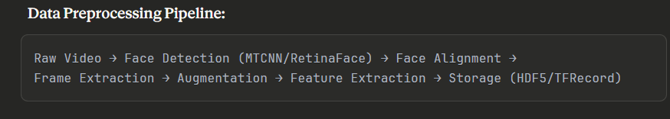

2.1 Multi-Modal Detection Framework
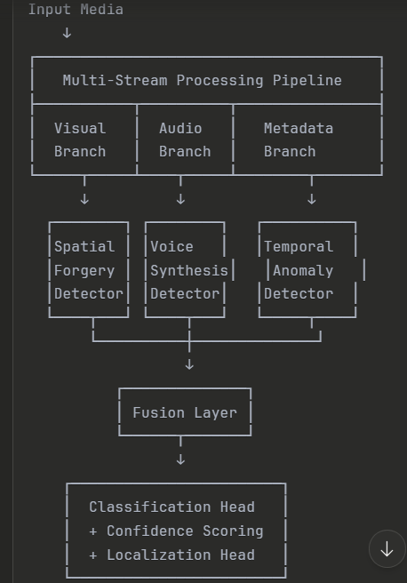

2.2 Component-Specific Architectures
A. Visual Spatial Analysis Module
Model Options:
- EfficientNet-B4/B7 Backbone
  - Pre-trained on ImageNet
  - Fine-tuned on deepfake datasets
  - Good accuracy/efficiency trade-off
- XceptionNet
  - Excellent for detecting compression artifacts
  - Depthwise separable convolutions
- Vision Transformer (ViT)
  - Global attention mechanisms
  - Better for subtle manipulations
  - Higher computational cost
Frequency Domain Analysis:
- Discrete Cosine Transform (DCT) analysis
- Fourier spectrum anomaly detection
- Implementation using scipy.fftpack or torch.fft
B. Temporal Inconsistency Module
Key Techniques:
- 3D Convolutional Networks (C3D/I3D)
  - Captures spatiotemporal patterns
  - Detects frame interpolation artifacts
- Temporal Shift Module (TSM)
  - Efficient temporal modeling
  - Lower computational overhead
- Optical Flow Analysis
  - Detect inconsistent motion patterns
  - FlowNet2.0 or RAFT for flow estimation
- Recurrent Architectures
  - ConvLSTM for sequential analysis
  - Bi-directional processing
Frame Sampling Strategy:
- Dense sampling: 32 frames @ 30fps
- Sparse sampling: 8-16 frames with adaptive selection
- Multi-scale temporal windows
C. Audio-Visual Synchronization Module
Lip-Sync Detection:
- SyncNet Architecture
  - Visual encoder: VGG-M face network
  - Audio encoder: VGG-M audio network
  - Contrastive loss for sync/async classification
- Wav2Lip Inverse Detection
  - Detect artifacts from lip-sync generators
  - Attention to mouth region
Voice Synthesis Detection:
- RawNet2/AASIST
  - Raw waveform processing
  - Sinc-convolution layers
  - Detects TTS and voice conversion
- Spectrogram-based CNN
  - Mel-spectrogram or STFT input
  - ResNet/EfficientNet backbone
D. Metadata & Digital Forensics Module
Analysis Components:
- EXIF/Metadata Parsing
  - Creation timestamps
  - Camera/software information
  - GPS data inconsistencies
  - Edit history
- Compression Artifact Analysis
  - JPEG quality estimation
  - Double compression detection
  - Resampling traces
- Noise Pattern Analysis
  - Photo Response Non-Uniformity (PRNU)
  - Sensor pattern noise extraction
  - Inconsistent noise across regions
- E. Localization & Segmentation Module
- Approach: Mask R-CNN / U-Net Hybrid
Loss Weights (α):
- Classification: 1.0
- Localization: 0.5
- Calibration: 0.3
- AV Sync: 0.7
3.2 Training Configuration
Optimization:
- Optimizer: AdamW (weight_decay=0.01)
- Learning Rate: 1e-4 with cosine annealing
- Batch Size: 32-64 (depending on GPU memory)
- Epochs: 50-100 with early stopping
- Mixed Precision Training (FP16)
Regularization:
- Dropout: 0.3-0.5
- Label Smoothing: 0.1
- MixUp/CutMix augmentation
- Stochastic Depth in transformers
3.3 Adversarial Training
Defense Mechanisms:
- Adversarial Example Generation:
  - FGSM (Fast Gradient Sign Method)
  - PGD (Projected Gradient Descent)
  - C&W attacks
- Training Protocol:
Robustness Augmentation:
- Gaussian blur (σ=0.5-2.0)
- JPEG compression (quality 50-95)
- Resize perturbations
- Adversarial patches

Phase 4: Advanced Features
4.1 Explainability Integration
Techniques:
- Gradient-based Methods:
  - GradCAM++
  - Integrated Gradients
  - SmoothGrad
- Attention Visualization:
  - Transformer attention maps
  - Channel attention weights
- Prototype-based Explanations:
  - This Looks Like That (TLT)
  - ProtoPNet architecture

4.2 Multi-Stage Manipulation Tracking
Approach:
- Manipulation Timeline Reconstruction:
  - Detect compression history
  - Identify editing software signatures
  - Track transformation sequence
- Graph Neural Network for Chain Analysis:
  - Nodes: manipulation operations
  - Edges: temporal dependencies
  - GCN for relationship modeling
- Forensic Feature Bank:
  - Store signatures of known tools (FaceApp, Reface, DeepFaceLab)
  - Match against database
