**Difference Between**

**Machine Learning and Deep Learning**

**What is Machine Learning?**

Machine Learning is a subset of Artificial Intelligence (AI) that enables systems to learn from data and improve over time without being explicitly programmed. It involves algorithms that analyse and learn patterns from data to make predictions or decisions.

**What is Deep Learning?**

Deep Learning is a specialized subset of Machine Learning that uses artificial neural networks with multiple layers (hence "deep") to model complex patterns in large datasets. It mimics the human brain's structure and function, allowing systems to learn from vast amounts of unstructured data.

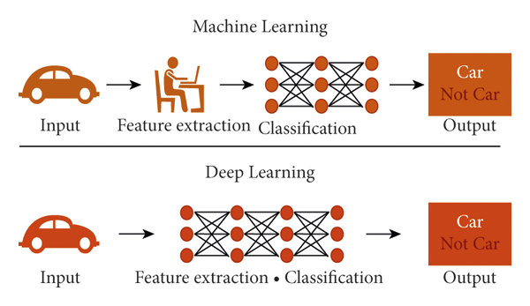

|  |  |  |
| --- | --- | --- |
| **Aspect** | **Machine Learning** | **Deep Learning** |
| **Subset of** | Artificial Intelligence (AI) | Machine Learning |
| **Data Type** | Structured data (e.g., spreadsheets, databases) | Unstructured data (e.g., images, audio, text) |
| **Feature Engineering** | Requires manual feature selection and extraction | Automatically learns features from raw data |
| **Data Volume** | Effective with smaller datasets | Requires large datasets for training |
| **Model Complexity** | Simpler models (e.g., linear regression, decision trees) | Complex models with multiple layers (e.g., CNNs, RNNs) |
| **Training Time** | Shorter training times | Longer training times due to model complexity and data volume |
| **Hardware Requirements** | Can run on standard CPUs | Requires powerful GPUs for efficient training |
| **Interpretability** | Easier to interpret and explain model decisions | Often considered a "black box"; harder to interpret |

