Computer programming

Final Project

Report

I.E.S. San Vicente
San Vicente del Raspeig (Alicante)
2015/2016

Teacher:
José Ignacio Cabanes

Student:
Mónica Esteve Fernández

1. Introduction
Project name
Sudoku

Made by
Mónica Esteve Fernández

Short description of the project
This is a "Sudoku" game, it will load a game, will let you play and finally resolve it. There will be 3 difficulty levels. It is a graphical application that uses windows forms.

2. Functionality of the project
The program displays a screen where the user can choose between:
- File
• Play new game
• Load new game
• Choose difficulty
• View records
• Quit the game
- Help
- Solve
- Clear

If the user chooses to “load New game”, a new game will load from an existing repository of games. The user can save and load their games at any time and also can choose from three different levels. The first level, “easy”, display in each the possible valid numbers to choose. The second level, “intermediate”, highlighting only the wrong numbers (mistakes) and the third level, “difficult”, does not offer any help.

These options will be contained in a main menu "file" along with the "help" to display a brief explanation of how to play. There will also be "about" option that shows the data programmer, creation date and other features.

Resolve and reset functions will be on the main screen. “Solve” Sudoku show you the solution and the option to “reset” erases all data entered by the user.

Improves: implement and view records

3. Screen prototype
The game screen will look like this:
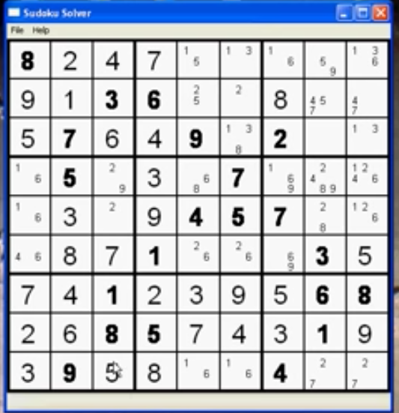

4.Analysis

4a. Requisites
Requisite | Date achieved
The game will start showing the interface screen with an empty board and “solve” and “clear” buttons and “File”, “Help”, “About” menus.
The user can start a new game or load one that already exists
The user can save your played games at any time
The program provides a help menu with the instructions “how to play”
The program provides a “about” menu that displays programmer data
The program can solve the Sudoku, showing the completed solution
The program will allow a player to play a "Sudoku" in an "easy level", showing the possible numbers of each cell
The program will allow a player to play a " Sudoku" in an " intermediate level", highlighting the wrong numbers entered by the user
The program will allow a player to play a " Sudoku" in an "hard level", that doesn’t offer any help, the user must resolve to see the solution
The program has a “reset” option that resets the Sudoku to the initial load
The program has a “quit” option to exit program
Improves: system points, according to the time spent on solving.
Improves: Show records

4b. Basic pseudocode

Program body:
Display welcome screen
Wait for user to press a key
If key = ESC, quit program
If key = 1, start one player game
…

One player game:
Display level selection screen
Wait for user to press a key
If key = ESC, return
…

…

4c. Classes diagram
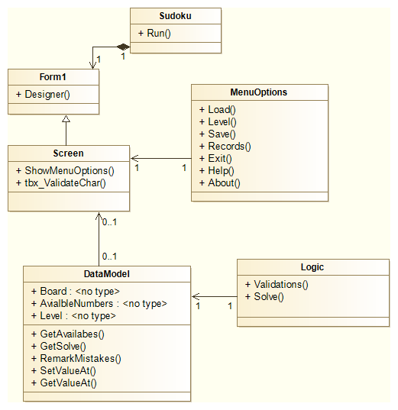

5. Initial planning and expected deliveries

5a. Expected deliveries
- Version 1: First contact: Implement the grid, with data grid or drawing the layout grid 9x9. The name of Form1 will be ”screen”. Implement tab index of the cells.
- Version 2: 1st Session of control logic: implement Cell class that will validate the entered characters by the user, only allows numbers between 1 and 9. Implement data model in the form1 that has matrix 9x9 cells.
- Version 3: Implement interface, menus File, About, Help and Solve and Clear button next to the grid. Implements options inside each menu (new game, load game, choose difficulty, exit program). Develop functionality exit the program and “reset board”.
- Version 4: Develop loading and save sudoku. Load and new game implement sudoku through file, instead of generating.
- Version 5: Implements part to save the game, you must open a dialog box that allows introduce the name by which the game will be saved
- Version 6: 2st Session of control logic: Implement matrix validations, rows and columns validations and 3x3 matrix validations.
- Version 7: Continue and finish session 5.
- Version 8: Implement difficulty control, level “easy”, show possible numbers in a cell. Draw matrix of help
- Version 9: Continue and finish session 8, implement logic numbers help.
- Version 10: Implement difficulty control, level “intermediate”, show highlighting to wrong numbers in a cell.
- Version 11: Implement solve logic, and show solution, comparing cells.
- Version 12: Improve level “easy”, shows the possible numbers and the user will choose one of them by one click.
- Version 13: Improve: draw screen for records. Show users and scores, measured in time. Implement logic of scores.
- Version 14: Implement test battery, debug and solve problems
- Version 15: Continue and finish session 14. Try to implement solve solution without comparing cells.

5b. Real deliveries
- Version 1 (6-May): Draw grid with 81 textbox to implement 9x9 board playable.
- Version 2 (23-May): Implement board, link matrix 9x9 to textbox to save the text entered. Validate that Textbox can only contain number 1 to 9. Begin Version 3, draw file menu
- Version 3 (24-May): Draw menu interface, implement exit option, try to implement load (mistakes and troubles).
- Version 4 (25-May): Develop loading Sudoku as a new game or a played game. It must load both of them of a file repository, differentiated by name. An empty cell is represented by “ * “ if is not an empty the cell will be disabled.
- Version 5 (27-May):

6. File formats

6a. Plain files format
So far only files contain the full board with the same format as the sudoku board, it’s 9 rows of 9 columns separated by spaces. If we are to load sudoku problems in the blanks will be represented by asterisks. The extension of time is .txt but chose other than facilamente can be read by the user. The directory has not been changed yet.

6b. Entity-Relationship Diagram (If needed)
(…)

7. Problems found and solutions
I preferred not to use the SDL library directly, which I found difficult to learn, so I have used the classes "Hardware", "GraphicsElement" and "Font" that we had used previously in class games (...)

Although in the level 3 (hard) I check the next three movements, sometimes the computer makes foolish moves, but always in the first column. I have not found where the bug is, but I think the problem may lie in this portion of code, in which I check each column versus the previous one: (...)

I noticed that if I take the game to another computer which has not the DotNet Framework installed in it, the program closes without any error or warning message (...)

(…)

8. Improvements or restrictions to the starting design
I have had time enough to include the effect of animation when the pieces fall (…)

I have not been able to implement (…) because of (…)

9. Screenshots of the final project
(…)

10. Source code of the final project
(…)

