

Monica Prieto
Data Analyst with strong operational and technical insight
Python • SQL • ETL Pipelines • Power BI • AWS Fundamentals • KPI Analytics
I specialize in connecting business problems with data-driven solutions.

About Me
I am a Data Analyst with over eight years of experience transforming operational, customer experience, and quality data into clear insights for strategic decision-making. My background includes KPI analytics, performance measurement, and process improvement—giving me a strong understanding of how data impacts day-to-day operations and business outcomes.
Currently, I am expanding my capabilities through a Data Engineering and Analytics program, where I design end-to-end data workflows using Python, SQL, and AWS. I enjoy working across the entire analytical lifecycle: cleaning and structuring datasets, building automated ETL processes, performing statistical analysis, and developing Power BI dashboards.
My goal is simple: bring structure, clarity, and measurable impact to organizations through data. Thrive on solving analytical problems, uncovering meaningful patterns, and creating tools that make complex information easy to understand.
I am actively building projects involving ETL automation, AWS-based data pipelines, data modeling, and analytical visualization—strengthening both my technical depth and my strategic thinking.

Skills

  - Technical Skills
Programming & Data Processing
Python (Pandas, NumPy, Matplotlib, Seaborn)
SQL (queries, joins, aggregations, data cleaning)
ETL Development (data extraction, cleaning, transformation, validation)

Data Engineering Foundations
Pipeline design (batch ETL)
Data modeling (star schema, relational schema)
Cloud fundamentals with AWS S3
Automation & scripting (Python)

Data Visualization & BI
Power BI (DAX, Power Query, dashboard design)
Exploratory data analysis (trend analysis, segmentation)
KPI development and performance tracking

Statistics & Analytical Methods
Hypothesis testing (Z, T, ANOVA, Chi-square)
Regression modeling
Sampling methods and confidence intervals
Observational pattern detection & correlation analysis

  - Tools & Technologies
Power BI
Python (Jupyter / VS Code)
PostgreSQL
AWS S3
Git / GitHub
Excel advanced analytics
Streamlit (interactive analytics apps)
dbdiagram.io (data modeling)

  - Professional Strengths
- Translating business needs into data solutions
- Simplifying complex information for stakeholders
- Strong operational analytics grounding
- Process-oriented mindset (consistency, structure, clarity)
- Cross-functional communication
- High ownership, autonomy, and problem-solving

  - What I Bring as a Data Analyst
• A rare combination of technical skills + operational experience
• Ability to understand business pain points and translate them into dashboards, models, or ETL workflows
• A structured thinker who makes data usable, clean, and decision-ready
• A learning mindset with a clear path toward Data Engineering

Professional Timeline
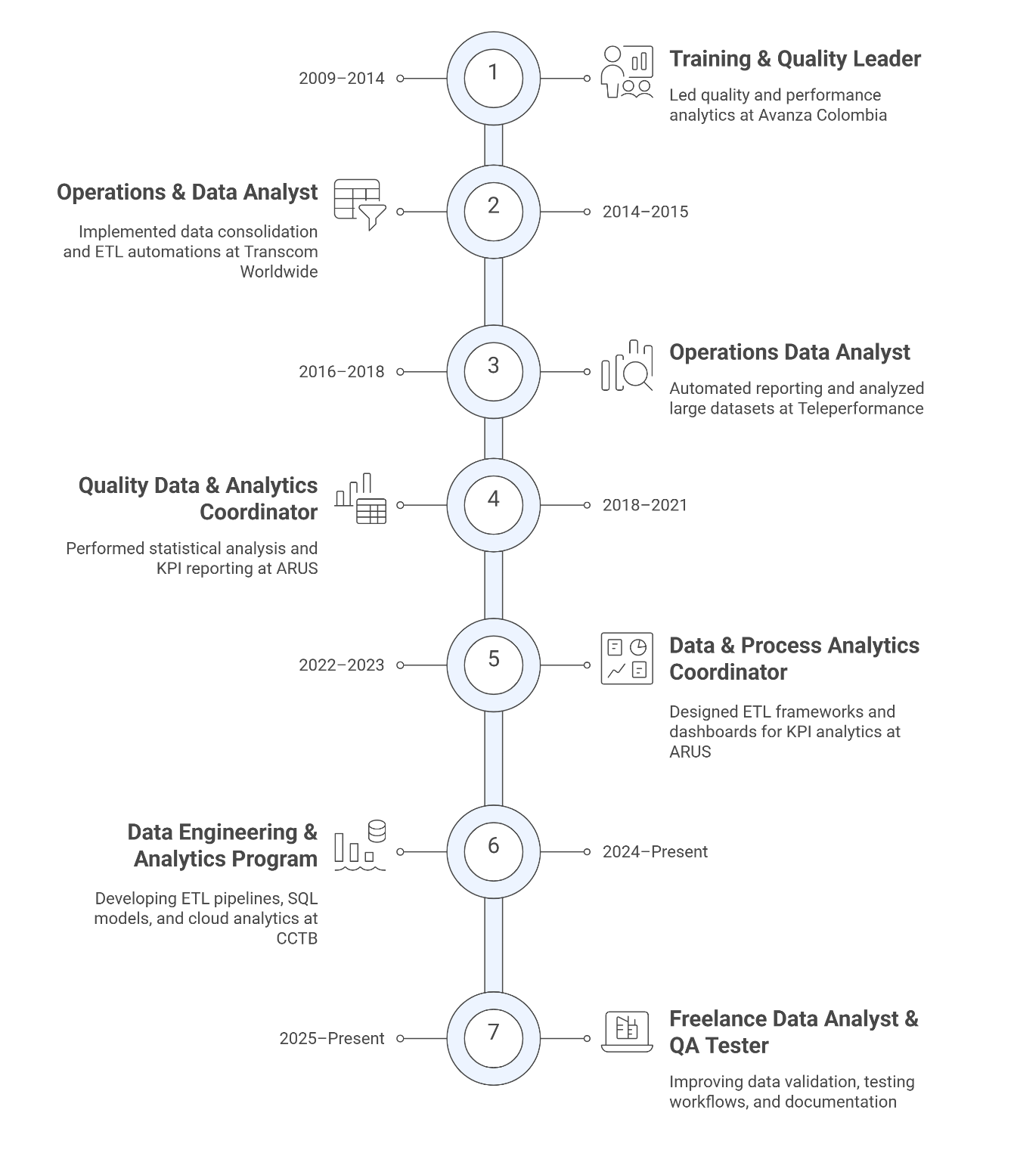

Projects Overview

Statistical Analysis Web Application
  - End-to-End Statistical Testing Tool Developed with Python and Streamlit

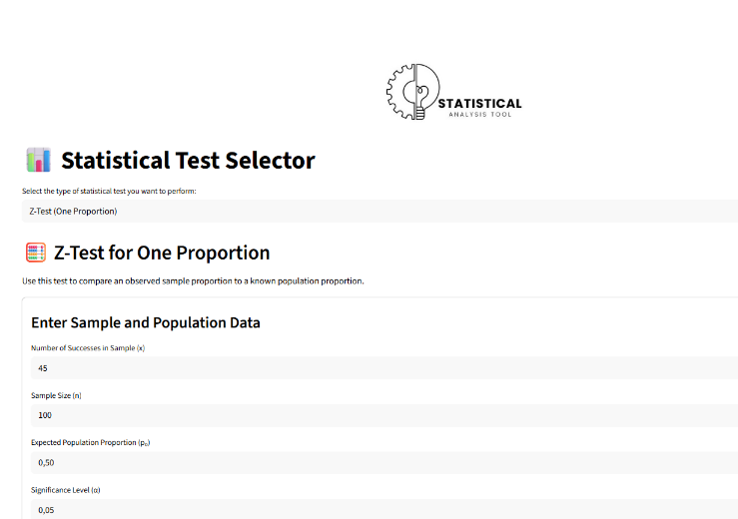
Brief Description (card): An interactive web application that guides users through descriptive statistics, hypothesis testing, ANOVA, regression, and correlation analysis with automatic summaries and visualizations.

- Multi-modular design: descriptive statistics, sampling, hypothesis testing, ANOVA, regression, and correlation.
- Supports CSV file uploads, parameter configuration, and automatic generation of graphs and interpretations.
- Developed with modular Python code and deployed using Streamlit for ease of access and usability.

Technologies: Python, Streamlit, Pandas, NumPy, Matplotlib, SciPy

Flight Delay Performance Dashboard
  - Power BI Dashboard for Delay Analysis and Operational Insights

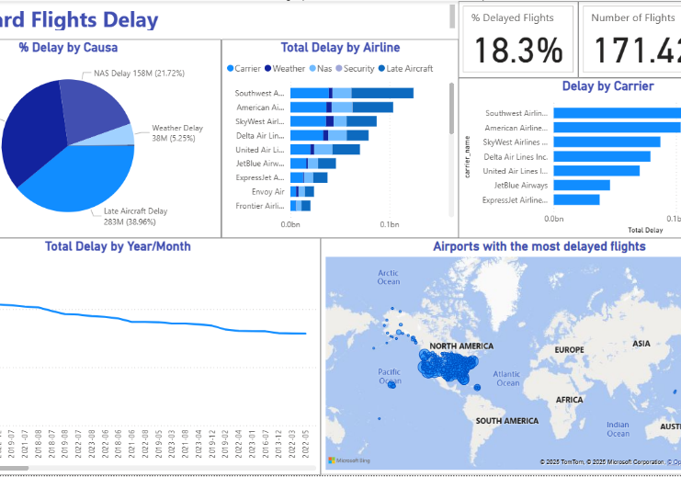
Brief Description: An interactive Power BI dashboard that analyzes flight delays by cause, airline, carrier, time, and location, enabling data-driven decisions for operations and planning.

- I cleaned and prepared a large flight dataset using Power Query and SQL-style transformations.
- Key performance indicators (KPIs) were designed, including the percentage of delayed flights, total delays by cause, and delay trends over time.
- Geographic visualization was included to identify the most affected airports and regions.

Technologies: Power BI, Power Query, DAX, Excel

Customer Support ETL Automation
  - Python ETL Pipeline Loading Clean Data into PostgreSQL

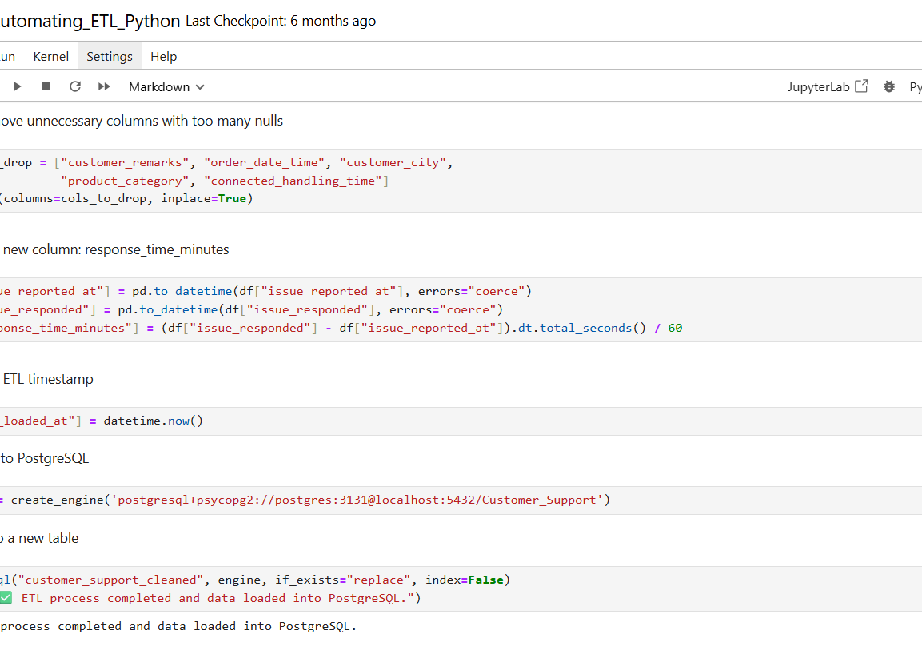
Brief Description: An automated ETL pipeline ingests raw customer support tickets, cleans and enriches the data, calculates response time KPIs, and loads the results into PostgreSQL for analysis.

- Data cleansing was implemented (null value handling, data type conversion, and removal of redundant columns).
- Response time metrics were calculated, and ETL timestamps were added for traceability.
- The transformed dataset was loaded into a PostgreSQL table for subsequent reporting.

Technologies: Python, Pandas, PostgreSQL, SQLAlchemy, Jupyter

Fashion Store Data Model and Architecture
  - Relational Schema for Ecommerce Analytics and Operations

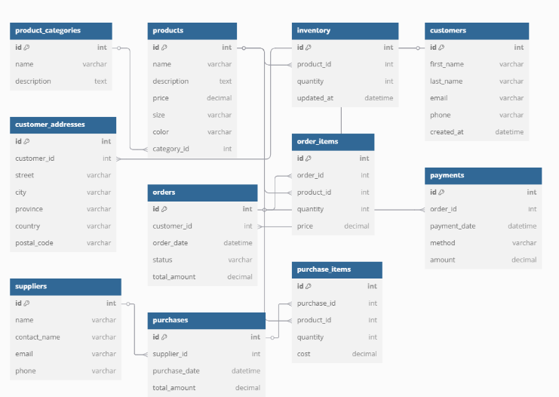
Brief Description: Logical and physical data model for an online fashion store, supporting inventory, sales, customers, and suppliers with a structure ready for analysis and reporting.

- I designed an ER diagram with entities for products, orders, customers, inventory, suppliers, and payments.
- Structured relationships to support order history, stock tracking, and financial information.
- A suitable foundation was created for building dashboards, key performance indicators (KPIs), and advanced analytics.

Technologies: SQL, PostgreSQL (or generic RDBMS), dbdiagram.io

Basic Data Pipeline Simulation
  - End-to-End Data Flow from Raw Files to Transformed Outputs
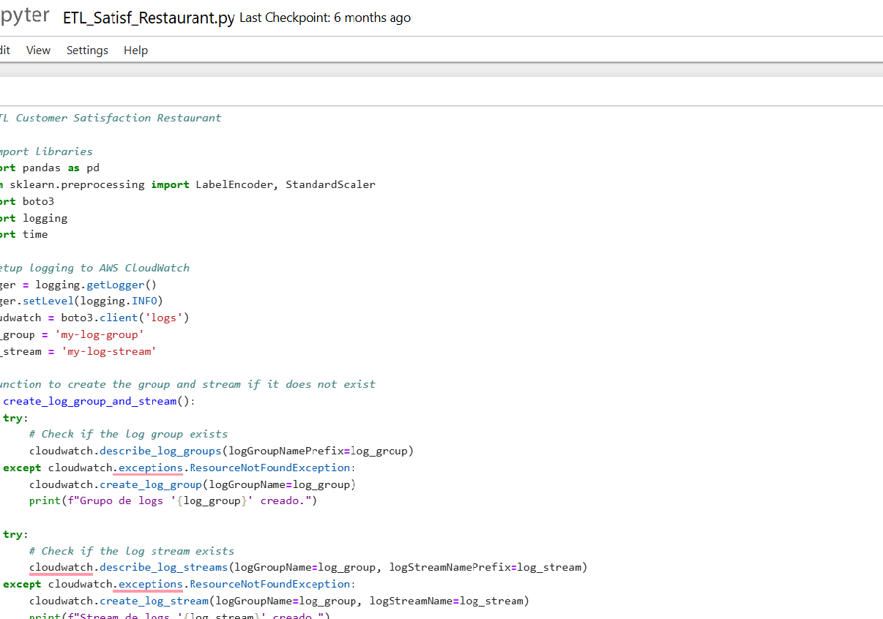

Brief Description: Simulated data pipeline that moves data from raw CSV files through cleaning, transformation, and loading steps, illustrating basic data engineering concepts.

- Step-by-step orchestrated flow: ingestion, cleaning, transformation, and export.
- Basic validation and logging were implemented to track pipeline execution.
- Designed as an educational/demo project to explain ETL concepts.

Technologies: Python, Pandas, file-based storage, Jupyter

Contact

I am currently open to opportunities as a data analyst, BI analyst, junior data engineer, and data analytics intern.

If my profile and projects align with your current projects, I would be happy to discuss how I can contribute.

Please feel free to contact me regarding:
• Collaboration on data and analytics projects
• Internship/co-op opportunities
• Freelance or part-time analytics work
• Discussing my projects or portfolio

e-mail: moniadmon@gmail.com
LinkedIn: https://www.linkedin.com/in/monica-prieto-data-analyst/
GitHub: https://github.com/Monikprieto

