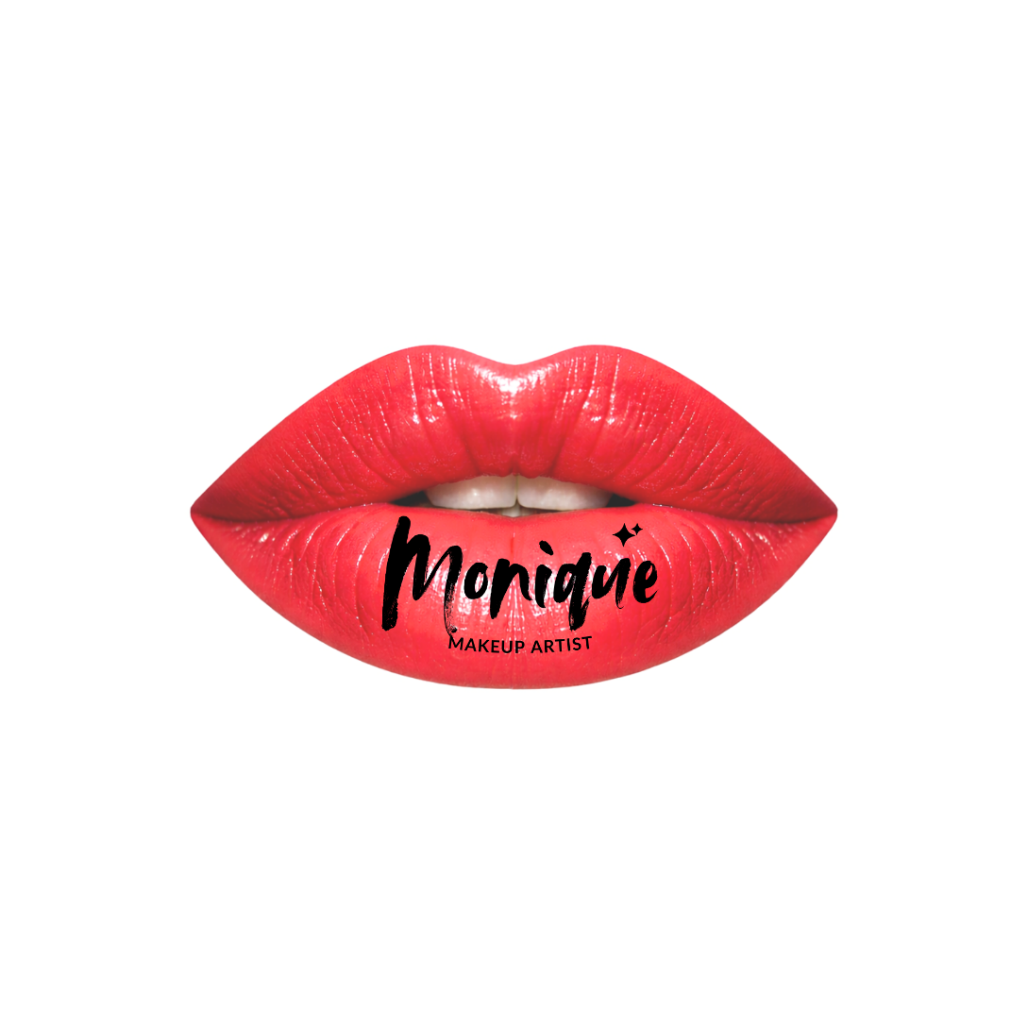
HOME | ABOUT ME | PORTFOLIO | CONTACT

Vocational Technician in Hairdressing & Makeup Artist.
Editorial-driven beauty creator focused on structure, texture, and visual impact.
Transforming faces and hair into expressive, high-fashion statements.

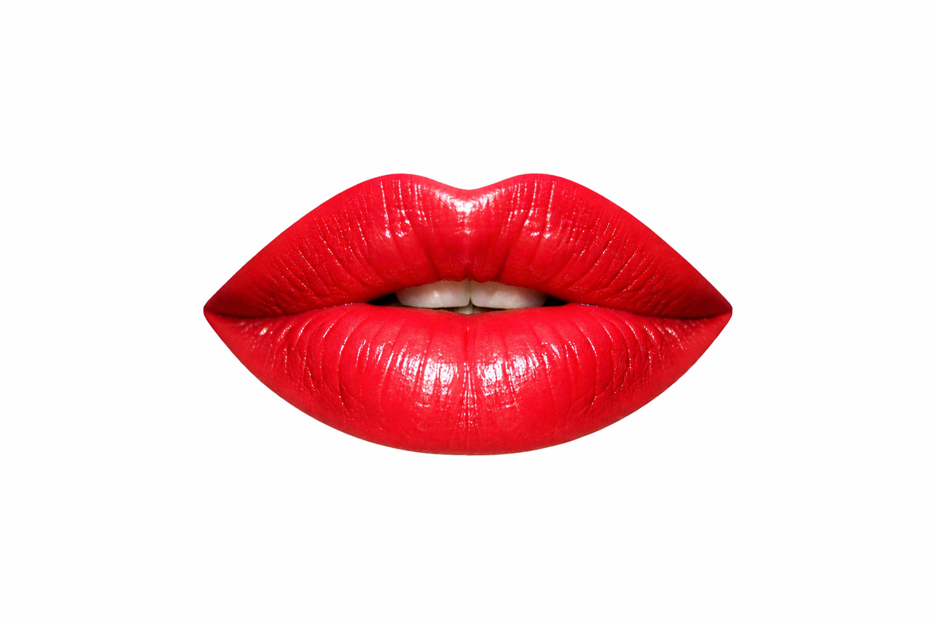
ABOUT ME

I am a certified hairstylist and professional makeup artist, passionate about enhancing natural beauty through technique, creativity, and precision.
My work focuses on creating looks that highlight each person's individuality, whether through structured hairstyles, editorial makeup, or elegant transformations for special events, photography, and television. I believe beauty is about refining and enhancing your best features.
With training in hair structure, color harmony, facial analysis, and modern styling techniques, I approach each project with professionalism, attention to detail, and an artistic vision.
I am committed to embracing industry trends and delivering timeless and impactful results.


CONTACT

Let's create something bold and unforgettable together. Get in touch to collaborate.

E-mail: monique.prieto31@gmail.com
Phone: 7786814038
Instagram: @monique_mkup

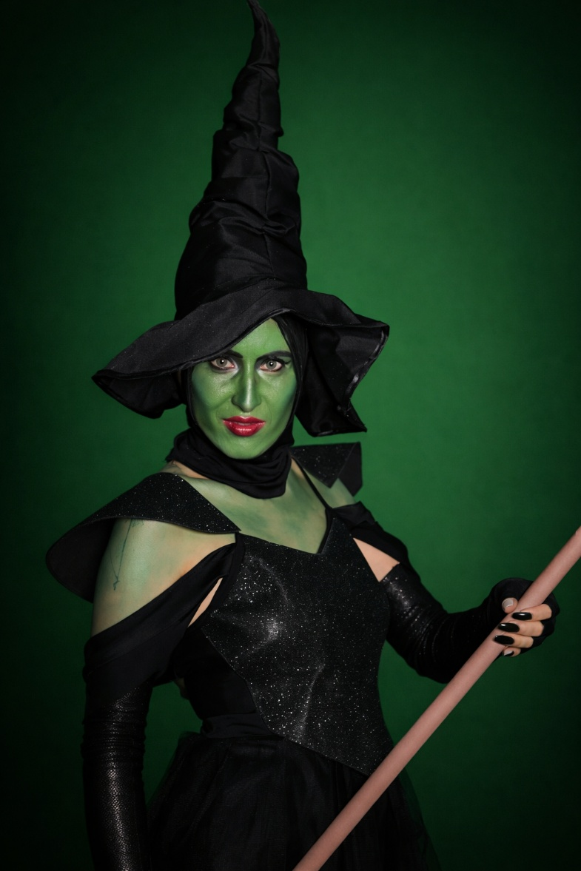
PORTFOLIO
