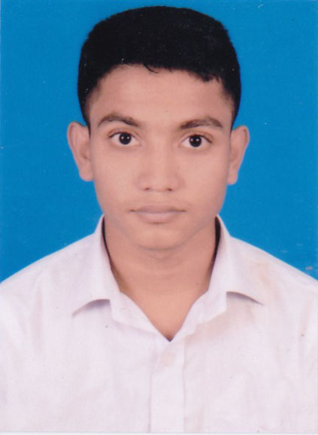
CURRICULUM VITAE
of
Md. Moniruzaman
Cell: 01640-174721

1. Name : Md. Moniruzaman
2. Father’s Name : Md. Buzlur Rahman
3. Mother’s Name. : Momotaz Khatun
4. Mailing Address : Village- Mostalipur, P.O. Katakhali Bazar
P.S-Chatmohar, District-Pabna .

5. Permanent Address : Village- Mostalipur, P.O. Katakhali Bazar
P.S-Chatmohar, District-Pabna .

6. Date of birth : 12 Sep 2001
7. Nationality : Bangladeshi.
8. Sex : Male
9. Marital statues : Unmarried
10. Religion : Islam
11. Blood Group : A+
12. Mobile No : 01640-174721
13. Height : 5'4"
14. Weight : 50 kg
15. NID No : 9162815410
16 Educational Background
SL | Exam Name | Group | GPA | Passing Year | Board
1 | SSC | Science | 4.18 | 2017 | Rajshahi
2 | HSC | Science | 3.58 | 2019 | Rajshahi

Signature..................... Date:.....................
Md. Moniruzaman

