Deliverable 2
Corporate Financial Performance Analytics
A Comparative Analysis of BP, Chevron, Shell and ExxonMobil (2022-2025)
Presenting the intermediary outputs and adjustments to the analysis framework

1. Introduction & Scope
This deliverable presents the intermediary outputs of a corporate financial performance analysis covering four major integrated oil & gas companies - BP, Chevron (CVX), Shell (SHEL) and ExxonMobil (XOM) - across the 2022-2025 period (16 company-year observations). The objective is to build, validate and interpret a complete financial KPI framework, and to use it to compare the four companies' profitability, liquidity, leverage, efficiency, cash generation and growth, before layering in a sector-specific reading of results appropriate to a cyclical commodity business.
This document is self-contained: it does not assume the reader has seen Deliverable 1.

2. Data & Methodology
Financial statement data (income statement, balance sheet, cash flow statement) was sourced for all four companies and standardized into a single master dataset keyed by Ticker and Year, covering fiscal years 2022 through 2025.

2.1 Confirmation of the Analysis Framework
The KPI framework was built out across seven standard categories, for a total of roughly 27 individual indicators, summarized below.
Indicator | Component Indicators
Profitability | Gross / EBITDA / EBIT / Operating / Net Margins, ROA, ROE
Liquidity | Current Ratio, Quick Ratio, Cash Ratio, Working Capital
Leverage / Solvency | Debt-to-Equity, Debt-to-Assets, Net Debt/EBITDA, Equity Ratio
Interest Coverage | EBIT / Interest Expense
Returns | ROA, ROE, ROIC (NOPAT / Invested Capital)
Efficiency | Asset Turnover, Inventory Turnover, Receivables Turnover, DSO, DIO
Cash Flow Quality | OCF Margin, FCF Margin, CapEx-to-Revenue, FCF & OCF to Net Income
Growth (YoY) | Revenue, EBITDA, EBIT, Net Income, OCF, FCF Growth

2.2 Adjustment to the Analysis Framework: Receivables Data Quality Issue
During validation, the standardized Receivables field was found to be fully missing for BP and Shell across all four years, while present for Chevron and ExxonMobil. Investigation of the raw balance sheet data traced the cause to inconsistent line-item naming between reporting standards: BP and Shell (both UK-listed, IFRS filers) report this line as "Accounts Receivable", while Chevron and ExxonMobil report it under "Receivables" directly.
This was resolved by standardizing both fields into a single Receivables column and adding a Receivables_Source column that records which original field each value was drawn from, preserving data lineage for audit purposes. This adjustment was necessary before the Efficiency ratio category (Receivables Turnover, Days Sales Outstanding) could be computed.
A comparable dtype adjustment (Year stored as datetime in some source tables vs. integer in others) was identified and standardized during the same validation pass.

3. Confirmation of Indicator Interpretation
- Profitability margins measure how much of each revenue dollar converts into profit at successive levels of the income statement (gross, operating, EBITDA, EBIT, net).
- Liquidity ratios (Current, Quick, Cash) measure the ability to meet short-term obligations; values above 1.0 indicate current assets exceed current liabilities.
- Leverage ratios measure reliance on debt financing; higher Debt-to-Equity and Net Debt/EBITDA indicate greater financial risk and sensitivity to commodity price downturns.
- ROIC (Return on Invested Capital) measures the after-tax operating return generated on the capital invested in the business (debt + equity), independent of capital structure - a cleaner cross-company comparison than ROE.
- Efficiency ratios (Asset Turnover, DSO, DIO) measure how effectively a company converts assets and working capital into revenue.
- Cash flow quality ratios test whether reported accounting profit is backed by real cash generation, and whether that cash is sufficient to fund the company's own capital investment program (FCF).

4. Visual Restitution

4.1 Four-Year Trend Analysis (2022-2025)
The chart below tracks all four companies across eight core indicators over the full period, giving a dynamic view that a single-year snapshot cannot.
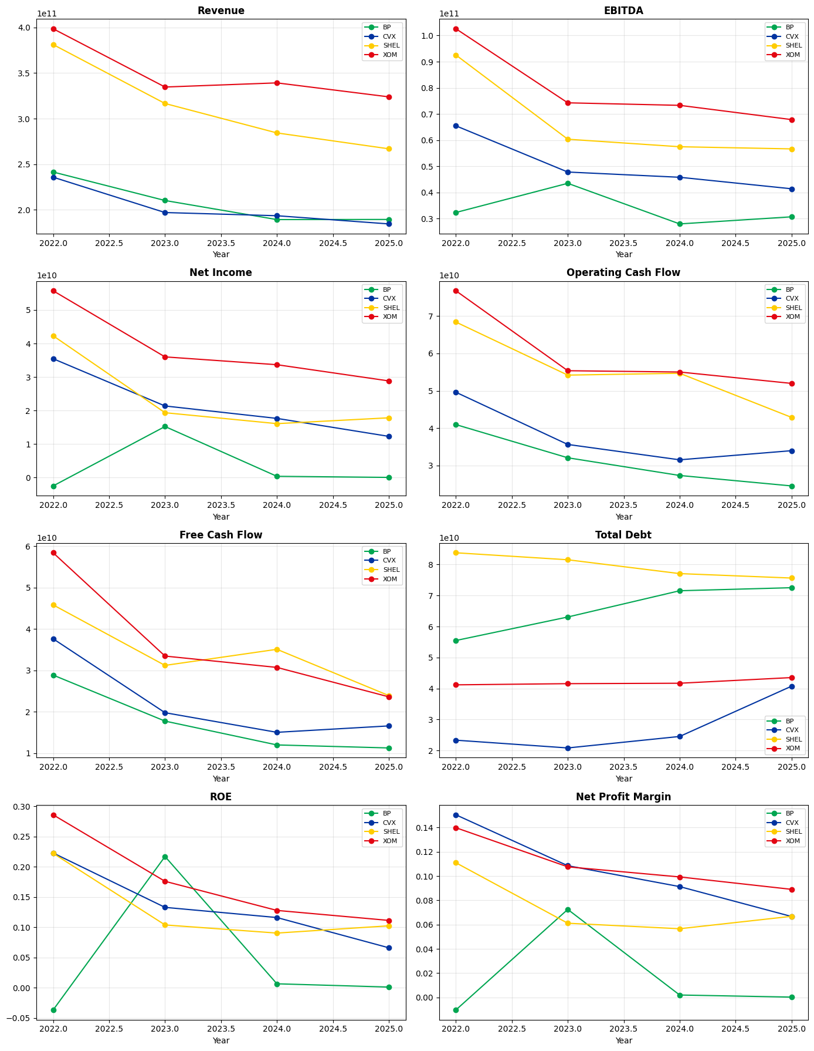
Reading across panels together: all four companies decline from 2022's cyclical peak, but BP stands out with a near-zero-to-negative Net Income and Net Profit Margin throughout the period, while simultaneously carrying rising Total Debt - a combination of collapsing profitability and increasing leverage that is not seen in the other three companies. Chevron and ExxonMobil show smoother, lower-volatility earnings trajectories; Shell shows the steepest revenue decline but is actively deleveraging over the same period.

4.2 2025 Benchmarking Table
A cross-sectional snapshot of the four companies on the eleven headline indicators, as of the most recent fiscal year (2025).
Indicator | BP | CVX | SHEL | XOM
Revenue Growth | 0.08% | -4.64% | -6.13% | -4.52%
EBITDA Margin | 16.21% | 22.46% | 21.23% | 20.95%
Net Profit Margin | 0.03% | 6.67% | 6.68% | 8.91%
ROA | 0.02% | 3.80% | 4.82% | 6.42%
ROE | 0.10% | 6.60% | 10.23% | 11.12%
ROIC | 7.69% | 5.83% | 8.42% | 9.54%
Current Ratio | 1.26x | 1.15x | 1.30x | 1.15x
Debt / Equity | 1.37x | 0.22x | 0.43x | 0.17x
Net Debt / EBITDA | 0.70x | 0.80x | 0.30x | 0.39x
FCF Margin | 5.95% | 9.00% | 8.96% | 7.29%
Asset Turnover | 0.68x | 0.57x | 0.72x | 0.72x

BP is the clear outlier across almost every dimension - near-zero profitability and returns, and by far the highest leverage (Debt/Equity of 1.37x vs. 0.17x-0.43x for the other three). ExxonMobil leads on ROE and Net Margin; Shell carries the most conservative balance sheet (lowest Net Debt/EBITDA) despite the steepest revenue decline.

5. Financial Scoring & Ranking
A composite score was built across five weighted-equal categories (Profitability, Liquidity, Financial Risk, Cash Generation, Growth), each metric min-max normalized across the four companies for the 2025 fiscal year, then averaged into an overall score out of 100.
Indicator | SHEL | XOM | CVX | BP
Profitability | 0.8 | 1.0 | 0.5 | 0.1
Liquidity | 1.0 | 0.0 | 0.2 | 0.8
Financial Risk | 0.9 | 0.9 | 0.5 | 0.1
Cash Generation | 0.8 | 0.5 | 1.0 | 0.0
Growth | 0.5 | 0.4 | 0.3 | 0.7
Overall Score (0-100) | 79.0 | 54.9 | 49.0 | 32.6

Shell ranks first overall (79.0) on the strength of balanced performance across all five categories rather than any single standout. ExxonMobil ranks second (54.9), driven almost entirely by the best profitability score, but held back by the weakest liquidity score of the four. BP ranks last (32.6), consistent with its poor profitability and leverage position seen throughout this analysis.
Note: this ranking is equal-weighted across categories and therefore favors balance over any single strength. A ranking that weighted profitability and growth more heavily (an investor-oriented view, versus this risk-balanced view) could place ExxonMobil first instead.

6. Oil & Gas Sector-Specific Analysis
Because earnings in this sector are inherently cyclical and commodity-price driven, headline ratios alone can understate risk. The table below adds volatility and full-cycle averages (coefficient of variation for Revenue/EBITDA, standard deviation for margin) across all four years, rather than a single-year snapshot.
Indicator | BP | CVX | SHEL | XOM
Revenue Volatility (CV) | 0.1187 | 0.1119 | 0.1615 | 0.0964
EBITDA Volatility (CV) | 0.2028 | 0.2110 | 0.2586 | 0.1968
Net Margin Stability (StdDev) | 0.0380 | 0.0353 | 0.0251 | 0.0219
Avg CapEx Intensity | 6.72% | 7.76% | 6.80% | 6.77%
Avg FCF Margin | 8.18% | 10.70% | 10.79% | 10.25%
Avg Net Debt / EBITDA | 0.72x | 0.38x | 0.23x | 0.19x
Avg Asset Turnover | 0.73x | 0.75x | 0.77x | 0.86x
Avg ROE (2022-2025) | 4.69% | 13.43% | 12.96% | 17.51%

A key finding here revises the initial hypothesis: BP is not the most volatile company on Revenue or EBITDA - Shell is (highest volatility on both measures). BP's instability is concentrated below the operating line: its Net Margin Stability (standard deviation) is nearly double ExxonMobil's, and its average Net Debt/EBITDA (0.72x) is roughly double the next-highest company. This points to BP's weakness being a capital-structure and earnings-quality issue rather than simple commodity-price exposure. ExxonMobil is the most consistently resilient operator across the full cycle, with the lowest volatility on both Revenue and EBITDA, and the highest average Asset Turnover and ROE.

7. Key Takeaways
- The KPI framework (7 categories, ~27 indicators) is complete, validated, and documented, including a resolved data-quality issue in the Receivables field with full audit lineage.
- BP is the standout risk case: near-zero profitability and returns, the highest leverage, and the least stable bottom line of the four companies - a capital structure and earnings-quality story more than a commodity-cycle story.
- ExxonMobil is the most consistently resilient operator across the full 2022-2025 cycle (lowest Revenue/EBITDA volatility, highest average ROE and Asset Turnover).
- Shell carries the most conservative balance sheet of the four despite the steepest revenue decline, and ranks first on the equal-weighted composite score.
- Chevron sits consistently mid-table across most measures, with the strongest cash generation (FCF/Net Income) among the four.

Next steps beyond this deliverable: full benchmarking dashboard build-out in Power BI, and a management-style executive report synthesizing company-by-company strengths and weaknesses.

