What Drives Return on Equity in Big Oil?
A Correlation, Regression, DuPont & PCA Analysis of BP, Chevron, Shell and ExxonMobil (2022-2025)
Mohamed Mounir | Financial Data Analytics Portfolio Project

Executive Summary
This analysis goes beyond standard financial ratio calculation to ask a sharper question: within a panel of four major integrated oil & gas companies over 2022-2025, what actually explains the differences in Return on Equity (ROE)? Using correlation analysis, ordinary least squares regression, DuPont decomposition, and principal component analysis with clustering, the analysis finds that BP's persistently weak ROE is driven overwhelmingly by a collapse in profit margin, not by its leverage - and that BP's leverage, if margins recovered, would in fact amplify returns rather than suppress them. This nuance would not be visible from ratio analysis alone.

1. Correlation Analysis
As a first pass, a correlation matrix was built across the panel's core financial ratios (all 16 company-year observations pooled together) to identify which metrics move together.
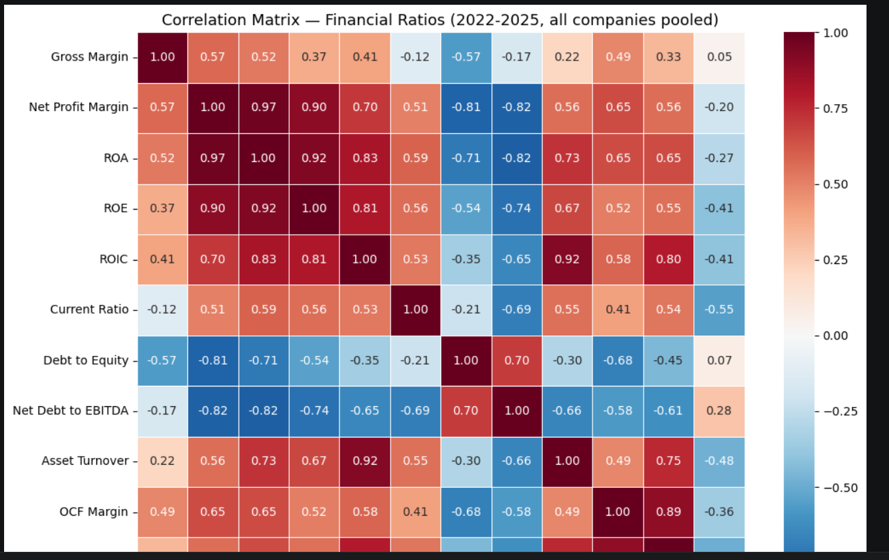
Figure 1. Pairwise correlation matrix across core financial ratios, pooled across all 4 companies and 4 years.
The matrix shows Debt to Equity and ROE are negatively correlated (-0.54) at face value - the naive read being that more leverage associates with weaker returns. Net Profit Margin and ROA are near-collinear (0.97), which is expected given their shared numerator, and is an important flag for the regression step that follows: these two should never be entered as separate predictors in the same model.

2. Regression: Isolating the Leverage Effect
A simple correlation cannot distinguish correlation from confounding - Debt to Equity and Net Profit Margin might simply move together across companies (as they do here) without either directly causing the other's relationship with ROE. An OLS regression was used to isolate each variable's independent association with ROE, controlling for the others.
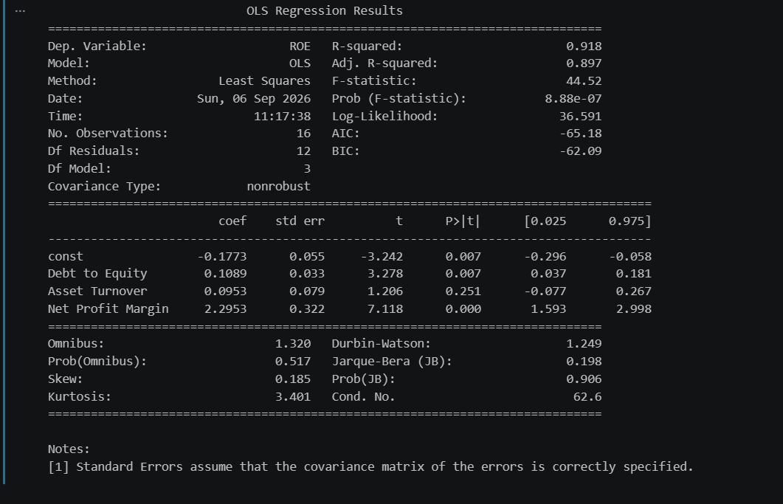
Figure 2. OLS regression of ROE on Debt to Equity, Asset Turnover, and Net Profit Margin (n=16).
Predictor | Coefficient | p-value | Interpretation
Net Profit Margin | +2.295 | <0.001 | Dominant driver of ROE, as expected from the DuPont identity
Debt to Equity | +0.109 | 0.007 | Positive and significant once margin is controlled for
Asset Turnover | +0.095 | 0.251 | Not statistically significant in this model

The Key Finding: A Sign Flip
The regression coefficient on Debt to Equity is positive (+0.109) and statistically significant (p=0.007) - the opposite sign from the simple correlation (-0.54). This is not a contradiction; it is exactly what financial leverage theory predicts. In the raw correlation, BP happens to carry both the highest leverage and the weakest margin in the panel, so the simple relationship mostly reflects "BP is weak on both dimensions," not a causal link between the two. Once margin is held constant, the regression asks a cleaner question: for two companies with equal profitability, does more debt increase or decrease ROE? The answer is that it increases it - the classic leverage amplification effect, where borrowing to fund assets magnifies the return earned on a smaller equity base, provided that return is positive.
This reframes the interpretation of BP's position: leverage itself is not the primary problem. Leverage is an amplifier that is currently working against BP only because its profit margin has collapsed to near zero. Were margin to recover, the same capital structure would amplify returns upward instead.

Caveats
- n=16 observations drawn from only 4 companies over time, not an independent random sample - coefficients should be read as descriptive of this specific panel, not generalized to the sector.
- Net Profit Margin and ROA are correlated at 0.97, and Debt to Equity with Net Debt/EBITDA at 0.70 - neither pair should be combined as separate predictors in future extensions of this model without checking variance inflation factors.

3. DuPont Decomposition: Making the Mechanism Visible
The regression identifies that leverage matters once margin is controlled for, but a DuPont decomposition (ROE = Net Profit Margin x Asset Turnover x Equity Multiplier) makes the mechanism directly observable rather than inferred from a coefficient.
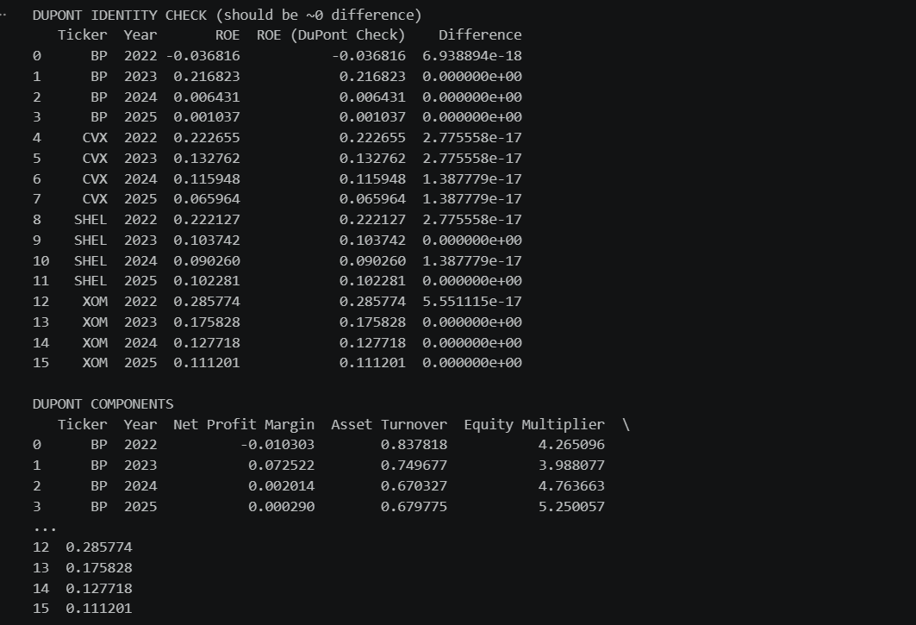
Figure 3. DuPont identity validation - decomposed ROE matches reported ROE to within floating-point precision for all 16 observations.
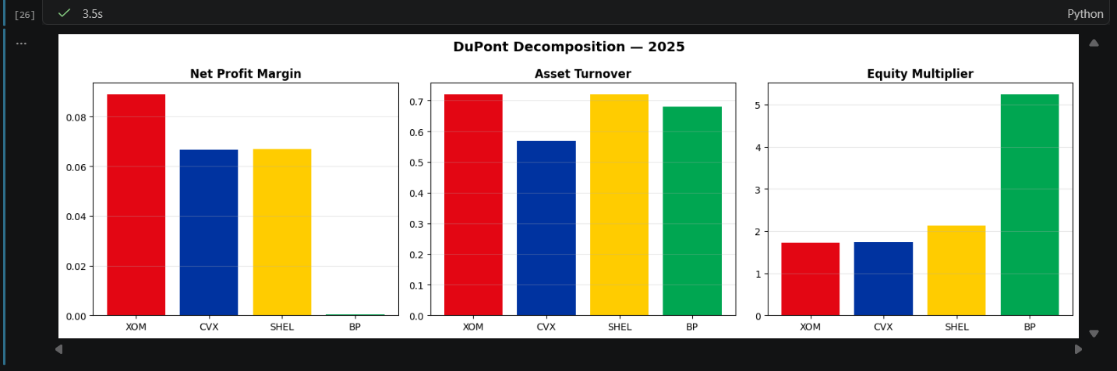
Figure 4. DuPont components by company, 2025.
The decomposition confirms the regression's finding directly: BP's Equity Multiplier (5.25x) is nearly triple ExxonMobil's (1.7x) - by far the largest leverage amplifier of the four companies - while its Net Profit Margin sits at essentially zero. BP is not a company with a moderate leverage problem and a moderate profitability problem; it is a company carrying the sector's largest leverage amplifier on top of a profit engine that has stalled. ExxonMobil and Chevron, by contrast, generate ROE primarily through margin and turnover rather than balance sheet amplification - a structurally higher-quality return, even where the headline ROE number is similar to a more leveraged peer.

4. PCA & Clustering: Formalizing Company Positioning
Finally, principal component analysis was applied to an 11-ratio feature set (profitability, leverage, liquidity, efficiency and cash flow measures together) for the 2025 snapshot, to test whether the qualitative "BP is an outlier" narrative holds up as a formal, quantified separation rather than an impression drawn from individual ratios.
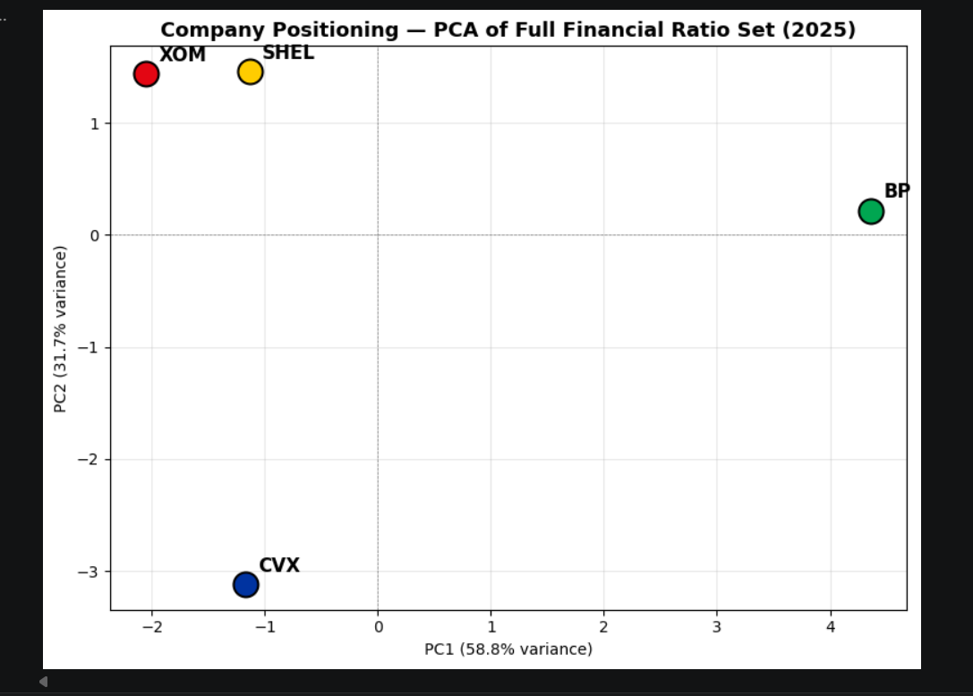
Figure 5. Company positioning on the first two principal components (90.5% of total variance explained).
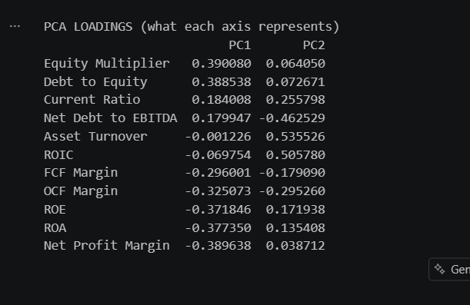
Figure 6. PCA loadings - which ratios drive each component.
The first principal component (58.8% of variance) is loaded positively on Equity Multiplier and Debt to Equity, and negatively on Net Profit Margin, ROA, ROE, and cash flow margins - in effect, a single "leverage vs. profitability" axis. BP sits at PC1 = 4.36, more than double the distance from the origin of any other company, while BP alone forms its own K-Means cluster against the other three. This is the same finding as the regression and DuPont sections, now expressed as a single quantified axis rather than three separate ratios.
The second component (31.7% of variance) is a distinct finding: it is driven by Asset Turnover, ROIC and Net Debt/EBITDA, and separates Chevron sharply (PC2 = -3.11) from ExxonMobil and Shell (both around +1.4). This indicates Chevron's capital efficiency profile differs meaningfully from its two peers, despite Chevron's ROE sitting in a similar range to theirs - a distinction the ROE-only view in earlier analysis did not surface.

Caveats
- With only 4 companies, K-Means and PCA are best understood here as a structured visualization and confirmation technique, not a statistical discovery method - a 4-point dataset does not support claims of general clustering structure in the wider sector.

5. Conclusion
Layering correlation, regression, DuPont decomposition, and PCA on the same underlying dataset produces a materially more precise conclusion than any single method alone: BP's weak ROE across 2022-2025 is a profitability problem currently amplified by an outsized capital structure, not a leverage problem in isolation. Chevron, Shell and ExxonMobil generate return through more conventional combinations of margin and turnover, with Chevron notably distinct from its two closest peers on capital efficiency once the full ratio set is considered rather than ROE alone.
Methodology note: this analysis was built as an extension beyond a standard financial-ratio review, intended to demonstrate applied statistical reasoning (isolating confounded relationships, validating identities, and being explicit about the limits of small-sample inference) alongside the underlying financial analysis itself.

