NullScale Project Update: Is It the Length or the Look-Alikes?
Progress Report — October 4, 2026 · M. I. Mahmud and Jayden, under Prof. Justin Zhan · Target: NAACL 2027

1. The project in one paragraph
When a language model is asked a question whose answer is not in a long document, it should say “not found”. Instead it often makes up an answer. Roig (2026) showed this gets worse as documents get longer — but longer documents also hold more records that look like the thing being asked. So nobody knows which one is the cause: the length, or the look-alikes. Our idea: to answer, a model needs only one matching record; to refuse, it must reject every record. So one convincing look-alike may be enough to cause a made-up answer, whatever the length. We build every document ourselves so we control both, and we prove the answer is absent. We test four research questions (RQ1–RQ4) across seven open models.

2. Progress so far
- Steps 1 to 7 of the 11-step plan are complete, plus the full Exp 1, Exp 6 and Exp 7 analysis.
- Generator (NullScale) built and verified: fake business world → look-alike ladder (4 levels, 2 kinds) → filler → exact-length documents → 12 questions each → a checker that proves every no-answer question is truly unanswerable.
- Dataset built: 565 documents, 6,780 questions per model; every document within 0.1% of target length; all absence checks pass.
- Scoring rules (fixed rules, no AI judge): 47/47 unit tests pass; agree with RIKER2’s own scorer on 99.2% of 605,948 answers.
- All 7 models run on the H200 cluster for Exp 2, Exp 3 and Exp 4, plus the three temperature-0.7 repeats of Exp 2.
- Exp 1 (Roig’s RIKER2 re-analysis), Exp 6 (real Wikipedia text) and Exp 7 (12-in-one-call) all run and scored; ~145,000 answers scored this round.
- Still to do: Exp 5 fixes, the 300-answer hand audit, and the final paper figures.

3. Models applied (all 7 open models + re-analysis)
- Qwen3 4B, Llama 3.1 8B — small, also run on the PC for testing.
- Gemma 3 27B, Qwen3 30B-A3B — mid-size.
- Llama 3.3 70B (FP8), Qwen3-Next 80B (FP8), GLM-4.5-Air (FP8) — large.
- Exp 1 re-uses Roig’s released answers from 35 models (RIKER2); 11 have answers at all three lengths.
- Hardware: 8× H200 (141 GB) on the UC ARCC2 cluster; data-parallel, several models at once.

4. Results so far

RQ1 — Do stronger look-alikes cause more made-up answers? (Exp 2, 32K fixed length)
- Every model is near 0% with no look-alike and 65–94% with one strong look-alike.
- Most made-up answers copy the look-alike’s exact value (94–99% for 6 of 7 models; Gemma 58%).
- Numbers are stable across three temperature-0.7 repeats (within ~3 points).
Table 1. Made-up answer rate (%) by look-alike level, 32K, T=0 [95% interval].
Model | none | weak | medium | strong | copied look-alike
Qwen3 4B | 0.0 | 0.4 | 15.8 | 65.0 | 99%
Llama 3.1 8B | 0.4 | 0.8 | 14.6 | 64.6 | 98%
Gemma 3 27B | 5.0 | 22.1 | 71.2 | 90.8 | 58%
Qwen3 30B-A3B | 1.7 | 9.6 | 25.8 | 82.9 | 96%
Llama 3.3 70B | 0.0 | 5.4 | 44.2 | 94.2 | 95%
Qwen3-Next 80B | 0.0 | 0.0 | 24.6 | 86.7 | 98%
GLM-4.5-Air | 0.4 | 10.4 | 24.2 | 93.3 | 94%
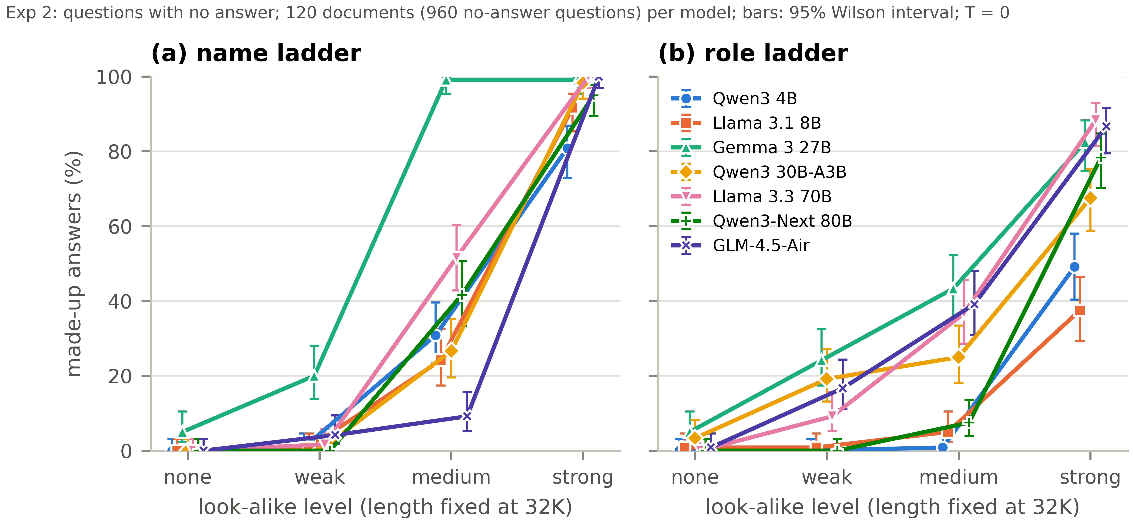
Figure 1 (Exp 2). Made-up answers rise sharply with look-alike strength at a fixed 32K length, on both the name ladder (a) and the role ladder (b).

RQ2 — Does length alone cause more made-up answers? (Exp 3)
- With a strong look-alike present, the made-up rate is high and flat from 8K to 128K for every model.
- With no look-alike, the rate stays near 0% for most models at every length.
- Exchange rate: one strong look-alike ≈ 6–8 doublings of length (a document ~60–250× longer). Both terms matter in the regression, but the look-alike effect is far larger (odds ratio ~120 vs. ~1.1 per doubling).
- Two exceptions (a genuine finding): Llama 3.3 70B at 128K jumps to 74% even with no look-alike, and Gemma 3 27B rises at 64K. In both, accuracy on answerable questions also drops — this is a reading breakdown at long length, not a look-alike effect.
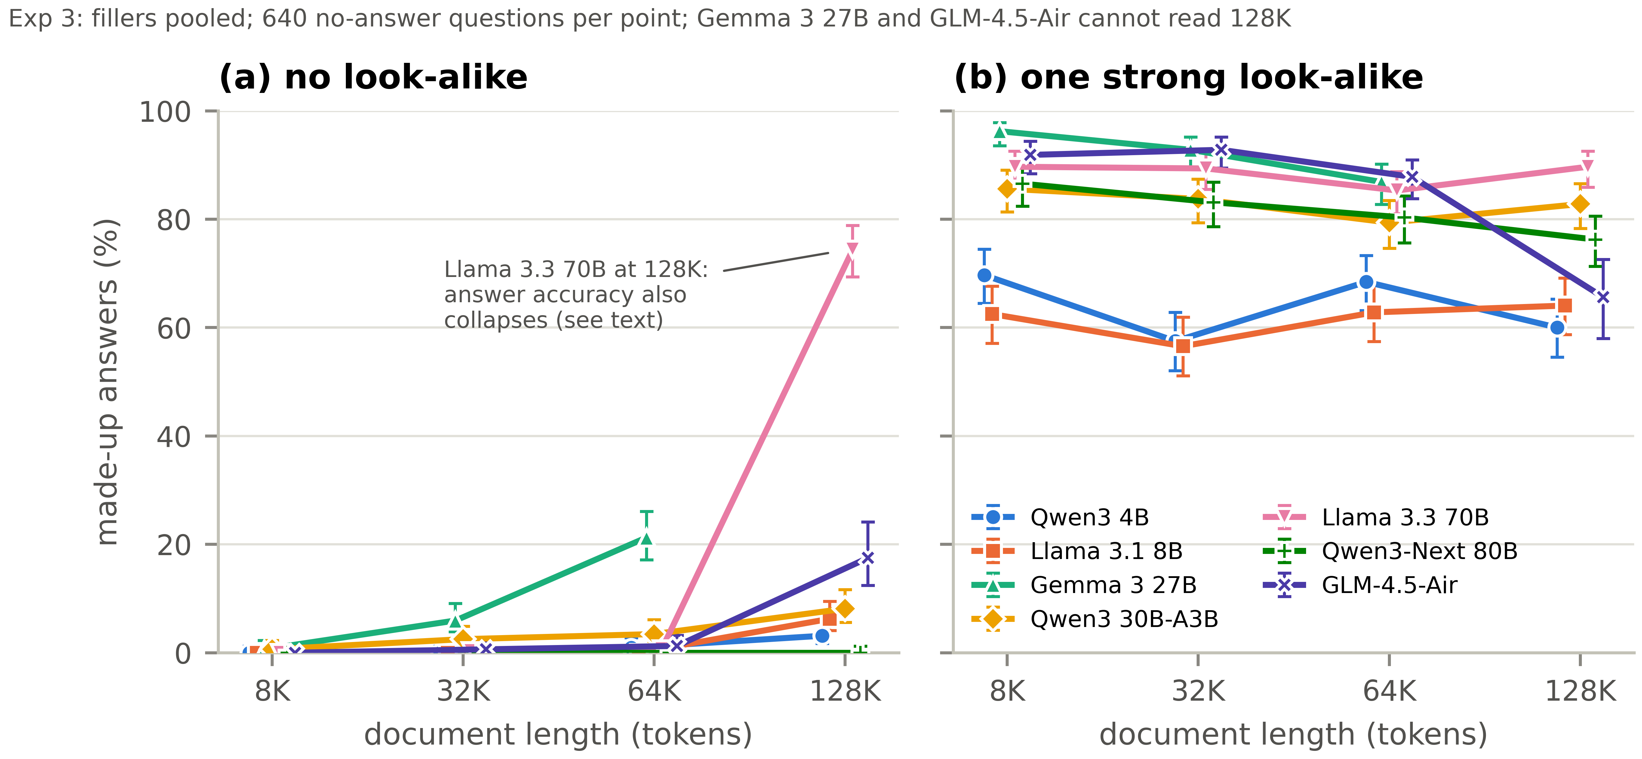
Figure 2 (Exp 3). (a) With no look-alike, length alone barely moves the rate for most models (the two exceptions are reading breakdowns). (b) With a strong look-alike, the rate is high at every length.

RQ1 (dose) — More copies of the same look-alike (Exp 4)
- Made-up answers rise from 1 to 2–4 copies, then fall at 8 copies for most models (the repeated record starts to look like a list, not a single fact).
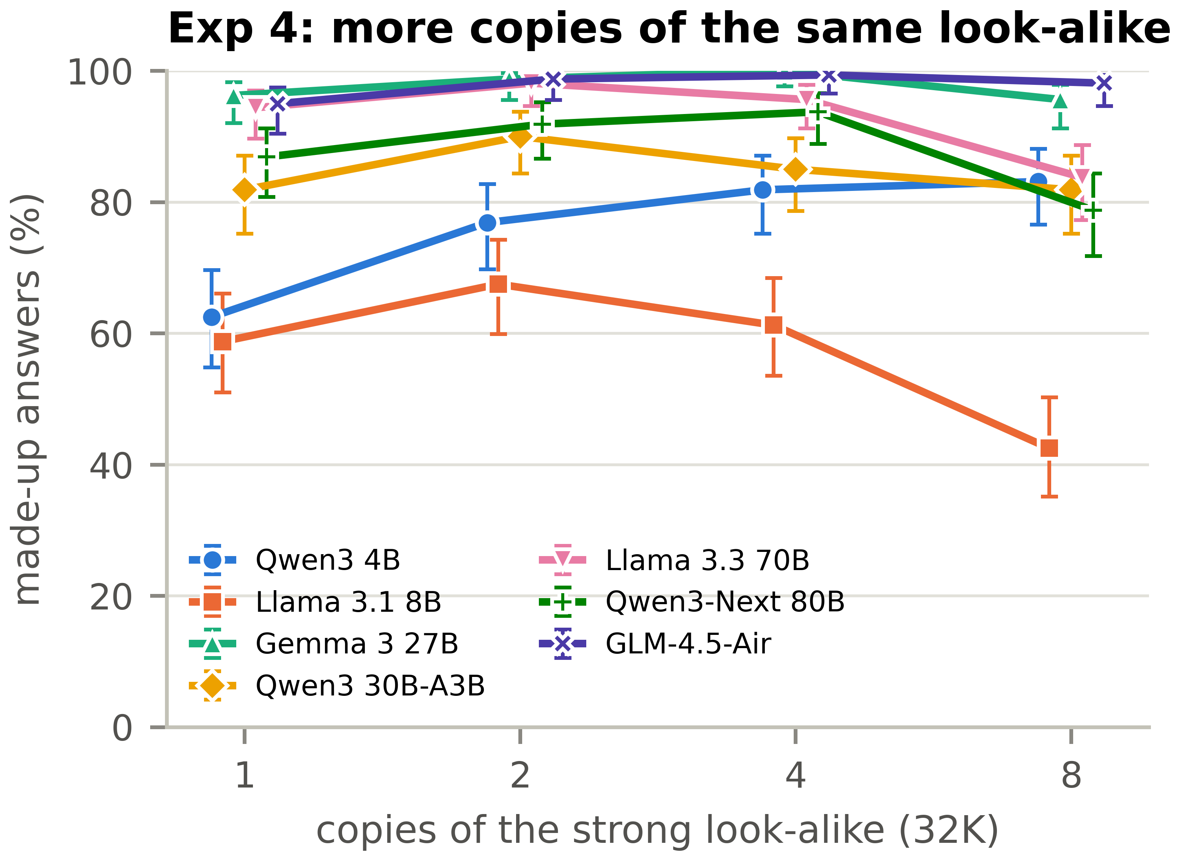
Figure 3 (Exp 4). Effect of 1, 2, 4, 8 copies of the same strong look-alike at 32K.

RQ4 (early sign) — Sibling padding helps (Exp 3, filler type)
- Replacing unrelated filler with sibling filler (same-kind records that clearly lack the fact) lowers made-up answers in every model (by 2–20 points).
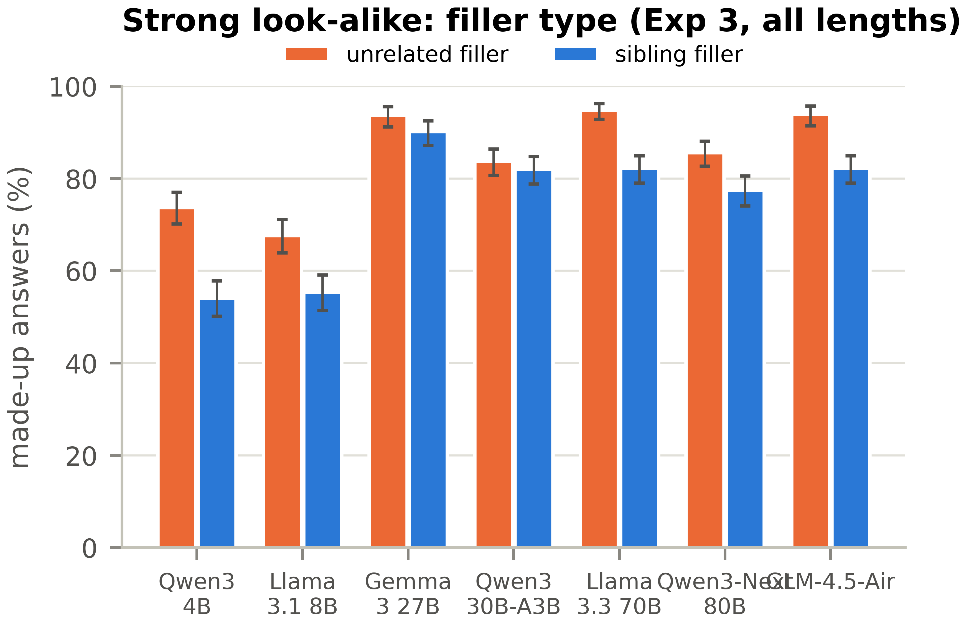
Figure 4. Sibling filler reduces made-up answers vs. unrelated filler (strong look-alike, all lengths).

RQ3 — Does Roig’s released data show the same pattern? (Exp 1, RIKER2)
- Our reading matches Roig’s published rates exactly (0.00-point difference, 465 settings) — a correctness check.
- Look-alikes do NOT grow with length in RIKER2 (~62% of trap questions have one at every length).
- At fixed 32K, same question type: look-alike present 42.5% vs. none 19.1% made up — look-alikes matter here too.
- But RIKER2 also shows a length effect with no look-alike — a useful tension (its long documents pack far more same-kind records our strict definition does not count).
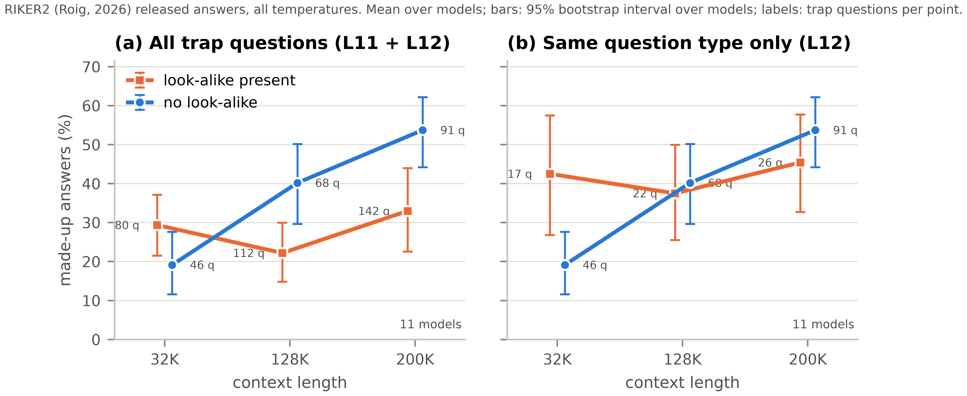
Figure 5 (Exp 1). Roig’s released answers, split by look-alike presence, at 32K/128K/200K. Left: all trap questions; right: same question type only.

Real-text check and protocol check (Exp 6, Exp 7)
- Exp 6 (real Wikipedia, answer passage removed) backs the main claim: with random surrounding passages, models almost never make up an answer (0–4%); with look-alike passages, they make up answers 48–87% of the time, at both 8K and 32K.
- Exp 7 (12 questions in one call) makes the problem worse: Qwen3 4B 63% → 76%; Llama 3.1 8B 58% → 95% — supports asking one question per call.
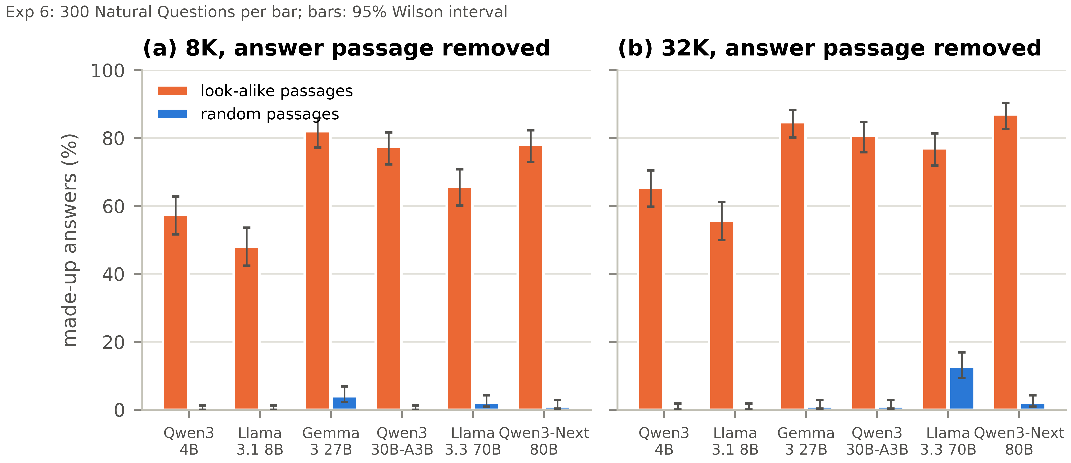
Figure 6 (Exp 6). Real Wikipedia text: look-alike passages cause made-up answers; random passages almost never do.

5. Does it support our proposal claims?
- RQ1 — YES. Stronger look-alikes clearly cause more made-up answers at fixed length, in every model; most answers copy the look-alike’s value.
- RQ2 — YES. With look-alikes fixed, length alone barely moves the rate; the exchange rate (≈6–8 doublings) is high. Two long-length reading breakdowns are reported honestly as separate failures.
- RQ3 — MIXED / USEFUL. Our controlled experiments say look-alikes dominate; Roig’s data shows look-alikes matter at fixed length but also a length effect we can explain. This tension strengthens the paper rather than weakening it.
- RQ4 — EARLY YES. Sibling padding already lowers made-up answers; the full fix comparison (Exp 5) is the next step.
- Overall message (so far): Control what goes into the context, not only how much. One convincing look-alike is worth dozens of doublings of length.

6. Next steps
- Write and run Exp 5 (sibling padding vs. strict prompt, reranker, fact-checker, at equal cost).
- 300-answer hand audit (both authors label independently; measure agreement).
- Re-check the Exp 6 control scoring (strict exact-match may undercount correct answers), and optionally rerun Llama 3.3 70B at 128K in full precision.
- Build the final paper figures and tables.

