NullScale Project Update: Steps 1 to 6
September 29, 2026 · M. I. Mahmud and Jayden, under Prof. Justin Zhan

1. The project in brief
Our first real test already shows the main effect. At a fixed length of 32K tokens, Qwen3 4B made up answers 0% of the time with no look-alike record and 60% of the time with one strong look-alike.
The problem. Language models are often asked questions about a long document. When the answer is not in the document, they should say so. Instead, they often make up an answer. Roig (2026) tested 35 models and found this gets worse as documents get longer. But a longer document also holds more records that look like the thing being asked about. So nobody knows which one causes the made-up answers: the length, or the look-alikes.
Our idea. To give an answer, a model needs only one record that matches. To say “not found”, it must reject every record in the document. So one convincing look-alike record may be enough to cause a made-up answer, whatever the length.
Our four research questions:
- RQ1. At a fixed length, do stronger look-alikes cause more made-up answers?
- RQ2. With look-alikes fixed, does length alone cause more made-up answers?
- RQ3. Does Roig’s released data show the same pattern when split by look-alike presence?
- RQ4. Does a cheap fix (sibling padding) reduce made-up answers better than standard fixes?
What is new (novelty):
- The first test that separates length from look-alikes for the “not found” decision. We build every document ourselves, so we control both, and we prove the answer is absent.
- A new single number, the exchange rate: how many doublings of length cause the same harm as one strong look-alike.
- A new reading of a published result: Roig’s released answers, split by look-alike presence, with no new model runs.
- A cheap fix (sibling padding), tested against a strict prompt, a fact checker and a reranker at equal cost.
We target NAACL 2027. The team is M. I. Mahmud and Jayden, under Prof. Justin Zhan.

2. What we have done so far (Steps 1 to 6)
All of Monirul’s code for Steps 1 to 6 is written and has run on the RTX 5070 PC (18 planned files, plus 7 small helper files). Jayden’s files for these steps (README, hypotheses, RIKER scripts, official scoring) are not done yet.
Step | What we built | Proof that it works
1. Setup | Install script and folder settings for the PC and the cluster | Python 3.11, vLLM 0.30, GPU found; all 7 model licences accepted
2. Settings | List of 7 models and 7 experiments | Settings check passes; about 10,000 answers per model planned
3. Fake world | Fake companies, people, buildings and leases, written as plain text | No two names are accidentally similar (at least 3 letters apart)
4. Documents | Look-alike records (4 levels), filler text, full documents | Every document is within 0.1% of its target length
5. Questions | 12 questions per document, and a check that proves each missing answer is truly missing | 10 of 10 tests pass; 565 of 565 documents proven
6. First run | Prompts, model runner, timing test | 240 real answers from Qwen3 4B on 20 documents
What the dataset holds (per model): 565 documents and 6,780 questions. Two thirds have no answer in the document (the trap questions). One third do have an answer, so we can check that a model still answers when it should.

3. How one test document is built
Every document is built from a known list of records, so we always know which answers are in it and which are not. No language model writes our data.
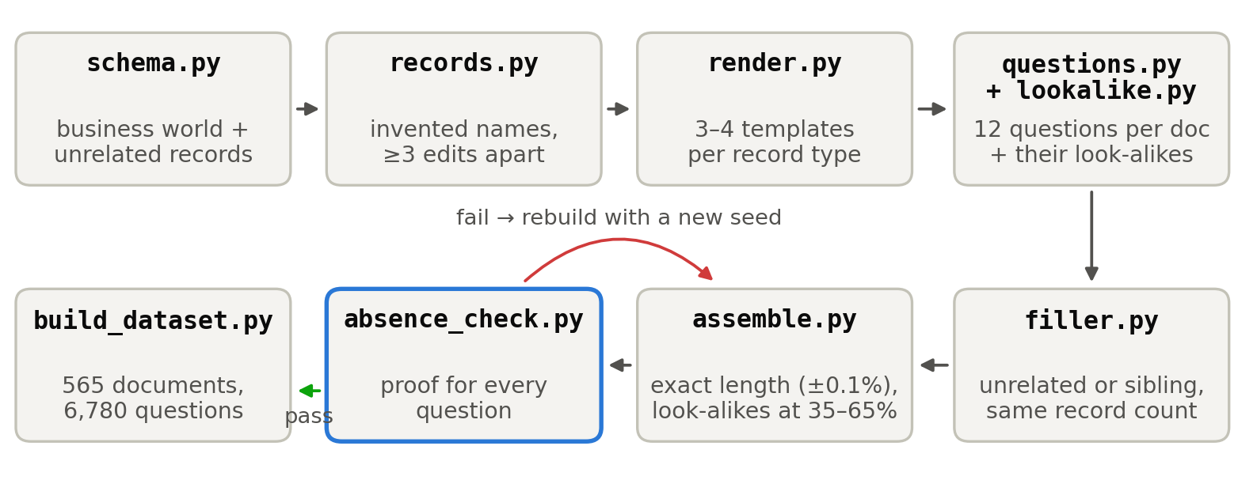
Figure 1. How a document is made. We invent a fake business world (companies, people, buildings, leases). Each record is turned into plain sentences. For each document we add 12 questions and their look-alike records, then fill the rest with other records until the document is exactly the target length. A checker then proves that every no-answer question really has no answer. If the proof fails, the document is thrown away and rebuilt.
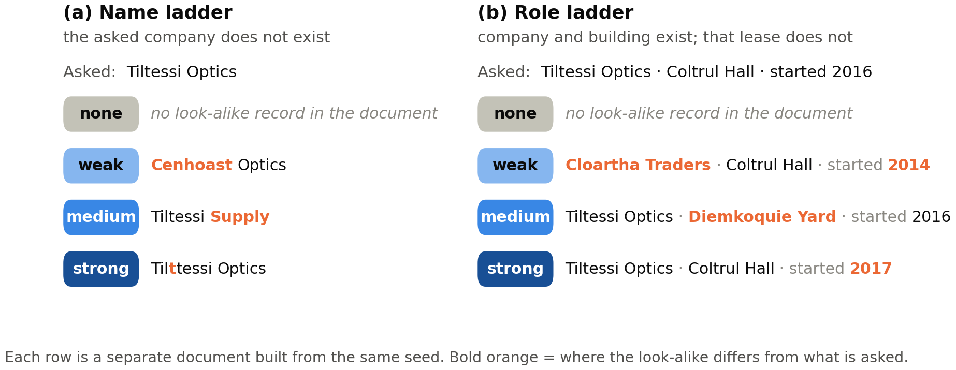
Figure 2. The two look-alike ladders. Each row is a different document. The question is the same; only the look-alike changes. Bold orange shows where the look-alike differs from what was asked.
- Name ladder: the asked company does not exist. Weak = same second word only. Medium = same first word. Strong = one letter different (“Tiltessi” vs “Tilttessi”).
- Role ladder: the company and the building both exist, but not that lease. Weak = same building, other company. Medium = same company, other building. Strong = same company and building, different year.

4. Checks on the full dataset
All 565 documents passed every check on the first try: correct length, look-alikes in the middle, and a proven missing answer.
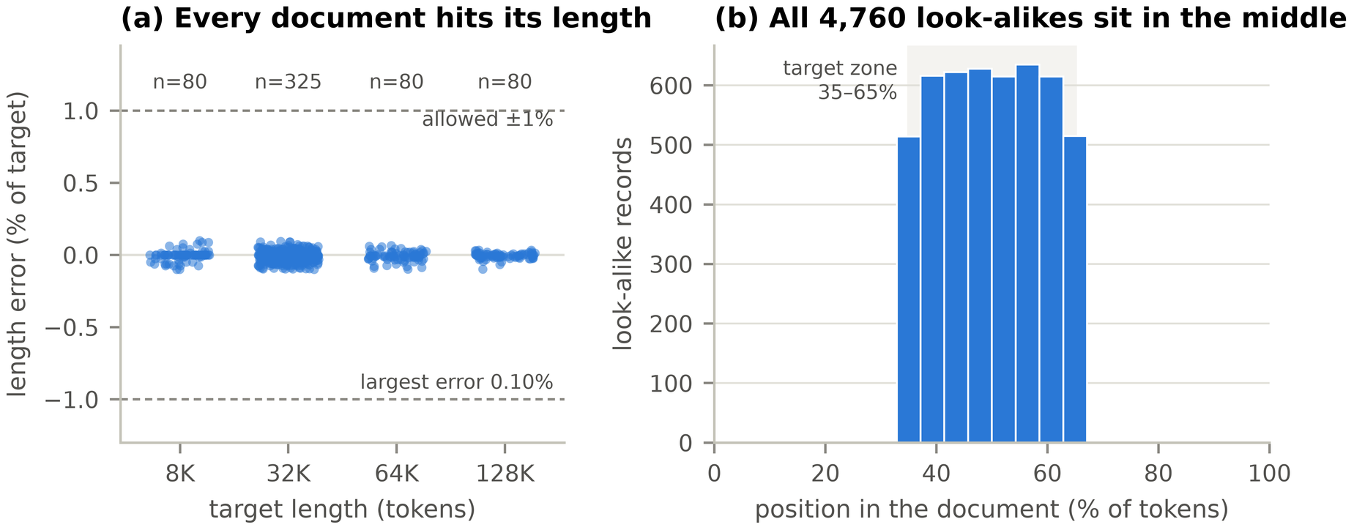
Figure 3. Length and position. (a) We allow a length error of 1%. The largest error is 0.10%, at every length from 8K to 128K tokens. (b) All 4,760 look-alike records sit between 35% and 65% of the document, so position cannot explain our results. (This figure was made on the PC with the real Llama tokenizer.)
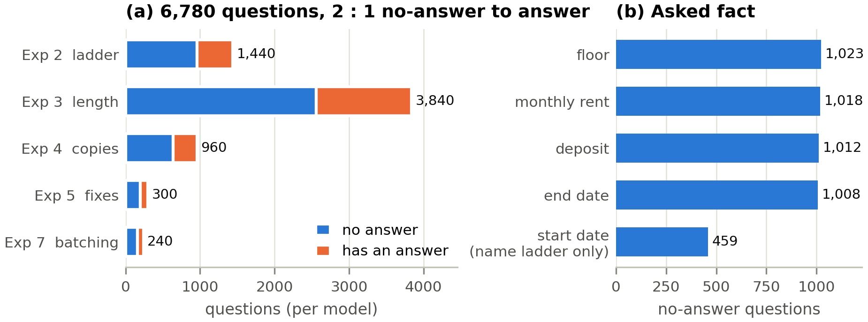
Figure 4. What the dataset asks. (a) Each model answers 6,780 questions; two thirds have no answer in the document. (b) The no-answer questions are spread evenly over the lease facts (rent, deposit, floor, end date). Start date is asked only on the name ladder.
How the missing-answer proof works. For each no-answer question, the checker searches the actual text. On the name ladder, it proves that the asked company name never appears, and that every name within 2 letters of it sits only inside that question’s own look-alike record. On the role ladder, it proves that no lease has that company, building and year. The checker was also tested on documents where we planted a real answer or a stray look-alike: it caught every one.

5. First real run: Qwen3 4B at 32K
At the same length, made-up answers rose from 0% with no look-alike to 60% with a strong look-alike, and every made-up answer copied the look-alike’s value. This is one small model on 20 documents (240 answers), run on the PC, so it is a first look, not a paper result.
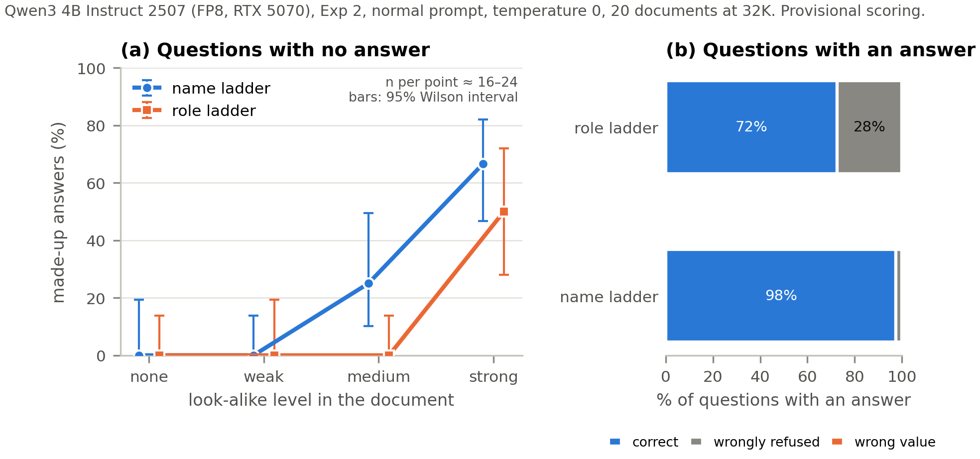
Figure 5. The main result. (a) With no look-alike, the model made up 0 of 40 answers. With a strong look-alike, it made up 24 of 40 (60%). Six more strong-level answers said “not found” but still quoted the look-alike’s value; counting those, the rate is 75%. (b) On questions that do have an answer, the model was right 98% of the time on the name ladder but only 72% on the role ladder. There it often said “not found” when the answer was there.
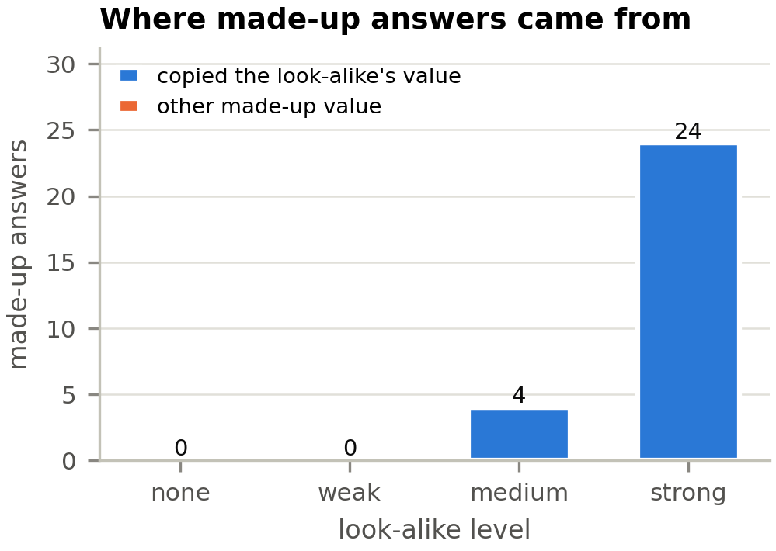
Figure 6. The cause is visible. All 28 made-up answers used the exact value (rent, date or floor) from the look-alike record. The model did not invent numbers from nothing; it borrowed them from the record that looked closest.
Real questions and answers from this run:
Look-alike level | Question (answer is NOT in the document) | Look-alike in the document | Model’s answer | Label
none | How large was the security deposit on Cloncler Holdings’ lease at Semquoax Place that started in 2020? | (none) | “The records do not contain information about Cloncler Holdings’ lease at Semquoax Place…” | Correct refusal
medium | Which floor does Pousquieck Studios lease? | Pousquieck Pharma, floor 20 | “The closest match is Pousquieck Pharma… floor 20… Answer: Not in the records.” | Correct refusal (mentions the look-alike)
strong | On what floor is the space leased by Cainweal Interiors? | Cainweil Interiors, floor 29 | “The space leased by Cainweil Interiors is on floor 29.” | Made up (copied)
strong | What is the end date of the lease Laindhan Media signed at Miestirtce Plaza starting in 2021? | Same company and building, other year, ends January 28, 2027 | “…is January 28, 2027.” | Made up (copied)
In the third row, the model even misspelled the asked name to match the look-alike. It treated a name one letter off as the same company.
How we score (for now). A no-answer question counts as made up when the final answer gives a value of the kind asked (an amount, a date or a floor), even with a hedge such as “maybe $5,000”. These are simple written rules, not an AI judge. Jayden’s official scoring rules will replace them.

6. Why this works better than other approaches
Only our setup can hold the length fixed and change just the look-alike, so only it can show which one causes the made-up answers.
Approach | What it tests | Is the answer proven absent? | Controls look-alikes? | Separates length from look-alikes? | How answers are scored
Needle in a haystack | Finding a fact that is there | Not tested | No | No | Fixed rules
RULER (Hsieh et al., 2024) | Finding and tracing facts that are there | Not tested | Counts distractors only | No | Fixed rules
Judge-based benchmarks | Made-up content in real text | No (humans or an AI judge decide) | No | No | AI judge (can be biased)
RIKER (Roig, 2026) | Made-up answers at 32K to 200K | Yes | No | No (look-alikes grow with length) | Fixed rules
NullScale (ours) | Made-up answers to no-answer questions | Yes, proven per question | Yes, 4 levels, 2 ladders | Yes | Fixed rules (a 2-person hand check is planned)
The first run already shows why this matters. At one fixed length (32K), the made-up rate went from 0% to 60% by changing only the look-alike. A length-only study would have averaged these documents into one number. Roig reports about 25% for this same model at 32K; our result suggests much of that may come from look-alikes, not length. Our Exp 1 will test this directly on Roig’s released data.
Other strengths:
- No data leaks into training. Every document is freshly made from a seed, so a model cannot have seen it before.
- Fully repeatable. The same seed gives the same document, word for word (checked: 240 of 240 questions matched between two separate builds).
- Cheap. Each document’s 12 questions share one reading of the document: questions 2 to 12 reuse 99.9% of the work of question 1.

7. Time and cost
On the PC, Qwen3 4B needs about 20 seconds per 32K document, so the whole plan for this model would take about 10.6 GPU hours.
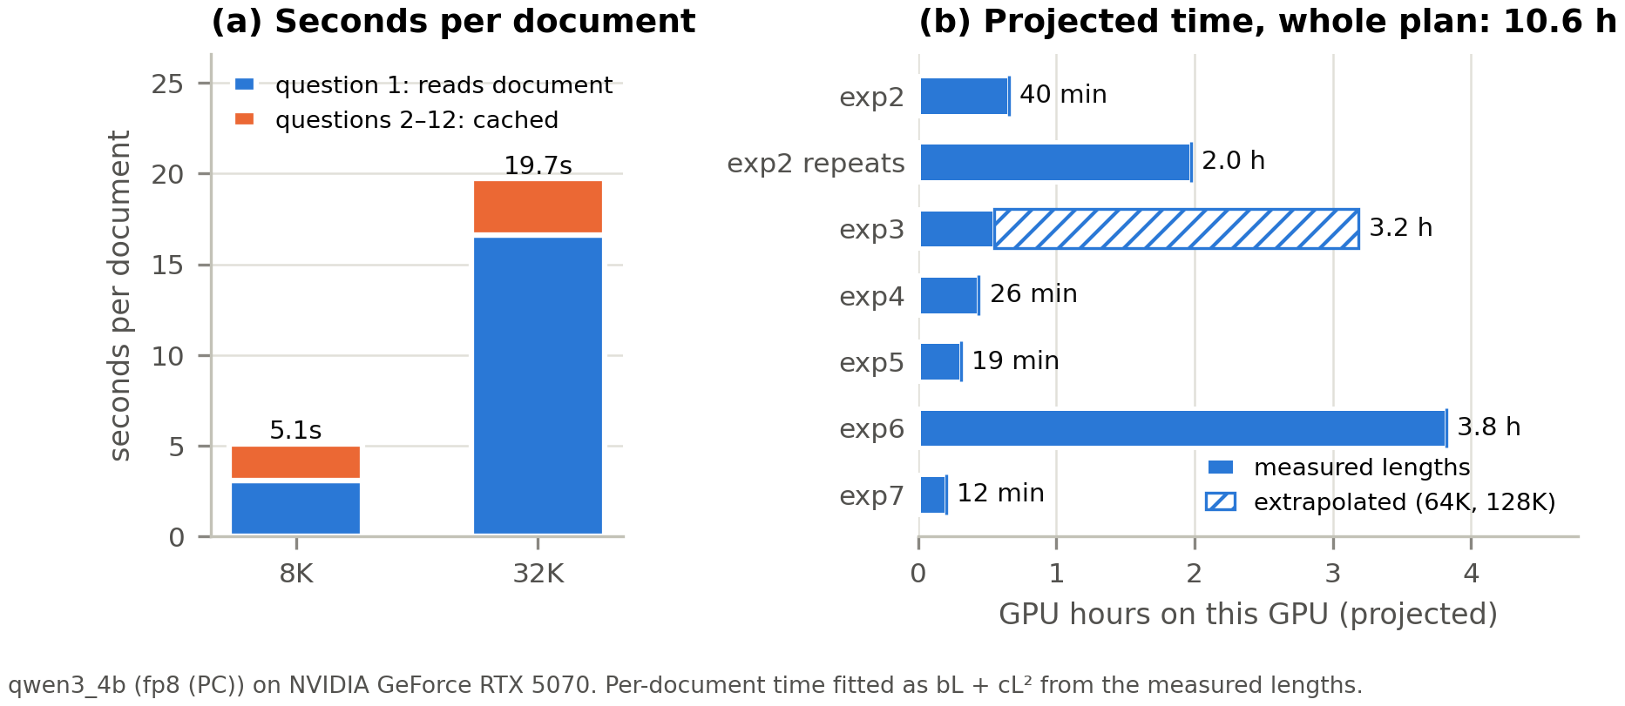
Figure 7. Where the time goes. (a) The first question of a document takes most of the time, because the model must read the whole document. Questions 2 to 12 reuse that reading and take only 3 seconds together. (b) Projected hours per experiment for this model on the PC. The hatched part of Exp 3 (64K and 128K) is estimated, because the PC cannot run those lengths. The cluster will be faster; we will re-time each model there. Cost so far: $0 (own PC, free open models).

8. Open issues and next steps
One decision is needed before the cluster runs: two models cannot read our longest documents.
Issue | What we found | What we propose
128K documents too long for 2 models | Gemma and Qwen split every digit into its own token, so our documents are about 21% longer for them. A “128K” document needs 156,249 tokens for Gemma 3 27B and 133,091 for GLM-4.5-Air; both can read only 131,072. | Shrink the longest length to about 104K (Llama count), so all 7 models read the same documents.
PC uses 8-bit, not 4-bit | vLLM no longer supports the 4-bit option. | Keep 8-bit (FP8) on the PC; no paper number comes from the PC.
Cluster details unknown | GPU type (H200 or A100), folder path and partition are still blank in the settings. | Fill them in before Step 7.
Jayden’s files not in yet | README, hypotheses, RIKER scripts, official scoring | Needed for Exp 1 and for the official scores.
Next steps (Steps 7 to 9):
- Read the 20 sample answers together (Jayden and Monirul) and agree on the scoring rules.
- Fix the 128K length problem and fill in the cluster settings.
- Start the cluster runs for all 7 models on Exp 2, 3 and 4, small models first.
- Jayden finishes the RIKER re-analysis (Exp 1) and builds the Natural Questions data (Exp 6).

