INVENTORY MANAGEMENT SYSTEM

REQUIREMENTS DOCUMENT

# Team Composition

Monisa Hassan Alvi (17L-4098)

Aiza Nadeem (17L-4338)

Bisma Jalal (17L-4557)

Tehreem Mushtaq (17L-4325)

M. Abdullah Farooqi (17L-4122)

**Table of Content**

1. **Introduction to the Document**

1.1 Purpose of the Product

1.2 Scope of the Product

1.3 Outline of the rest of the SRS

1. **General Description of Product**

2.1 Context of Product

2.2 Product Functions

2.3 User Classes and Characteristics

2.4 Constraints

2.5 Assumptions and Dependencies

1. **Specific Requirements**

3.1 External Interface Requirements

3.1.1 User Interfaces

3.1.2 Hardware Interfaces

3.1.3 Software Interfaces

3.1.4 Communications Interfaces

3.2 Functional Requirements

3.2.1 Requirement 1

3.2.2 Requirement 2

3.2.3 Requirement 3

3.2.4 Requirement 4

3.2.5 Requirement 5

3.2.6 Requirement 6

3.2.7 Requirement 7

3.2.8 Requirement 8

3.2.9 Requirement 9

3.2.10 Requirement 10

3.2.11 Requirement 11

3.2.12 Requirement 12

3.2.13 Requirement 13

* 1. Performance Requirements
     1. Requirement 1
     2. Requirement 2
     3. Requirement 3
     4. Requirement 4
     5. Requirement 5
     6. Requirement 6

3.4 Design Constraints

3.5 Other Quality Requirements

3.6 Other Requirements

1. **Appendix: Analysis Models**
2. **Introduction to the Document**
   1. **Purpose of the Product**

This document presents an in-depth view of the Inventory Management System that is being developed for National Highway and Motorway Police. This system will facilitate the organization to efficiently and effectively manage the inventory of the organization. In this document, we will mention the functional and non-functional requirements of the system. The classes and their characteristics are also included in the document.

* 1. **Scope of the Product**

The Inventory Management System will provide the organization with the efficient management of the inventory. There are various things in the management of the inventory and this system will take care of all the appropriate things. It will allow the administrator to issue items to the employees. It will provide the administrator with one click report that will provide a brief report to the administrator about the items in the inventory. The administrator will also be notified about if some item is running out of stock so that it can be restocked in time. The system will also take care of sending reminders via SMS to the employees to return a borrowed item when the due date is near. In this way, the system will provide the organization a reliable way to manage the operations related to inventory.

* 1. **Outline of the rest of the SRS**
* General Description of Product
  + Context of Product
  + Product Functions
  + User Classes and Characteristics
  + Design and Implementation Constraints
  + Assumptions and Dependencies
* Specific Requirements
  + External Interface Requirements
    - User Interfaces
    - Hardware Interfaces
    - Software Interfaces
    - Communications Interfaces
* Functional Requirements
* Performance Requirements
* Other Quality Requirements

1. **General Description of Product**
   1. **Context of Product**

The Inventory Management System is designed to replace the conventional inventory management system in which the administrator had to manually keep track of the inventory and managing the stock was very difficult. The Inventory Management System provides the administrator of the organization with an easy and reliable way to manage inventory. It will eliminate the manual record keeping and will keep track of stock by itself. It will notify the administrator when an item is below specified value, keep track of issued items and send reminders to employees to return borrowed items and generate fines if an employee does not return the item within the due date.

* 1. **Product Functions**

The Inventory Management System will be capable of performing following tasks:

* Keep record of the inventory
* Keep track of items issued to employees
* Notify administrator when some item is below certain threshold
* Generate Reports about stock of inventory
* Generate fines for overdue items
* Send reminders to employees for borrowed items via SMS before 1 day of due date
* Record all the relevant details while issuing item to an employee
* Allow administrator to add new items to existing inventory
* Provide administrator an option to approve or disapprove request to acquire an item by employee
* Keep track of items that does not need to be returned
* Allow employees to make request for acquisition of product

The main features of Inventory Management System are summarized below using the context diagram:

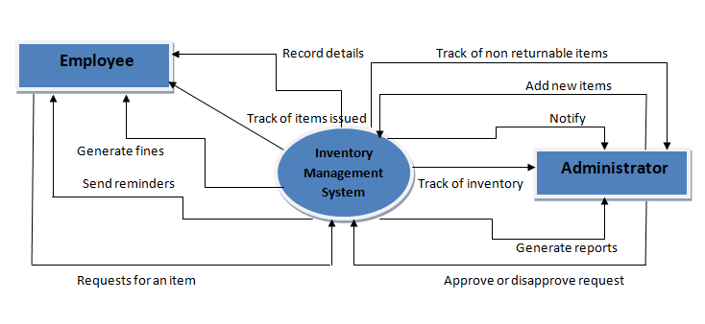

        Context diagram

* 1. **User Classes and Characteristics**

There will be two users of our system: administrator and employees.

The Administrator will be able to do following tasks:

* Login
* Change Password
* Issue Items
* Add Items
* Update Items
* View the system generated reports
* Approve or Disapprove item acquisition request

The Employee will be able to do following tasks:

* Make request to acquire an item
  1. **Design and Implementation Constraints**

Following are the design and implementation constraints:

* Learning Web Development for implementation
* Full implementation cannot be guaranteed in given time span
  1. **Assumptions and Dependencies**

The assumptions taken for the system are:

* The interface of the system will be easy to use
* User has an internet connection
* Administrator will not turn down request of acquisition without a reason

The dependencies of the system are:

* The data should be consistent, meaning that the data changes made at the interface should reflect immediately in the database.
* User should have proper understanding of the system
* All the requirements for the system are fulfilled

1. **Specific Requirements**
   1. **External Interface Requirements**
      1. **User Interfaces**

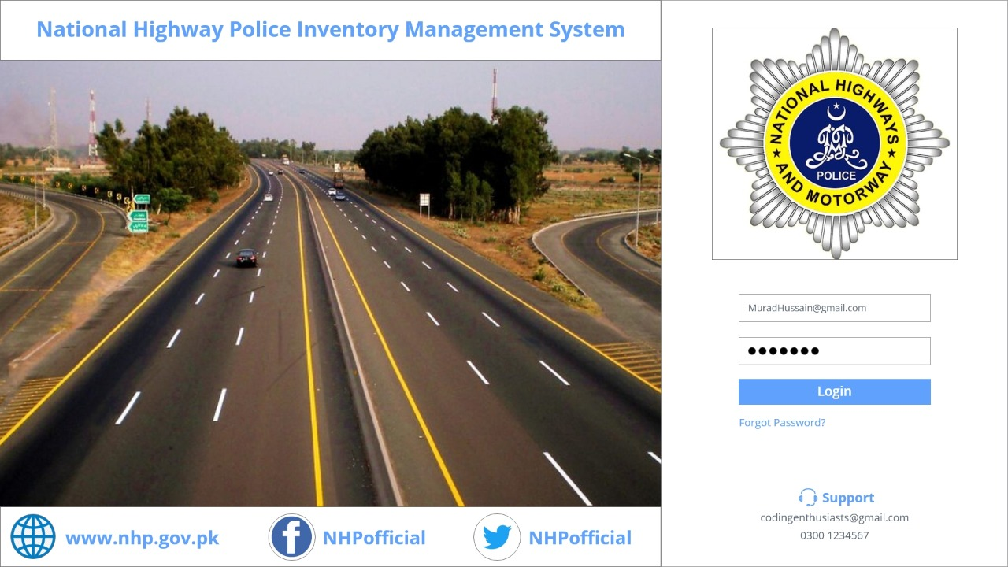

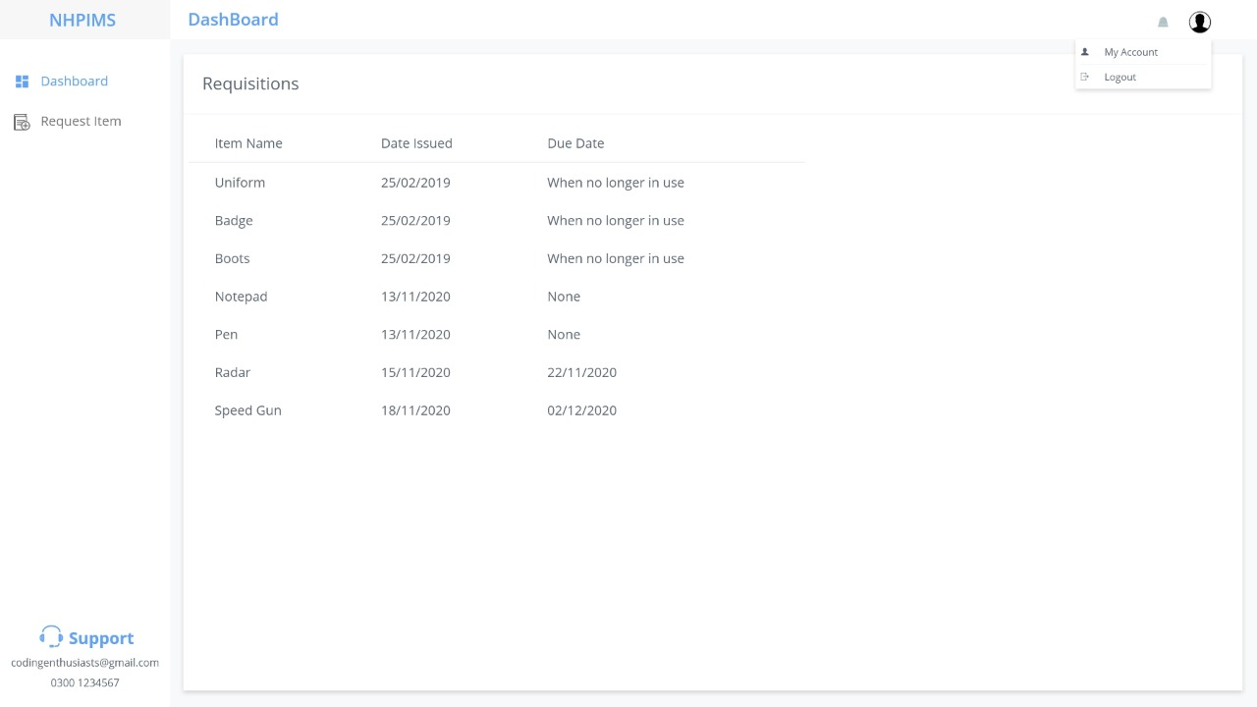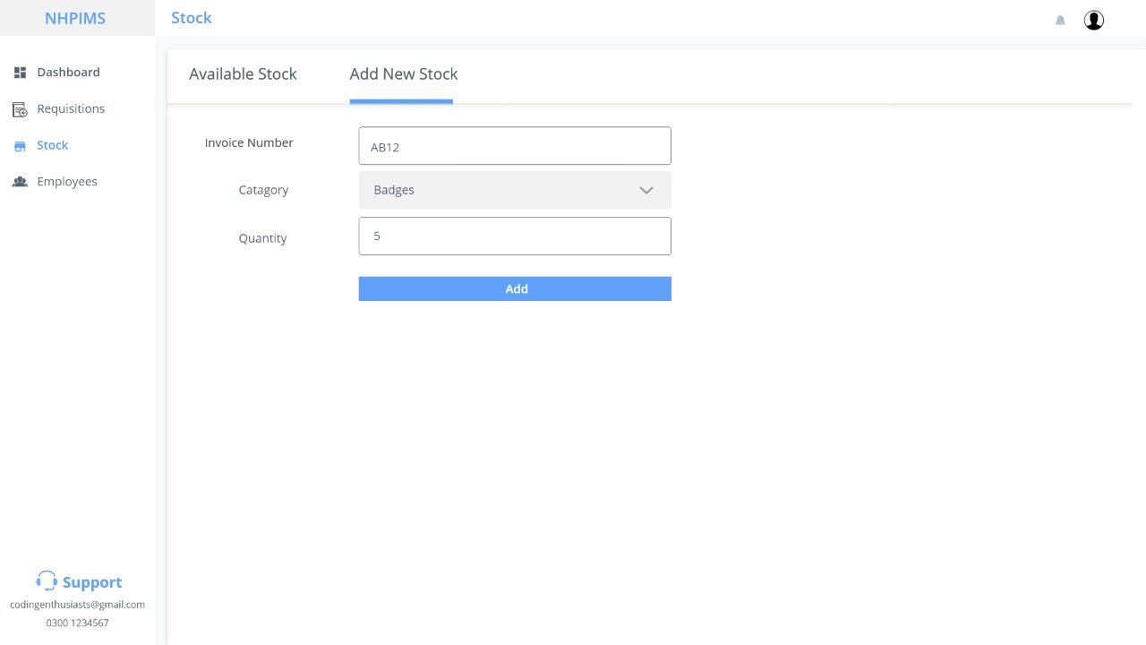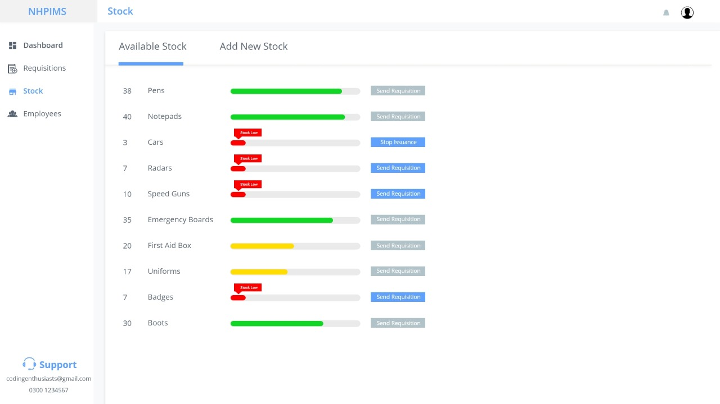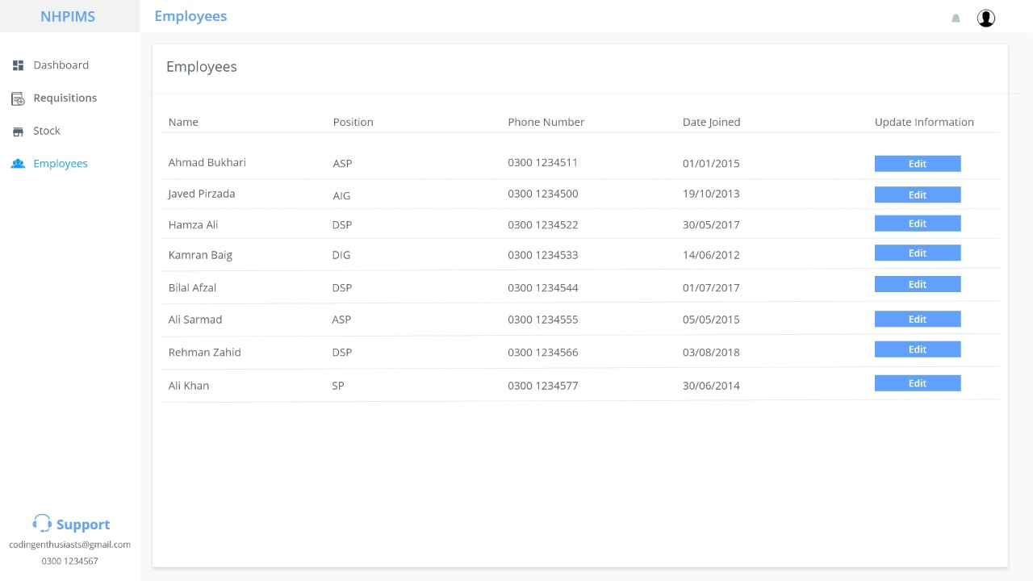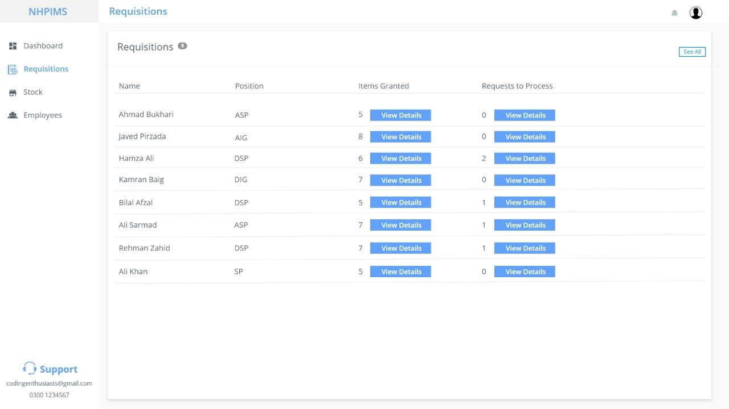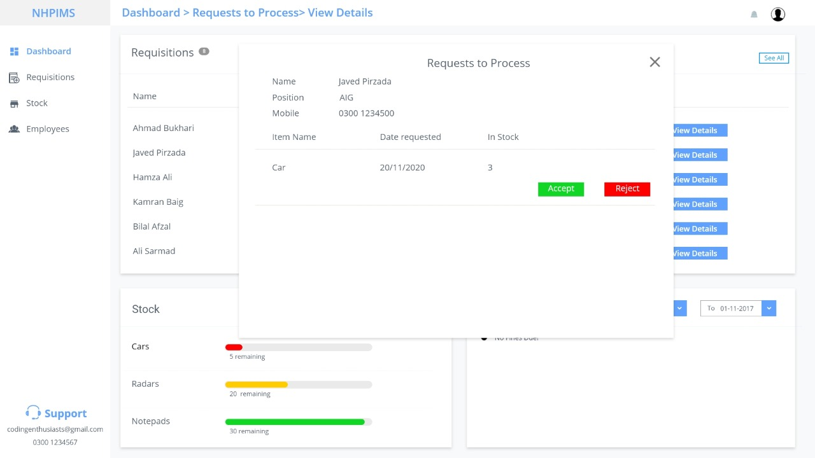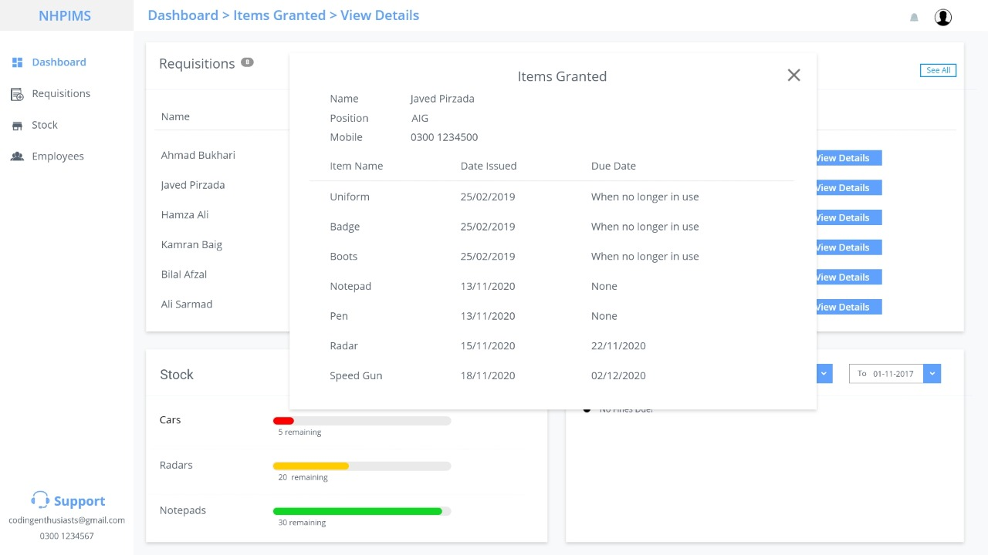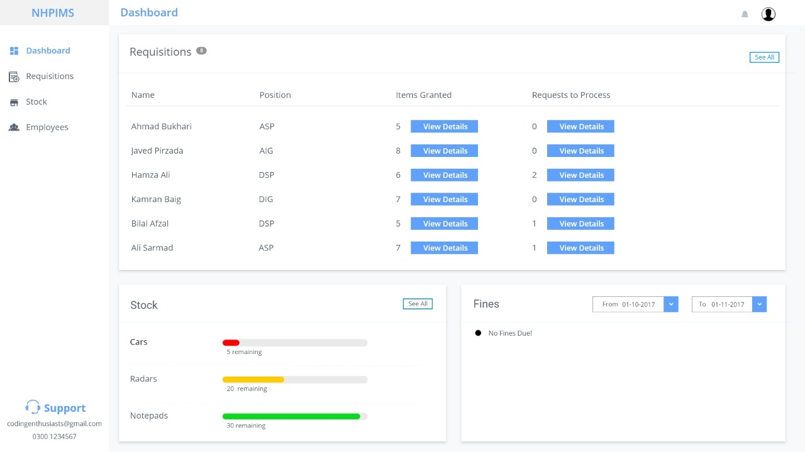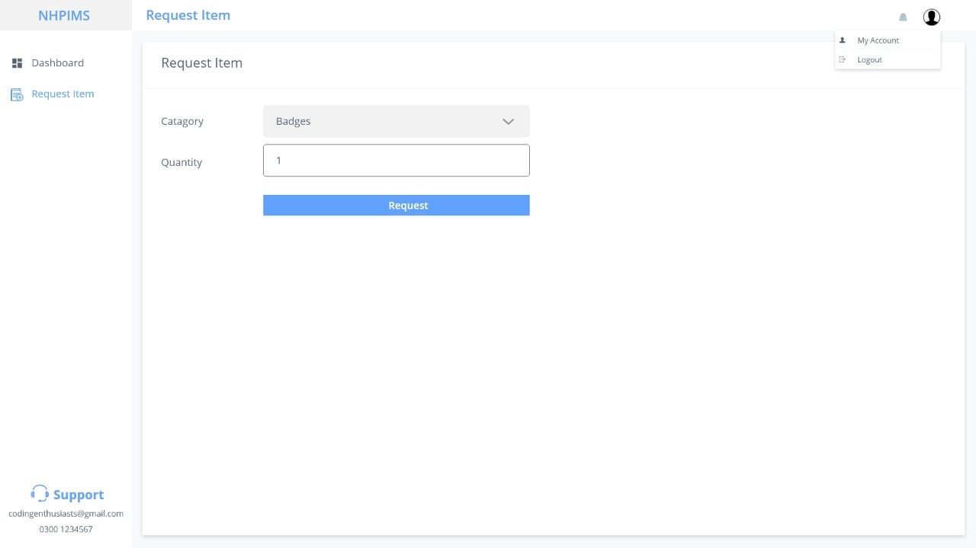

* + 1. **Hardware Interfaces**

The Inventory Management System will be available as a web application. The user needs to have a device that can run web applications. The device can either be a desktop PC, laptop or a smartphone.

* + 1. **Software Interfaces**

The Inventory Management System will be developed as a web application connected to a database that can store all the details related to inventory. The application will be developed using Node Javascript and the database to be used will be mysql.

* + 1. **Communications Interfaces**

The user will be able to communicate with the application using a stable internet connection.

* 1. **Functional Requirements**
     1. **Requirement 1**

The Inventory Management System should allow the administrator to login to the system.

* + 1. **Requirement 2**

The Inventory Management System should allow the administrator to change the password.

* + 1. **Requirement 3**

The Inventory Management System should be able to keep records of inventory items.

* + 1. **Requirement 4**

The Inventory Management System should keep track of items issued to the employees.

* + 1. **Requirement 5**

The Inventory Management System should notify the administrator if a certain item is below threshold value.

* + 1. **Requirement 6**

The Inventory Management System should be able to generate reports about the stock of inventory.

* + 1. **Requirement 7**

The Inventory Management System should generate fines for overdue items.

* + 1. **Requirement 8**

The Inventory Management System should send a reminder to return an item before 1 day of due date to employees.

* + 1. **Requirement 9**

The Inventory Management System should record all relevant details while issuing an item to employees.

* + 1. **Requirement 10**

The Inventory Management System should allow the administrator to add new items.

* + 1. **Requirement 11**

The Inventory Management System should allow the administrator to approve or disapprove an item acquisition request.

* + 1. **Requirement 12**

The Inventory Management System should only allow issuance of items in case of emergency if they are below threshold value.

* + 1. **Requirement 13**

The Inventory Management System should allow employees to make request to acquire an item.

**3.3. Performance Requirements**

**3.3.1. Requirement 1**

The Inventory Management System should keep the data consistent.

**3.3.2. Requirement 2**

The Inventory Management System should be available to the administrator all the time.

**3.3.3. Requirement 3**

The Inventory Management System should be able to handle all the items required in the stock.

**3.3.4. Requirement 4**

The Inventory Management System should complete requests in at most 3 seconds.

**3.3.5. Requirement 5**

The Inventory Management System should be accurate in calculating fines.

**3.3.6. Requirement 6**

The Inventory Management System should be reliable.

* 1. **Other Quality Requirements**

**3.4.1. Requirement 1**

The interface for the system should be user friendly and easy-to-use.

**Appendix: Analysis Models**

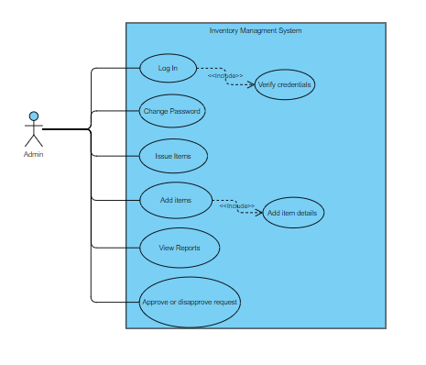

                Admin Use Case Diagram

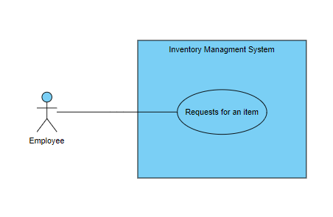

                  Employee Use Case Diagram