CS303: Software Engineering

**Project Deliverable 4: Component Diagram + ER Diagram**

# Team Composition (Coding Enthusiasts)

Monisa Hassan Alvi (17L-4098)

Aiza Nadeem (17L-4338)

Bisma Jalal (17L-4557)

Tehreem Mushtaq (17L-4325)

M. Abdullah Farooqi (17L-4122)

**COMPONENT DIAGRAM**

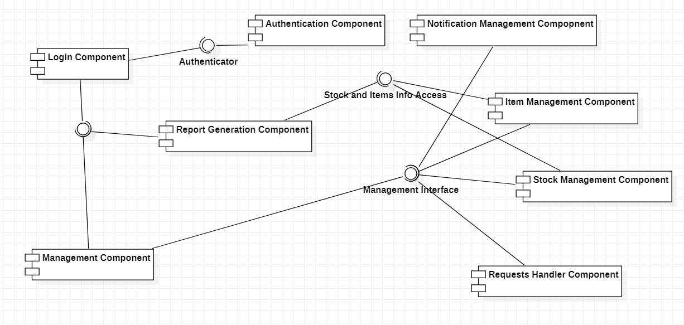

**COMPONENT-TO-COMPONENT INTERFACE**

**Authentication Component**

Authentication Component will receive the login details from user and then will match the credentials with the records and will provide output for authentication.

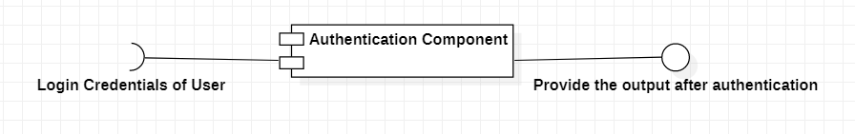

**Login Component**

Login Component will receive the user id and password and will redirect to home page of application after authentication.

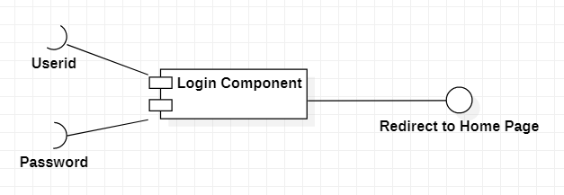

**Report Generation Component**

Report Generation Component will receive the information from the list of items and will receive information about the stock to generate requested reports.

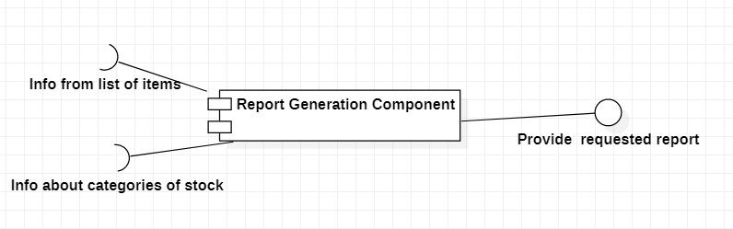

**Requests Handler Component**

Requests Handler Component will receive input as the list of requests made by employees for item acquisition and display those requests to the administrator and provide output as per the approval of admin.

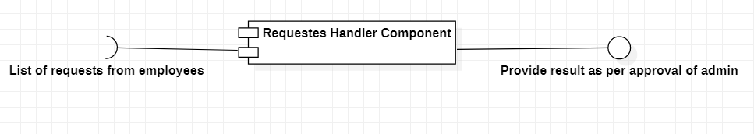

**Notification Management Component**

Notification Management Component will receive notification for the employees to return due items and forward those alerts to appropriate employee. It will also receive alerts from items data to alert admin about values that are below threshold value.

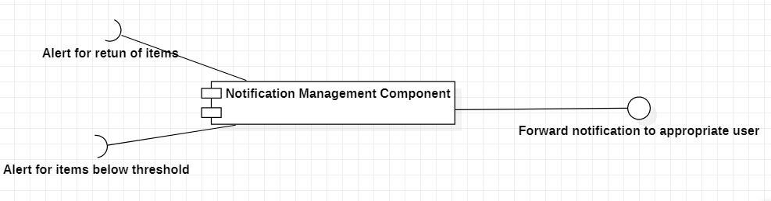

**ER DIAGRAM**

