**INTRODUCTION**

Customer feedback is a valuable source of information for businesses across various domains. Understanding customer sentiments, preferences, and pain points is crucial for improving products and services, driving customer satisfaction, and gaining a competitive edge in the market. This project aims to leverage data analysis techniques, specifically K-means clustering and Principal Component Analysis (PCA), to analyze customer feedback data and present the results using Power BI.

In today's data-driven business landscape, customer feedback plays a pivotal role in understanding customer preferences and improving products and services. However, analyzing and deriving valuable insights from vast volumes of customer feedback data can be a challenging task. Our project aims to tackle this challenge by applying advanced data analysis techniques.

Using K-means clustering, we will group similar customer feedback into distinct clusters, uncovering underlying patterns and sentiments. Additionally, Principal Component Analysis (PCA) will be employed to reduce the data's dimensionality, simplifying its visualization and interpretation.

To present our findings effectively, we will utilize Power BI, a powerful business intelligence tool. Through interactive dashboards and visualizations, we will provide meaningful insights into customer preferences, allowing data-driven decisions and better understanding of customer needs.

By the end of this project, we expect to deliver actionable recommendations to improve customer satisfaction, optimize products, and refine business strategies. Our approach will enable businesses to make informed decisions based on a deeper understanding of customer feedback, enhancing overall customer experiences and driving growth.

* 1. **About the Domain**

The project focuses on the domain of customer feedback analysis. In this domain, businesses collect feedback from customers through various channels such as surveys, reviews, and social media platforms. Analyzing and understanding this feedback helps businesses identify areas for improvement, make informed decisions, and enhance customer experiences.



**Fig 1.1 Importance of Visuals**

* 1. **Objective**

The primary objective of this project is to analyze customer feedback data using K-means clustering and PCA. By applying these techniques, we aim to:

- Identify distinct customer segments based on shared feedback characteristics.

- Reduce the data's dimensionality while retaining critical information using PCA.

- Uncover hidden patterns and sentiments within the customer feedback data.

- Provide data-driven insights and recommendations for business improvement.

* 1. **Scope**

The scope of this project encompasses the following key aspects:

**- Data Collection:** Gathering relevant and structured customer feedback data from various sources.

**- Preprocessing:** Cleaning and preparing the data for analysis, handling missing values, and ensuring Data Quality

**- K-means Clustering:** Applying the K-means algorithm to group similar feedback points into clusters.

**- PCA:** Reducing the data's dimensionality using Principal Component Analysis.

**- Power BI Visualization:** Creating interactive visualizations and dashboards to represent the clustered data.

**- Cluster Trait Analysis**: Exploring and understanding the characteristics of each customer feedback cluster

* 1. **Motivation**

The motivation behind this project stems from the increasing importance of customer feedback in today's competitive business landscape. Businesses recognize that understanding customer sentiments and preferences is vital for delivering products and services that align with customer needs. Analyzing large volumes of feedback data manually is time-consuming and challenging. Therefore, leveraging advanced data analysis techniques and visualization tools can significantly enhance the efficiency and accuracy of extracting insights from customer feedback.

* 1. **Organization of the Report**

This report is organized into several sections, each focusing on a specific aspect of the project:

**- Introduction:** Provides an overview of the project, the domain of customer feedback analysis, and the project's objectives and scope.

**- Data Collection and Preprocessing:** Details the process of collecting and preparing the customer feedback data for analysis.

**- K-means Clustering:** Describes the implementation of the K-means clustering algorithm to group customer feedback into clusters.

**- Principal Component Analysis (PCA):** Explores the application of PCA to reduce the dimensionality of the data.

**- Power BI Integration and Visualization:** Presents the integration of the clustered data and PCA results into Power BI and the creation of interactive visualizations.

**- Cluster Trait Analysis:** Analyses the characteristics and insights derived from each customer feedback cluster.

**- Business Recommendations:** Provides data-driven recommendations based on the cluster analysis.

**- Conclusion:** Summarizes the findings, highlights key insights, and emphasizes the significance of customer feedback analysis.

Throughout the report, we will showcase visualizations, graphs, and explanations to communicate the analysis and insights effectively. The project aims to facilitate informed decision-making, foster business improvements, and enhance customer satisfaction through a data-driven approach to customer feedback analysis.

**RELATED WORK**

|  |  |  |  |  |
| --- | --- | --- | --- | --- |
| **Title / Year** | **Applied Methodology** | **Findings** | **Results** | **Limitations** |
| Understanding Customer Experience and Satisfaction through Airline Passengers’ Online Review, 2019 | CONCOR (CONvergence of iterated CORrelation) | All evaluation factors except ‘entertainment’ factor significantly had impact on customer satisfaction and recommendation | Online review can provide both academic implication and practical implication to develop sustainable strategy in the airline industry | model couldn't handle large datasets |
| Sentiment Analysis of Events in social media  2019 | Network Analysis using Natural Language Processing | Focuses on the network features, without an in-depth analysis of the textual content. Natural Language Processing analyses only the textual content, not integrating the graph-based structure of the network. | We can observe that MABED and OLDA manage to detect different emerging events when analysing the most representative topic keywords using the text preprocessing CT, although some are the same. | model was taking long duration to compute results |
| Opinion mining on large scale data using sentiment analysis and k-means clustering  2017 | K-means clustering | Clear insight of customer preference and behaviour to help decision makers for better decision making | Sentiment analysis on the large-scale dataset of product (6 categories) reviews given by various customers on the internet | categories were including less insightful information |
| Students feedback analysis model using deep learning-based method  2023 | DTLP - Combination of CNNs, Bidirectional LSTMs and Attention Mechanism | Unified feature set, which is representative of word embedding, sentiment knowledge, sentiment shifter rules, linguistic and statistical knowledge. | The results showed that DTLP outperforms the existing systems in the field. | The major limitations related to this work include the pre trained word embedding method, which is a google pretrained model that contains public online data. |

**Table 2.1 Related Work**

**OPEN ISSUES & PROBLEM STATEMENT**

*Open Issues:*

**1. Data Quality and Consistency:** The quality and consistency of customer feedback data can significantly impact the effectiveness of the analysis. Open issues might include incomplete or inconsistent feedback entries, noisy text data, and varying feedback formats from different sources. Addressing data quality issues will be crucial to ensure reliable and meaningful insights.

**2. Optimal Number of Clusters (K):** Determining the optimal number of clusters (K) in the K-means algorithm is a critical challenge. Selecting an inappropriate value for K could lead to inaccurate clustering and misinterpretation of customer segments. Proper methods for evaluating and selecting the optimal K will need to be explored.

**3. Interpretability of Clusters**: The interpretation of clusters and the meaningful characterization of each group will require careful consideration. Understanding the traits and reasons for cluster formation will be essential for actionable insights and targeted business improvements.

**4. Handling Large and High-Dimensional Data:** If the customer feedback dataset is extensive and contains a high number of features, it might pose challenges in terms of computation time and memory usage. Devising efficient ways to handle large datasets and optimizing the PCA process will be necessary.

**5. Overfitting or Underfitting in PCA:** Principal Component Analysis (PCA) involves a trade-off between retaining important information and reducing dimensionality. Overfitting or underfitting the data during PCA could lead to a loss of critical information or misleading representations of the data.

*Problem Statement:*

The primary problem addressed in this project is to analyse and extract meaningful insights from customer feedback data using K-means clustering and PCA, and to represent the results through interactive visualizations in Power BI. The specific components of the problem statement are as follows:

* **Customer Feedback Clustering:** Apply the K-means clustering algorithm to segment the customer feedback data into distinct clusters based on shared characteristics. The goal is to identify customer segments with similar feedback sentiments and preferences.
* **Dimensionality Reduction with PCA:** Implement Principal Component Analysis (PCA) to reduce the data's dimensionality while preserving critical information. The objective is to transform high-dimensional feedback data into a lower-dimensional space, making it easier to visualize and interpret.
* **Insights and Interpretation:** Uncover meaningful insights from each cluster to understand the traits, sentiments, and preferences associated with the customer feedback. Interpret the characteristics of each cluster to make actionable recommendations for business improvements.
* **Interactive Visualizations in Power BI:** Integrate the clustered data and PCA results into Power BI to create interactive and visually appealing dashboards. The aim is to present the analysis outcomes effectively and enable users to explore and drill down into the customer feedback clusters.
* **Data-Driven Recommendations:** Utilize the insights gained from the analysis to provide data-driven recommendations for product optimization, service enhancements, and tailored marketing strategies based on customer preferences.

**DATA COLLECTION & VALIDATION**

For this project, we collected a substantial dataset of customer feedback from an event. The dataset comprises of 14,784 rows and 19 columns, representing individual feedback entries and their associated attributes. Ensuring the quality and reliability of the data is crucial for accurate analysis.

* **Missing Values Handling:** We checked for missing values in the dataset and applied appropriate techniques to handle them. Depending on the context, we either imputed missing values or removed rows with significant missing data.

* **Data Consistency:** We examined the consistency of the data across different columns and identified any inconsistencies in formatting, spelling errors, or data types. Inconsistent data was standardized to ensure uniformity.

* **Duplicate Data:** We checked for duplicate entries and eliminated any redundant feedback records, ensuring that each entry is unique.

* **Outlier Detection:** Outliers in the data could skew the analysis. We used appropriate statistical methods to identify and handle outliers appropriately.

* **Data Transformation:** As part of the PCA process, we scaled and normalized the data to ensure that each feature contributes equally to the principal components.

With 19 columns in the original dataset, the dimensionality could become a challenge for analysis and visualization. Hence, we applied Principal Component Analysis (PCA) to reduce the data's dimensionality while retaining critical information. By transforming the dataset into a lower-dimensional space, we retained the most significant components that explained the majority of the variance in the data. PCA allowed us to represent around 14,000 feedback entries using a reduced set of principal components, which significantly simplifies the visualization process and facilitates a more comprehensive understanding of customer feedback patterns.

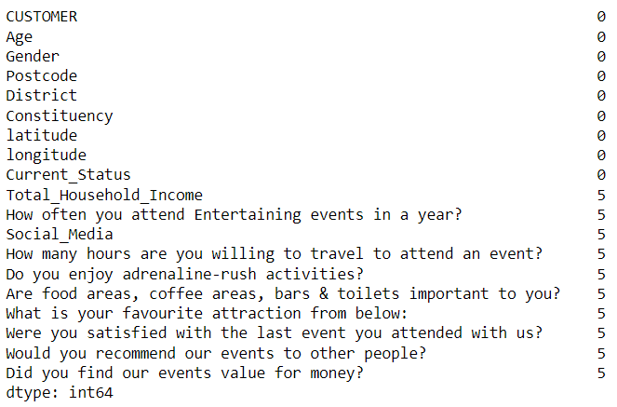

**Fig 4.1 Handling Missing Values**

**DETAILED DESIGN**

**5.1 Proposed Architecture**

The proposed architecture for the Customer Feedback Analysis project involves a seamless integration of data processing, clustering algorithms, dimensionality reduction, and interactive visualization using Power BI.

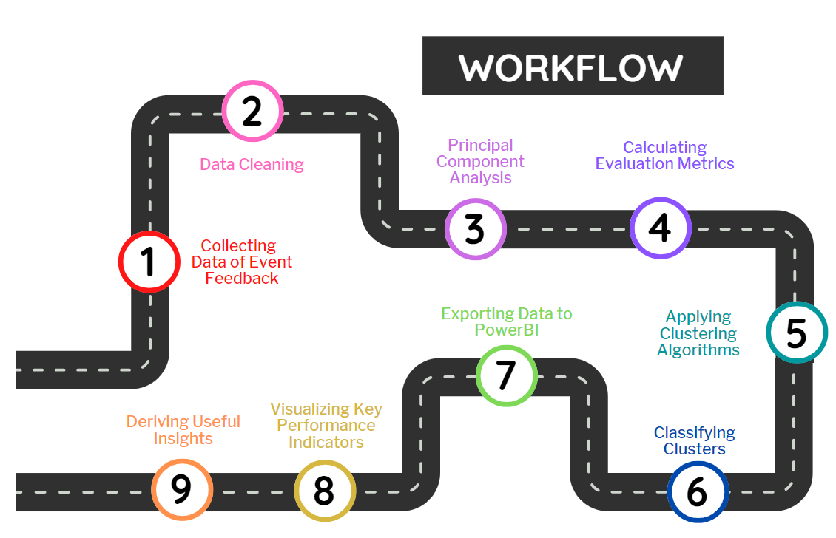

**Fig 5.1 Proposed Architecture**

*The key components of the architecture include:*

**- Data Collection:** Gathering customer feedback data from various sources.

**- Data Preprocessing:** Cleaning, validating, and transforming the data for analysis.

**- K-means Clustering:** Applying the K-means algorithm to group customer feedback into clusters.

**- Principal Component Analysis (PCA):** Reducing data dimensionality for efficient visualization.

**- Power BI Integration:** Importing the clustered data and PCA results into Power BI.

**- Interactive Visualizations:** Creating interactive dashboards and visual representations for effective data exploration.

**5.2 Functional & Non-Functional Requirements**

|  |  |
| --- | --- |
| **Functional Requirements** | **Non-Functional Requirements** |
| * Data Collection * Data Preprocessing * K-means Clustering * PCA Implementation * Power BI Integration | * Performance * Scalability * Usability * Reliability |

**Table 5.1 Functional and Non-Functional Requirements**

**5.3 Methodology**

*The project follows a systematic methodology for customer feedback analysis:*

* **Data Collection:** Gather feedback data from multiple sources and ensure data integrity.
* **Data Preprocessing:** Clean and validate the data, handling missing values and outliers.
* **K-means Clustering:** Apply K-means algorithm to group similar feedback points into clusters.
* **PCA:** Implement PCA for dimensionality reduction while preserving important features.
* **Power BI Integration:** Import clustered data and PCA results into Power BI for visualization.
* **Interactive Visualization:** Create interactive dashboards to present cluster insights.
* **Cluster Trait Analysis:** Analyse cluster characteristics and interpret customer preferences.
* **Data-Driven Recommendations:** Derive actionable recommendations based on the analysis.

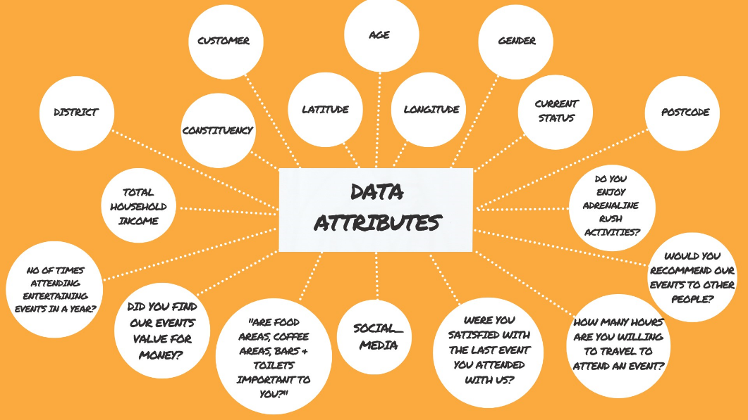

**Fig 5.2 Data Attributes**

**5.4 Implementation**

This project implementation involves using Python for data processing, K-means clustering, and PCA. Power BI will be used for interactive visualization and creating dynamic dashboards.

**5.5 Data Flow & Control Flow Sequence**

*Data Flow Sequence:*

1. Data Collection 🡪 2. Data Preprocessing 🡪 3. K-means Clustering 🡪 4. PCA 🡪 5. Power BI Integration 🡪 6. Interactive Visualization 🡪 7. Cluster Trait Analysis 🡪 8. Data-Driven Recommendations

*Control Flow Sequence:*

1. Start

2. Collect Feedback Data

3. Preprocess Data

4. Implement K-means Clustering

5. Apply PCA

6. Integrate with Power BI

7. Create Interactive Visualizations

8. Analyse Cluster Traits

9. Derive Data-Driven Recommendations

10. End

**5.6 Testing & Validation**

To validate and evaluate the effectiveness of the K-means clustering algorithm, we will compare its performance with other clustering methods, namely DBSCAN (Density-Based Spatial Clustering of Applications with Noise) and Agglomerative clustering. The evaluation will be based on several metrics, including the number of clusters formed, silhouette score, and inertia.

*Comparing K-means with DBSCAN and Agglomerative Clustering:*

**1. Number of Clusters:**

*- K-means:* The number of clusters will be determined using the elbow method or other appropriate techniques to find the optimal K value.

*- DBSCAN:* The number of clusters is not explicitly specified in DBSCAN. It identifies clusters based on density, and outliers are considered noise.

*- Agglomerative Clustering:* The number of clusters is specified beforehand in the agglomerative clustering algorithm, often using a hierarchical dendrogram.

**2. Silhouette Score:**

   - The silhouette score measures the quality of clustering results. It quantifies how similar an object is to its own cluster compared to other clusters. A higher silhouette score indicates better-defined clusters.

   - We will calculate the silhouette scores for each clustering method to compare their clustering quality.

**3. Inertia:**

   - Inertia is the sum of squared distances between each data point and its cluster's centroid. It measures how tightly grouped the data points are within each cluster.

   - We will compute the inertia for K-means and compare it with the intra-cluster distances for DBSCAN and agglomerative clustering.

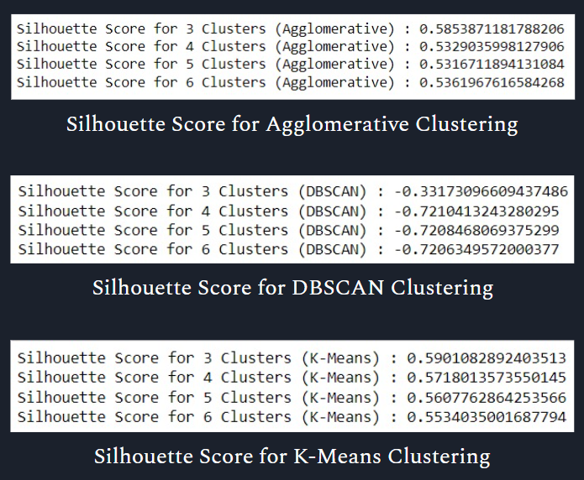

**Fig 5.3 Comparing Different Algorithms**

*Validation:*

**1. Data Preparation:** Preprocess the feedback data, handle missing values, and normalize the features as required for the clustering algorithms.

**2. K-means Clustering:** Apply the K-means algorithm to the pre-processed data and determine the optimal number of clusters (K). Compute the silhouette score and inertia for K-means clustering.

**3. DBSCAN Clustering:** Implement DBSCAN on the pre-processed data. Since DBSCAN does not require specifying the number of clusters, we will examine the clustering results and evaluate its performance.

**4. Agglomerative Clustering:** Perform agglomerative clustering with a predefined number of clusters. Evaluate its performance based on the silhouette score and inertia.

**5. Comparison and Analysis:** Compare the results of the three clustering algorithms. Analyse the number of clusters formed and the clustering quality (silhouette score and inertia) to understand the strengths and weaknesses of each method.

**6. Validation and Interpretation:** Validate the clustering results by inspecting cluster characteristics and interpretability. Check if the clusters make sense from a business perspective and align with expected customer feedback patterns.

By comparing K-means with DBSCAN and agglomerative clustering using metrics such as the number of clusters, silhouette score, and inertia, we determined the most suitable clustering method for our customer feedback analysis as K-Means Clustering method. The validation process will help us identify the most effective clustering approach, providing valuable insights into customer segments and preferences, ultimately guiding data-driven decisions for business improvements.

|  |  |  |  |
| --- | --- | --- | --- |
| **Number of Clusters** | **Visualization** | **Inertia** | **Silhouette Score** |
| 3 |  | 92911.46 | 0.5901 |
| 4 |  | 85693.40 | 0.5718 |
| 5 |  | 80703.38 | 0.5607 |
| 6 |  | 78454.81 | 0.5534 |

**Table 5.2 Testing and Validation**

**RESULTS AND DISCUSSIONS**

**Results:**

We outline the key findings and insights obtained from the clustering process. The results will include the following aspects:

- *Number of Clusters:* We report the optimal number of clusters (K) determined through the elbow method or other evaluation techniques for the K-means algorithm.

- *Dimensionality Reduction:* We present the PCA results, showcasing the most significant components that explain the variance in the feedback data while reducing its dimensionality.

- *Cluster Characteristics:* We discuss the traits and patterns identified within each customer feedback cluster. This includes common sentiments, preferences, and themes expressed by customers in each cluster.

**Discussions:**

In the discussion section, we interpret and analyse the results of our customer feedback analysis. We delve into the implications of the identified clusters and explore their potential business applications. The discussion will cover the following points:

- *Business Insights:* We discuss the insights gained from each cluster and how they provide valuable information for decision-making. We highlight any surprising or unexpected findings and their significance.

- *Customer Segmentation:* We explore how the identified customer segments can be effectively targeted with tailored marketing strategies and personalized offerings.

- *Actionable Recommendations:* Based on the analysis, we propose data-driven recommendations for product enhancements, customer engagement, and overall business improvements.

- *Limitations:* We acknowledge any limitations in our analysis, such as data quality issues, assumptions made during clustering, or potential biases. We discuss how these limitations might impact the validity of our results.

- *Comparison with Other Methods:* If we explored other clustering algorithms like DBSCAN and agglomerative clustering during the project, we discuss the reasons behind K-means' superior performance.

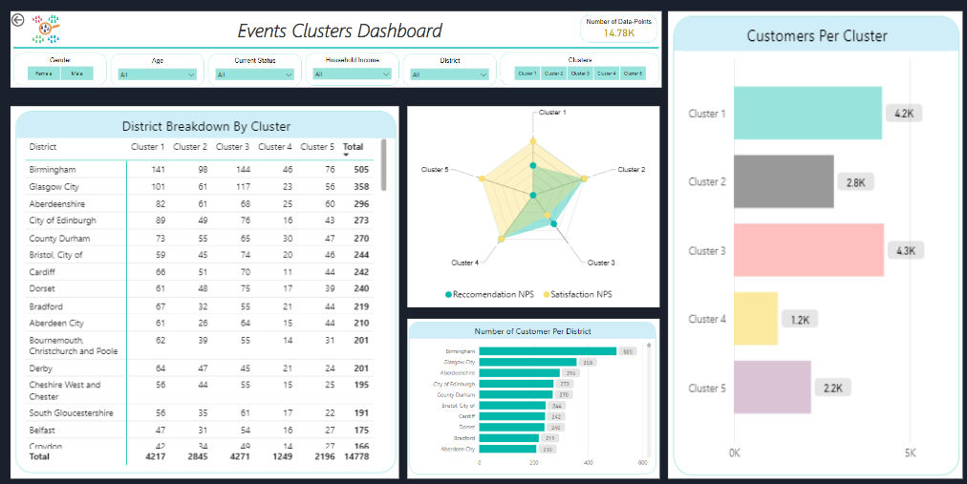

**Fig 6.1 Dashboard**

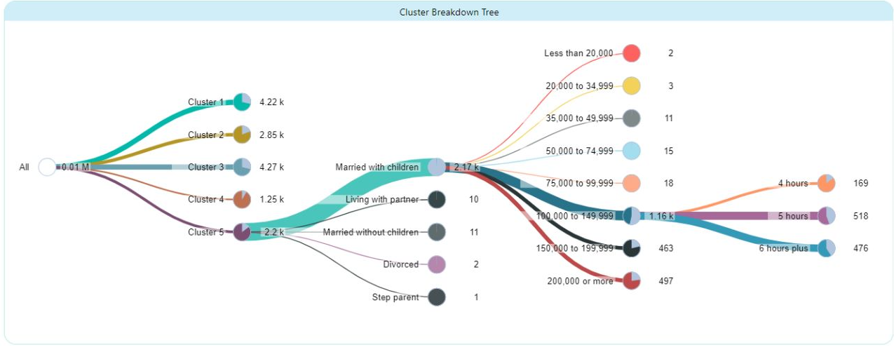

**Fig 6.2 Cluster Breakdown Tree**

**CONCLUSION & FURTHER ENHANCEMENTS**

**Conclusion:**

We summarize the key findings and outcomes of the customer feedback analysis project. We restate the significance of the project's objectives and how they were achieved using K-means clustering and PCA. The conclusion highlights the following points:

*- Successful Clustering:* We emphasize that K-means clustering successfully grouped similar feedback points into meaningful clusters, providing valuable insights into customer preferences.

- *Dimensionality Reduction:* PCA effectively reduced the dimensionality of the feedback data, simplifying visualization and analysis without losing crucial information.

- *Data-Driven Decision Making:* We reiterate how the data-driven insights derived from the analysis can aid in making informed decisions for product improvements and business strategies.

**Further Enhancements:**

In this section, we discuss potential avenues for further enhancing the customer feedback analysis project. This may include the following:

- *Text Analysis:* If the customer feedback data contains textual information, we can explore natural language processing techniques to extract more nuanced insights from the text data.

- *Real-time Analysis:* Implementing real-time data processing and analysis can enable timely responses to customer feedback and dynamic customer segmentation.

- *Incorporating Additional Data Sources:* Integrating data from additional sources, such as demographic information or purchase history, could enrich the customer feedback analysis and provide deeper customer insights.

By outlining possible enhancements, we demonstrate the project's potential for future development and expansion. The conclusion and further enhancements section solidify the project's contributions and set the stage for ongoing improvements to customer feedback analysis in the organization.

**REFERENCES**

**Coursera IBM Data Science**

<https://www.coursera.org/account/accomplishments/professional-cert/HTDAXJ7NZ3W6>

**Udemy Python for Machine Learning and Data Science**

<https://www.udemy.com/certificate/UC-2898e6cd-51a5-4956-9db3-9f8761697e4c/>

**Coursera Mathematics for Machine Learning and Data Science**

<https://www.coursera.org/account/accomplishments/specialization/TX8G257TA8SZ?utm_source%3Dandroid%26utm_medium%3Dcertificate%26utm_content%3Dcert_image%26utm_campaign%3Dsharing_cta%26utm_product%3Ds12n>

**Codebasics Power BI**

<https://codebasics.io/certificate/CB-49-28359>

**APPENDIX-A**

**CERTIFICATES**

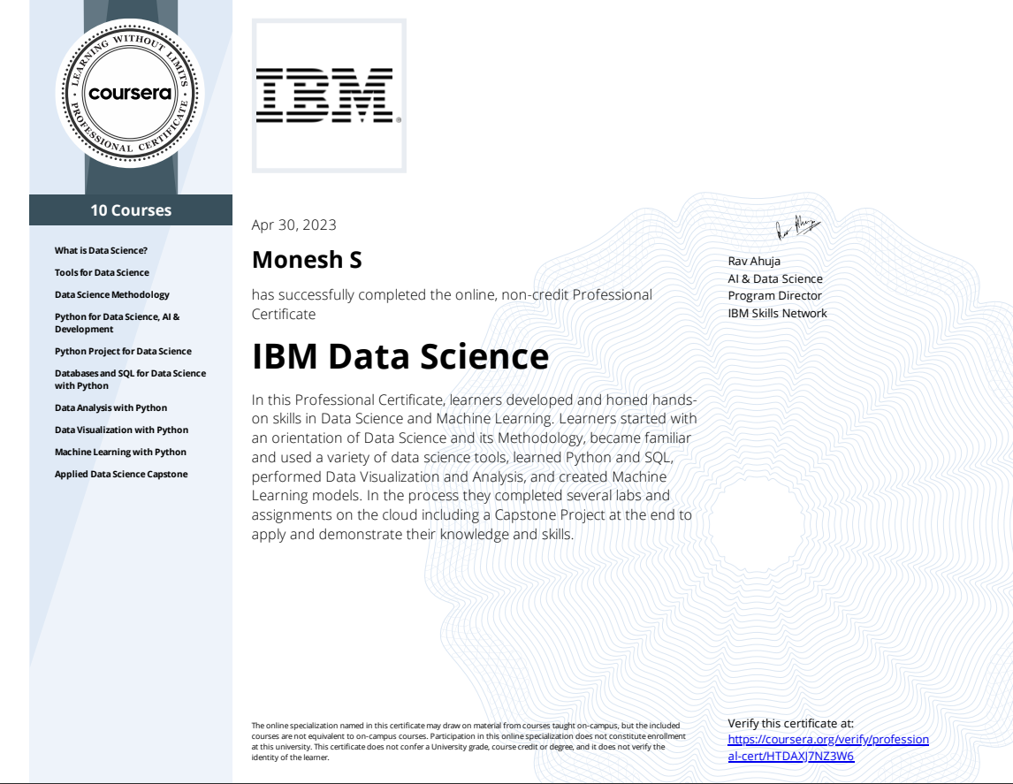



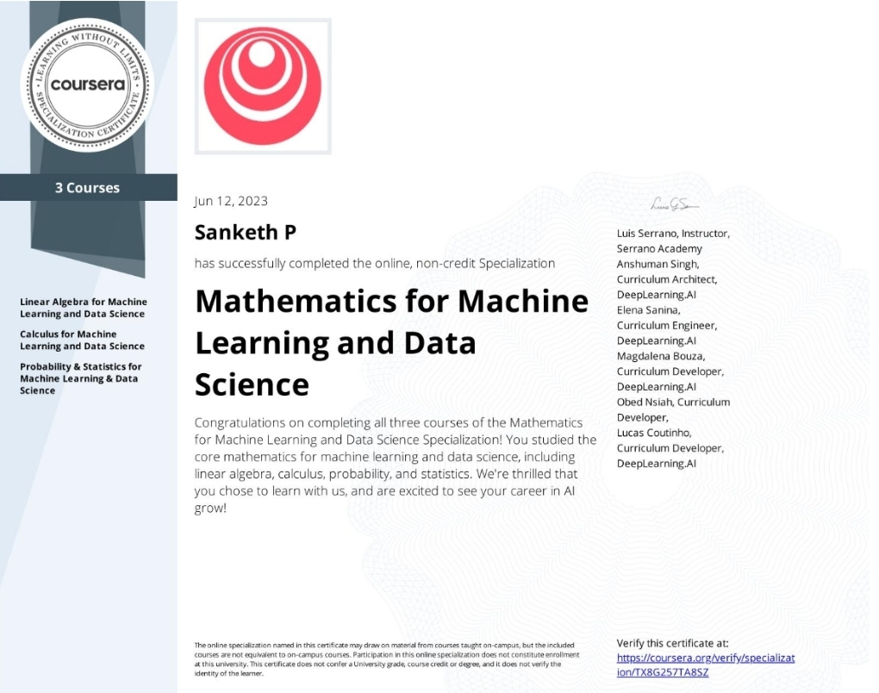



**APPENDIX-B**

**RELATED MATHEMATICAL CONCEPTS**

The customer feedback analysis project involves various mathematical concepts that underpin the data analysis and clustering techniques used. Below are some key mathematical concepts relevant to the project:

**1. Distance Metrics:** Distance metrics play a crucial role in clustering algorithms like K-means and DBSCAN. Common distance metrics include Euclidean distance, Manhattan distance, and cosine similarity. These metrics quantify the similarity or dissimilarity between data points in multi-dimensional space, aiding in the formation of clusters.

**2. K-means Clustering:** K-means is a partition-based clustering algorithm that aims to divide data points into K distinct clusters. It relies on optimization techniques to minimize the intra-cluster variance and maximize the inter-cluster variance. The algorithm iteratively assigns data points to the nearest cluster centroid and recalculates the centroids until convergence.

**3. Principal Component Analysis (PCA):** PCA is a dimensionality reduction technique that transforms high-dimensional data into a lower-dimensional space while preserving its variance. PCA computes the principal components, which are orthogonal linear combinations of the original features. These components represent the most significant patterns in the data, allowing for efficient visualization and analysis.

**4. Elbow Method:** The elbow method is a graphical technique used to determine the optimal number of clusters (K) in K-means clustering. It involves plotting the variance explained as a function of K and identifying the "elbow" point, where the rate of variance reduction slows down. The elbow point indicates the optimal K value that strikes a balance between intra-cluster similarity and inter-cluster separation.

**5. Silhouette Score:** The silhouette score is a measure of clustering quality. It quantifies how well-separated the clusters are and ranges from -1 to 1. A higher silhouette score indicates better-defined clusters, where data points are closer to their own cluster centroids than to others.

**6. Density-Based Spatial Clustering of Applications with Noise (DBSCAN):** DBSCAN is a density-based clustering algorithm that groups data points based on their density. It identifies core points (data points with a minimum number of neighbours within a specified radius) and expands clusters around them, including density-reachable points. Outliers are considered noise.

**7. Inertia (Within-Cluster Sum of Squares):** Inertia is a measure used in K-means clustering to assess the compactness of the clusters. It represents the sum of squared distances between each data point and its cluster centroid. Lower inertia values indicate more tightly grouped data points within each cluster.

**8. Statistical Testing:** Statistical testing techniques may be used to validate the significance of differences between clusters or to assess the statistical significance of findings derived from the analysis.