**NITTE MEENAKSHI INSTITUTE OF TECHNOLOGY**

(AN AUTONOMOUS INSTITUTION, AFFILIATED TO VISVESHWARAYA TECHNOLOGICAL UNIVERSITY, BELGAUM, APPROVED BY AICTE & GOVT.OF KARNATAKA

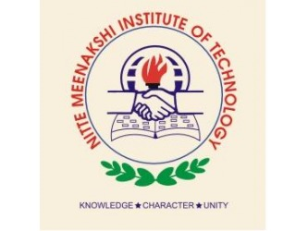

**COURSE PROJECT REPORT**

On

**IMAGE EDITOR**

*Submitted in partial fulfilment of the requirement for the award of Degree of*

*Bachelor of Engineering*

*In*

*Computer Science and Engineering*

Submitted by:

|  |  |
| --- | --- |
| AMITH KUMAR R | 1NT18CS009 |
| MONISH K | 1NT18CS100 |
| RITHIK G | 1NT18CS132 |
|  |  |



**Department of Computer Science and Engineering**

2019-20

|  |  |  |
| --- | --- | --- |
|  | **Nitte Meenakshi Institute of Technology**  (AN AUTONOMOUS INSTITUTION AFFILIATED TO VISVESVARAYA TECHNOLOGICAL UNIVERSITY, BELGAUM)  PB No. 6429, Yelahanka, Bangalore 560-064, Karnataka  Telephone: 080- 22167800, 22167860  Fax: 080 - 22167805 |  |

**Department of Computer Science and Engineering**

**CERTIFICATE**

This is to certify that the Course Project titled “IMAGE EDITOR” is an authentic work carried out by **Amith kumar R(1NT18CS009), Monish K (1NT18CS100),Rithik G(1NT18CS132),** bonafide students of **Nitte Meenakshi Institute of Technology**, Bangalore in partial fulfilment for the award of the degree of ***Bachelor of Engineering*** in COMPUTER SCIENCE AND ENGINEERING of Visvesvaraya Technological University, Belagavi during the academic year ***2019-2020.***

|  |  |  |
| --- | --- | --- |
| **Name Signature of the Faculty In charge** |  | **Name and Signature of the HOD** |

**DECLARATION**

We hereby declare that

(i) This Presentation does not contain text, graphics or tables copied and pasted from the Internet, unless specifically acknowledged, and the source being detailed in the report and in the References sections.

(ii) All corrections and suggestions indicated during the internal presentation have been incorporated in the report.

(iii) Content of the report has been checked for the plagiarism requirement

Name USN Signature

|  |  |  |
| --- | --- | --- |
| Amith kumar R | 1NT18CS009 |  |
| Monish K | 1NT18CS100 |  |
| Rithik G | 1NT18CS219 |  |
|  |  |  |

**Date: 15-04-2020**

**ACKNOWLEDGEMENT**

The satisfaction and euphoria that accompany the successful completion of any task would be incomplete without the mention of the people who made it possible, whose constant guidance and encouragement crowned our effort with success. We express our sincere gratitude to our Principal **Dr. H. C. Nagaraj**, Nitte Meenakshi Institute of Technology for providing facilities.

We wish to thank our HoD**, Dr. Thippeswamy M.N** for the excellent environment created to further educational growth in our college. We also thank him for the invaluable guidance provided which has helped in the creation of a better technical report.

Thanks to our Guide. We also thank all our friends, teaching and non-teaching staff at NMIT, Bangalore, for all the direct and indirect help provided in the completion of the presentation.

|  |  |  |
| --- | --- | --- |
| Name  Amith kumar R  Monish K  Rithik G | USN  1NT18CS009  1NT18CS100  1NT18CS132 | Signature |

Date: 15-04-2020

**ABSTRACT**

Image editing refers to modifying or improving digital or traditional photographic images using different techniques, tools or software. Images produced by scanners, digital cameras or other image-capturing devices may be good, but not perfect. Image editing is done to create the best possible look for the images and also to improve the overall quality of the image according to different parameters.

The main objectives are as follows

* Correct for lens aberrations, if needed: distortion (barrel and pincushion), chromatic aberration (color fringing), and light falloff (in wide angle lenses).
* Adjust the brightness, contrast, color tint, and color saturation of the image as a whole.
* Adjust portions of the image to bring them into balance with the image as a whole. This typically involves the use of masks and may be facilitated by sophisticated techniques such as contrast masking.
* Sharpen the image, and, if necessary, reduce grain.

**TABLE OF CONTENTS**

* **INTRODUCTION**
* **LITERATURE SURVEY**
* **THEORETICAL CONCEPTS (OOP PRINCIPLES)**
* **SNAPSHOTS OF THE RESULT**
* **CONCLUSION**
* **BIBLIOGRAPHY**

* **INTRODUCTION**

Image editing encompasses the processes of altering images, whether they are digital photographs, traditional photo-chemical photographs, or illustrations. Traditional analog image editing is known as photo retouching, using tools such as an airbrush to modify photographs or editing illustrations with any traditional art medium. Graphic software programs, which can be broadly grouped into vector graphics editors, raster graphics editors, and 3D modelers, are the primary tools with which a user may manipulate, enhance, and transform images.

The main objectives are as follows

* Correct for lens aberrations, if needed: distortion (barrel and pincushion), chromatic aberration (color fringing), and light falloff (in wide angle lenses).
* Adjust the brightness, contrast, color tint, and color saturation of the image as a whole.
* Adjust portions of the image to bring them into balance with the image as a whole. This typically involves the use of masks and may be facilitated by sophisticated techniques such as contrast masking.
* Sharpen the image, and, if necessary, reduce grain.
* **LITERATURE SURVEY**

In order to fully understand the impact of this image viewer and editor in an industrial scenario, it is important to first take a back-seat and ensure what an image editor conjures up with, by having feasibility study and evaluating various scenarios, and why it should beimplemented and from what perspective it will be accountable?

Lastly, the conceptual literature review will focus on how an innovative and practical model can be implemented alongside the pre-existing models in the modern trends of an industrial scenario, keeping in mind of both the subject world and the usage world. The facts that this image editor deals with to innovate in designing this software which would help us in image viewing and editing, thereby making modifications in digital images to view different effects without destroying the original image and the very nuances of devising the notion of ensuring the modular design.

* **THEORETICAL CONCEPTS (OOP PRINCIPLES)**

The various OOP principles involved are

* Classes and objects: Basically classes are user defined data types which describe the properties of an object. An object is an instance of a class which has its own behavior and properties.
* Data encapsulation: Bundling of data and functions into a single unit called class which supports data abstraction and data hiding. Abstraction refers to the act of representing essential features without including the background of details or the explanations. Access specifiers are used to set the visibility of data as private protected or public
* Member functions: They are the functions declared in the class or with respect to the class. They can be defined either inside or outside the class.
* Inheritance: Inheritance in Java is a mechanism in which one object acquires all the properties and behaviors of a parent object. ... The idea behind inheritance in Java is that you can create new classes that are built upon existing classes. When you inherit from an existing class, you can reuse methods and fields of the parent class.
* Virtual function: In object-oriented programming, a virtual function or virtual method is a function or method whose behaviour can be overridden within an inheriting class by a function with the same signature to provide the polymorphic behavior.
* Abstract class: An abstract class is a class that is declared abstract —it may or may not include abstract methods. Abstract classes cannot be instantiated, but they can be subclassed. When an abstract class is subclassed, the subclass usually provides implementations for all of the abstract methods in its parent class.
* **SNAPSHOTS OF THE RESULT**



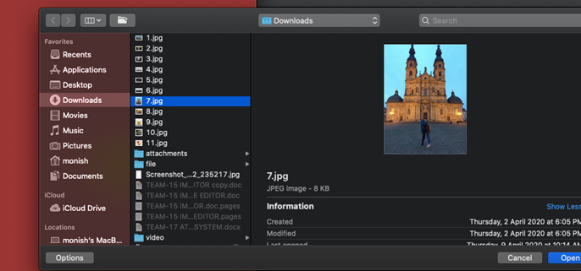

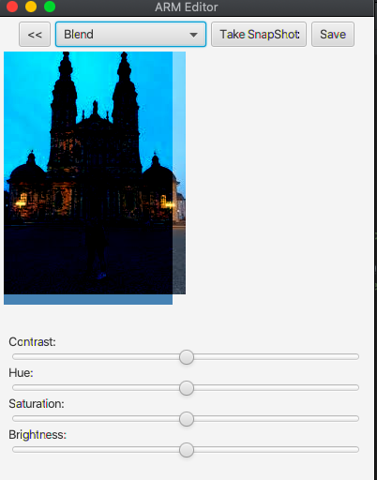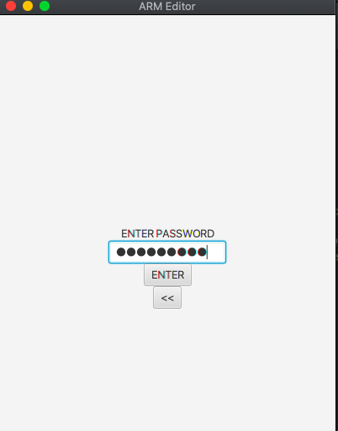

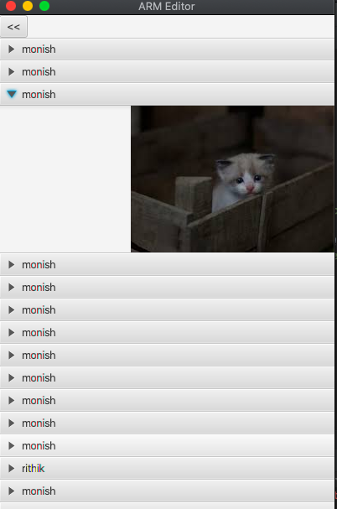

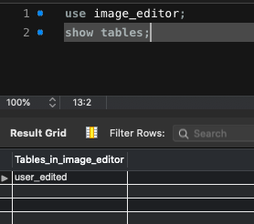 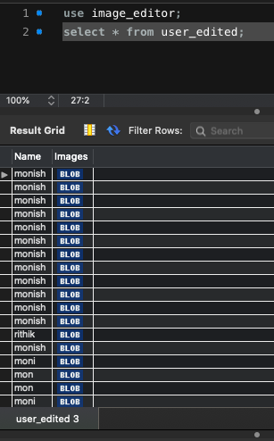

* **CONCLUSION**

It helps the user to increase the quality of the image like changing the perspects of the image as per the user desires.

The job of a photo editor also includes allocating and coordinating assignments and approving images. They are also tasked with selecting, editing, and positioning photos.

* **BIBLIOGRAPHY**

* JAVA TEXT BOOK –

Java:The complete reference,7th edition,Tata McGraw

* **SITES <https://www.tutorialspoint.com/javafx/index.htm>**

<https://www.javatpoint.com/javafx-tutorial>

<https://www.w3schools.com/java/>