FORTENS SOLUTIONS
End-to-End Manufacturing Tracking Software
Product Documentation & Solution Overview

Prepared by Fortens Solutions
June 2026

1. Introduction
Fortens Solutions has developed a unified manufacturing tracking software that allows steel and metal manufacturing companies to manage their complete production journey — from raw material receipt to final dispatch — within a single platform.
The software replaces scattered registers, spreadsheets, and manual paperwork with one connected system, giving manufacturers real-time visibility, accurate quality records, and complete traceability for every batch produced.

Core Modules
- Raw Materials – manage incoming billets, chemical composition, and inventory.
- Production Details – track rolling, lot creation, and production efficiency.
- Mechanical Properties – conduct quality tests and generate test certificates.
- Dispatch – process customer orders and auto-generate billing.
- Every stage is linked, so data entered once flows automatically through the next stage — reducing duplicate work and human error.

2. Dashboard — Single Point of Control
After logging in, users land on a clean dashboard with quick access to all four core modules, plus quick actions for license management and QR code generation.
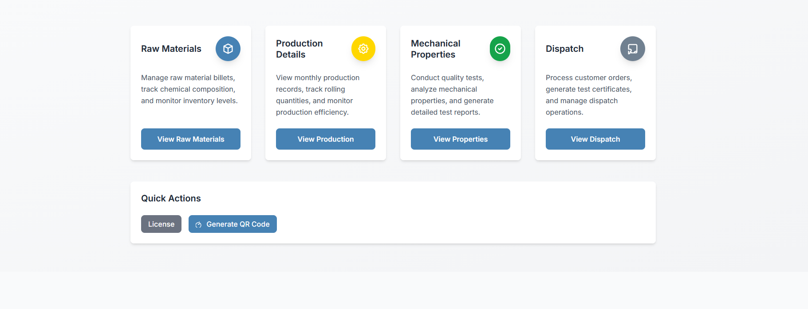
Figure 1: Dashboard — Raw Materials, Production Details, Mechanical Properties, Dispatch
- One-click navigation into Raw Materials, Production Details, Mechanical Properties, and Dispatch.
- Quick Actions panel for License management and Generate QR Code.

3. Raw Material Management
The Raw Materials module records every incoming batch of material with complete chemical and physical specifications, keeping live stock levels always up to date.
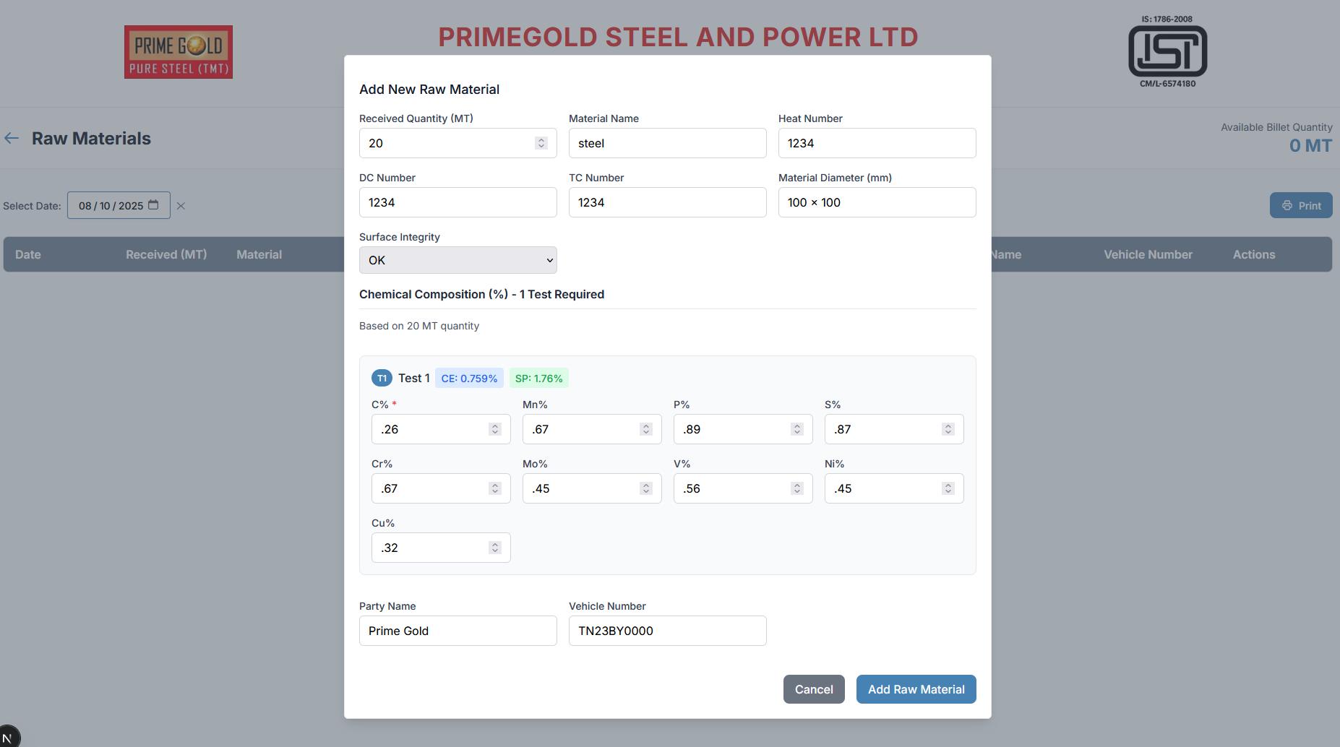
Figure 2: Add New Raw Material — quantity, heat number, chemical composition
Each entry captures Received Quantity, Material Name, Heat Number, DC Number, TC Number, Diameter, and Surface Integrity, along with full chemical composition (C%, Mn%, P%, S%, Cr%, Mo%, V%, Ni%, Cu%) with auto-calculated Carbon Equivalent (CE%) and Strength Parameter (SP%).
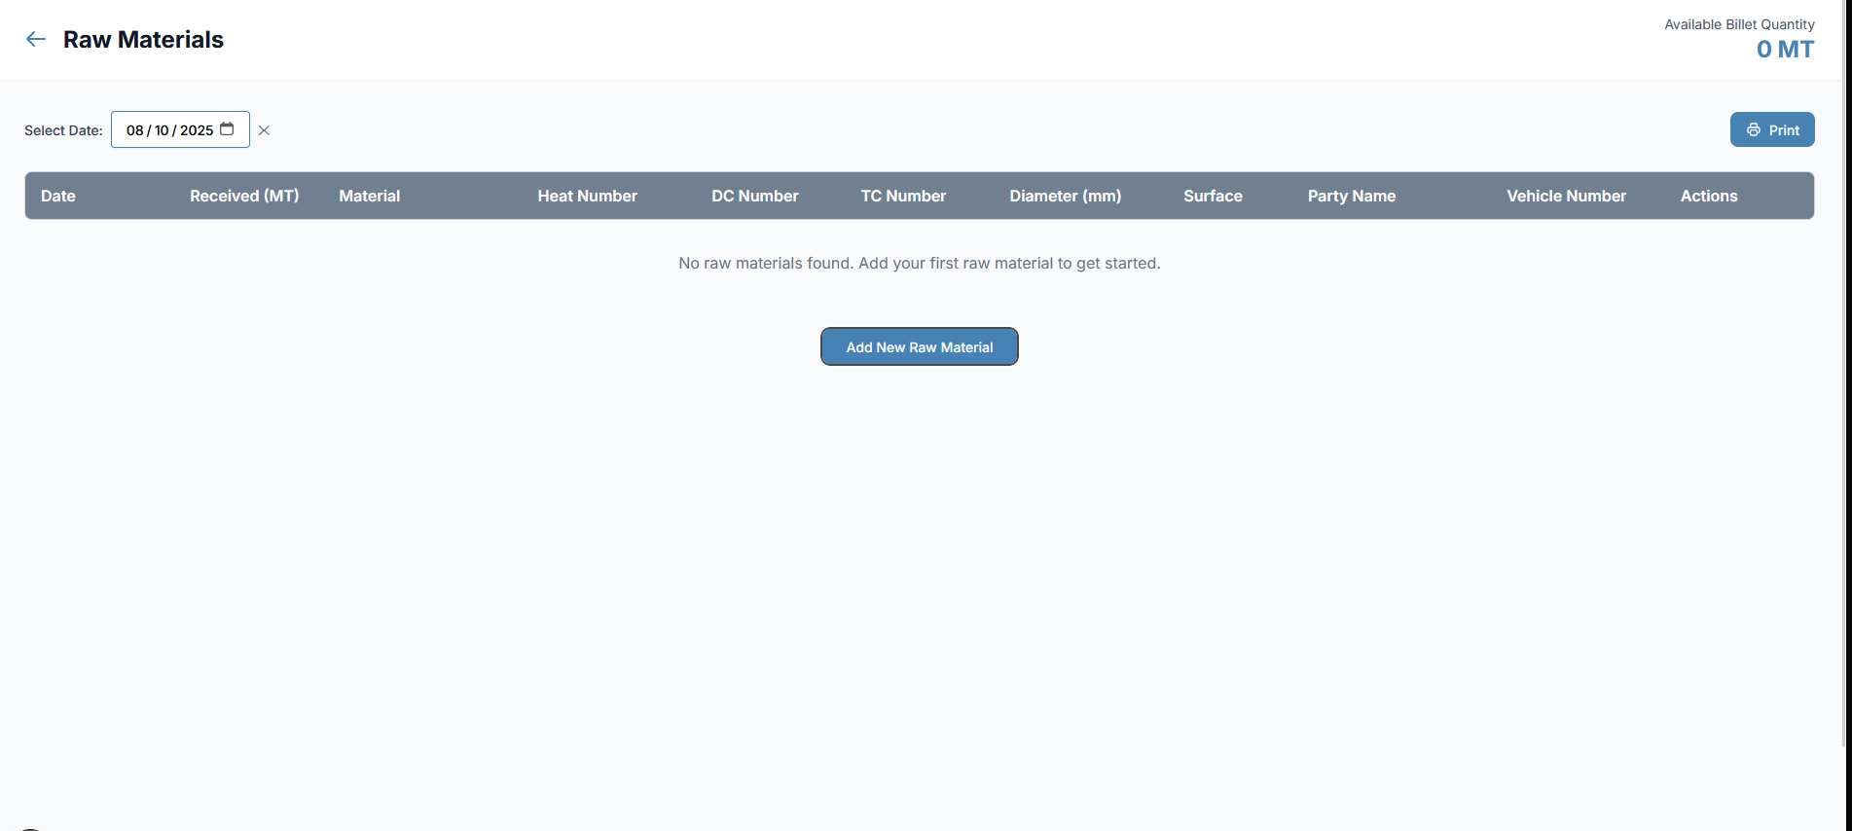
Figure 3: Raw Materials list with date filter and available billet quantity
- Filter records by date to view what was received on any given day.
- Live tracking of Available Billet Quantity at all times.
- One-click Print to generate a report of materials received on the selected day.

4. Production Details — Rolling Process
Raw materials added in the previous step become available for rolling here, connecting inventory directly to production without re-entering data.
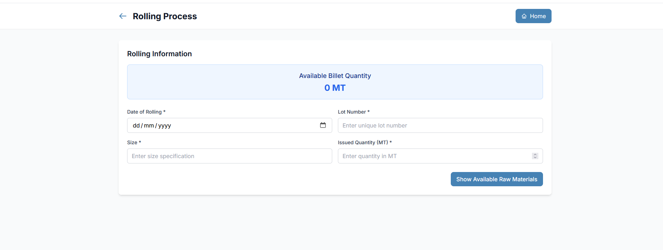
Figure 4: Rolling Process — lot creation from available raw materials
- Displays live Available Billet Quantity pulled from Raw Materials stock.
- Captures Date of Rolling, unique Lot Number, Size, and Issued Quantity.
- “Show Available Raw Materials” lets the user select stock and push it into production as a tracked lot.

5. Mechanical Properties Testing
Once a lot completes production, it automatically appears here for quality testing — closing the gap between production and quality control.
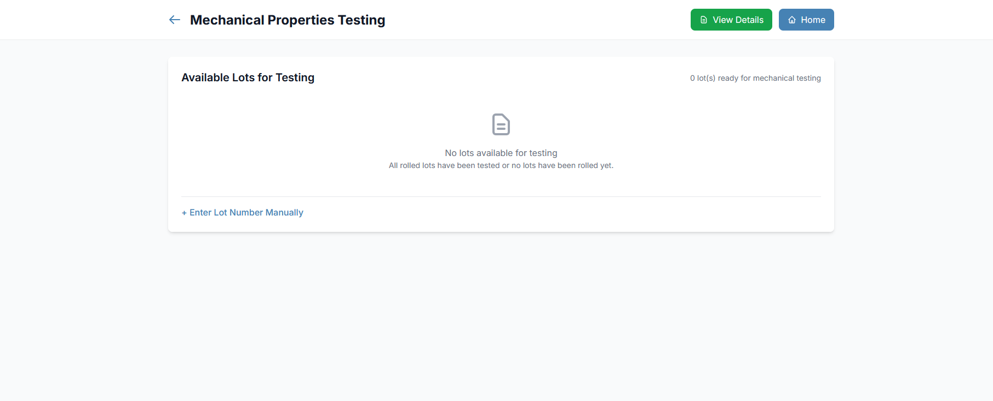
Figure 5: Available Lots for Testing, with manual lot entry option
- Lots ready for mechanical testing are listed automatically after rolling.
- Lot numbers can also be entered manually if needed.
- Multiple tests can be recorded against a single lot, and detailed test certificates are generated from the results.

6. Dispatch Management
Tested and approved lots flow into Dispatch, where customer orders are processed and billing is generated automatically — no manual invoice preparation needed.
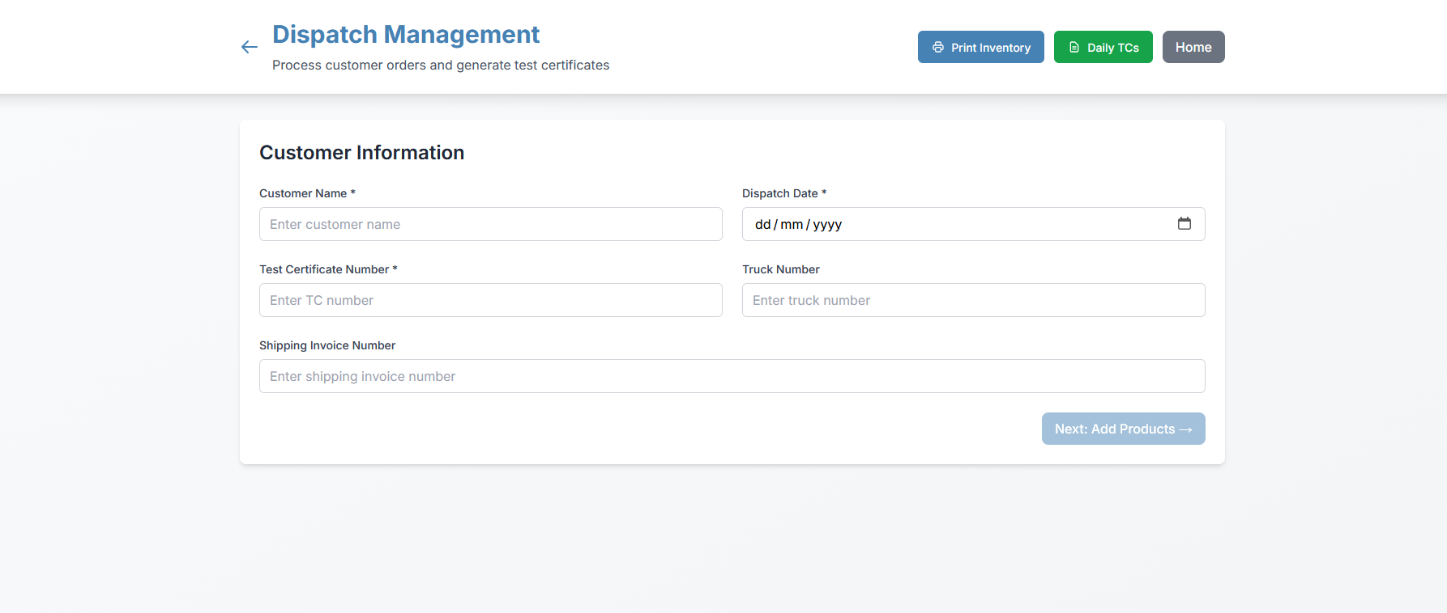
Figure 6: Dispatch Management — customer information and order processing
- Captures Customer Name, Dispatch Date, Test Certificate Number, Truck Number, and Shipping Invoice Number.
- Produced and tested items can be selected directly from inventory for the order.
- The bill is generated automatically once items are selected and confirmed.
- Print Inventory and Daily TCs options provide instant reporting for dispatch records.

7. End-to-End Traceability via QR Code
Every tested lot can be linked to a QR code, giving instant, verifiable traceability from raw material to finished product.
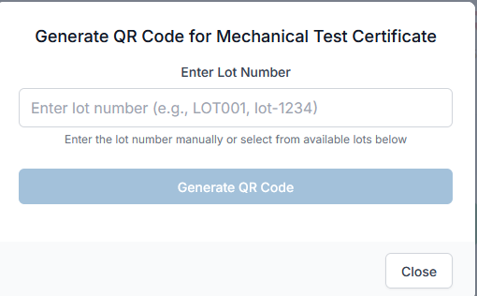
Figure 7: Generate QR Code for Mechanical Test Certificate
Once a lot has been tested, entering its Lot Number generates a unique QR code for that batch. Scanning the code instantly displays the complete lot history:
- Raw Material report — source, composition, and inspection details.
- Production report — rolling date, size, and lot details.
- Mechanical Testing report — quality test results and certification.
This gives customers, auditors, and internal teams a single scan to verify product quality and origin — with no paperwork to search through.

8. Reporting & Customization
Every module in the platform includes a built-in Print option, so records from any stage — raw materials, production, testing, or dispatch — can be exported as a clean report at any time. This supports day-to-day tracking as well as audits and compliance checks.
The software is also fully customizable to each company's needs — forms, test parameters, certificate formats, and branding can be tailored to match how a specific business already works.
- Print-ready reports available on every page of the system.
- Custom fields and workflows configurable per company.
- Branding support, e.g. company name and certification marks on generated documents.

9. Summary
Fortens Solutions' manufacturing tracking software connects every stage of production into one continuous, traceable workflow:
Stage | What Happens | Key Outcome
Raw Materials | Incoming billets logged with full chemical composition | Accurate, live inventory
Production | Raw material rolled into lots with size & quantity | Linked, traceable lots
Mechanical Testing | Quality tests run on completed lots | Verified product quality
Dispatch | Orders processed, items selected, bill auto-generated | Faster, error-free billing
QR Traceability | Scan a lot's QR code | Full history in one scan

By bringing raw material handling, production, quality testing, and dispatch into a single system — with print-ready reporting and full customization — Fortens Solutions gives manufacturers the visibility and control needed to run an efficient, audit-ready operation.

