ECA56 ADVANCED WIRELESS COMMUNICATION SYSTEMS
CO1 Integrated Engineering Analysis and Planning Assignment
Evolution, Cellular Planning, Spectrum Use and Interference Management
Engineering Design Report for a Regional Wireless Operator

Submitted by
Name: Monish.S
Register Number: 192312617

1. Requirements, Method and Assumptions
A regional operator is planning the next stage of its mobile network and has supplied a small set of planning data. This report uses that data to explain how mobile systems evolved from 1G towards the 6G vision, and then to size the cell layout, traffic capacity, handoff behaviour, interference margin and spectrum choice for a first deployment. The report follows the order requirements, analysis, calculations, comparison and recommendation. Sections 2 to 6 correspond to Stages 1 to 5 of the assignment, with the calculations and their meaning given together. Section 7 covers the spectrum comparison and international coordination, and Section 8 gives the phased recommendation.
The supplied inputs are summarised in Table 1. All calculations were checked by hand and by a short script; the script only performs the arithmetic, and the method for each result is written out in the text.
Table 1. Planning inputs used in this report
Topic | Input values
Cell geometry | Hexagonal cells, radius r = 2 km; planning cluster of 19 cells; reuse cluster size N = 7
Traffic | 1,000 subscribers × 0.08 Erlang in the busy hour; C = 100 channels at the initial base station; blocking target ≤ 2 %
Mobility | v = 60 km/h; overlap-zone dwell time 6 s; route length per cell 1 km; handoff interruption 0.5 s; target cell unavailable 1 % of the time
Interference | S = −70 dBm; co-channel I₁ = −85 dBm; adjacent-channel I₂ = −90 dBm; minimum SINR 15 dB
Spectrum | 900 MHz, 3.5 GHz, 28 GHz at d = 100 m; c = 3 × 10⁸ m/s; FSPL = 20 log₁₀(4πd/λ)
1G / 2G / 3G | AMPS: 800 MHz, 30 kHz channels, 10 MHz allocation. GSM: 900 MHz, 200 kHz carrier, 8 TDMA slots. UMTS: 5 MHz carrier

Assumptions that apply throughout. (a) Cells are ideal regular hexagons, so every cell has the same area and the same number of neighbours. (b) The 1,000 subscribers generate Poisson call arrivals independently of each other, and blocked calls are cleared, which is the basis of the Erlang B model. (c) Thermal noise is not given in the data, so the “SINR” in Stage 5 is computed from the supplied signal and interference levels only and ignores noise. (d) Free-space propagation is used for the band comparison, which gives a lower bound on path loss. (e) For the idealised 1G channel count, guard bands, control channels and duplex separation are ignored.

2. Stage 1: Evolution of Mobile Systems

2.1 Generational comparison
Table 2 follows each generation using the examples in the planning data. The last column gives the main limitation or engineering change that pushed the industry towards the next generation.
Table 2. Comparison of mobile generations
Gen. | Main service | Access / radio technology | Key parameters | Limitation that motivated the next step
1G  (AMPS) | Analog voice only | Analog FM with FDMA; one user per 30 kHz channel | 800 MHz band; 30 kHz channels; 10 MHz allocation | Low capacity, no encryption, poor use of spectrum, no data service; motivated digital transmission
2G  (GSM) | Digital voice, SMS, low-rate data | TDMA on FDMA carriers, 8 slots per carrier | 900 MHz; 200 kHz carrier; 8 slots | Circuit-switched design and low data rates; web and multimedia traffic needed packet data
3G  (UMTS) | Voice plus mobile data and multimedia | Wideband CDMA | 5 MHz carrier; frequency reuse of one possible | Interference-limited capacity and modest data rates; users wanted broadband speeds
4G  (LTE) | Mobile broadband over an all-IP network | OFDMA with MIMO | Scalable carrier bandwidth | Sub-6 GHz spectrum is scarce; latency and cell-edge rates limit new services
5G  (NR) | eMBB, URLLC and massive IoT | OFDM-based NR, massive MIMO and beamforming | Mid-band (about 3.5 GHz) and mmWave (about 28 GHz) | mmWave has short range and blockage; dense sites raise cost and energy use
6G  (vision) | Holographic communication, tactile internet, ISAC | THz bands, AI-native networking | Not yet standardised | THz propagation loss, hardware cost, energy use and standards still to be settled

2.2 Wavelength and idealised channel count for 1G
The wavelength at 800 MHz follows from λ = c/f:
λ = c / f = (3 × 10⁸ m/s) / (800 × 10⁶ Hz) = 0.375 m (1)
The idealised number of 30 kHz AMPS channels in a 10 MHz allocation is:
N_ch = 10 MHz / 30 kHz = 10 000 kHz / 30 kHz ≈ 333 (2)
This figure ignores guard bands, control channels and duplexing. In a real FDD system such as AMPS, the base-to-mobile and mobile-to-base directions use separate frequencies, so if the 10 MHz were shared between both directions only about 166 duplex pairs would exist, and some channels would be used for signalling. Guard bands between operators add a further loss. The figure of 333 is therefore an upper bound and not a usable traffic-channel count. With a reuse factor of N = 7 the 333 channels would be split so that each cell has only about 47 of them, which shows how strongly 1G capacity was limited.

2.3 From analog FDMA to digital TDMA
In GSM a 200 kHz carrier is shared by 8 time slots, so each full-rate user occupies the equivalent of 200/8 = 25 kHz, compared with 30 kHz for one AMPS user. That is a modest gain by itself, but the bigger benefit of digital transmission is that speech is compressed, error-protected and encrypted. Digital links tolerate a lower carrier-to-interference ratio than analog FM, so cells that use the same frequencies can be placed closer together, and this raises capacity per unit area. Digital signalling also made roaming, SMS and later packet data possible. These improvements are what made 2G more efficient than 1G rather than the slot arithmetic alone.

2.4 Synthesis
Across the generations the role of spectrum changed from a resource that was divided into narrow fixed channels (1G and 2G) to one that is shared flexibly by many users through codes (3G), subcarriers (4G) and beams (5G and 6G). Capacity moved from being limited mainly by the number of channels to being limited by interference, which is why each generation added a stronger interference tool: fixed reuse patterns in 1G and 2G, power control and soft handoff in 3G, scheduling and inter-cell coordination in LTE, and beamforming in 5G. The 6G vision pushes this further by using AI to manage resources and by sensing the environment with the same signals used for communication. At the same time, each jump to a higher frequency range has made cells smaller, which is why the later sections of this report treat cell size, handoff and spectrum band as a single design problem.

3. Stage 2: Cell Coverage and Frequency Reuse

3.1 Cell area and cluster area
For a regular hexagon with circumradius r, the area is A = (3√3/2) r². With r = 2 km:
A_cell = (3√3 / 2)(2 km)² = 2.598 × 4 = 10.39 km² (3)
A_19 = 19 × 10.39 km² = 197.45 km² (4)

3.2 Frequency reuse fraction and reuse distance
With cluster size N = 7, each cell uses one seventh of the available channels, and the distance between the centres of nearest co-channel cells is:
Reuse fraction = 1 / N = 1 / 7 = 0.143 (5)
D = r√(3N) = 2 km × √21 = 2 × 4.583 = 9.17 km (6)
The ratio D/r = 4.58 is the co-channel reuse ratio. A larger ratio means better isolation between co-channel cells, but fewer channels per cell. Figure 1 shows the seven-cell cluster and the position of the nearest co-channel cell.
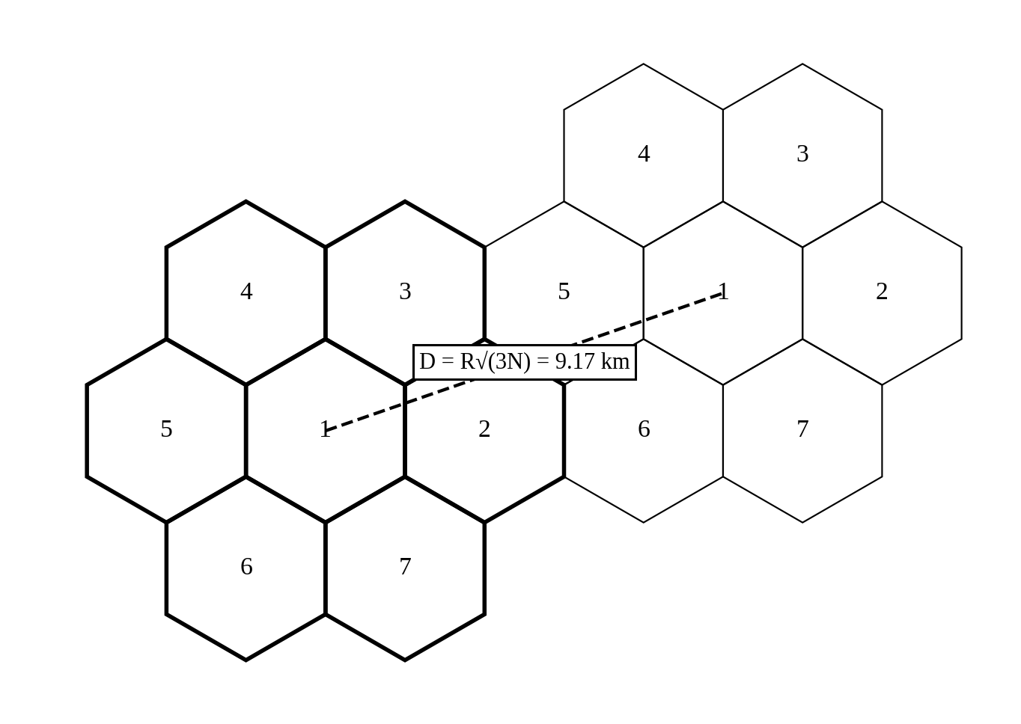
Figure 1. Seven-cell cluster (N = 7) and the nearest co-channel cell at distance D

3.3 Hexagonal approximation and real coverage
The hexagon is used because it is the regular shape closest to a circle that tiles a plane without gaps or overlap. Circles would leave gaps or overlap and squares and triangles give less uniform distances to the base station. The model assumes flat terrain, an omnidirectional antenna at the cell centre, identical transmit power and identical path loss in all directions. Real cells are irregular because of buildings, hills, foliage and antenna patterns. Geometric coverage only says that a point lies inside the hexagon, whereas guaranteed radio coverage requires the received signal to exceed a threshold with a given reliability. Shadow fading and indoor loss mean that a point inside the hexagon can still have no usable signal, and the signal can also be strong outside the hexagon, which is the origin of co-channel interference. The 197 km² cluster area is therefore a planning figure and not a coverage guarantee.

3.4 Capacity-expansion techniques
Table 3. Effect of cell-structure techniques on coverage and capacity
Technique | Effect on coverage and capacity | Effect on interference | Effect on handoff
Cell splitting | A cell is divided into smaller cells with lower power. Halving r cuts the cell area to a quarter (10.39 to 2.60 km²), so capacity per km² rises about four times for the same channels per cell | D/r stays the same, so C/I is roughly unchanged if power is reduced correctly | Handoffs per kilometre roughly double
Sectoring (120°) | Same coverage, but channels are divided between three sectors. Antenna gain is higher and capacity per site can increase because a tighter reuse becomes possible | First-tier co-channel interferers drop from about 6 to about 2 | More handoffs between sectors, though these are inside one site
Microcell | Cells of a few hundred metres, with antennas below rooftop; suitable for streets and hotspots | Interference is contained by buildings | Fast users cross many microcells, so handoffs are frequent
Picocell | Tens of metres, normally indoors in offices, malls or stations | Isolated by walls, but may interfere with the outdoor layer on the same carrier | Few handoffs for stationary users
Femtocell | Home access point of a few tens of metres, connected through broadband | Uncoordinated deployment can create interference with the macro layer | Handoff between femto and macro layers needs careful policy

Recommendation. For this operator the most suitable first expansion measure is 120° sectoring on the existing macro sites, followed by selective cell splitting or microcells only where measured traffic demands it. Sectoring needs no new sites or land, it raises the SINR (Section 6.1 shows the interference case misses its target by about 1.2 dB), and it keeps the 2 km cell layout. The cost is more handoffs between sectors and a loss of trunking efficiency, because the channel pool is divided into three smaller groups. Cell splitting should be held back for hotspots, since it multiplies the number of sites and the handoff rate.

4. Stage 3: Traffic Capacity

4.1 Offered traffic
Offered traffic is the number of subscribers multiplied by the traffic each one generates in the busy hour:
A = U · a = 1000 × 0.08 Erlang = 80 Erlangs (7)
On average, 80 channels would be busy if no calls were ever blocked. Because call arrivals are random, the actual number of busy channels fluctuates around this value, and capacity has to be provided above 80 to keep blocking low.

4.2 Erlang B blocking
The Erlang B model gives the probability that all C channels are busy when an arriving call is cleared. It can be evaluated with the recursion B(A,0) = 1 and B(A,k) = A·B(A,k−1) / [k + A·B(A,k−1)]. For A = 80 Erlangs:
B(80, 100) = 0.00399 ≈ 0.40 % (8)
The initial 100 channels therefore give a blocking probability of about 0.4 %, which is well below the 2 % target. To find the smallest channel count that meets 2 %, the recursion was evaluated for increasing C, with the results near the target given in Table 4.
Table 4. Erlang B blocking for A = 80 Erlangs
Channels, C | Blocking B (%) | Meets 2 % target?
90 | 2.62 | No
91 | 2.25 | No
92 | 1.92 | Yes (smallest value)
95 | 1.14 | Yes
100 | 0.40 | Yes (initial design)

The smallest channel count that meets the target is C = 92, with a blocking probability of 1.92 %. With 91 channels the blocking is 2.25 %, which fails. Figure 2 shows how steeply the blocking falls once C exceeds the offered load.
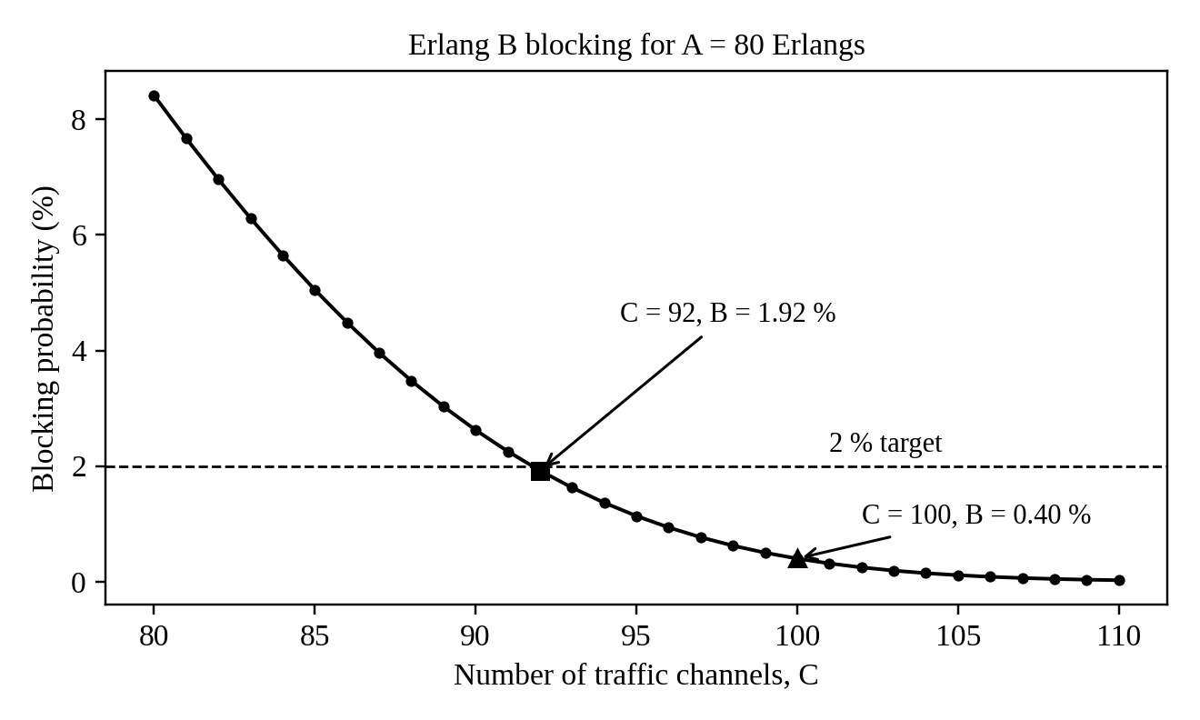
Figure 2. Erlang B blocking probability against number of channels for A = 80 Erlangs

4.3 Number of base-station channel groups
The requirement of 92 channels is less than the 100 channels of one base station, so one 100-channel group is enough for the offered load: ⌈92 / 100⌉ = 1. The extra 8 channels act as headroom. Solving the Erlang B equation for 100 channels at 2 % blocking gives a maximum load of about 88 Erlangs, which corresponds to about 1,100 subscribers at 0.08 Erlang, so the design can absorb roughly 10 % growth before it fails the target.

4.4 Trade-offs and limits of the estimate
Providing 100 channels instead of 92 costs 8 more channels of radio equipment and spectrum but reduces blocking from 1.92 % to 0.40 %. The cost of a very low blocking figure is poor utilisation: carried traffic per channel is about 85 % at C = 92 and about 80 % at C = 100, and the last few channels are used rarely. This is the usual trunking trade-off, since larger channel groups are more efficient but cost more to build.
This is only a first-order estimate and not a site plan. The calculation treats all 1,000 subscribers as sharing one pool of channels at one place, but in a real network they are spread over 19 cells and each cell can only use its own channels. As a check, if the 80 Erlangs were spread evenly over the 19 cells, each cell would carry about 4.2 Erlangs and would need 9 channels for 2 % blocking, giving 171 channels in total instead of 92. Uneven demand makes this worse, because busy cells block calls while quiet cells have idle channels. The model also assumes Poisson arrivals, blocked calls cleared, a constant 0.08 Erlang per user at the same busy hour, and ignores handoff calls that arrive from neighbouring cells, which add to the load.

5. Stage 4: Mobility and Handoff

5.1 Distance in the overlap zone and handoff rate
The speed is 60 km/h, which is 60 000 m / 3 600 s = 16.67 m/s. During the 6 s overlap interval the mobile travels:
d_overlap = v · t = 16.67 m/s × 6 s = 100 m (9)
The overlap zone is therefore about 100 m long, which is only about 10 % of a 1 km cell length. The mobile spends 1 000 m / 16.67 m/s = 60 s in each cell, so:
Handoffs per minute = v / L = (1 km/min) / (1 km) = 1 per minute (10)
Here I have interpreted the 1 km as the route distance between consecutive handoff points, so that one handoff occurs every cell crossed. This is a conservative planning value. A route passing through the centre of a hexagon with r = 2 km would be about √3 r = 3.46 km long, giving only about 0.29 handoffs per minute, so the 1 km figure represents a smaller cell or a route that clips the cell edge. If the overlap zone were removed from the cell length the rate would be about 1.1 per minute, so the result is not very sensitive to this interpretation.

5.2 Hard, soft and softer handoff
Table 5. Comparison of handoff types
Type | How it works | Continuity | Resource use
Hard | The old link is released before the new link is made (break-before-make); the mobile uses one channel at a time. Used in AMPS and GSM | A short interruption occurs (0.5 s in this problem) and the call can be dropped if the target fails | Lowest; only one channel is used at any moment
Soft | The mobile is connected to two or more base stations at the same time (make-before-break) and signals are combined. Used in CDMA/UMTS | Very good; no gap in the connection | Higher; several radio links and backhaul connections are held during the handoff
Softer | A soft handoff between two sectors of the same base station, combined inside that site | Very good | Uses extra radio resources but little extra backhaul, since the combining is done at one site

5.3 Call-drop risk for one handoff
If the target cell is unavailable 1 % of the time, a hard handoff attempt fails with probability about 0.01, and the simplest estimate of the drop risk per handoff is:
P_drop ≈ 0.01 = 1 % per handoff (11)
The 0.5 s interruption is a separate effect: it is 0.5 / 60 = 0.83 % of the time spent in a cell, and it appears as a short speech gap and not as a dropped call. At one handoff per minute, a 5-minute call crosses about 5 cells, so the chance of at least one drop is 1 − 0.99⁵ = 4.9 %, which is high for voice and shows why handoff failure matters more than blocking in a fast-moving case.
The estimate has several limits. It treats each attempt as independent and assumes that “unavailable” always means “call dropped”, whereas in practice the mobile can retry during the 6 s overlap (which is 12 times longer than the interruption) and the real failure rate would be lower. Against that, it ignores handoffs lost through weak signal, late triggering, shadow fading and ping-pong between cells, which would raise the figure. It also assumes constant speed and a fixed unavailability, whereas the latter is higher at peak hours when target cells are loaded.

6. Stage 5: Interference and Spectrum-Band Comparison

6.1 Interference calculation
The carrier-to-interference ratio with only the co-channel interferer is the difference of the two levels in dB:
C/I = S − I₁ = −70 − (−85) = 15 dB (12)
This is exactly equal to the target. To include both interferers the powers must be added in linear units, not in dB. Using P(mW) = 10^(dBm/10):
I₁ = 10^(−8.5) = 3.162 × 10⁻⁹ mW I₂ = 10^(−9.0) = 1.000 × 10⁻⁹ mW (13)
I_total = 4.162 × 10⁻⁹ mW = 10 log₁₀(4.162 × 10⁻⁹) = −83.81 dBm (14)
SINR = S − I_total = −70 − (−83.81) = 13.81 dB (15)
The SINR is 13.81 dB, which is below the 15 dB target by about 1.19 dB, so the target is not met. The adjacent-channel signal is 5 dB weaker than the co-channel one, yet it still costs more than 1 dB, which shows that a small interferer should not be ignored when the margin is zero. As noted in Section 1, thermal noise is not included, so a real SINR would be slightly lower still.
Mitigation. I recommend 120° sectoring with coordinated channel assignment. Each sector antenna sees only about 2 first-tier co-channel cells instead of 6, an ideal reduction of 10 log₁₀(6/2) = 4.8 dB in co-channel interference. If only I₁ is reduced by this factor, the total interference becomes 2.054 × 10⁻⁹ mW (−86.87 dBm) and the SINR rises to about 16.9 dB, which meets the target with about 1.9 dB of margin. The trade-off is that the channels of a cell are split into three smaller groups, so trunking efficiency falls. For example, if the 80 Erlangs were divided into three sectors of 26.7 Erlangs each, 36 channels per sector (108 in total) would be needed instead of 92 for the same 2 % blocking. Sectoring also adds sector-to-sector handoffs and requires more antennas and feeders. Increasing the cluster size to N = 9 or 12 would also improve SINR, but it would reduce the channels per cell more severely.

6.2 Free-space path loss at 900 MHz, 3.5 GHz and 28 GHz
The wavelength is λ = c/f and the free-space path loss at d = 100 m is FSPL = 20 log₁₀(4πd/λ). For 900 MHz, λ = 0.3333 m, so 4πd/λ = 3 770 and FSPL = 71.53 dB. The same method was used for the other two bands, and the results are collected in Table 6.
Table 6. Wavelength and free-space path loss at d = 100 m
Frequency | Wavelength | FSPL at 100 m | Difference from 900 MHz
900 MHz | 33.3 cm | 71.53 dB | Reference
3.5 GHz | 8.57 cm | 83.32 dB | +11.80 dB (20 log₁₀(3.5/0.9))
28 GHz | 1.07 cm | 101.38 dB | +29.86 dB (20 log₁₀(28/0.9))

The differences match 20 log₁₀(f₂/f₁), which confirms the arithmetic. In free space, path loss grows by 6 dB for every doubling of frequency when both antennas have the same effective aperture, as the formula assumes.

6.3 Comparison of the three bands
Table 7. Deployment characteristics of the three bands
Band | Penetration and range | Antenna size | Coverage / capacity implication
900 MHz | Best penetration through walls and foliage; longest range | Largest elements (λ/2 ≈ 17 cm) | Wide-area and indoor coverage with few sites, but only a small bandwidth is usually available, so capacity is limited
3.5 GHz | Moderate penetration; range about a third to half of 900 MHz in the same conditions | λ/2 ≈ 4.3 cm; allows massive MIMO panels of many elements | Good balance; wide channels (up to 100 MHz) give high capacity, and beamforming helps recover coverage
28 GHz | Poor penetration; blocked by walls, vehicles and even people; short range | λ/2 ≈ 5 mm; very large arrays fit in a small panel | Very large bandwidth (hundreds of MHz) for hotspots and fixed access, but needs dense small cells with line of sight

Higher path loss at higher frequency does not by itself decide network performance, for several reasons. The extra loss in the formula comes from the smaller aperture of an antenna at that frequency; a physically larger array at 28 GHz has more elements and can supply beamforming gain that recovers much of the difference. Higher bands also have much more bandwidth, and Shannon capacity depends on bandwidth as well as SNR, so a link with lower SNR but ten times the bandwidth can still carry more data. In addition, narrow beams reduce interference, so the SINR can improve even where the signal is weaker. What actually limits a deployment is the combination of path loss, blockage, bandwidth, interference, site density and cost, and this is why the three bands should be used together.

7. Stage 6: International Spectrum Coordination

7.1 Roles of ITU-R, WRC and the Radiocommunication Bureau
Table 8. Roles in international spectrum coordination
Body | Role | Example relevant to this plan
ITU-R (Radiocommunication Sector of the ITU) | Develops technical standards, recommendations and reports through study groups, and prepares the technical basis for spectrum decisions | Defined the IMT-2020 (5G) requirements and the IMT-2030 (6G) framework
WRC (World Radiocommunication Conference) | Meets about every 3 to 4 years and has the authority to revise the Radio Regulations, which is an international treaty; it allocates frequency bands to radio services and identifies bands for IMT | Identified mmWave bands in the 24.25–27.5 GHz range and others for 5G at WRC-19
Radiocommunication Bureau (BR) | Executive arm of ITU-R; applies the Radio Regulations, records frequency assignments in the Master International Frequency Register, handles coordination and notification of assignments and supports the study groups and conferences | Registers and coordinates cross-border frequency assignments

7.2 Effect on national regulators and operators
International coordination affects national regulators because the national frequency table has to be consistent with the Radio Regulations, and a country that licenses a band in a way that causes harmful interference to neighbours can be challenged. Near borders, base stations in a band such as 3.5 GHz normally need a bilateral coordination agreement, which may limit transmit power or antenna direction along the border. For the operator, harmonised band identification means that equipment and handsets are produced in large volumes for the same band, which lowers cost; on the other hand, a band that is not harmonised in the home country, or that is used by satellite services, may not be available at all. The exact edges of the 28 GHz range differ between regions, so the operator must confirm what its national regulator has actually released before ordering equipment.

8. Recommended Phased Deployment Strategy
The evidence from the calculations can be pulled together into the comparison in Table 9, and then into a three-phase plan.
Table 9. Summary of key results
Item | Result | Design meaning
Cell area / 19-cell area | 10.39 km² / 197.45 km² | Defines the macro layer footprint
Reuse distance D (N = 7) | 9.17 km (D/r = 4.58) | Isolation between co-channel cells
Offered traffic | 80 Erlangs | Load for channel sizing
Channels for 2 % blocking | 92 (100 gives 0.40 %) | One 100-channel group is enough in the pooled model, with about 10 % growth headroom
Handoff rate | 1 per minute at 60 km/h | Drop risk about 1 % per handoff
SINR | 13.81 dB against 15 dB | Fails by 1.19 dB; mitigation is needed
FSPL at 100 m | 71.5 / 83.3 / 101.4 dB | 28 GHz is 29.9 dB worse than 900 MHz

Phase 1: coverage and basic capacity (existing sites). Use the 900 MHz band as the wide-area coverage layer on the existing 2 km macro grid, with 120° sectoring and coordinated channel assignment to bring the SINR above 15 dB. Size each cell with the Erlang B method per cell and not on the pooled value, using the 92-channel result only as a lower bound. This phase fixes the interference deficit at the lowest cost and keeps the handoff rate manageable.
Phase 2: capacity layer (mid-band). Add 3.5 GHz 5G NR on the same sites with massive MIMO and beamforming. Its path loss is 11.8 dB higher than 900 MHz, but beamforming gain and wide channels compensate for most of it, so the existing sites can be re-used with some infill. Where measured traffic exceeds the sector capacity, split cells or add microcells, accepting a higher handoff rate and using soft or fast handoff procedures to keep the drop risk down on fast routes.
Phase 3: hotspots and future services. Introduce 28 GHz small cells only in dense, line-of-sight locations such as stations, campuses and stadiums, or for fixed wireless access, where its bandwidth and 29.9 dB extra loss at 100 m can be justified by demand. Pilot features of the 6G vision such as ISAC and AI-driven resource management only after standards and equipment are available.
Assumptions and uncertainties to check before deployment. (1) Real traffic per user and its spatial distribution, since the pooled Erlang B result of 92 channels hides a per-cell requirement that could be nearly twice as large. (2) Thermal noise and the real propagation exponent, which the data did not give and which would lower the SINR below 13.81 dB and change the reuse distance needed. (3) The actual overlap-zone dwell time and target-cell availability on the real routes, because the 1 % failure figure is only a single supplied value. (4) The national availability and licence conditions of 900 MHz, 3.5 GHz and 28 GHz, including border coordination. (5) Indoor penetration loss and equipment cost for the higher bands. These should be verified by drive tests, a propagation planning tool and busy-hour traffic measurements before the final investment decision.

References
[1] T. S. Rappaport, Wireless Communications: Principles and Practice, 2nd ed. Upper Saddle River, NJ: Prentice Hall, 2002.
[2] A. Goldsmith, Wireless Communications. Cambridge, U.K.: Cambridge University Press, 2005.
[3] V. H. MacDonald, “The cellular concept,” Bell System Technical Journal, vol. 58, no. 1, pp. 15–41, 1979.
[4] ITU-R, Recommendation M.2083-0, “IMT Vision – Framework and overall objectives of the future development of IMT for 2020 and beyond,” International Telecommunication Union, 2015.
[5] ITU-R, Recommendation M.2160-0, “Framework and overall objectives of the future development of IMT for 2030 and beyond,” International Telecommunication Union, 2023.
[6] International Telecommunication Union, Radio Regulations, Edition of 2020 (including the Final Acts of WRC-19).
[7] E. Dahlman, S. Parkvall and J. Sköld, 5G NR: The Next Generation Wireless Access Technology. London: Academic Press, 2018.

