Software Requirements Specification

for



**Version 2.0**

**Prepared by**

**Nagaratna Manjunath Naik:PES1UG21CS821**

**MonishaN:PES1UG21CS820**

**Nandini M V:PES1UG21CS823**

|  |  |  |
| --- | --- | --- |
|  |  |  |

**Revisions**

|  |  |  |  |
| --- | --- | --- | --- |
| **Version** | **Primary Author(s)** | **Description of Version** | **Date Completed** |
| 2.0 | Team Phoenix | The final version of the SRS document has been drafted with all the requirements being incorporated into the document. | 3/12/2022 |

Table:1

# 

# 

# *.*

# 

# 

# Introduction

## 1.1 Document Purpose

The product whose software requirements are specified in this document is ONLINE FOOD ORDER DELIVERY

The purpose of this document is to present a detailed description of the product, online food order delivery.

This document is intended to

* Explain the purpose and features of the product,
* The constraints under which the product must operate
* How the product would respond to different users’ requests.

The document’s primary goal is to help the reader get a better understanding of the project.

The document is intended for the developers of the software, the end users of the product who have been identified in the later sections, and to the professors who would review the project.

## 1.2 Product Scope

The main objective of the Project on Online Food Ordering System is to manage

the details of Food Item, Category, Customer, Order, Confirm Order. It manages all the

information about Food Item, Payment, Confirm Order, Food Item. The project is totally

built at administrative end and thus only the administrator is guaranteed the access. The

purpose of the project is to build an application program to reduce the manual work for

managing the Food Item, Category, Payment, Customer. It tracks all the details about

the Customer, Order, Confirm Order.

The main objective of the Project on Online Food Ordering System is to manage

the details of Food Item, Category, Customer, Order, Confirm Order. It manages all the

information about Food Item, Payment, Confirm Order, Food Item. The project is totally

built at administrative end and thus only the administrator is guaranteed the access. The

purpose of the project is to build an application program to reduce the manual work for

managing the Food Item, Category, Payment, Customer. It tracks all the details about

the Customer, Order, Confirm Order.

The main objective of the Project on Online Food Ordering System is to managethe details of Food Item, Category, Customer, Order, Confirm Order. It manages all theinformation about Food Item, Payment, Confirm Order, Food Item. The project is totallybuilt at administrative end and thus only the administrator is guaranteed the access. Thepurpose of the project is to build an application program to reduce the manual work formanaging the Food Item, Category, Payment, Customer. It tracks all the details aboutthe Customer, Order, Confirm Order.

## 

## 1.3 Intended Audience and Document Overview

**1.3.1** **Intended Audience:**

The intended audience for an online food delivery service would be individuals who are looking for a convenient and affordable way to get food delivered to their home or office. This could include busy professionals, families, college students, and anyone else who would prefer to have food delivered instead of having to go out and pick it up. This service could also be beneficial for people with mobility issues, who may not be able to leave their home to get food.

This document is primarily intended for the:

* Developers of this software
* Software engineers who would work on further development of the project
* The professors who would review the document and finally,
* Clients that is novice or professional event managers, volunteers.

**1.3.2** **Document Overview:**

The first chapter, that is the Introduction section of the document is intended to introduce the reader to the product, Event4u.

The second chapter, Overall Description section of SRS v2.0 document provides an

overview of the overall functionality of the product. It describes the informal requirements.

The third chapter, Specific Requirements section, of SRS v2.0 document is written primarily for the developers and describes in technical terms the details of the functionality of the product.

The second and the third chapter of the document describe the same software product, but are intended for different audiences and thus use different language.

## 

## 1.4 Definitions, Acronyms and Abbreviations

|  |  |  |
| --- | --- | --- |
| 1 | FOOD | Any nutritious substance that people or animals eat or drink, or that plantabsorbs, in order to maintain life and growth |
| 2 | **MENU** | A list of dishes available in a restaurant or the food available or to beserved in a restaurant or at a meal for example "a dinner-   party menu”, “politics   and sport are on the menu tonight". |
| 3 | Online food ordering | Online food ordering services are websites that feature interactive menus allowing customers to place orders with local restaurants and food cooperatives |
| 4 | Credit Card | A**credit card**is a[payment card](http://en.wikipedia.org/wiki/Payment_card)issued to users as a system of[payment.](http://en.wikipedia.org/wiki/Payment) It allows the cardholder to pay for goods and services based on the holder’s promise to pay for them |
| 5 | SRS | SRS stands for Software Requirement Specification. It is a document that completely describes all of the functions of a proposed system and the constraints under which it must operate. |
| 6 | Team Head | Team head is an individual who is responsible for all the actions undergoing under his/her team. |
| 7 | UI | UI stands for User Interface. It is defined as the space where interaction between humans and machines occurs. |
| 8 | View | View means to display and look at data on screen. |
| 9 | Customer | Sometimes known as a client, buyer, or purchaser) is the recipientof goods, services, products or idea obtained from a seller, vendor, or supplier for amonetary or other valuable consideration |

Table no:2

## 

## 

## 1.5 Document Conventions

Formatting Conventions:

* The font style for the headings of each section is Arial Bold and the font size is 18.
* The font style for the headings under each section is Arial Bold and the font size used is 14.
* For the remainder of the document, the font style is Arial and the font size is maintained at 11.
* Italics has been used to indicate comments.
* The text is single spaced and margins are maintained at 1’’ separation.

## 1.6 References and Acknowledgments

**1.6.1 References:**

C. Larman, APPLYING UML AND PATTERNS An Introduction to Object-Oriented

Analysis and Design and Iterative Development, 3rd ed., Massachusetts: Pearson Education, 2005.

D. Carrington, CSSE3002 Course Notes, School of ITEE University of Queensland, 2008

IEEE Recommended Practice for Software Requirements Speciﬁcations, IEEE Standard 830, 1998.

C. Larman, APPLYING UML AND PATTERNS An Introduction to Object-OrientedAnalysis and Design and Iterative Development, 3rd ed., Massachusetts: Pearson Education, 2005.

D. Carrington, CSSE3002 Course Notes, School of ITEE University of Queensland, 2008

IEEE Recommended Practice for Software Requirements Speciﬁcations, IEEE Standard 830, 1998.

**1.6.2 Acknowledgments:**

We would like to thank Mr.Abhishek, Mr.HarshGolyan, Mr.Prathik and Mr.Rakesh Kumar for sharing their experiences of organizing an event with us. We have gained a lot from their valuable input. A special mention to Mr.Ananth Raman sir for advising us about the different frameworks available and helping us decide the framework most suited for the software, event4u.

# 

# *2.* Overall Description

11

## 2.1 Product Perspective

The software described in this SRS is the software for a complete Restaurant food ordering system. The system merges various hardware and software elements and further interfaces with external systems. it relies on a number of external interfaces for persistence and unhandled tasks, as well as physically interfacing with humans

## 2.2 Product Functionality

The Restaurant food ordering system interfaces with an existing payment system, including a cash register and software accessible credit system, in order to quickly and easily handle customer billing. The payment system should be operable such that it can return information to the RFOSsystem as to whether payment was successful or failed

## 2.3 Users and Characteristics

1. Characteristics
2. There are three separate user interfaces used by the RFOS software, each related to an
3. interfaced physical hardware device . These three user interfaces are the Surface Computer UI,
4. Tablet UI and Display UI.

Characteristics

There are three separate user interfaces used by the RFOS software, each related to an

interfaced physical hardware device . These three user interfaces are the Surface Computer UI,

Tablet UI and Display UI.

There are three separate user interfaces used by the RFOS software, each related to an

interfaced physical hardware device . These three user interfaces are the Surface Computer UI,

Tablet UI and Display UI

There are three separate user interfaces used by the RFOS software, each related to an

interfaced physical hardware device . These three user interfaces are the Surface Computer UI,Tablet UI and Display UI

## 2.4 Operating Environment

1. The Surface Computer UI is the interface used by restaurant customers. This interface uses
2. the surface computer paradigm - users interact with the system by dragging 'objects' around on the
3. ﬂatscreen touch-sensitive display.
4. The Tablet UI is designed to run on a small, wireless-enabled touch-screen tablet PC, to be
5. used by waiters to accommodate customer needs.
6. The Display UI provides kitchen staﬀ with simple functionality related to ordered items

The Surface Computer UI is the interface used by restaurant customers. This interface uses

the surface computer paradigm - users interact with the system by dragging 'objects' around on theﬂatscreen touch-sensitive display.

The Tablet UI is designed to run on a small, wireless-enabled touch-screen tablet PC, to be

used by waiters to accommodate customer needs.

The Display UI provides kitchen staﬀ with simple functionality related to ordered items.

## 2.5 Design and Implementation Constraints

1. he RFOS should be written in an object-oriented language with strong GUI links and a
2. simple, accessible network API. The primary candidate tool chains are Java/Swing, C++/Qt and
3. Python/Qt. The system must provide a capacity for parallel operation and system design should not
4. introduce scalability issues with regard to the number of surface computers, tablets or displays
5. connected at any one time
6. he RFOS should be written in an object-oriented language with strong GUI links and a
7. simple, accessible network API. The primary candidate tool chains are Java/Swing, C++/Qt and
8. Python/Qt. The system must provide a capacity for parallel operation and system design should not
9. introduce scalability issues with regard to the number of surface computers, tablets or displays
10. connected at any one time

Constraints The RFOS should be written in an object-oriented language with strong GUI links and a simple, accessible network API. The primary candidate tool chains are Java/Swing, C++/Qt and Python/Qt. The system must provide a capacity for parallel operation and system design should not introduce scalability issues with regard to the number of surface computers, tablets or displays connected at any one time The system must be reliable enough to run crash and glitch free more or less indeﬁnitely, or facilitate error recovery strong enough such that glitches are never revealed to its end-users.

## 2.6 User Documentation

The end-users of the RFOS fall into three primary categories, unskilled, partly skilled and highly skilled.

.

## 2.7 Assumptions and Dependencies

1. The SRS assumes that none of the constituent system components will be implemented as embedded applications. It is further assumed that tablet PCs of sufficient processing capability and battery life will be utilized.

***3.* Specific Requirements**

## 

**3.1.** **External Interface Requirements**

3.1.1. User Interfaces

User interface design is concerned with the dialogue between a user and the computer.It is concerned with everything from starting the system or logging into the system to the eventually presentation of desired inputs and outputs. The overall flow of screens and messages is called a dialogue.

**Sample Screenshots:**

**Home page**

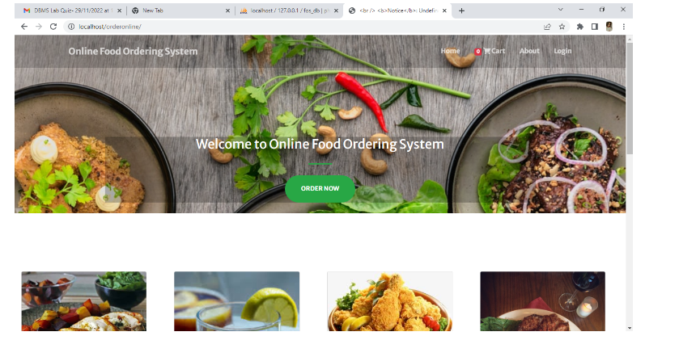

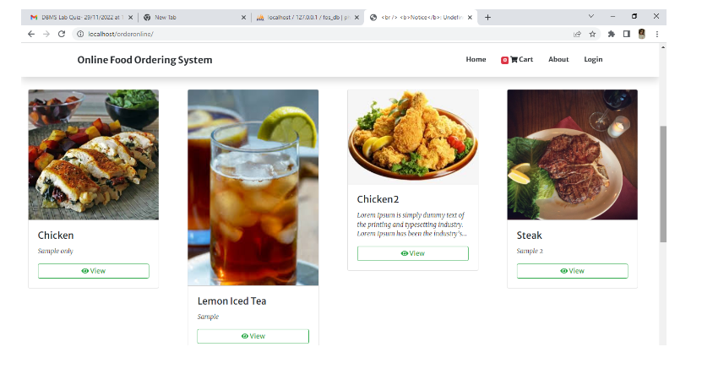

Fig 3.1.1 (a)

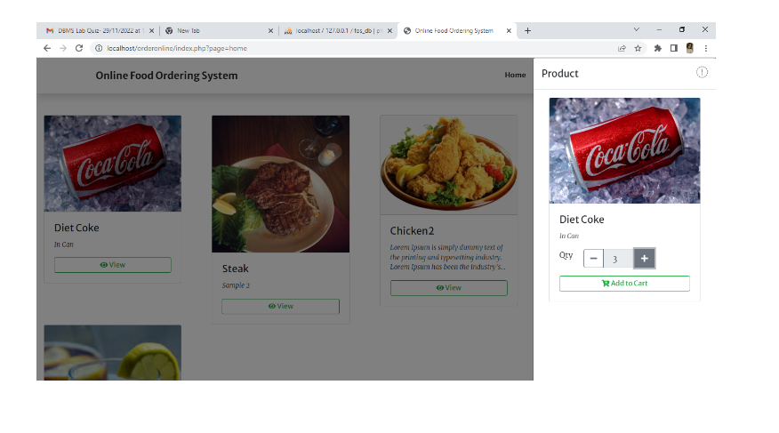

**Manager View**

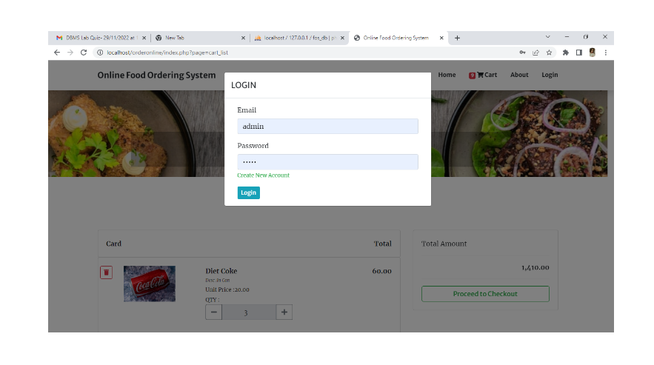

Fig 3.1.1 (b)

**Team Head view**

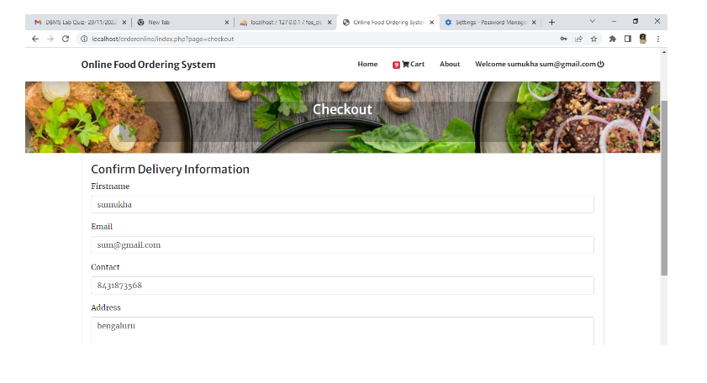

Fig 3.1.1 (c)

**Todo list**

### 3.1.2. Hardware Interfaces

Not applicable.

### 3.1.3. Software Interfaces

### The software is operating system independent. It would run on Windows.

### 3.1.4. Communications Interfaces

1. The RFOS will interface with a Local Area Network (LAN) to maintain communication
2. with all its devices. It should use a reliable-type IP protocol such as TCP/IP or reliable-UDP/IP for
3. maximum compatibility and stability. All devices it will interface with should contain standard
4. Ethernet compatible, software accessible LAN cards to maintain communication between the server
5. and the surface computers, tablets, displays and the external payment system.

The RFOS will interface with a Local Area Network (LAN) to maintain communication with all its devices. It should use a reliable-type IP protocol such as TCP/IP or reliable-UDP/IP for maximum compatibility and stability. All devices it will interface with should contain standard Ethernet compatible, software accessible LAN cards to maintain communication between the server and the surface computers, tablets, displays and the external payment system.

## 

## 

## 

## 3.2. Functional Requirements

The web-based Event4u being developed is generic. It can be used to manage any type of event, be it customized events or event types that are provided as templates:

* Event Creation:

Event4u would be able to create customized events and event types to match the requirements. Some of the most common events would be bundled in the database,but it would be very easy to add new ones if needed.

* Task and Team Management:

Tasks are the small pieces that build up a whole event. The event manager would create teams and group the staff into teams,and assign individual tasks to people involved in all the phases of the process, from event planning to event completion.

* Budget:

Inside every organization, budget control is one of the key features for success. The event manager would define maximum amount of money to be spent, and accordingly track the amount of money spent .

* Automatic notifications:

Notifications would be defined to keep all the team members informed about the important appointments or tasks that are pending. Notifications would also be helpful in establishing collaboration between two different teams if their tasks are dependent.

## 3.3. Behavior Requirements

### 3.3.1 Use Case View

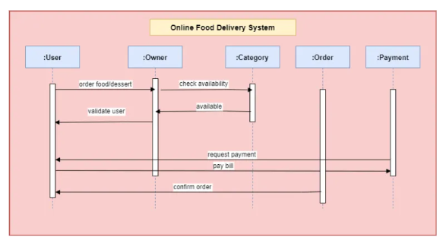

# *4.* Other Non-functional Requirements

Other Nonfunctional Requirements

This subsection presents the identiﬁed non-functional requirements for the subject RFOS.

The subcategories of non-functional requirements given are performance, safety,securtity

requirements.

5.1 Performance Requirements

The server shall be capable of supporting an arbitrary number of surface computers, tablets

and displays, that is, it shall provide no limit on how many devices are in the system.

The server shall be capable of supporting an arbitrary number of active customer payments, that is,

no payments shall be lost under any circumstances

Other Nonfunctional Requirements

This subsection presents the identiﬁed non-functional requirements for the subject RFOS.

The subcategories of non-functional requirements given are performance, safety,securtity

requirements.

**4.1 Performance Requirements**

The server shall be capable of supporting an arbitrary number of surface computers, tabletsand displays, that is, it shall provide no limit on how many devices are in the system.The server shall be capable of supporting an arbitrary number of active customer payments, that is,no payments shall be lost under any circumstances

Safety Requirements

The system shall log every state and state change of every surface computer, tablet and

display to provision recovery from system failure.

The system shall be capable of restoring itself to its previous state in the event of failure

(e.g. a system crash or power loss).

The system shall be able to display a menu at all times to facilitate manual order taking

should the need arise.

The system shall utilise periodic 30-second keep-alive messages between tablets and the

server to monitor tablet operational status.

5.3 Security Requirements

A waiter password used for tablet login must have a bit-strength of at least 64 bits.

A waiter password used for tablet login must be changed every three months.

A waiter shall only be able to log into one tablet at any given instance of time.

A waiter that attempts to log into a second tablet while already logged into

5.4 Software Quality Attributes

The software shall be capable of supporting an arbitrary number of surface computers,

tablets and displays, that is, it shall provide no limit on how many devices are in the system. It shall

7

**4.2 Safety Requirements:**

The system shall log every state and state change of every surface computer, tablet anddisplay to provision recovery from system failure.

The system shall be capable of restoring itself to its previous state in the event of failure(e.g. a system crash or power loss).

The system shall be able to display a menu at all times to facilitate manual order takingshould the need arise.

The system shall utilise periodic 30-second keep-alive messages between tablets and theserver to monitor tablet operational status.

**4.3 Security Requirements:**

A waiter password used for tablet login must have a bit-strength of at least 64 bits.

A waiter password used for tablet login must be changed every three months.

A waiter shall only be able to log into one tablet at any given instance of time.

A waiter that attempts to log into a second tablet while already logged into

**4.4 Software Quality Attributes:**

The software shall be capable of supporting an arbitrary number of surface computers,

tablets and displays, that is, it shall provide no limit on how many devices are in the system. It shall be capable of supporting an arbitrary number of active meals/orders, that is, no meals/orders shall be lost under any circumstances

be capable of supporting an arbitrary number of active meals/orders, that is, no meals/orders shall

be lost under any circumstances

# 

# 

# 

# 

# *5.* Other Requirements

**5.1 Requirements Elicitation:**

Interviews were conducted to get a better picture of the requirements of the user:

1) Abhishek ,Secretary of “Saahaayyamdridha” was interviewed by Anil kumar V.

Saahaayyamdridha is a public charitable trust in Raichur. This trust has in the past organised a full day cultural event for children. The details of the management of the event(by dividing the manpower) are as follows:

1) Core team.

2) Event coordinator.

3) Logistics.

4) Finance and fund raising.

5) Communication team.

6) Program coordinator.

7) workload coordinators.

8) Others.

**Roles of the volunteering teams**

1) Core team

a) Group of experienced people.

b) Reviewing the volunteering teams.

c) Suggestions to make the event successful.

2) Event coordinator

a) Conduction of competitions on the day of event.

b) Handing over the materials to the judges.

3) Logistics

a) Food management.

b) Transport.

4) Finance and Fund raising

a) Get the sponsors.

b) Raise funds required for the event.

c) Take care of financial accounts.

5) Communication

a) Media.

b) Marketing.

c) Documentation.

6) Program coordinator

a) Program schedule management on the day of the event.

7) Workload coordinators

a) Getting the materials required for the event(things used for cooking).

b) Stage management.

8) Others

a) Help desk on the day of event.

b) Emergency conditions.

2) With respect to this project, we, Megha.L.S and Prashant Kumar, interviewed Mr. Harsh Golyan who has worked in three different Event Management Companies. He enlightened us with the teams that volunteers are divided into while organising different types of events. He also helped us get a clearer picture about the way an event is organised. Few of the teams he mentioned are as follows:-

* Catering
* Stage and Infrastructure
* Hospitality
* Public Relations
* Transportation
* Security
* Finance
* Logistics

This interview has given us an idea on the type of templates to provide to an event manager for particular types of events.We thank Mr.Golyan for taking some time out to share his valuable input with us.

3) **Event**: Concert.

**Interviewed**: Prathik.

Organized a concert.

·Things to be done first,

* + Permission from government authorities.
  + Distribution of tasks.

Stage design.

Technicians.

Food and beverages.

Security.

Publicity.

Finance.

Hospitality.

Cleaners.

·Things to take care for a performer,

Travel expenses.

Stay.

Food and beverages.

Security.

Equipments.

Crackers(optional).

·Things to take care for public,

Security.

Food and beverages(optional).

Parking facility.

**4) Technical event**

Mr. Rakesh Kumar who had been a part of technical event organizing team for hackathons like Ayana and hashcode was interviewed regarding the actors and teams that are involved in the process of organizing such an event.

Apart from the above mentioned teams there is a need of strong tech team expertised in various technologies involved in the event. A network team also is a must. He also stated that developing such a software can be extremely helpful for novice event managers.

**5.2 Technical Feasibility:**

A series of interviews with event managers were held to gather their requirements and to gauge if the software, Event4u is feasible to implement.

Technical feasibility:

For the implementation of the software, Event4u, the technical resources needed were estimated.

The current solution to the software was decided based on

* The complexity of the technical resources needed.
* The manpower needed to implement the project.
* Team member's prior experience with the technology.
* Ease of learning the implementation tool that isdjango.
* The limited time constraint empowered by django which is specialised for

agile development.

**Appendix A – Data Dictionary**

|  |  |  |
| --- | --- | --- |
| 1 | Employer | Employer is an individual who has contacted the event organiser. |
| 2 | Event Manager | Event Manager is an individual who is responsible for the whole event and can view the entirety of the event being planned on the software.He/She is usually the lead event organiser. |
| 3 | HTTPS | HTTPS stands for Hypertext Transfer Protocol Secure.This protocol is a widely used communications protocol forsecure communication over a computer network, with especially wide deployment on the Internet. |
| 4 | OpenID | OpenID is a decentralized single sign-on authentication system for the Internet. The goal of the OpenID initiative is to allow users to log in at websites around the Internet with one ID, instead of having to create multiple unique accounts. |
| 5 | SRS | SRS stands for Software Requirement Specification. It is his used to refer to a document that completely describes all of the functions of a proposed system and the constraints under which it must operate. |
| 6 | Team Head | Team head is an individual who is responsible for all the actions undergoing under his/her team. |
| 7 | UI | UI stands for User Interface. It is defined as the space where interaction between humans and machines occurs. |
| 8 | View | View means to display and look at data on screen. |
| 9 | Volunteer | Volunteer is a person who offers to take part and help in organizing the event. |

**Appendix B - Group Log**

**Date :23/8/2022 (2.30 p.m)**

**Duration: 1 hour**

**Co-ordinator: Nagasundari**

**All members present**

The first team meeting took place on this day. After a friendly chat ,it was decided that we would observe and find out any sort of a problem and would decide on its feasibility as an application software.

**Date :04/9/2022 (3.30 pm)**

**Duration:30 minutes**

**Co-ordinator: Nagasundari**

**All members present**

Interesting ideas were put across and we made a brief discussion on which among them would be feasible to implement in the given time period. Since all the ideas were equally good we did not come into a mutual accord.Some of the ideas put across were :

1.To have a software for better schemes for toll booths.

2.A software that tracks corruption and gives information to common man.

3.To develop a software for knowledge of exact rates of trasportation.

4.A portal that will help student to prepare for interviews and aptitude during placements.

5. Software to implement Intelligent traffic signals.

6.Improve and develop another version of Gems.

We decided to take a day off to come up with more feasible ideas.

**Date:26/9/2022 (8:30 P.M)**

**Duration:2 hours**

**Co-ordinator: Nagasundari**

**All members present**

The approach with which the scope had to be presented was discussed and we decided to go with the observation->problem->Solution model.After a final group chat on saturday we finalised the Event Management Centre(Name yet to be finalised).The temporary name was given by Navaneeth and Prashant as **Event4u.**

**Date :21/9/2022(1.30 pm)**

**Duration: 45 mins**

**Co-ordinator: Nagasundari**

**All members present**

The project Scope was given an approval. We decided to work towards the requirements of our project which has been asked to be submitted by 5th February . As the first step is to inquire and get more knowledge about the particular field we are making the software for,we all decided to take interviews from people involved in organising events and members of different companies involved in the event management field.

Our team decided and agreed upon the fact that we’ll have an online meet at 9 P.M every day for better coordination and interaction.

**End-Result:** Each member of the group was assigned a particular type of event by the group leader.Each group member took upon the responsibility of researching more about that specific event and getting the requirements by interviewing the necessary people.

**Date :30/8/2022(3.30 pm)**

**Duration: 30 mins**

**Co-ordinator: Nagasundari**

**All members present**

Every person of the group were told to brief about the information they gathered regarding the events that was assigned to them. Since it was not very much refined it was decided that we would continue with the same set of people to refine their idea.

**Date :10/9/2022(3.30 pm)**

**Duration: 30 mins**

**Co-ordinator: Nagasundari**

**All members present**

The requirements for all the events were brief, but comprehensive this time. Queries regarding the decided events were answered by the team member in charge of the task of knowing the event , thus tying up the loose ends. Now the team has a clear idea of what is to be dealt with. Team members were given time to review the SRS template and to think of the details that can be put since they have a better idea of the events to be handled by the proposed software.

**Date :11/9/2022(3.30 pm)**

**Duration: 30 mins**

**Co-ordinator: Nagasundari**

**All members present**

An assignment regarding cleanroom SE was to be submitted before saturday. The team members, well advised before via e-mail, came with their thoughts regarding cleanroom SE. Every one were asked to write their thoughts on cleanroom SE , which was to be collaborated by Friday. Each one also explained their progress with the SRS template. Each team member talked about their interests regarding coding , designing, their experiences in various programming languages. A brief discussion regarding how the application should run as a web service also took place.

**Date :2/10/2022(4.00 pm)**

**Duration: 30 mins**

**Co-ordinator: Nagasundari**

**All members present**

Assignment regarding Cleanroom SE was successfully completed and was submitted. Project manager decided to build a SWAT (Skilled Worker with Advance Tools) team for the project development because of the deadline criteria.

The team was divided into 3 equally important parts for the earlier stage of product development.

**Designers**

Nagaratna Manjunath Naik

Nandini M V

Monisha N

**Implementors**

Front end

Nandini M V

Nagaratna Manjunath Naik

Back end

Monisha N

Nagaratna Manjunath Naik

**Testers**

Nagaratna Manjunath Naik

Nandini M V

**Documentation head**

Nagaratna Manjunath Naik

The designers were asked to come up with designs for the web pages involved in the software which is shown in SRS v1.0. The front end implementers were informed to brush up on their basics in HTML,CSS and Javascript. Depending on the scope and requirements collected of the proposed software , “django” based on python was chosen as the backbone for the entire software. The backend implementors decided to learn basic application development on it before the actual implementation starts. It was decided that based on the initial designs which should be ready by 9PM [25/11/22] , S.R.S template would be filled online via google docs.