Guidelines for No due clearance in SSP.
The check list below will help ensure a smooth and quick closure of your exit formalities. Employee’s role
- Your no due clearance should be initiated on the SSP Tool. The tool will send out automated triggers to respective departments to complete your no dues. You are requested to ensure No Dues closure on or one day prior to your last working day.
- Please pay special attention to the no due clearance provided by respective departments and ensure all inputs provided by each of them are accurate. In case of any difference / clarifications, please reach out to the respective department SPOC (mentioned on the SSP Tool) for corrections.
- Based on your validation, you are requested to sign off on the SSP tool one day prior to your last working day.(Path Given Below)
- Please update your valid personal email id and complete communication address, personal mobile number on the SSP tool.(Path Given below) Mphasis will use either/all the contact details as provided by you at the time of leaving for all correspondence with you in future. This includes communication of your Full and Final documents.
- Departments giving no dues on the SSP tool: Admin, Visa, System Support, Legal, Accounts, Payroll, Training & HR OPS. Contact details of the respective spoc will be available in SSP tool. 
Department clearance details
Admin:
Employees are requested to hand over ID card and Access Card & all Admin asset to the Admin SPOC/Property SPOC only, one day prior to the employee’s last working day. If this is handed over to anyone else, an applicable amount will be recovered in the Full and Final settlement
For return of Mobile / Data Card / Conference bridge, please raise a return request by logging onto the ASMS>>APPACCESS–
Select the service that needs to be returned, For e.g. – Corporate Mobile SIM - Request - Return Request
Data Card - Request - Return Request
ACS – Request – Return request
If Data Card / Hot spot is not returned, the cost of the same will be deducted in the full and final settlement
- System Support:
Employees are requested to hand over/surrender the Laptop or Desktop, HP Manual, OATH token / Active Key / RSA Token to the respective location SPOC one day prior to employee’s last working day (Respective Location System Support SPOC). If not handed over /surrendered, the due amount will be recovered in the full and final settlement.
- Reporting Manager:
Employees have to ensure that inputs provided by their reporting manager are correct in the No Dues Clearance. Please ensure accurate entries in the following fields;
- Last working day. o Incentive amount and Incentive Rating/Allowances or any one time payout to be paid as part of full and final settlement.
- Notice period recovery or waiver. o Headset
- Performance Incentive o Notice Period Applicable in days o Notice period served o Notice period recovery waived off o Client incentive o Completed self-appraisal o Number of Unapproved leave taken during NP o
Shift Allowance o Product support Allowance
- On call eligibility o Med claim Insurance Premium o Fuel Reimbursement
- Finance Reimbursement:
Employee to ensure that all pending I-expenses raised in the Oracle system are cleared before the last working day. Employees can check with Finance reimbursement team for any queries or clarification. Full and final settlement will not take care of I-expense claim reimbursement.
- Accounts Department Clearance
If an employee who has availed Inland travel advance, foreign travel, corporate cards, FBT recovery on RSU / Stock Options Premium ( if opted for ) would be recovered in full and final settlement
If an employee resigns within 1 year the relocation expenses would be recovered in full and final settlement
- Legal Department Clearance
If an employee who has ESOP warrants allocated would be recovered in full and final settlement
- Repayment of Training Expenses
Employee who has received training from the Company and decides to resign before completing one (1) year of service with the Company but after completing training, the Employee shall, on resignation, repay to the amount of training expenses yet to be amortized over the portion of the service period that was not performed.
- HROPS Department Clearance
Required if an employee who has eligible encasement leaves available which is not availed. The same will be given in HR OPS no dues and if any excess leave availed will be deducted from the full and final settlement
- Payroll Department Clearance
If an employee who has availed Salary Advance, Loan for onsite travel, Salary arrears, Medi-claim, Final Settlement due would be recovered in full and final settlement
SSP Navigation for employees
Log in to SSP on: https://mployee.corp.mphasis.com to follow the steps to Initiate and complete the sign off on SSP.
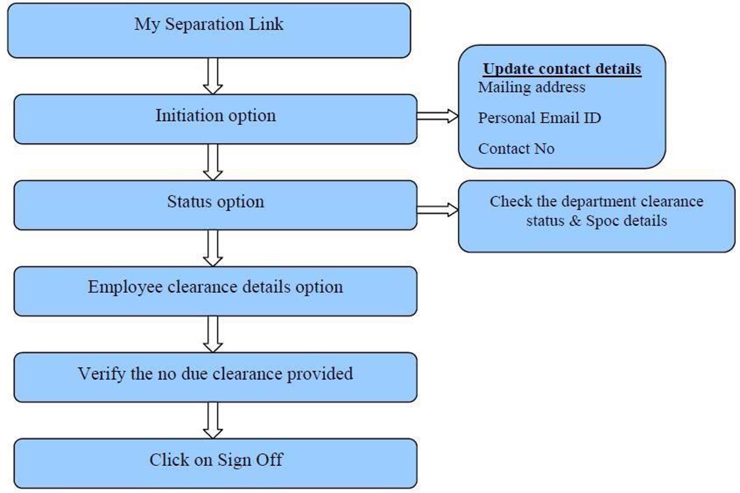
HR Helpdesk Contact details
For any queries employees can raise HR Help Desk Ticket through the below link:
Active Employees can raise a HR Help Desk Ticket by the using the following link: - https://mphasisin.service-now.com/mphasis_sp_cio
Ex-Employees can raise a HR Help Desk Ticket by the using the following link: - https://mphasisin.service- now.com/ExEmployeeServiceForm


