MIT COLLEGE OF ARTS AND SCIENCE FOR **WOMEN,MUSIRI.**

**TS-AI TRACK CAPSTONE PROJECT**

**TITLE OF THE PROJECT**

**HOUSE SECURITY**

***SUBMITTED BY,***

***SANDHIYA N(TEAM LEADER)***

***MONISHA P***

***SARUMATHI S***

***SANTHIYA S***

***GUIDED BY,***

***MAYANK SHRIVASTAVA***

***OUTLINE***

* ***ABSTRACT***
* ***PROBLEM STATEMENT***
* ***PROPOSED SOLUTION***
* ***SYSTEM ARCHITECTURE***
* ***SYSTEM DEPLOYMENT APPROACH(TECHNOLOGY USED)***

***CONCLUSION***

* ***REFERENCES***

***ABSTRACT***

*Security is the priority* ***. E****specially when we are already dealing with this deadly virus,Covid-19,we don’t want security threats in our home.Home is the place where you relax,spend time with your family,and be yourself. Compromising*

*With the security of the home means risking yours and your family’s life.Moreover ,there are unforgettable memories and emotions attached to the home So,protecting your home from fire,burglary,of any crime becomes your prime responsibility and concern.*

***Let’s go through the detailed information about the IOT enabled best home security systems of 2024 that can help you in keeping your home secure and smart.***

**PROBLEM STATEMENT**

**A problem statement is a concise description of the problem or issues a project seeks to address.**

MUST BE INEXPENSIVE.

**PROPOSED SOLUTION**

## ARDUINO UNO

As clearly it’s an embedded systems project,so first of all we need to select a Microcontroller for our project.

As I have mentioned earlier ,we will use the Arduino UNO -Microcontroller board for designing this project.

Arduino UNO will act as the brain of the brain of the project and will control all sensors and modules.

FLAME SENSOR:

A flame senor is used to detects the presence of fire.

The Sensor basically consists of a photo-diode that detects the infrared rays that emit from the fire. When it defects a fire, its output goes HIGH.

**SYSTEM ARCHITECTURE**

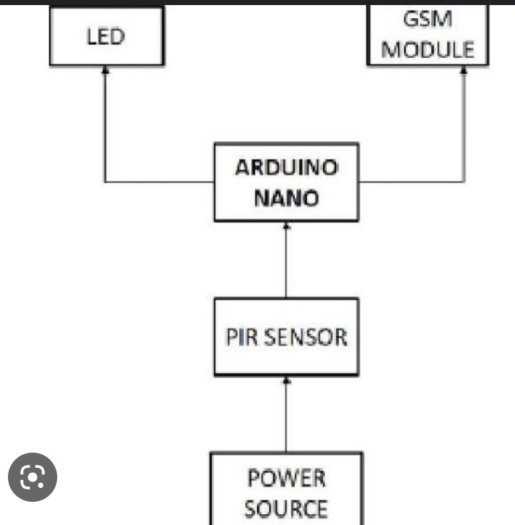

**SYSTEM DEPLOYMENT APPROACH**

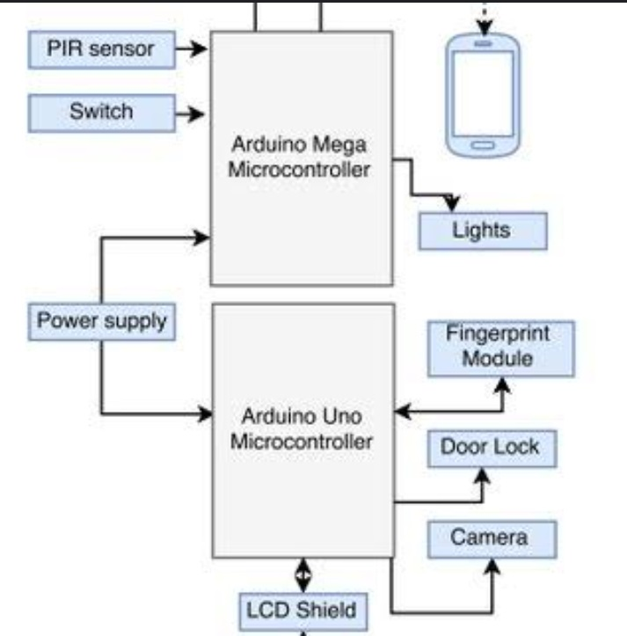

Reference:

GitHub website.

THANK YOU