Welcome to ATM Java project below are the artifacts for the project

Initial Project Run

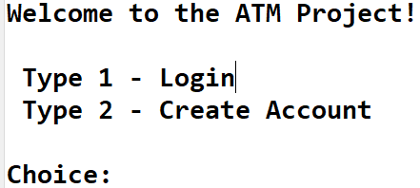

Case1: Login with wrong account number

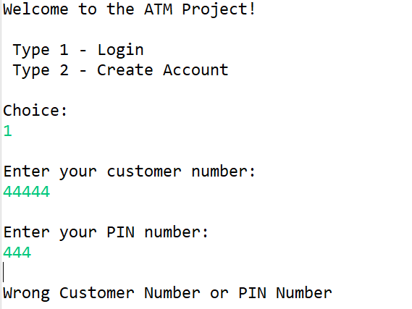

Case2: Entering Wrong character

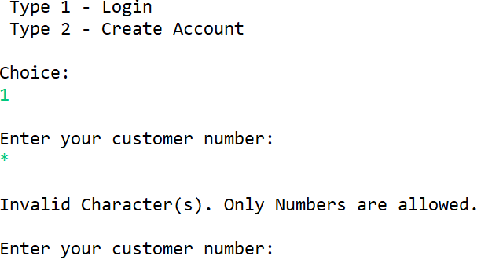

Case3: Entering first customer credentials

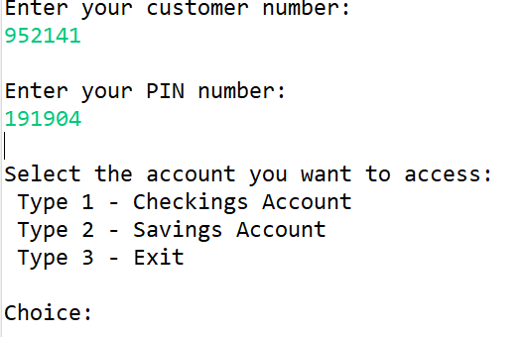

Case4: First customer checking account

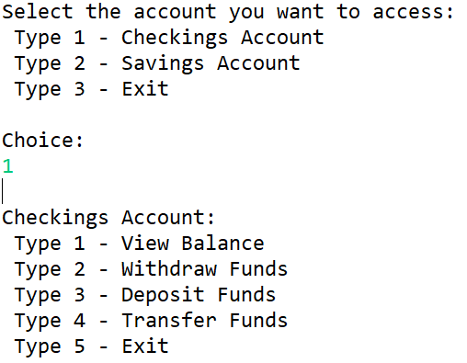

Case5: First customer account balance

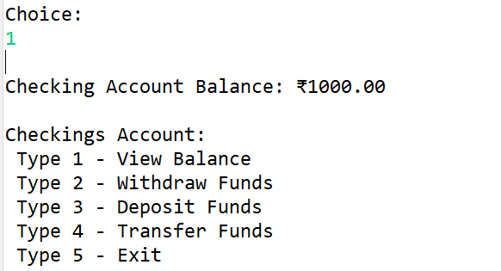

Case6: First customer Transfer Funds

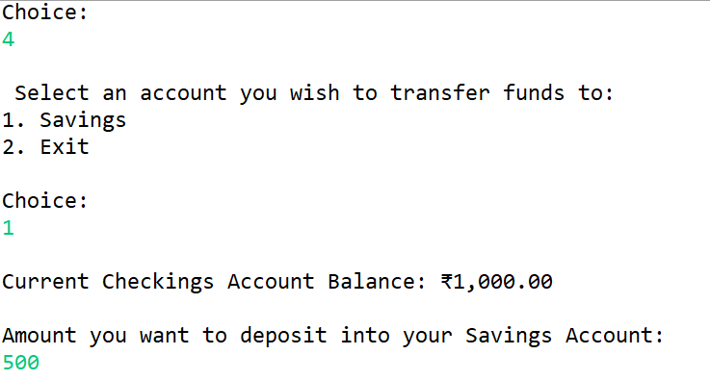

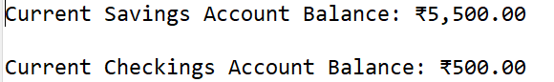

Case7: First customer check-withdraw Funds

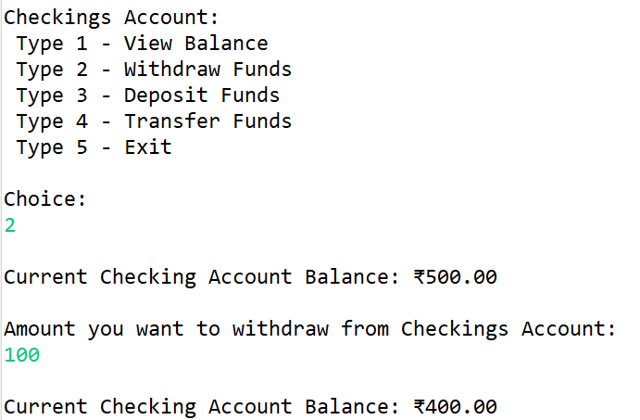

Case8: First customer check Deposit Funds

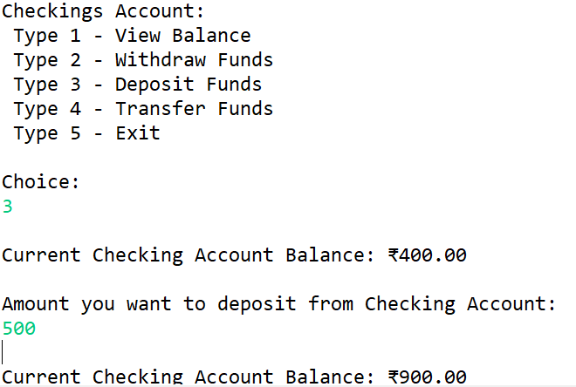

Case9: First customer check- Exit

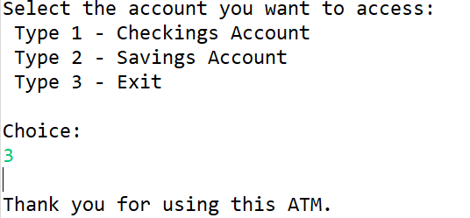

Case10: First customer saving acc view balance

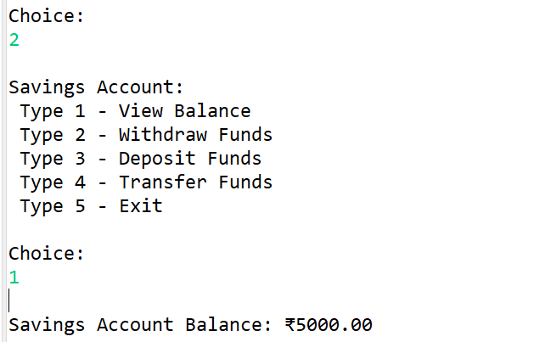

Case11: First customer saving acc withdraw funds

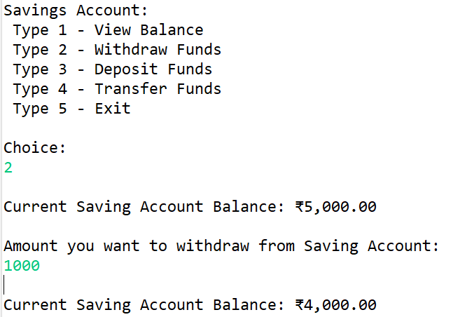

Case12: First customer saving acc Deposit funds

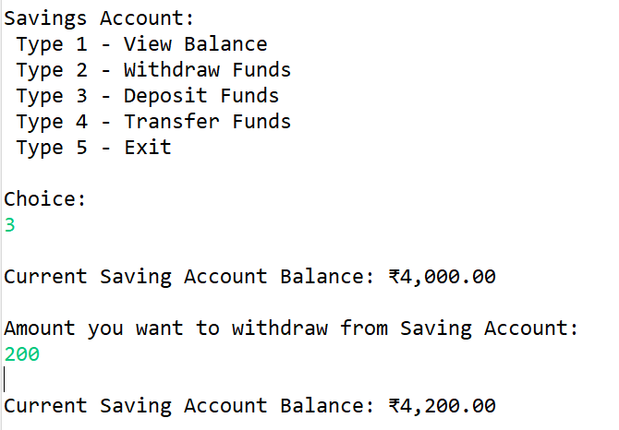

Case13: First customer saving acc Transfer funds

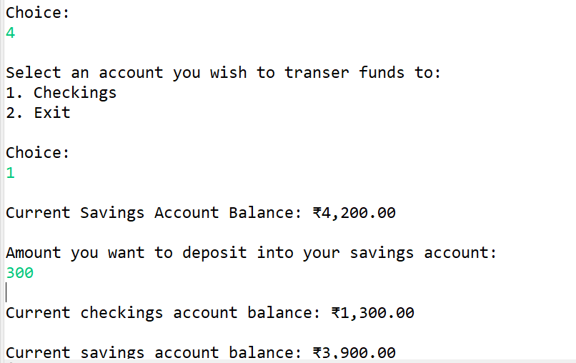

Case14: First customer saving acc exit

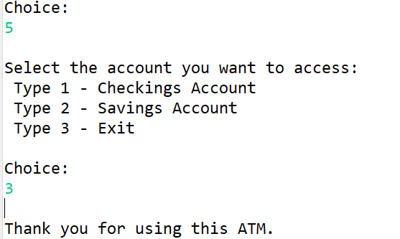

Case15: Login with wrong account number

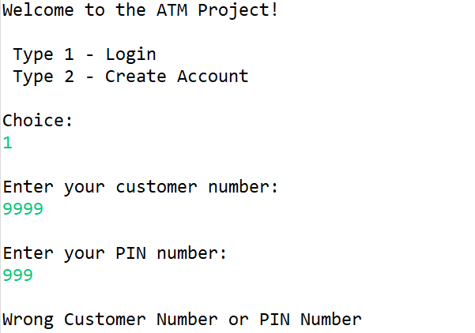

Case16: entering wrong character

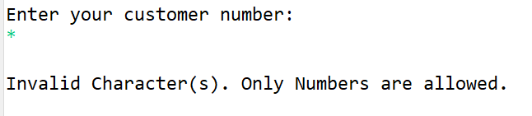

Case17:entering second customer credentials

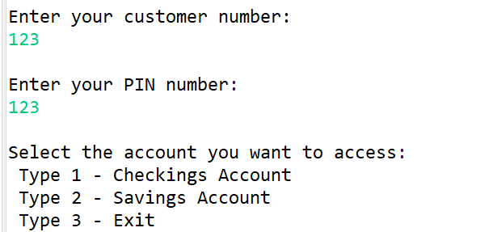

Case18: Second customer checking account

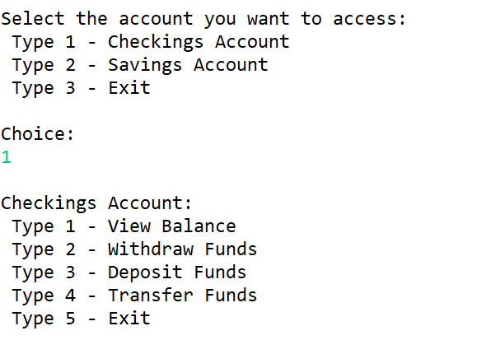

Case19: Second customer account balance

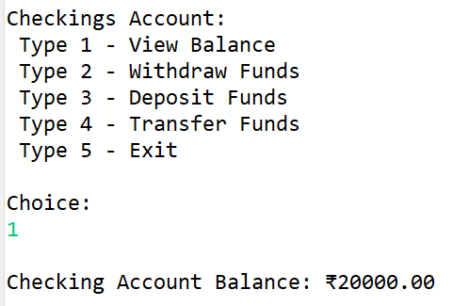

Case20: Second customer Transfer funds

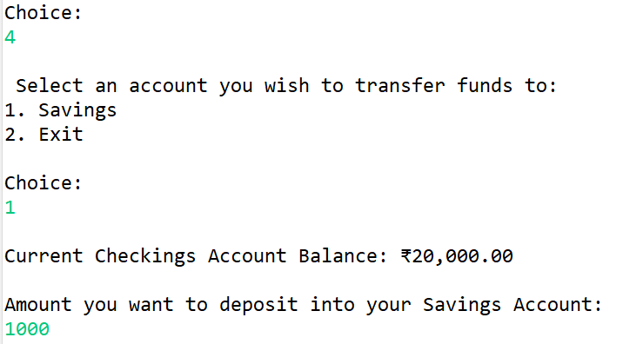

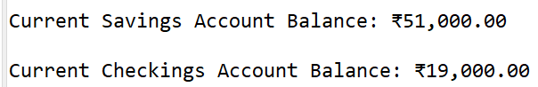

Case21: Second customer check withdraw funds

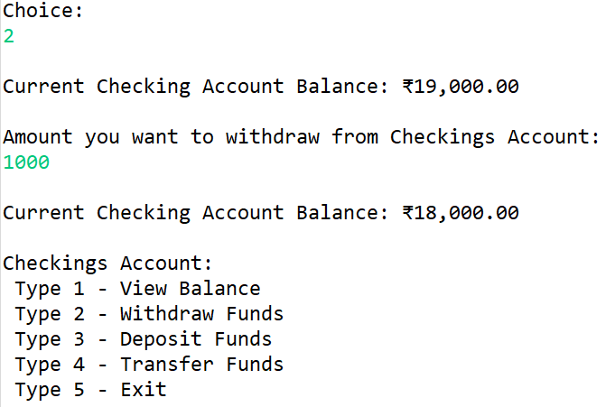

Case22: Second customer check Deposit funds

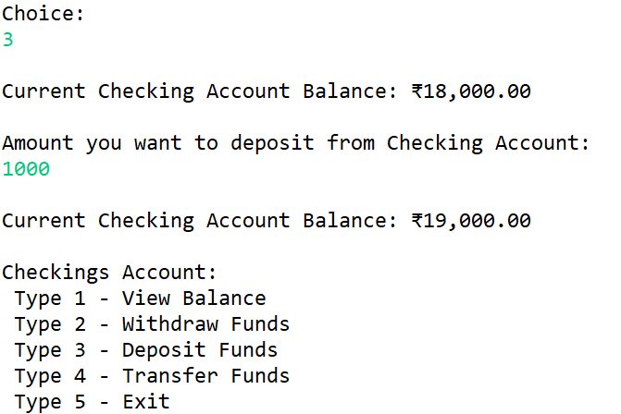

Case23: Second customer check exit

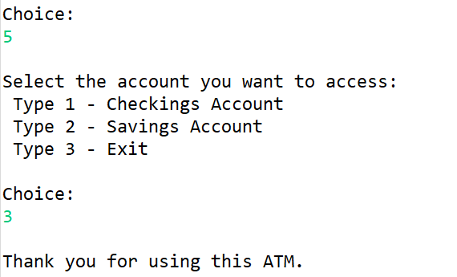

Case24: Second customer saving acc view balance

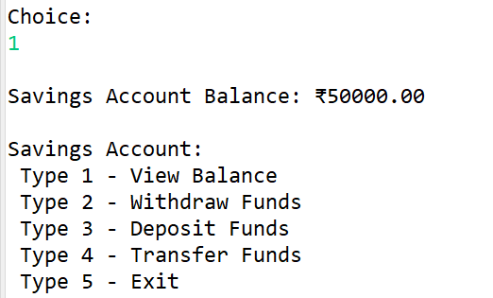

Case25: Second customer saving acc withdraw funds

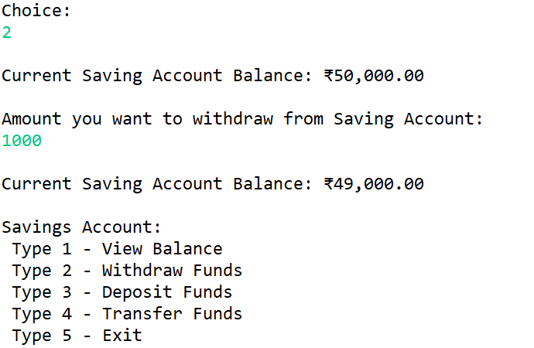

Case26: Second customer saving acc Deposit funds

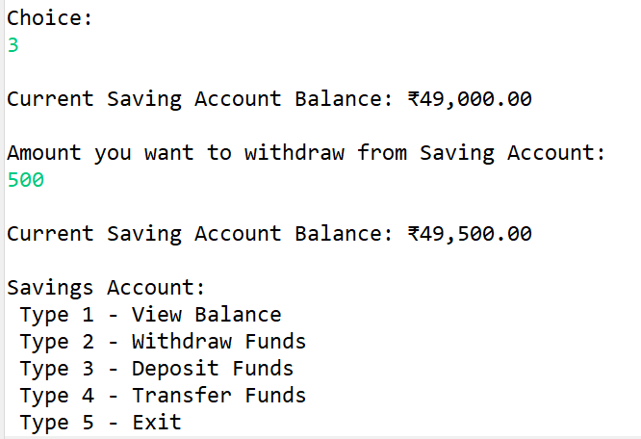

Case27: Second customer saving acc Transfer funds

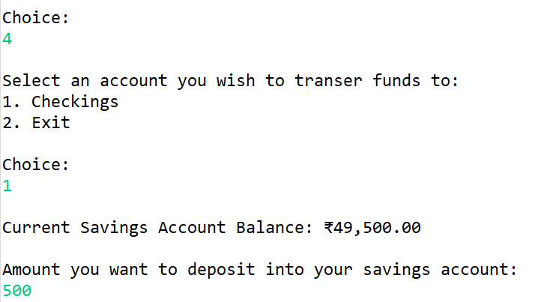

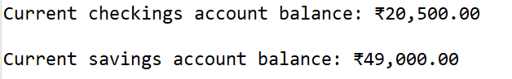

Case28: Second customer saving acc exit

