PRAJAN K- 1RVU23BSC100

MLOps program7

STEP 01:Create the directory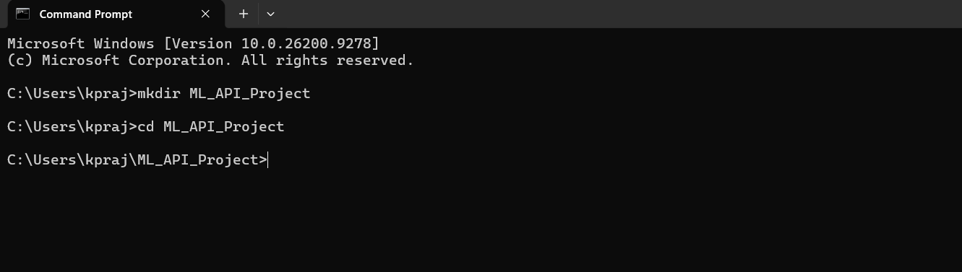

STEP 02: Install Required packages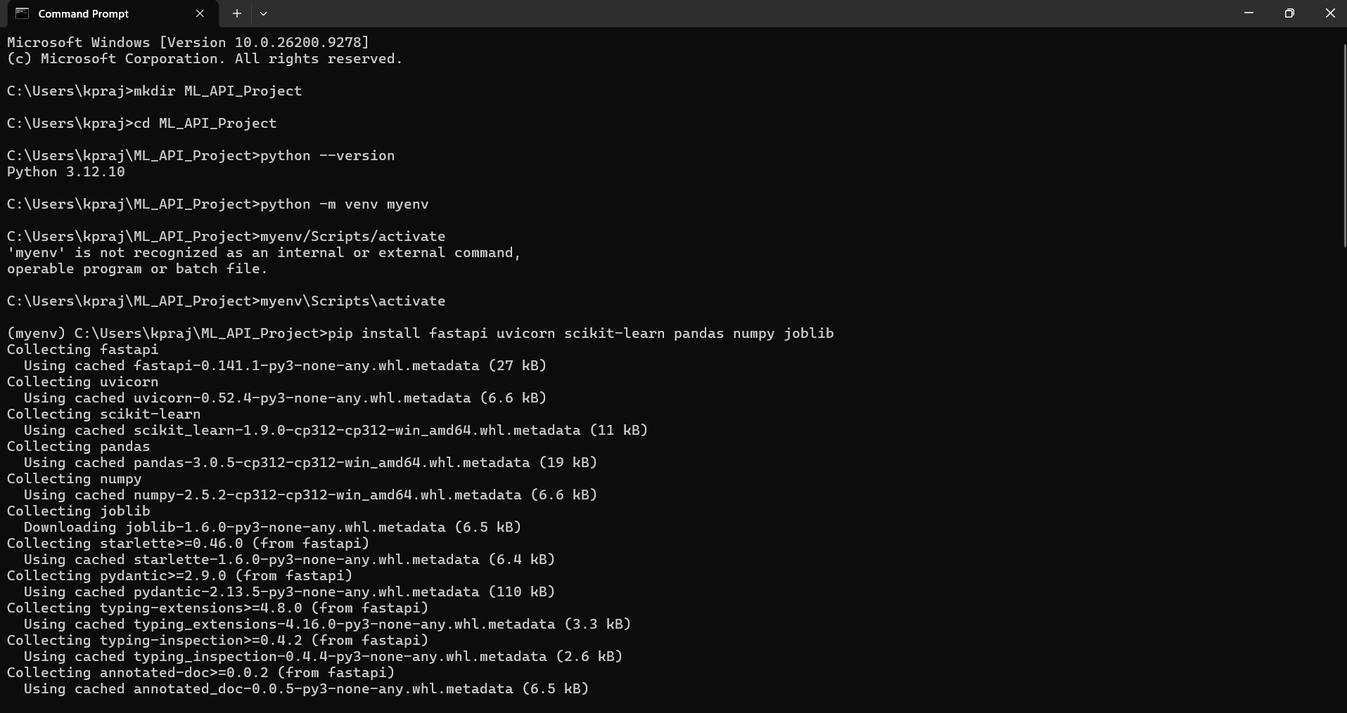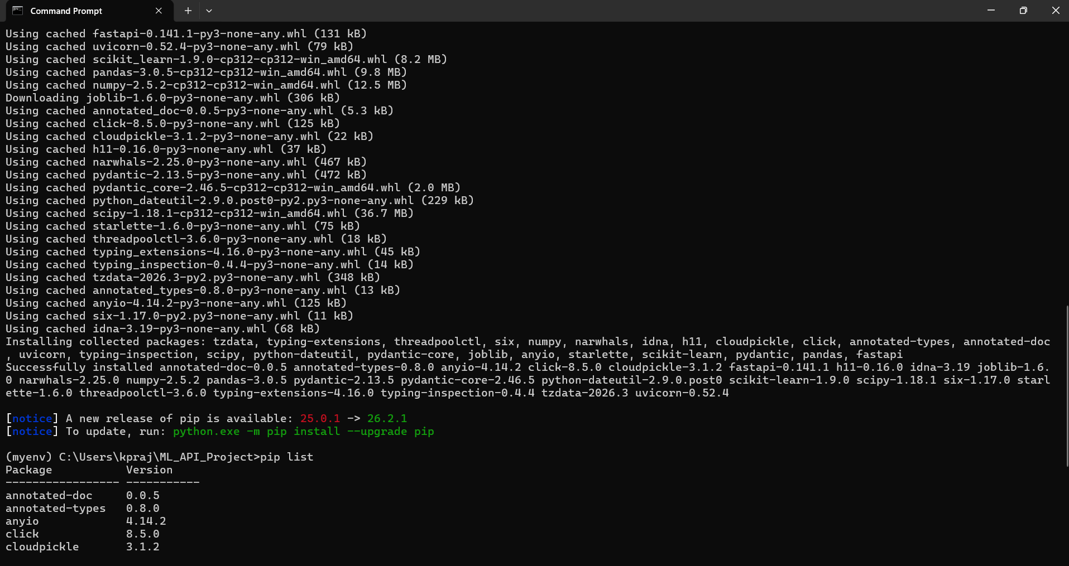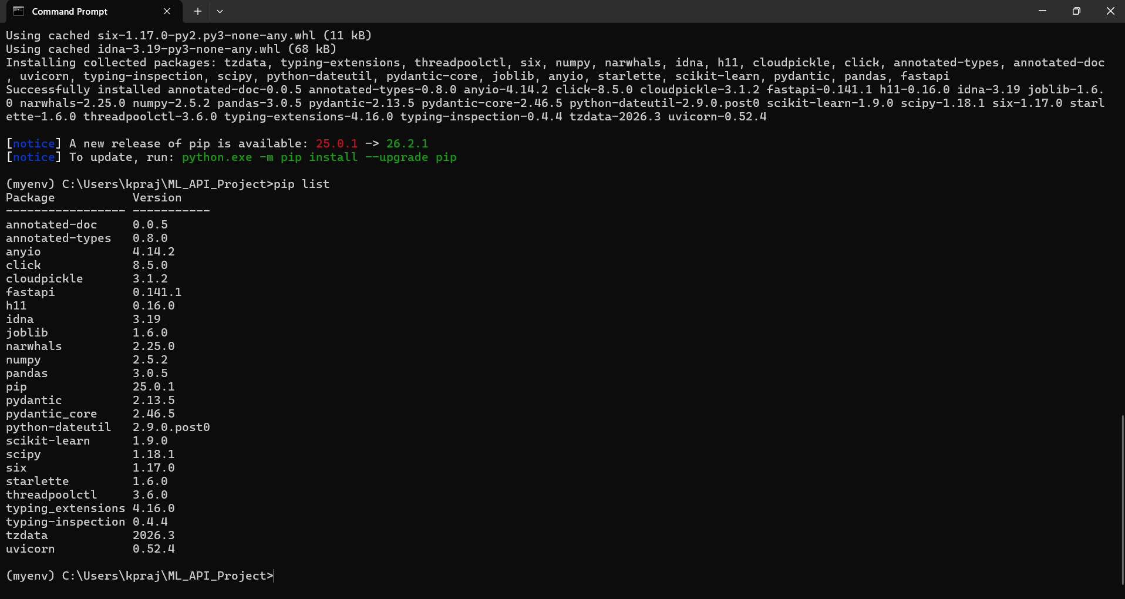

STEP 03: Project Structure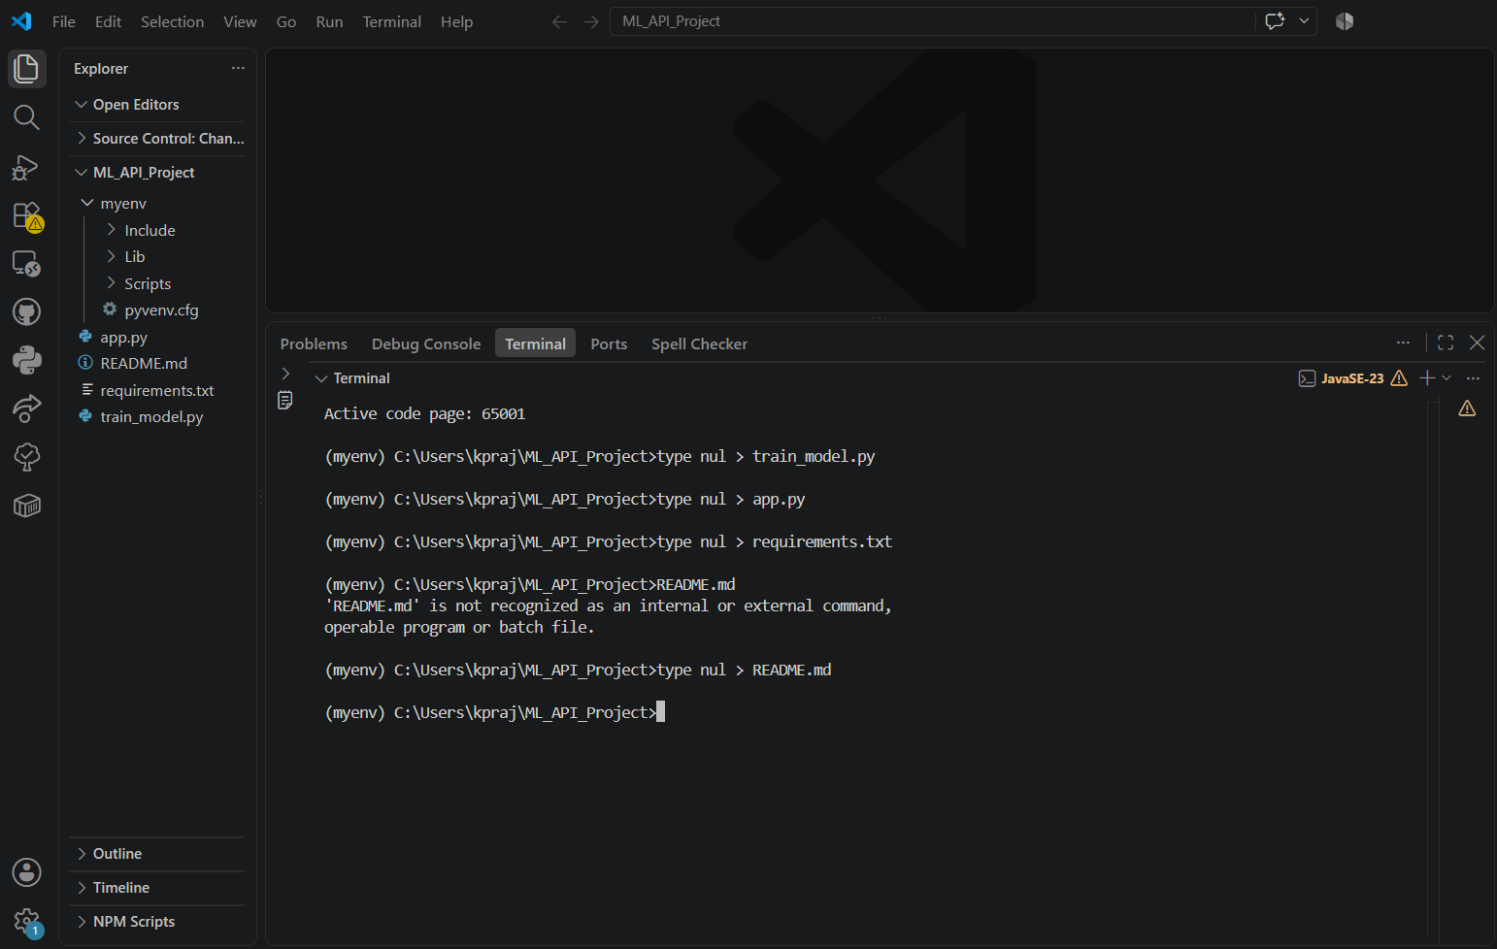

STEP 04: Train the model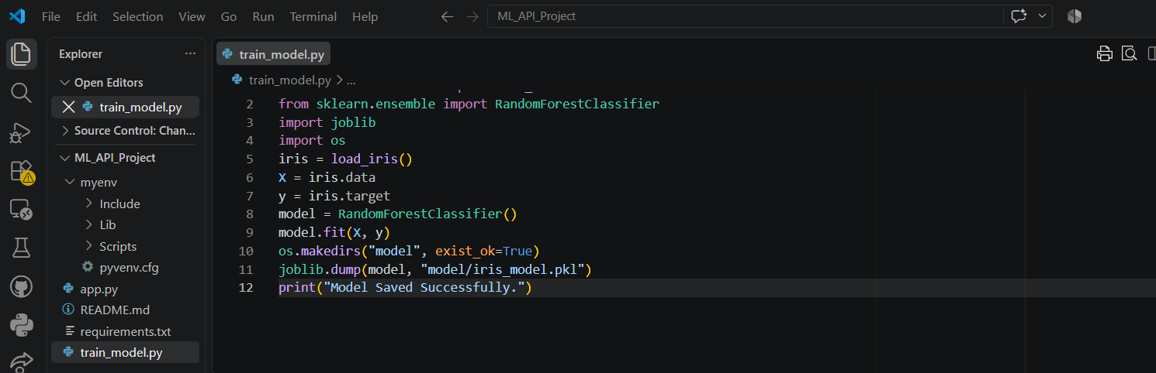

STEP 05: Train & Verify the Model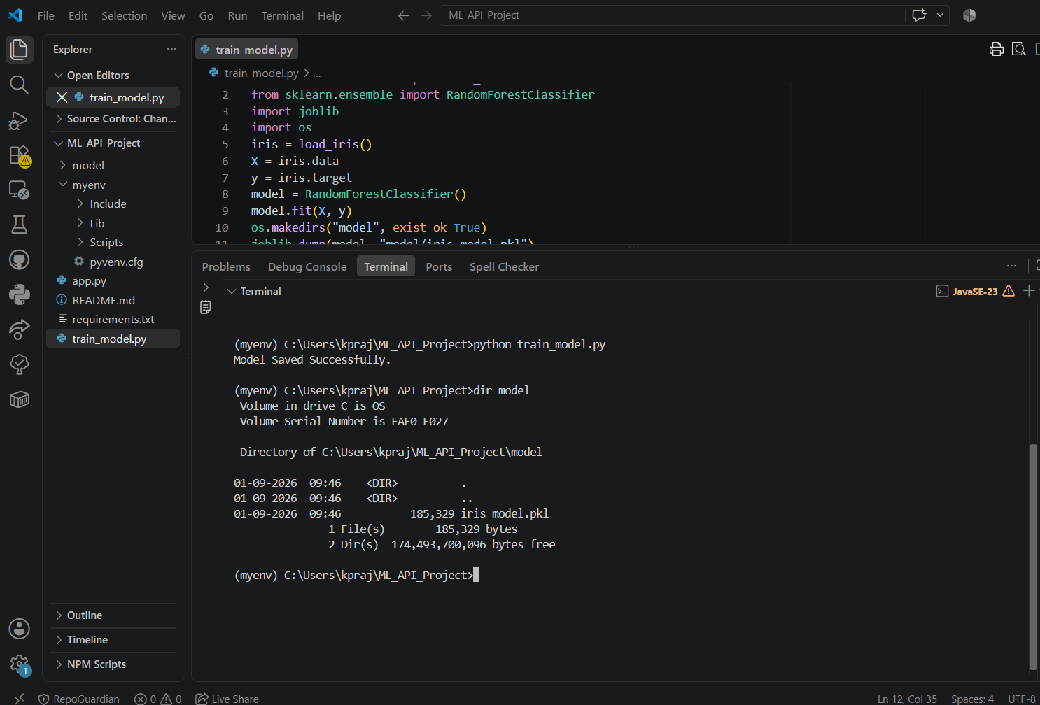

STEP 06: Build the FastAPI Application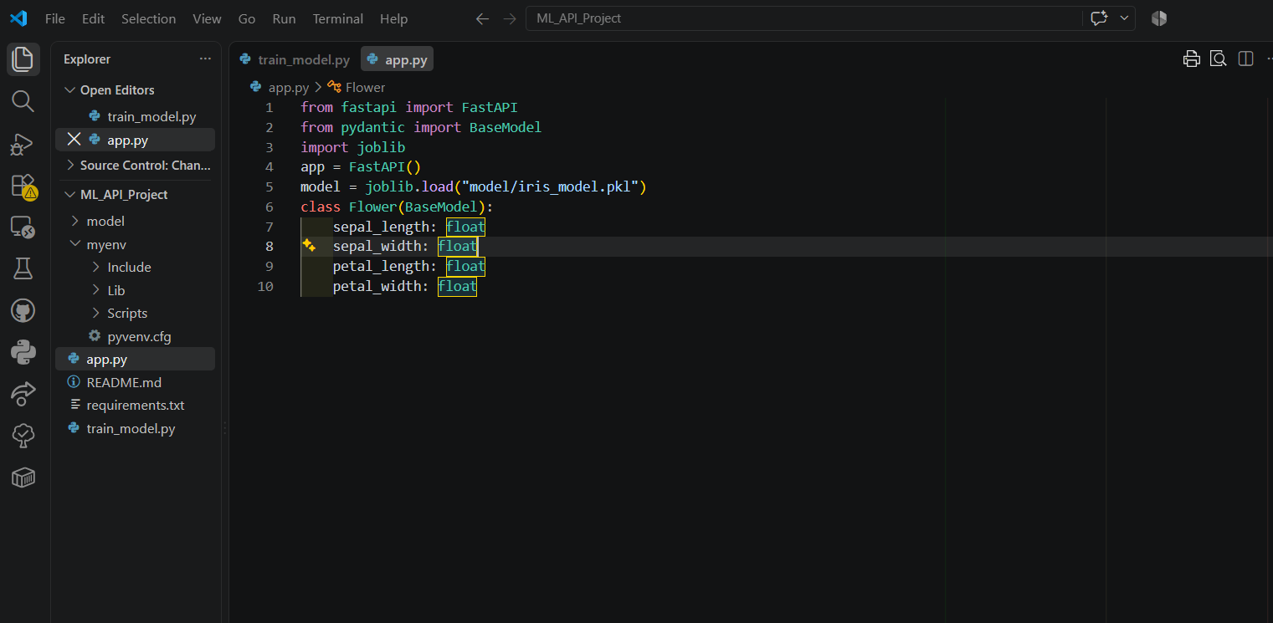

STEP 07: Create the API Endpoints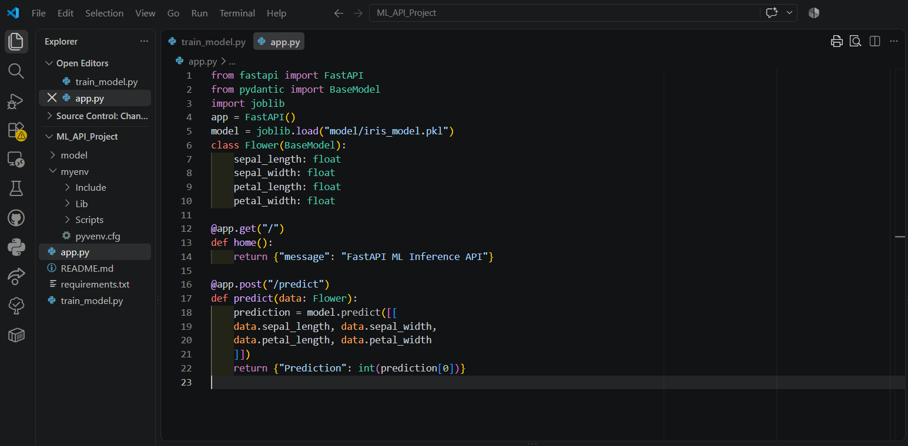

STEP 08: How the REST API Works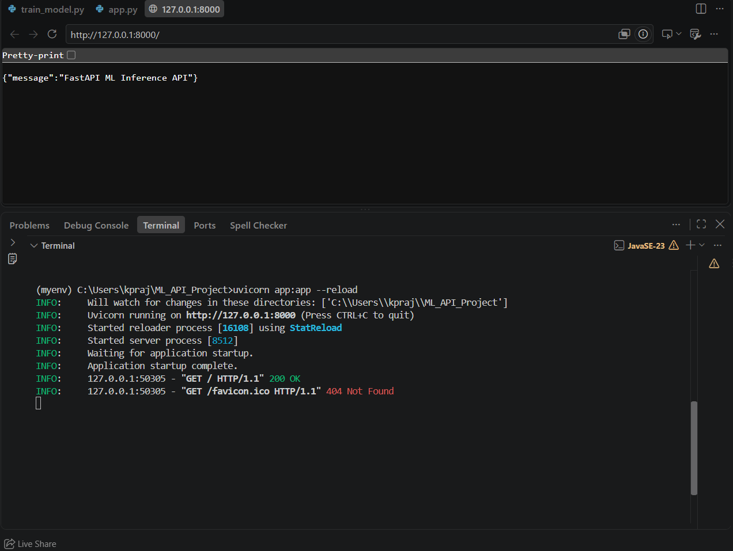

STEP 09: Run the FastAPI Server

STEP 10: Test the Home API

STEP 11: Open Swagger UI

STEP 12: Test POST /predict in Swagger

